Summer water play

While summer is just a few days away. Here are some fun activities you can do with your infants.

Beach sensory bag
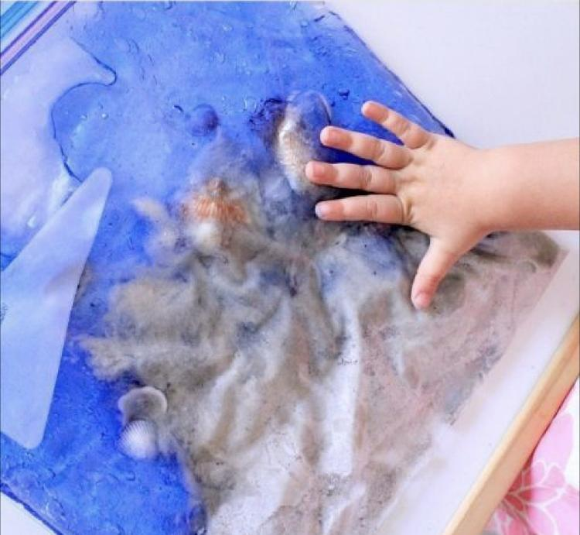

Material
Ziploc bag
Clear gel
Blue food coloring
Sea shells
Sand

Directions
Add a few scoops of clear gel in your ziplock and add a few drops of blue food coloring. Once it’s combined, go ahead and add the sea shells and a handful of sand into the ziplock. After adding the sand, seal the ziplock bag with tape and let your little one discover.

** As always narrate what your child is doing and talk about what they see.

Ocean sensory bag

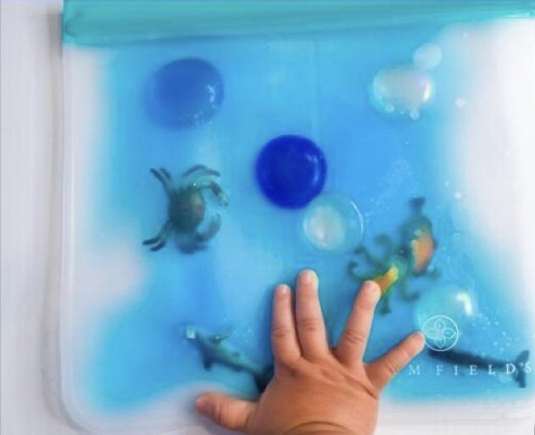

Material
Ziploc bag
Ocean creatures
Blue and clear beads
Clear gel
Blue food coloring

Directions
Add a few scoops of clear gel in your ziplock and add a few drops of blue food coloring. Once it’s combined, go ahead and add the sea creatures and beads into the bag. After adding the sea creatures and beads, close the ziplock bag shut and seal it with tape.

Wave sensory water bottle

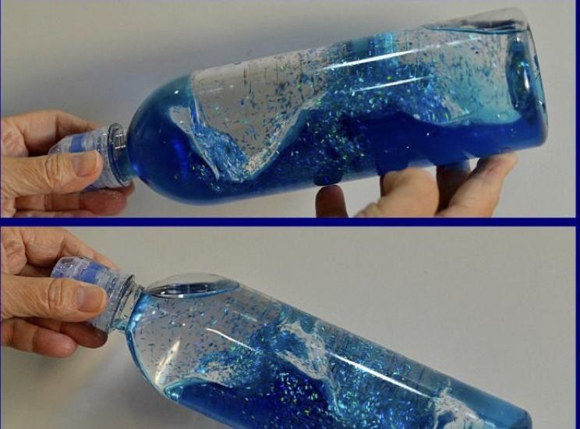
Material
Water bottle
Water
Glitter
Oil or cooking oil
Superglue to secure the lid

Directions
Fill an empty water bottle about one-third full with water. Add a few drops of food coloring. Once the food coloring has spread throughout the water, fill the rest of the bottle with baby oil or cooking oil.Secure the lid with superglue. Your child can put the bottle on its side to see the waves or shake it to see the oil and water separate.

Boat sensory bin
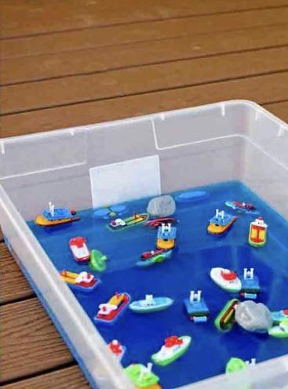
Material
Medium bin
Food coloring (optional)
Toy boats

Directions
Fill your bin less than half and add a few drops of water color into the bin (optional). Once combined, add your toy boats and let your infant explore. As your child is discovering the sensory bin, use descriptive words and narrate what they are doing.

