Hello Parents/Guardians,
I hope all is well. Here is our lesson plan for the month of June. To continue to allow this transition to remain smooth during this time it’s best that we remain on a set schedule, the schedule that children are used to. Every day we should start off with circle time. During this time songs such as the alphabet song, Mr.Sun , if you're happy and you know it should be sung with the children. A book of their choice should be read as well. After circle time is music and movement, during this time songs such as head shoulders knees and toes can be played. Following music and movement an activity can be completed. (Please allow your children to be creative, please remember that whatever activity that has been assigned doesn’t need to be perfect. It’s best we allow children to express themselves within their work) This month we will be working on two different themes which are Hello & Goodbye as well as Loud & Quiet.

MONDAY (6/01/20)
PEEK A BOO
If the children are interested, cover them with a blanket or any piece of cloth that can probably cover their little bodies from head to toe and then proceed to lifting it up and saying Hello and cover again and say Goodbye.
Tuesday (6/02/20)
WHERE DID IT GO?
Supply your child with containers that have a slit on the top, such as a baby wipe container. Give children buttons or anything else that they can place in the container through the slit and make sure to use HELLO and GOODBYE to narrate their play as they place the item in and out of the container.

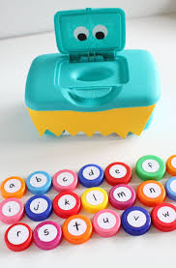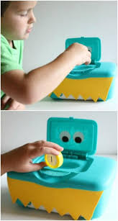
Wednesday (6/03/20)
HIDING

Invite your child to play Hide and Go Seek in your home to ensure that you keep your child in your line of sight. Don't forget to narrate their play with HELLO and GOODBYE.
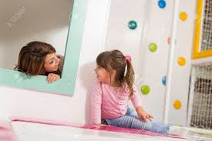
THURSDAY (6/04/20)
Take a Trip
Pretend that you’re taking a trip and tell them then allow your child to help you pack a bag. Pretend walking out the door and saying GOODBYE & then come back in and say HELLO.
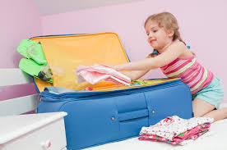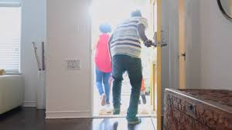
FRIDAY (6/05/20)
TIME FOR BED

Pretend that you are going to bed and say “GOODBYE” I’m going to sleep. Pretend to go to sleep and then when you wake up can say “HELLO”.

YOUTUBE VIDEOS
https://www.youtube.com/watch?v=QnFMLpaRSZQ
https://www.youtube.com/watch?v=89RLqTklt1w

Ducks (6/8/20)
Fill up the bathtub with water and allow your child to place the rubber duckie in the water, while the duck is in the water it will start flowing back and forth, while it leaves the child can say GOODBYE and when it comes back the child can say HELLO. Please Narrate your child’s action throughout the activity.
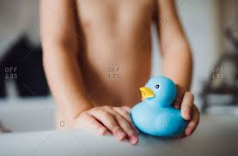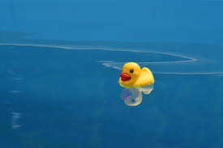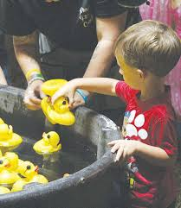

Windows(6/9/20)
Use a cardboard box to create a window where your child can say HELLO & GOODBYE to you.
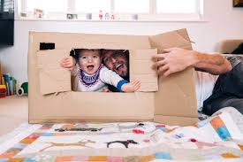

Scarf Play (6/10/20)
Place a scarf over your face as you say “GOODBYE”. Then reveal your face and by removing the scarf and say “HELLO”. Invite your child to join and she/he are interested.
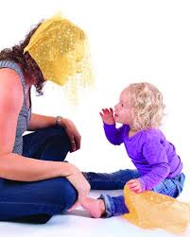

Finger Play (6/11/20)
Point your index finger up and say “Hello” & when you put your finger down say “GOODBYE”. Allow your child to participate as he/she becomes interested in trying to imitate what you’re doing.
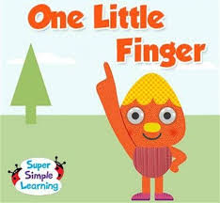
Found Me (6/12/20)
After waking up and do all of your personal things your child it can be great time in which you sit down and allow your child to hear the read aloud of Peek A Boo Morning by Rachel Isadora ( https://www.youtube.com/watch?v=mf8oBLrvoso ). Then grab a mirror and place it in different parts of your living room or bedroom and allow your child to find themselves on it and say “HELLO” & when they walk away say “GOODBYE”.
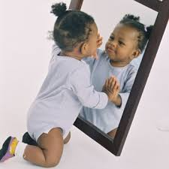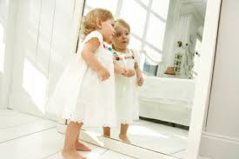

Monday 6/15/2020
Collage- Provide children with construction paper, glue and various pieces of paper from a magazine/ news paper. Talk to the children as they collage, labeling which images make loud noises and which one makes quiet noises.
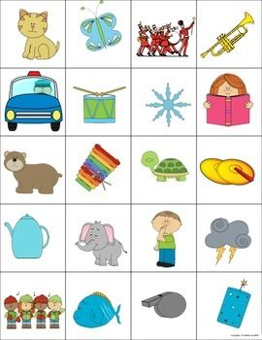

Tuesday 6/16/2020
Noisy Vehicles- In the link provided below you can invite the children to mimic and identify the sounds of the vehicles.
https://www.youtube.com/watch?v=tQ3eTieZi9o
Wednesday 6/17/2020
Drumming-Supply children with different pots, bowls, and spoons at home. Model how to play loudly and quietly. Invite the children to explore. As they are ready, invite them to play loudly and quietly.
. 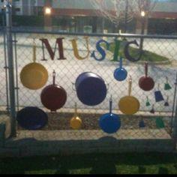

Thursday 6/18/2020
Nature Walk- Take children outside on a nature walk. Encourage them to be very quiet in order to see more animals.

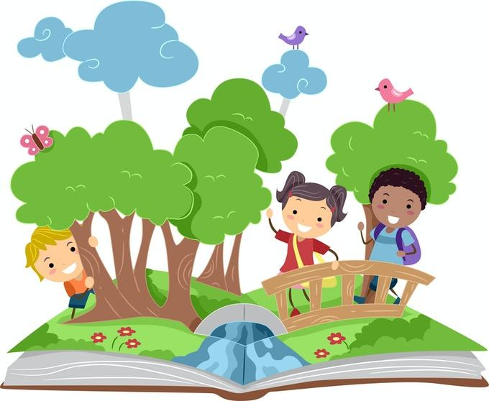
Friday 6/19/2020
What Do You Hear?- Read Polar Bear, Polar Bear What Do You Hear? By Bill Martin Jr. (Or another text related to quiet and loud that is more relevant to the classroom community) Invite the children to make the animal sounds with you. Below is the link to Polar Bear, Polar Bear What Do You Hear
https://www.youtube.com/watch?v=ehoGdGokXfc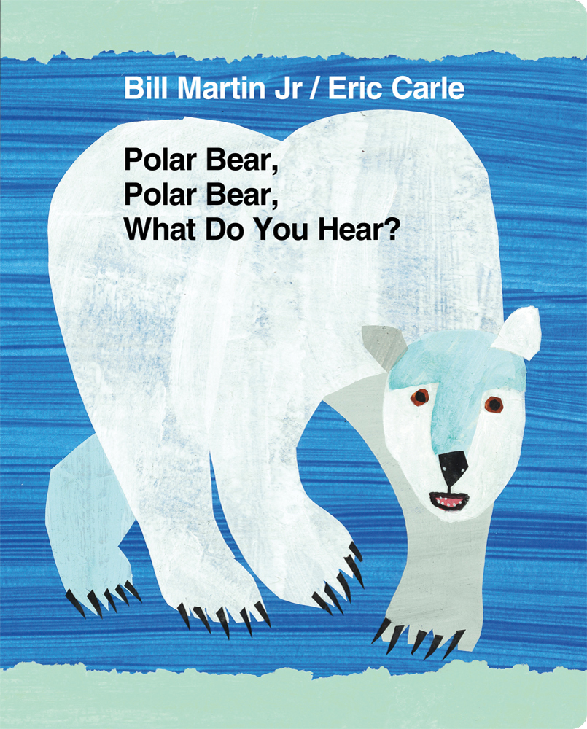
Monday 6/22/2020
Shoe Noises- Provide the children with shoes with different types of soles that can make varying noises ( example- rubber soles, and high heels). Encourage the children to count the number of shoes that are provided to them as well as identifying the colors of the shoes. Take the children to an area where they can experiment with the sounds the shoes can make. Use language related to quiet and loud throughout the experience.
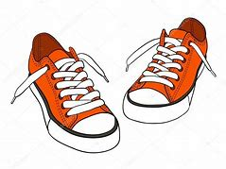
Tuesday 6/23/2020
Rubber Ducks- Inside of the bags provided, there are rubber ducks. Encourage the children to have some fun in the tub with the ducks provided to them. While in the tub encourage the children to squeeze the duck so that they will be able to hear the duck make noise. Use language related to quiet and loud throughout the experience.
Here’s a video that can also be entertaining and will demonstrate how to play with the ducks in the bathtub. https://www.youtube.com/watch?v=Mh85R-S-dh8
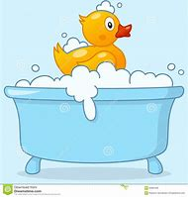
Wednesday 6/24/2020
Quiet Or Loud?
With supplies provided in the bag, create a book that has a picture of items that are typically quiet as well as items that are typically loud. Label each page with the word quiet or quieter and loud or louder accordingly.
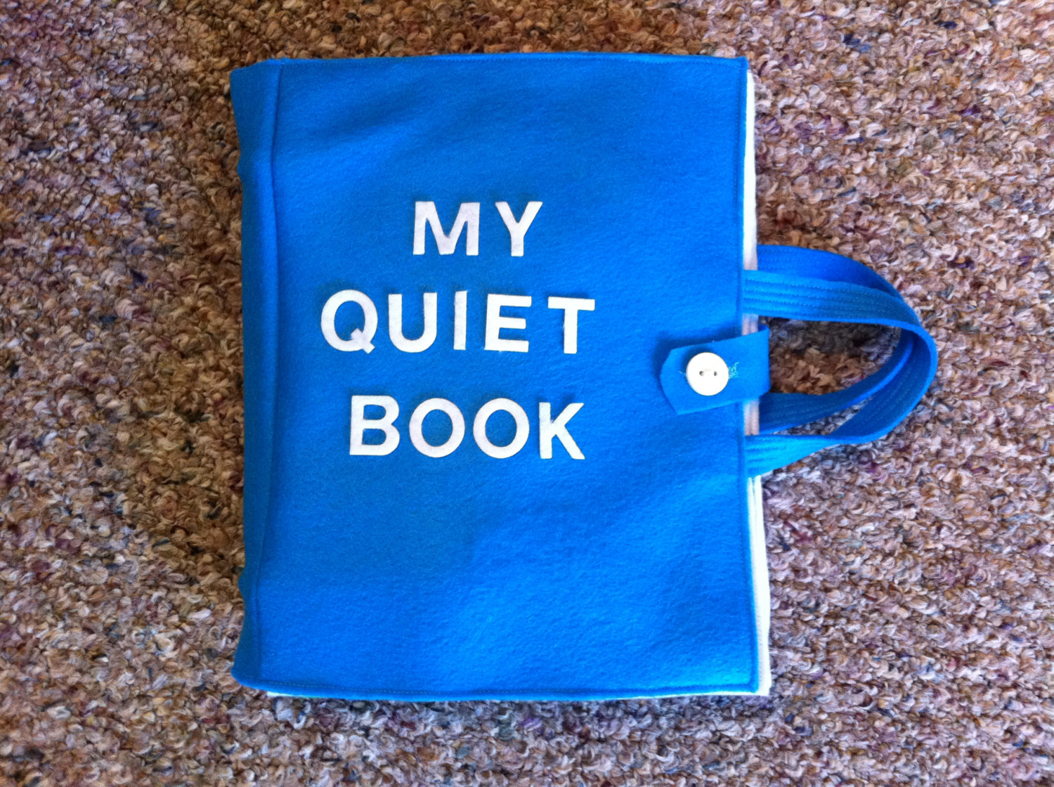
Thursday 6/25/2020
Noise Making- Read Quiet and Loud by Leslie Patricelli (or another text related to quiet and loud). Invite the children to make loud noises and quiet noises. Below is the link to the book Quiet and loud.
https://www.youtube.com/watch?v=TUwzV8xnPDU
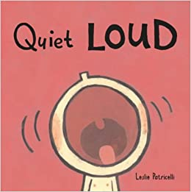
Friday 6/26/2020
Sensory Bottles- Create sensory bottles with items that will make louder noises and quieter noises.( You will need a empty bottle, tape and items such as buttons, cotton balls, beads ect, to make sensory bottles). Invite the children to explore. Use language such as loud, louder, loudest, quiet,quieter, and quietest throughout the experience. 