June 15 – June 19
2020
“Only surround yourself with people who will lift you higher.”  – Oprah Winfrey | 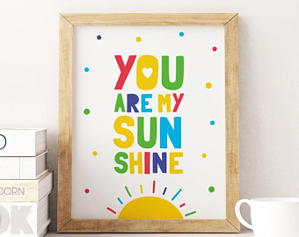
Monday
YouTube: https://www.youtube.com/watch?v=UY1bQ2tIfjg How to play by Anderson party of 5

Parent & Child Activity:
- Allow your child to select a book and read it to you (Please keep in mind that your child may not read the actual words, allow the child to make them up. Focus on appropriate page turning)
- Make a daily weather observation (Sunny, Rainy, Cloudy, Etc.)

1, 2, 3…Sun!
Make your room as dark as possible to represent night-time. In one corner of your room, set up a flashlight (or another light source). Allow your child to be the leader of the game and stands facing the light. The other players stand on a line, a few meters behind him. The leader of the game says, “1, 2, 3…sun!” As the leader of the game counts, the others move towards him. When the leader of the game says “sun”, he quickly turns around and the other players must stop in their tracks. If the individual moves, he becomes the leader of the game for the next round.

CHECK EDUCATION.COM FOR ADDITIONAL ASSIGNMEMTS
CHECK YOUTUBE CHANNEL FOR MORE READ ALOUDS https://www.youtube.com/channel/UCLF1tXNG27yD-LXTREf5Ifg?view_as=subscriber

Tuesday
YouTube: https://www.youtube.com/watch?v=CE_FMWKH-_M<- Beach Day by Patricia Lakin

- Parent & Child Activity: Use the Alphabet chart provided or write out the Alphabet and point to each letter as you sing the Alphabet song with your child.
- Write your child’s name on a piece of paper and practice naming the letters in order.
- Make a daily weather observation (Sunny, Rainy, Cloudy, Etc.)
- Talk about shapes and their sides choose a shape and draw it on a paper allow your child to trace/color. (You may use shape chart provided)
- Practice counting 1-10 using small objects such as blocs, Coins, or Dried beans. SUPERVISE child as small items can be a choking hazard.
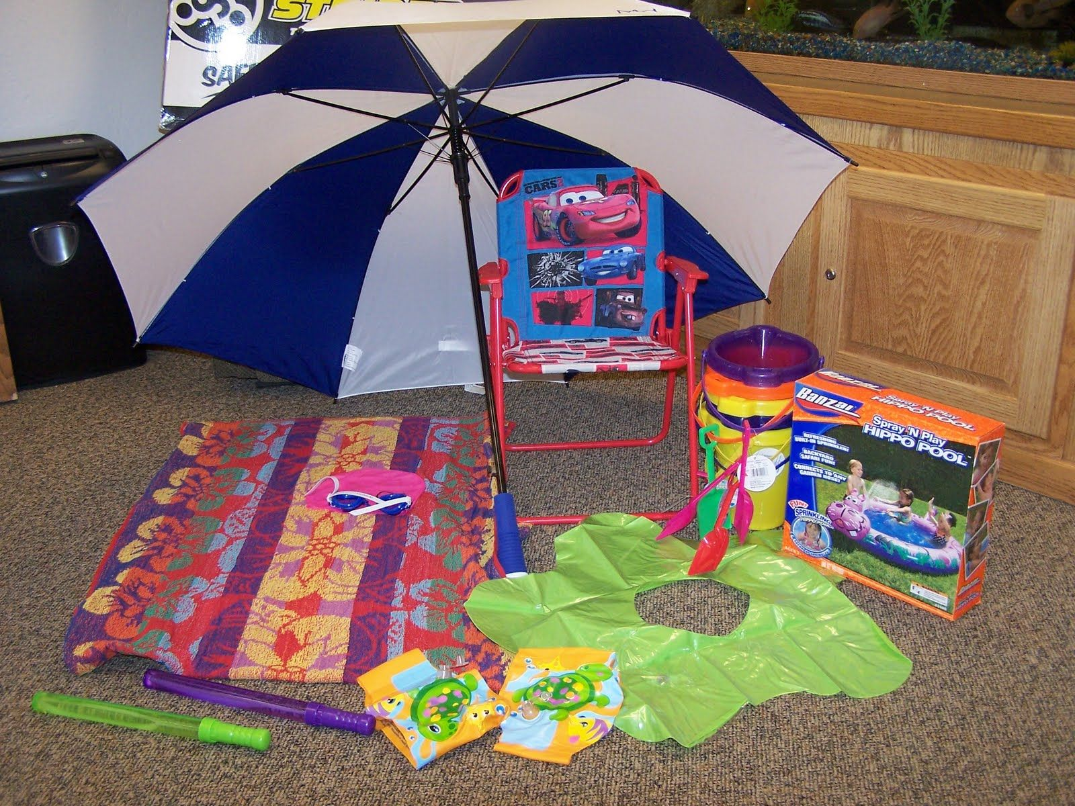

Beach Day!
Set up your dramatic play area with beach towels, empty plastic containers for pretend sunscreen, sunglasses, play picnic food, floaties, etc. You can use a flashlight to represent the sun and have a conversation about how does the sun make them feel.

Wednesday
YouTube: https://www.youtube.com/watch?v=8L52xSUtJNg Click to see video of activity

Parent & Child Activity:
- Write your child’s name on a piece of paper and practice naming the letters in order.
- Talk about shapes and their sides choose a shape and draw it on a paper allow your child to trace/color.

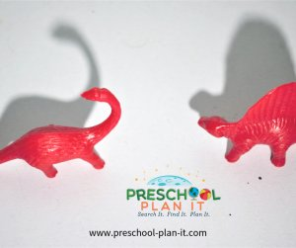

Shadows

Provide flashlights for the children to check out how light makes shadows depending upon where the light is shining on an object.

Thursday
YouTube : https://www.youtube.com/watch?v=WnpgmXZuIfU Click to hear “The Letter S Song

- Parent & Child Activity:
- Use the Alphabet chart provided or write out the Alphabet and point to each letter as you sing the Alphabet song with your child.
- Write out the numbers 1-10 and practice counting, be sure to also ask the child to name the number sporadically to help them actually learn the numbers. (Use chart provided or write the numbers on a blank sheet of paper)
- Make a daily weather observation (Sunny, Rainy, Cloudy, Etc.)

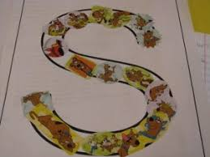

"S" Practice
Making letters that have curves are difficult at this age! Provide some papers that you have printed large "S"'s on or written out using a marker.
Allow your child to trace with their finger
You may cut pieces of paper and have them glue it onto the letter “S” or simply color the letter.

Friday
You Tube: https://www.youtube.com/watch?v=WhCgyTUlVBw by Carla G

- Parent & Child Activity: Use the Alphabet chart provided or write out the Alphabet and point to each letter as you sing the Alphabet song with your child.
- Write your child’s name on a piece of paper and practice naming the letters in order.
- Make a daily weather observation (Sunny, Rainy, Cloudy, Etc.)
- Talk about shapes and their sides choose a shape and draw it on a paper allow your child to trace/color. (You may use shape chart provided)
- Practice counting 1-10 using small objects such as blocs, Coins, or Dried beans. SUPERVISE child as small items can be a choking hazard.

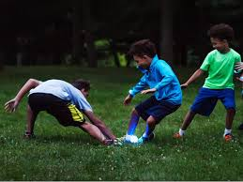

Capturing light
Turn all the lights off. Using a flashlight, project light on the floor, moving it around in every direction. Children must try to step on the ray of light or catch it with their hands.

Talk about what is celebrated June 21, 2020
Talk about Father’s Day
Who do we celebrate? What do we say?
Create a post card together for a Dad, Grandpa or even uncle.

