Jue 8 – June 12
2020
“My parents used to take me to the pet department and tell me it was a zoo.”  - Billy Connolly | 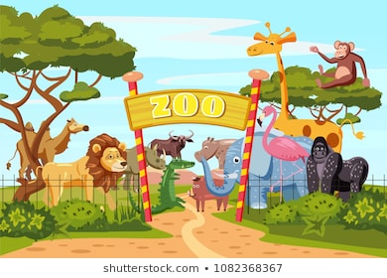
Monday
YouTube: https://www.youtube.com/watch?v=RXCc4voREDY <- 1, 2, 3 to the Zoo by Eric Carl

- Parent & Child Activity: Use the Alphabet chart provided or write out the Alphabet and point to each letter as you sing the Alphabet song with your child.
- Write your child’s name on a piece of paper and practice naming the letters in order.
- Make a daily weather observation (Sunny, Rainy, Cloudy, Etc.)
- Talk about shapes and their sides choose a shape and draw it on a paper allow your child to trace/color. (You may use shape chart provided)
- Practice counting 1-10 using small objects such as blocs, Coins, or Dried beans. SUPERVISE child as small items can be a choking hazard.

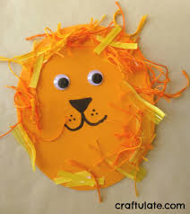
Lion Face
After watching the video above about zoo animals. Using a blank sheet of paper cut out a circle. Give your child crayons and markers and allow them to create a lion face. Cut out circles for the eyes.

CHECK EDUCATION.COM FOR ADDITIONAL ASSIGNMEMTS
CHECK YOUTUBE CHANNEL FOR MORE READ ALOUDS https://www.youtube.com/channel/UCLF1tXNG27yD-LXTREf5Ifg?view_as=subscriber

Tuesday
YouTube: https://www.youtube.com/watch?v=7kfW1UIeIwQ&t=4s <- Watch Ms.B READ DEAR ZOO

Parent & Child Activity:
- Allow your child to select a book and read it to you (Please keep in mind that your child may not read the actual words, allow the child to make them up. Focus on appropriate page turning)
- Make a daily weather observation (Sunny, Rainy, Cloudy, Etc.)
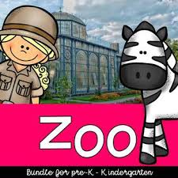

Helpful Animals
Discuss how some animals can be helpful to human. Examples: camels are used as transportation in some countries, elephants are often used to pull things, dogs can be used as seeing-eye dogs or sled dogs, goats can give milk to drink, etc. Ask the children to come up with some ideas as well.

Wednesday
YouTube: https://www.youtube.com/watch?v=tohQm3qYBEk Click to see video of activity

Parent & Child Activity:
- Write your child’s name on a piece of paper and practice naming the letters in order.
- Talk about shapes and their sides choose a shape and draw it on a paper allow your child to trace/color.
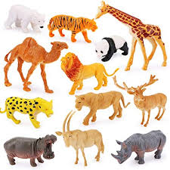

Walk Like the Animals

This game is played like “Simon Says:” The zookeeper says to walk like a giraffe. The child can walk as they believe each animal would/ Repeat using different animals (monkey, elephant, lion, turtle, bear, snake, alligator, tiger, etc.). Let the child take a turn leading the game

Thursday
YouTube https://www.youtube.com/watch?v=o0wweS8P-tY Click to hear GIRAFFE’S CANT DANCE

- Parent & Child Activity: Use the Alphabet chart provided or write out the Alphabet and point to each letter as you sing the Alphabet song with your child.
- Write out the numbers 1-10 and practice counting, be sure to also ask the child to name the number sporadically to help them actually learn the numbers. (Use chart provided or write the numbers on a blank sheet of paper)
- Make a daily weather observation (Sunny, Rainy, Cloudy, Etc.)

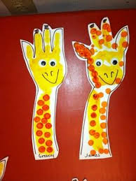
Giraffe
Using a white sheet of paper help your child trace their hand and cut out. Provide your child with markers or crayons and allow them to color their giraffe.

Friday
You Tube: https://www.youtube.com/watch?v=eqtCQ9ei5fo Click to hear Ms.B READ THE VERY HUNGRY CATERPILLAR

- Parent & Child Activity: Use the Alphabet chart provided or write out the Alphabet and point to each letter as you sing the Alphabet song with your child.
- Write your child’s name on a piece of paper and practice naming the letters in order.
- Make a daily weather observation (Sunny, Rainy, Cloudy, Etc.)
- Talk about shapes and their sides choose a shape and draw it on a paper allow your child to trace/color. (You may use shape chart provided)
- Practice counting 1-10 using small objects such as blocs, Coins, or Dried beans. SUPERVISE child as small items can be a choking hazard.

Beginning Sounds

Using the internet, book, or toy animals talk to your child about beginning sounds state “this is a zebra” “with what alphabet letter does Zebra begin with” Talk about the letter an its sound. Repeat this with different animals that are found at the zoo.

