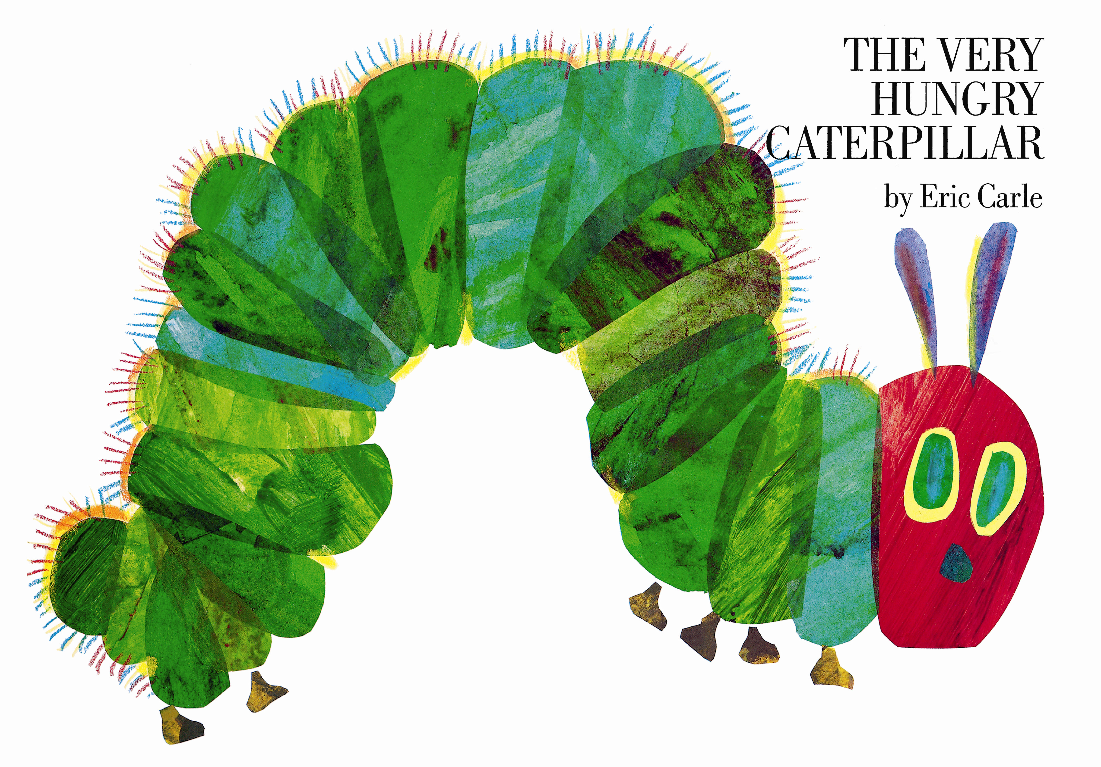

Tell children you are going to go on a picnic and would like to take all the food the caterpillar eats in The Very Hungry Caterpillar by Eric Carle. Invite them to help you pack the food for the picnic. Use pretend food or real food you have at home.

Read aloud The very hungry Caterpillar by Eric Carle https://www.youtube.com/watch?v=75NQK-Sm1YY

Color the caterpillar

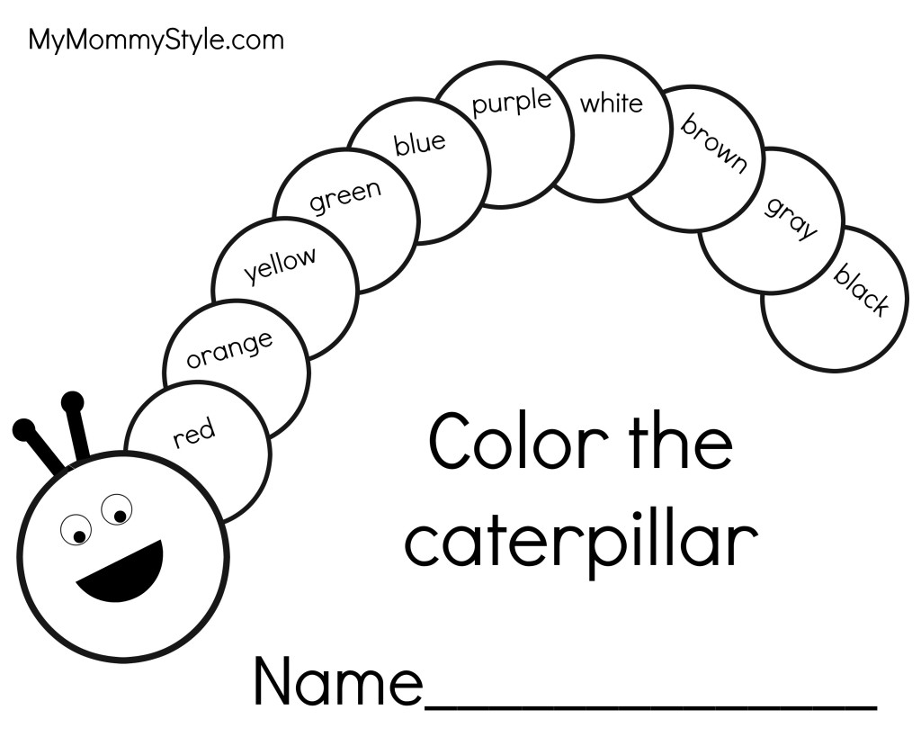

Color the food the caterpillar ate

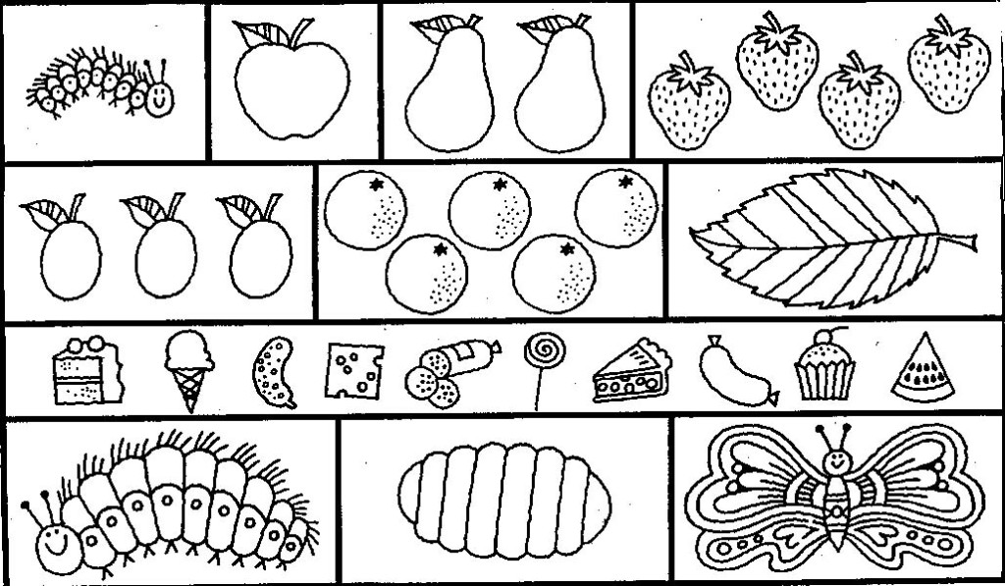

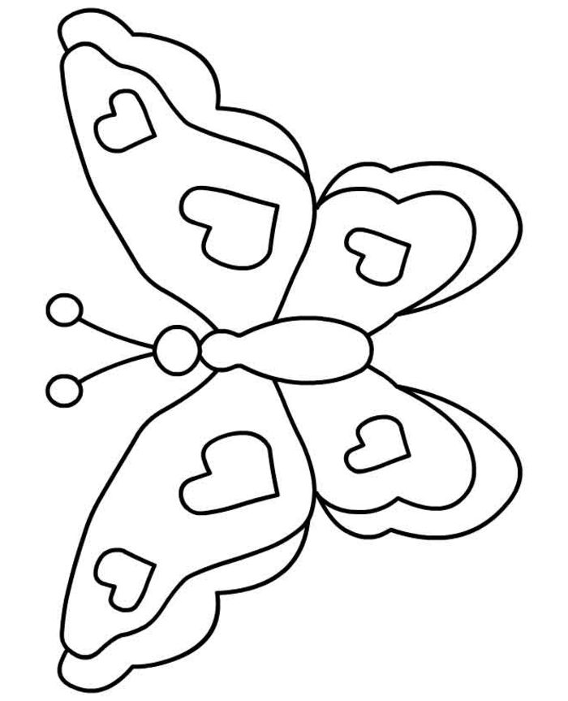

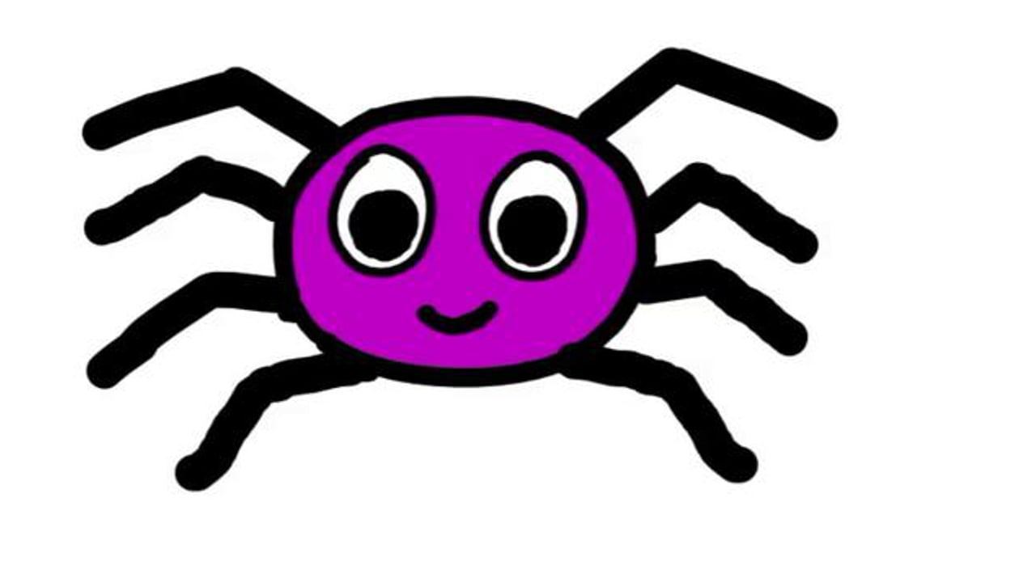
Supply Styrofoam cups, pipe cleaners, paints or markers. Invite children to make spiders. Consider supplying a picture of a spider in the art area.

Sing along: Sing Little Miss Muffet and replace Miss Muffet with the children’s names. Consider using a spider on a string while you sing.
https://www.youtube.com/watch?v=2AXsMkYV5ms

color the spider

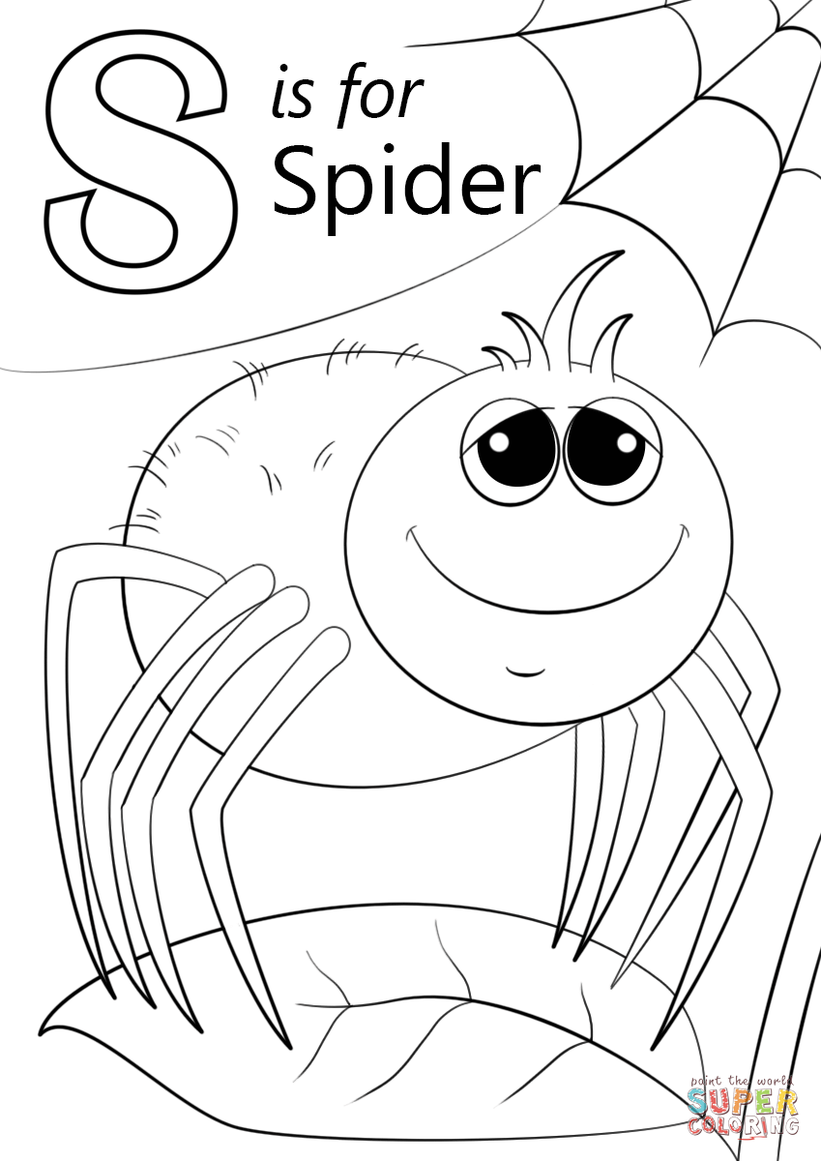
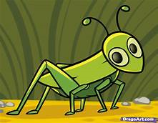

Invite children to pretend they are grasshoppers and hop around the gross motor or playground like a grasshopper.

Read aloud: In the The tall tall grass by Denise Fleming https://www.youtube.com/watch?v=_fUCBejo2fM

Clolor the picture

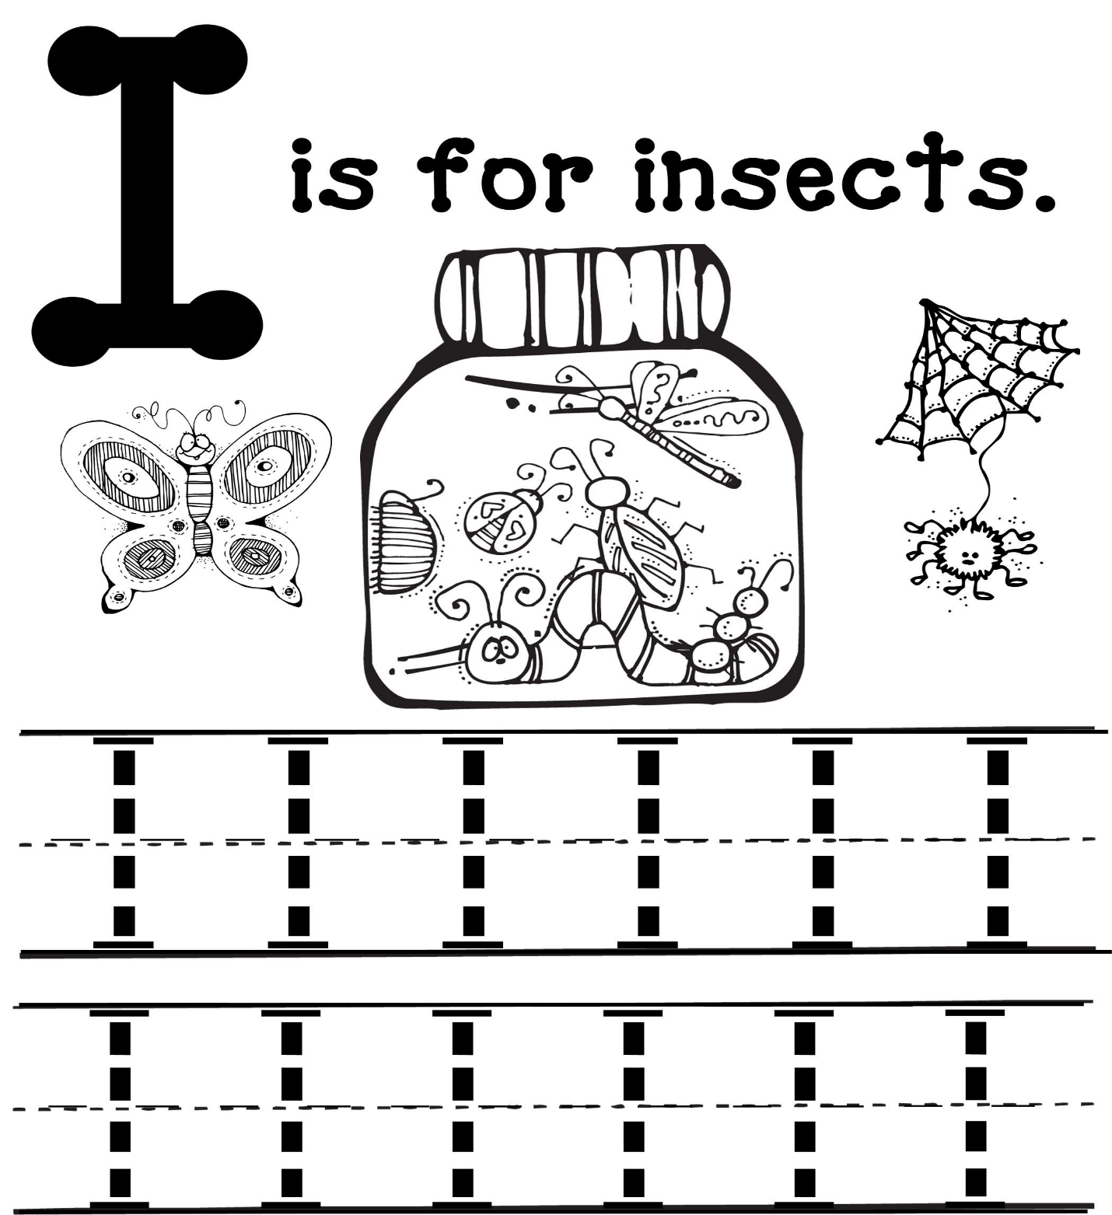

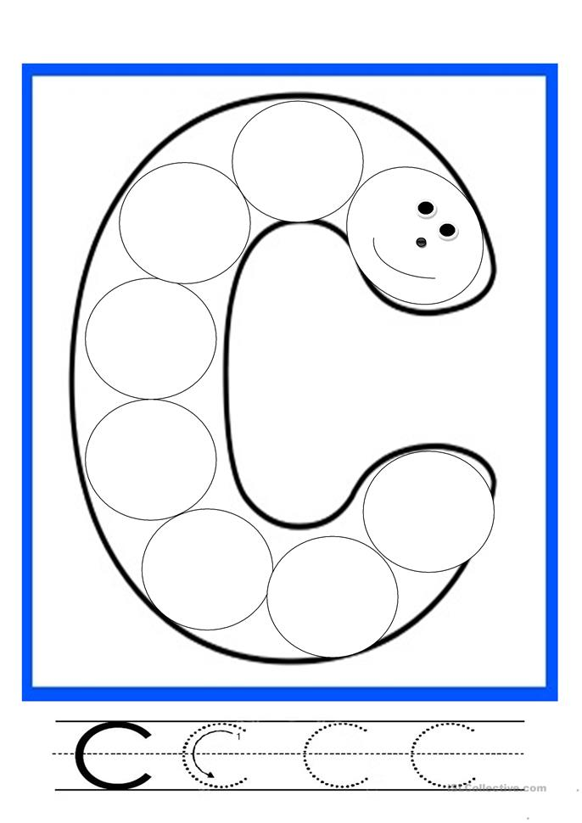

Cover a table with paper and provide liquid watercolors, as well as pieces of yarn to represent worms and caterpillars. Invite children dip the worms and caterpillars in the paint and paint on the paper by wiggling them across or above the paper.

Read aloud Pete the Cat and the cool Caterpillar https://www.youtube.com/watch?v=T3zsR1V82wk

The Crunching Munching Caterpillar https://www.youtube.com/watch?v=7QQUNBjIlts

