Summer time fun!!

Water Play 6-12 Months

Playing in the water is fun, but all water activities must be supervised!

Pool Noodles
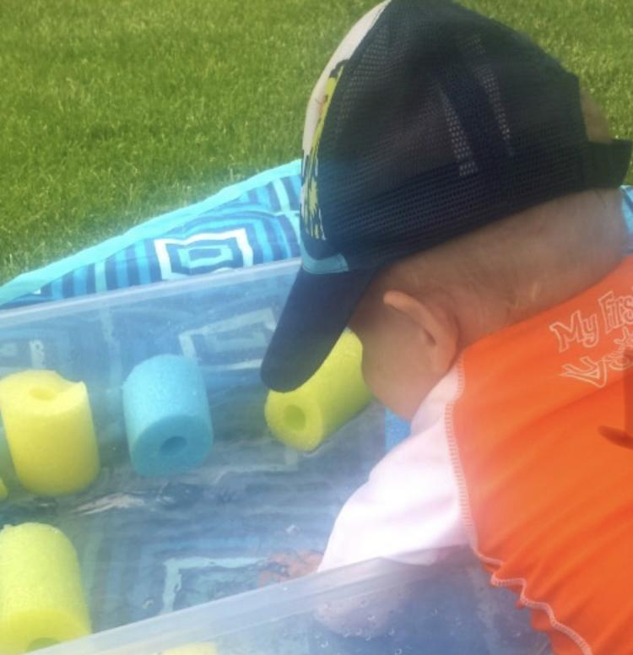

There are so many fun ways to play with pool noodles. For the little ones cut them up and put them in a kiddie pool or plastic bin. Let them splash around both in and out of the water. As they play describe what they are doing and the texture of what they are feeling.

Nature water bin.
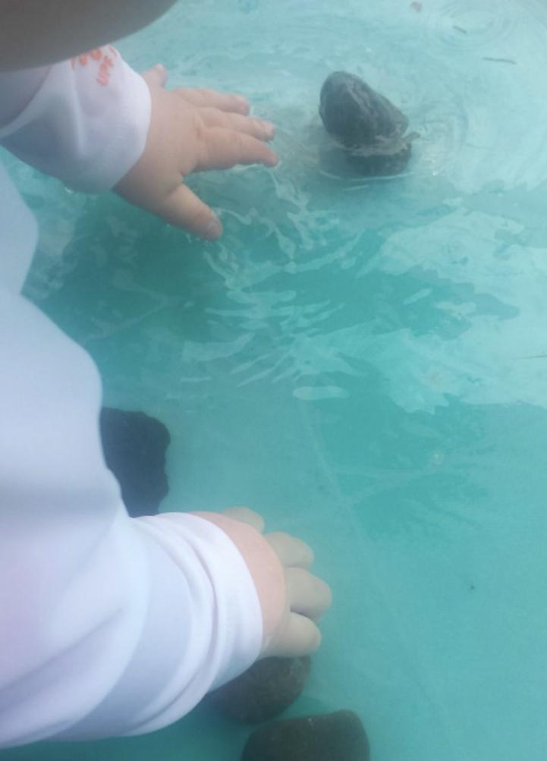
Rocks and round sea shells are great items to explore during the summer fun, so why not add it to water?

Bath Toys
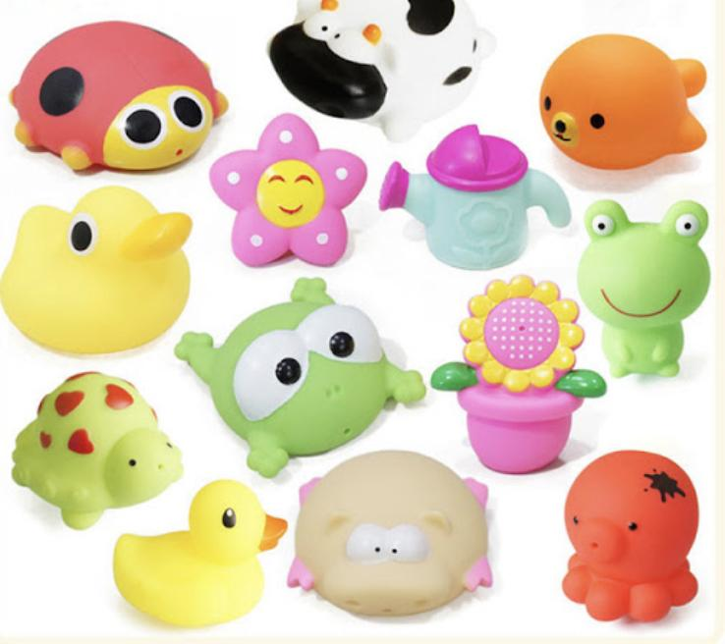
Bath toys aren’t just for baths. Bring them outside and let your little one enjoy bath toys while in a different environment.

Beach fun!!
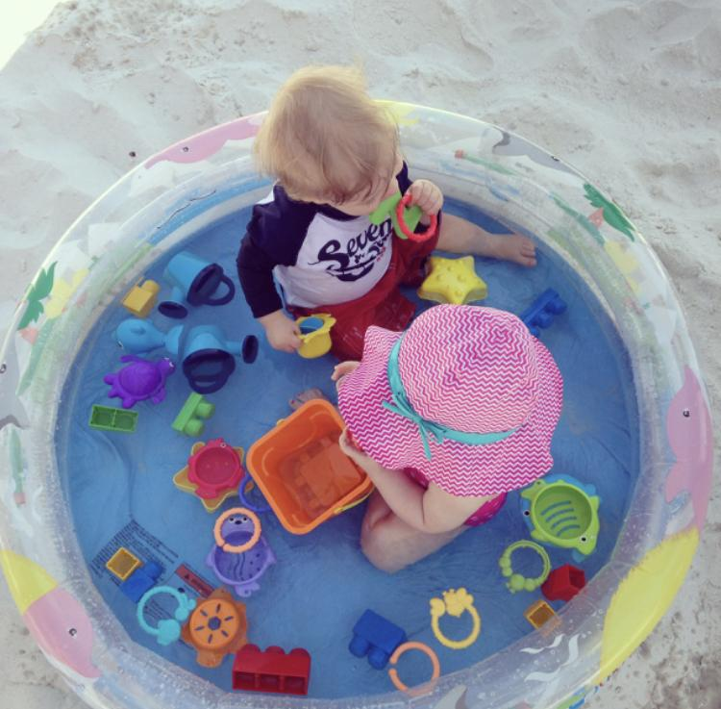

Material
Inflatable pool
Beach toys
Squishy toys etc

Directions
Inflate your infant pool and add beach toys and toy rings.

