HELLO FAMILIES OF ROOM 205 I HOPE ALL ARE DOING WELL AT THIS TIME, HERE IS OUR LESSON PLAN FOR THE WEEEK MAY 18TH- 22nd 2020. THIS WEEK THEME IS COLOR EXPLORATION LETS SEE WHAT COLORS WE CAN FIND AROUND US.

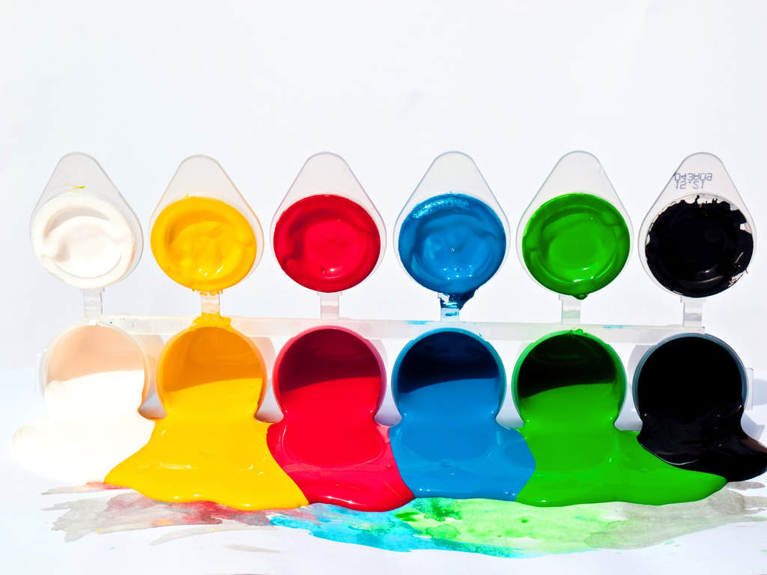

Place a large sheet of paper on the floor.
Supply finger-paint of various colors.
Invite children to paint with their hands.
As they explore the materials narrate
how they are moving their hands, and
the colors they are using (or creating).

Read aloud Mouse Paint: https://www.youtube.com/watch?v=AjohJiyvA0Q

Can we circle the letter A:

L T M A T A L
Can we circle the letter L

M L L A M A L L

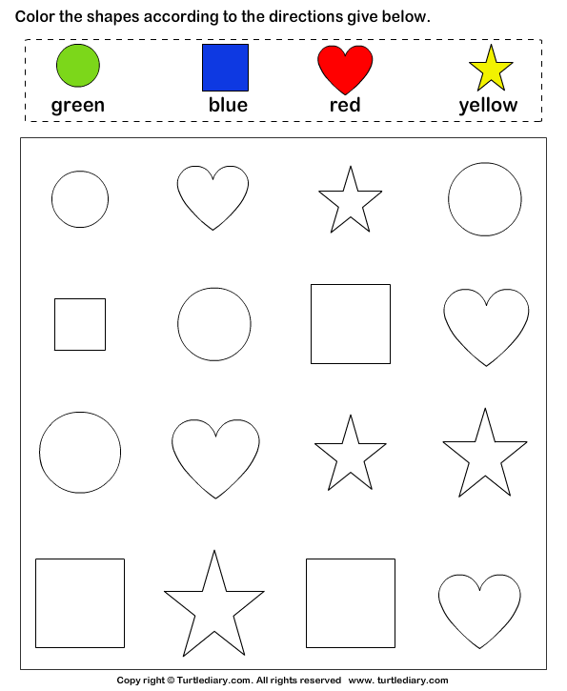
Color the shapes

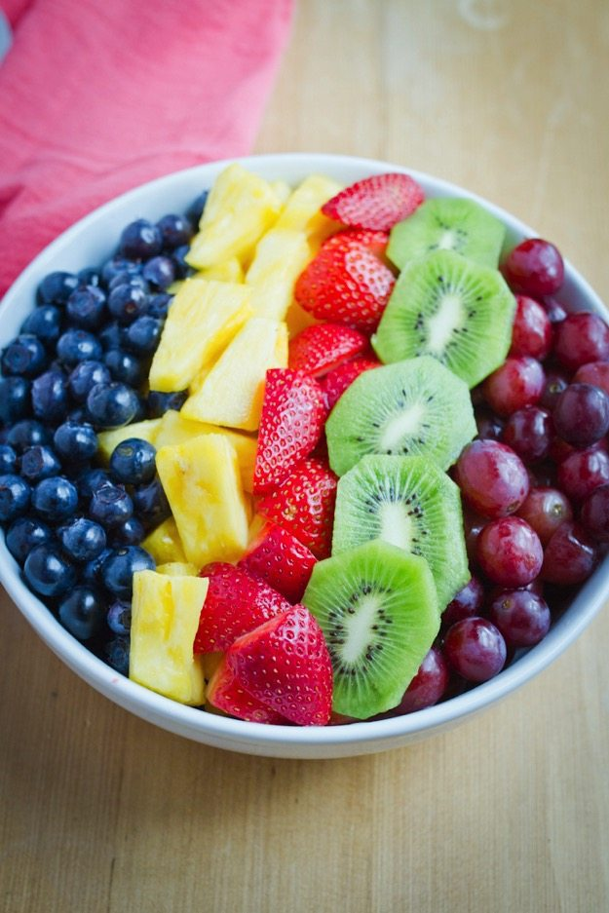

Tell children you are going to make a
fruit salad in the dramatic play center.
Use toy fruit, or another material such as
paper pieces or colored play dough as
fruit. Invite children to discuss the colors,
their color preferences and how the
colors look together in the bowl.

Read aloud: learn colors fruit song https://www.youtube.com/watch?v=uHgsKVLQbe4

Count the letter L’s
L L L L L
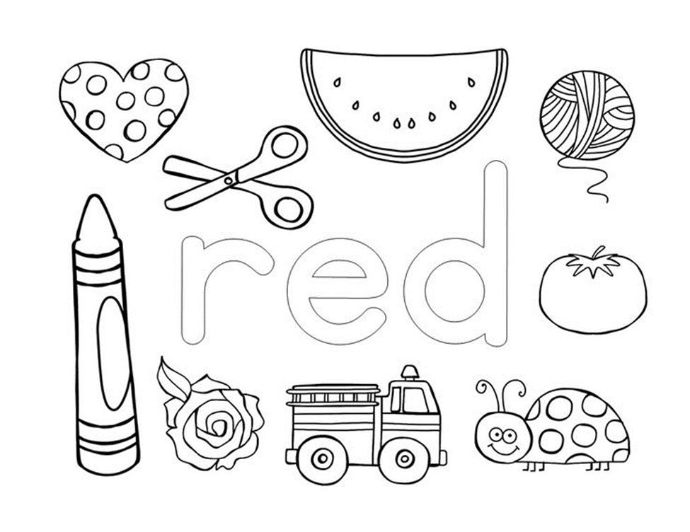
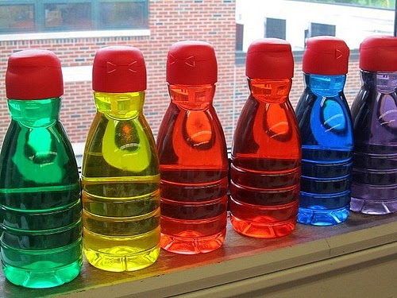

Supply squirt bottles filled with colored
water. Color water can be made with food dye or cool-aid Fill the sensory table with water
and invite children to squirt the colored
water in the table. Talk with the children
about the colors as they explore.

Read aloud: Little Blue and Little Yellow By Leo Lionni https://www.youtube.com/watch?v=mxN8-rWdn88

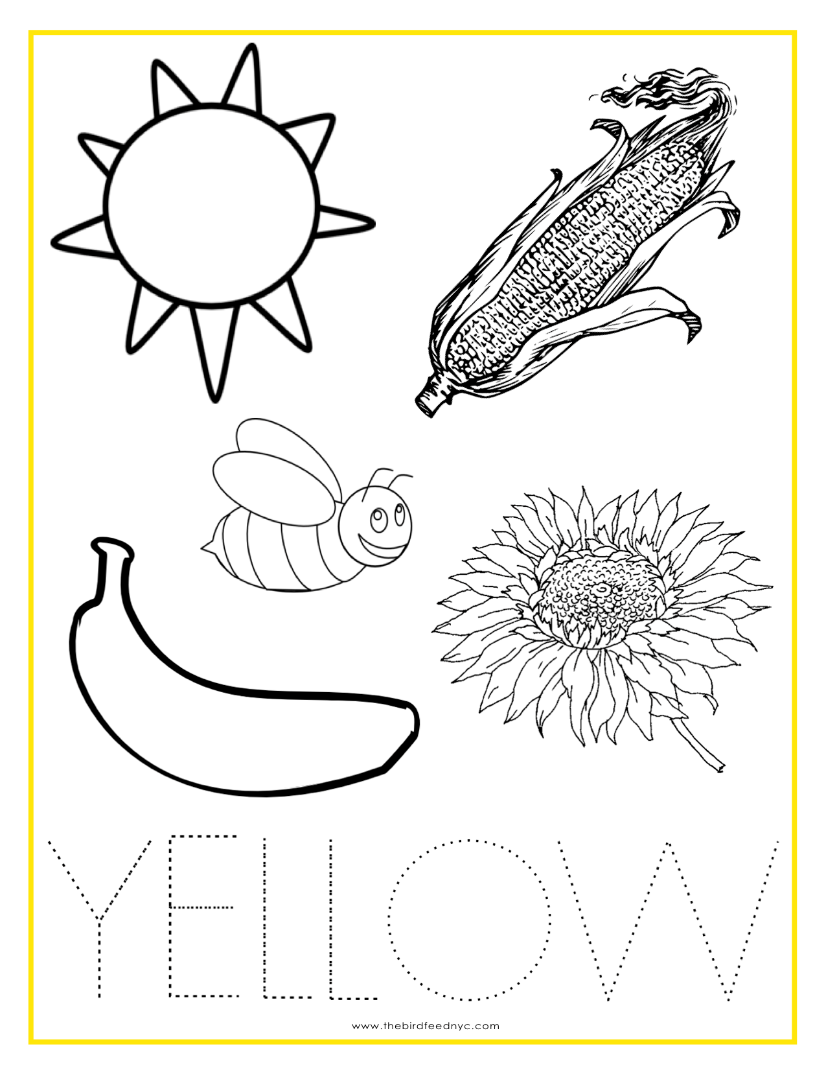

Count the letter A’s

A A A

Invite children to do laundry with you
and pretend to wash colorful scarves or colorful clothing.
When it is time to dry the laundry, drape
the scarves or colorful clothing around the house or as they are helping you put them in the dryer ask what colors do they see on the clothing.

Read aloud: The day the crayons quit https://www.youtube.com/watch?v=Hrd-Wdxbg-Q
