HELLO FAMILIES OF ROOM 205 I HOPE ALL ARE DOING WELL AT THIS TIME, HERE IS OUR LESSON PLAN FOR THE WEEEK MAY 4TH- 8TH 2020. THIS WEEK THEME IS COLOR EXPLORATION LETS SEE WHAT COLORS WE CAN FIND AROUND US.

Morning yoga: https://www.youtube.com/watch?v=skSbg1IGup8&t=238s

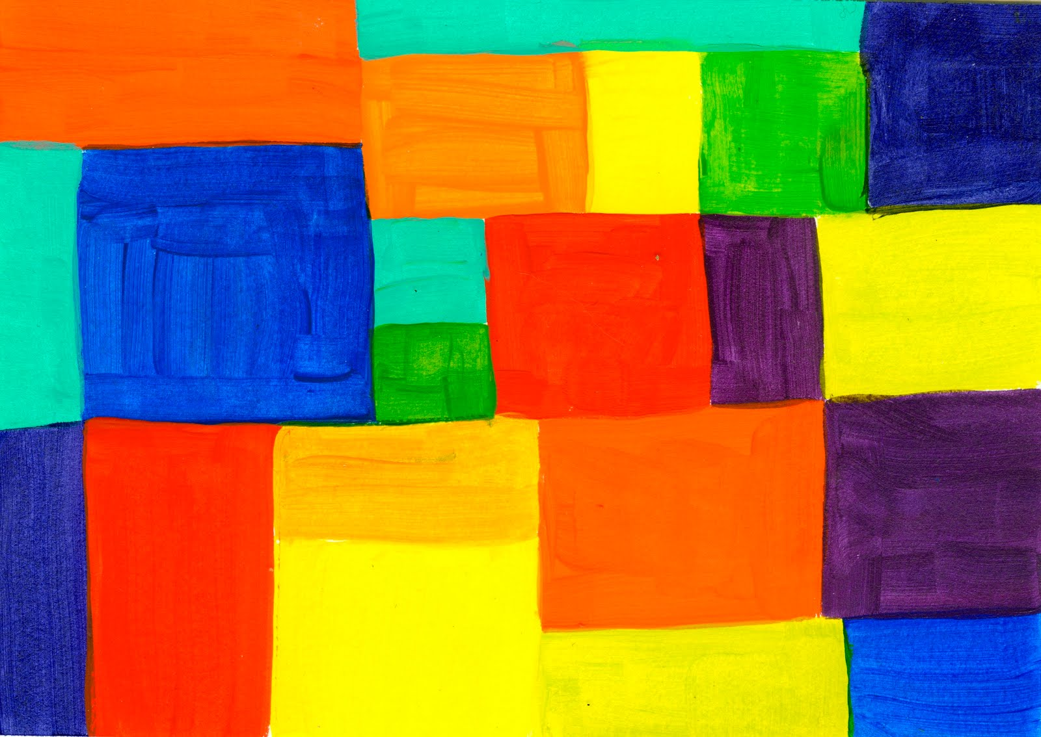

Create a collage by hanging construction paper at the ease or on the wall. Supply scraps such as pom poms, colored paper, fabric, ribbon, and/or cardboard. While children are creating, talk to them about the colors they are using. When the collage is finished, hang it at children’s eye level so they can continue the color exploration.

Read aloud: Little Blue and Little Yellow By Leo Lionni https://www.youtube.com/watch?v=mxN8-rWdn88

Color the rainbow

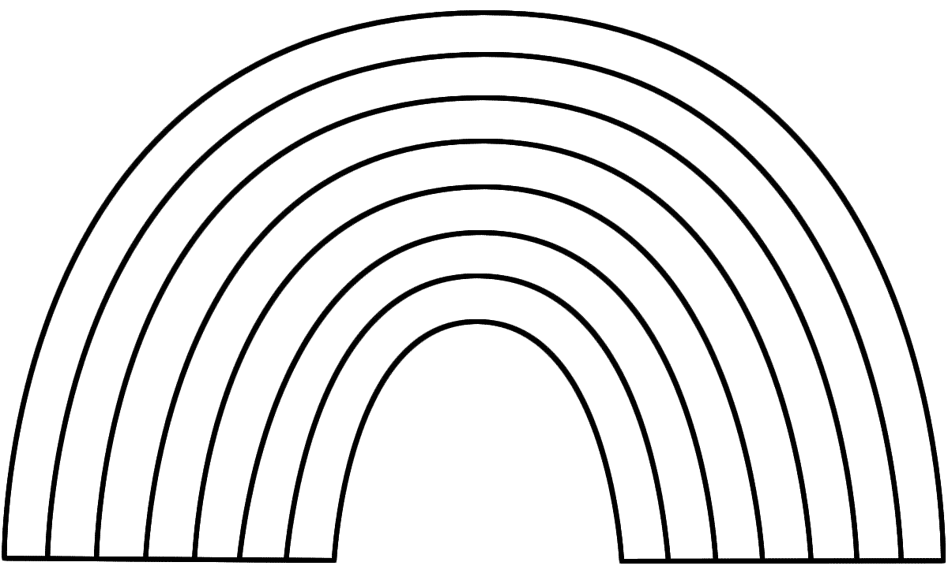

After coloring the rainbow parents have your child name the colors they used.
Then ask them to count the different colors they use. How many colors ?

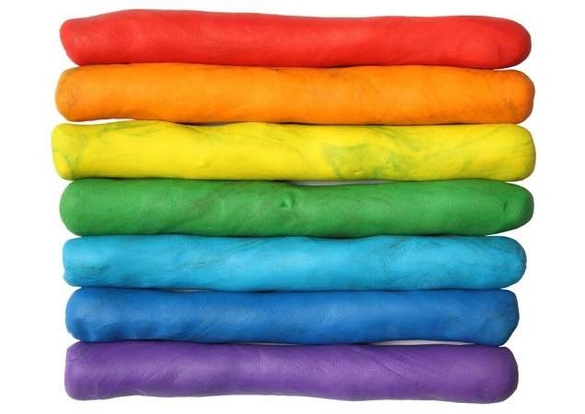

PARENTS THAT DON’T HAVE PLAYDOUGH YOU CAN USE THIS RECIPE
https://www.youtube.com/watch?v=F-MKQYhpeUM&feature=emb_logo
Make playdough of a variety of colors, supply sticks, molds and other play dough tools that capture the children’s interests. As children are playing, narrate the colors they are using and how the colors change when mixed together.

Morning yoga; https://www.youtube.com/watch?v=skSbg1IGup8&t=238s

Read aloud: The day the crayons quit https://www.youtube.com/watch?v=Hrd-Wdxbg-Q

Color the pictures yellow

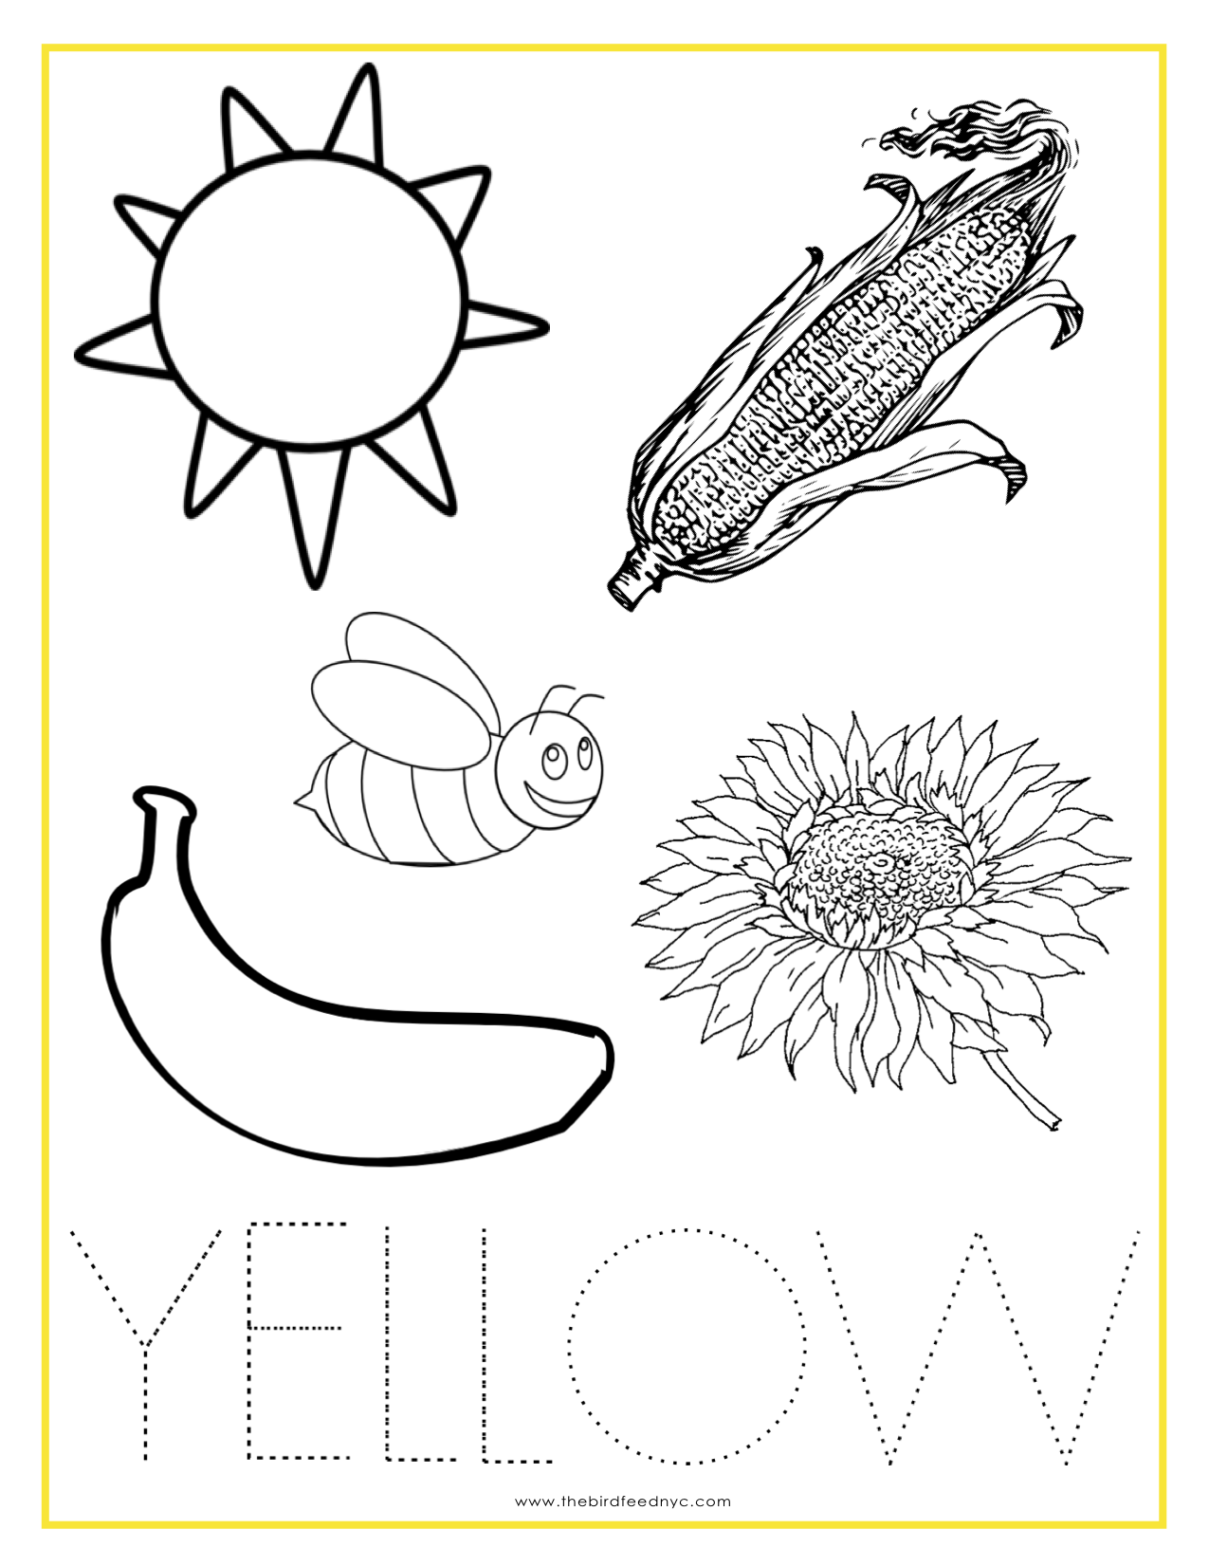

Morning yoga: ; https://www.youtube.com/watch?v=skSbg1IGup8&t=238s

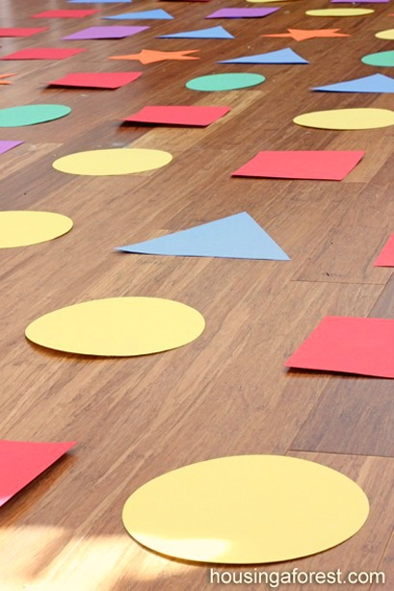
Create different color shapes on the floor by using painter’s colored masking tape or cut out shapes from construction paper. Invite children to jump from shape to shape.

Ask children what shapes do they see?
Ask children what colors do they see?
Ask children to count the shapes?

Color the pictures blue
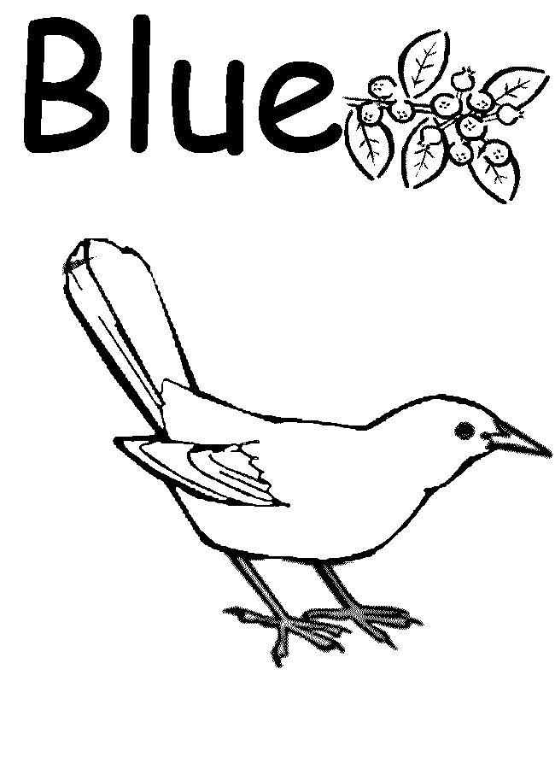

Morning yoga: https://www.youtube.com/watch?v=skSbg1IGup8&t=238s

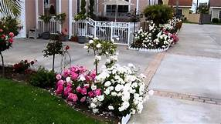
On a walk to the playground, store or looking outside your window, talk about all the colors that can be seen outside.

Read aloud: The crayons book of colors https://www.youtube.com/watch?v=Qfrf-5WpXks&t=108s

Color the pictures brown

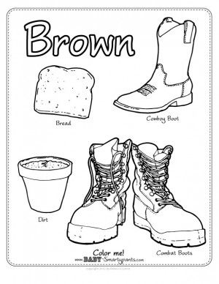

MORNING YOGA: https://www.youtube.com/watch?v=skSbg1IGup8&t=238s

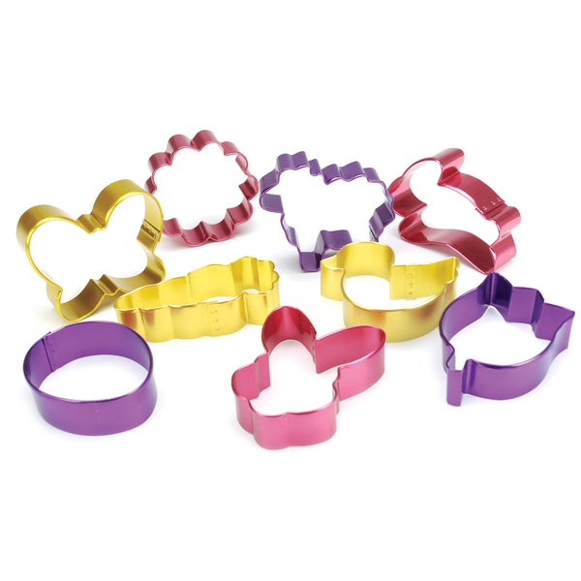
If available, supply shape sorters that have colorful shapes or a cookie cutter. While the children are interacting with the shape sorter, narrate the color and shape they are using. If shape sorters are unavailable, consider making simple 2-4 piece puzzles out of paper of a single color. Cut puzzle pieces into shapes such as triangles, rectangles and squares. Talk to the children about the colors and shapes.

Read aloud: Mouse Shapes https://www.youtube.com/watch?v=UDie3vzy7-w&t=126s

Color the picture

