Happy week 11 of online distance learning student/families

Welcome to the last Unit of Study of the School Year. In this Unit, children conclude the year by investigating how things change over time. It is an opportunity to apply knowledge and skills children learned in previous units, and to help children prepare for upcoming transitions.

*Parents if you can, please take pictures of your child's
completed work/activity and sent it to Google Classroom or email us!

Google Classroom https://classroom.google.com/c/NzcyMTA1ODg4ODla
Ms. Esmeralda: habitotclass222@gmail.com

All families can visit the nearest DOE District School to pick up grab-and-go breakfast starting at 7:30 AM and lunch starting at 11:30AM. Families can find the nearest District School by visiting https://www.nycenet.edu/schoolsearch or calling 311.

Best,
Ms.Esmeralda & Ms Ashley

Unit Title: Transformation
Essential Question: What is transformation and how do things change?
Focus Question:What changes around me?
Monday June 1, 2020
Letter of the week: S for the 4 Seasons of the year
Vocabulary words of the day: appearance, change, date
Book of the Week:
ebook/youtube story of the week: Little Tree by Loren Long
Youtube link to story: https://youtu.be/HSrSmN1vtnI
* Parents review with your child what an author is and what an illustrator is.
-Author writes the story, illustrator draws & paints the pictures in the story.

After reading the story, here are some questions to consider with your child:
1.Why did Little Tree stay little when all of the other trees started to grow bigger?
2. Why did Little Tree finally decide to let go of his leaves?
3. What happened after Little Tree dropped his leaves?

Literacy Activity
Invite your child to create his/her own story book with the images below. Let him/her observe the pictures and talk about what the pictures show? Help with dictation as you ask your child to name the characters and tell the story of what he/she thinks is going on in the story. Invite your child to start the story with Once upon a time...
c

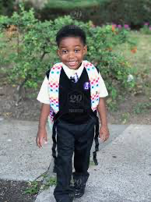

Gross motor Activity:
Children should exercise in a fun and interactive way everyday. Click the youtube link and you and your child can both engage in a singing and movement activity that both will enjoy.

Youtube Link:https://www.youtube.com/watch?v=WX8HmogNyCY
https://www.youtube.com/watch?v=WX8HmogNyCY

Arts & Craft Activity: Supply various objects such as recycled materials and challenge your child to select one and transform it into something new. Allow your child to use an assortment of art materials, recycled materials, magazines, markers, paint, glue, etc. to transform the object they select. Talk with your child about what the original item was and what they have transformed it into as well as how they transformed the object.
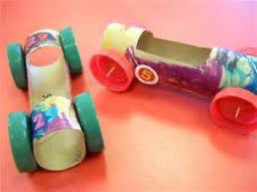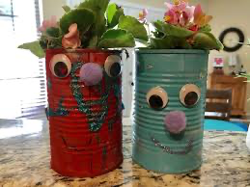
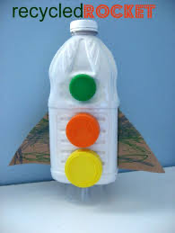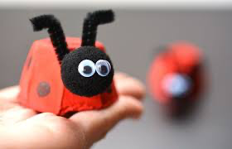

Tuesday June 2, 2020
Vocabulary words of the day: feelings, larger, longer
Letter of the week: S for the 4 Seasons of the year
Book of the Week:
ebook/youtube story of the week: Little Tree by Loren Long
Youtube link to story: https://youtu.be/HSrSmN1vtnI

Questions to ask once the story has ended:
1.Why do you think Little Tree wanted to keep his leaves for so long?
2.Why do you think the animals in the forest tried to help Little Tree drop his leaves?
3. How do you think Little Tree felt about staying the same when all of the other trees were growing and changing?

Literature Activity: Have your child draw a picture according to what they respond to one out of the three questions about the book Little Tree by Loren Long and record your child’s response. * Please take a photo of child’s photo along with which question they are responding to, and what your child’s response was to the image they drew according to their response.

Dramatic Play Activity, Adults: Provide props for your child to pretend he/she is an adult such as clothing or uniforms for work, purses, wallets, pretend money, credit cards, keys, MetroCards, etc. Talk with your child about how he/she will change as they grow up and invite your child to pretend he/she is an adult. Observe how your child acts and speaks as he/she takes on an adult role.
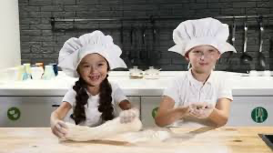

Science Activity: Invite your child to observe the pictures below and talk about the four seasons and how things in nature change around us through Spring, Summer, Fall and Winter, in this case the trees. Do they observe any difference in the trees as the seasons change? How does the tree change from season to season?Invite your child to create their own pictures of how trees change through the seasons.

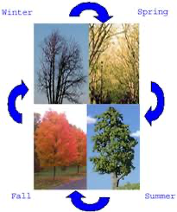

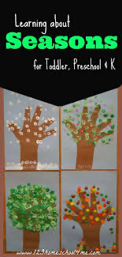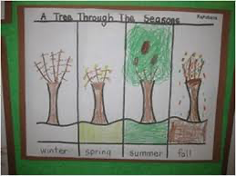

Wednesday June 3, 2020

Vocabulary words of the day:narrower, objects, state
Review letter S for the 4 Seasons of the year
Book of the Week:
ebook/youtube story of the week: Little Tree by Loren Long
Youtube link to story: https://youtu.be/HSrSmN1vtnI

Questions to consider after the story has ended.
1.If you were in the forest with Little Tree would you try to help him drop his leaves? Why or why not?
2.What do you think the other trees and the animals in the forest thought about Little Tree keeping his leaves and staying the same?

Ocular Motor Control Activity:
This refers to the ability of the eyes to work together to follow and hold an object in the line of vision as needed. Make a simple worksheet and have your child use a highlighter to find all the letters S. (see picture below as an example) Review the sound and distinguish the difference between uppercase S and lowercase s.
Youtube link for the S song: https://youtu.be/WnpgmXZuIfU
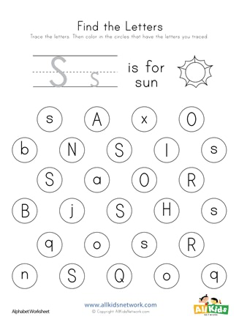
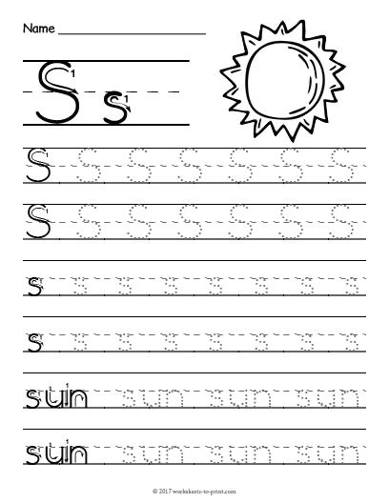

Gross motor Activity: Yoga Time
Yoga works on balance, coordination, strength, motor planning and so much more. It increases core strength and postural control, which children need in order to sit up straight in their chairs.

Youtube Link:https://youtu.be/YKmRB2Z3g2s

Math Activity : Find the path from 1 to 10
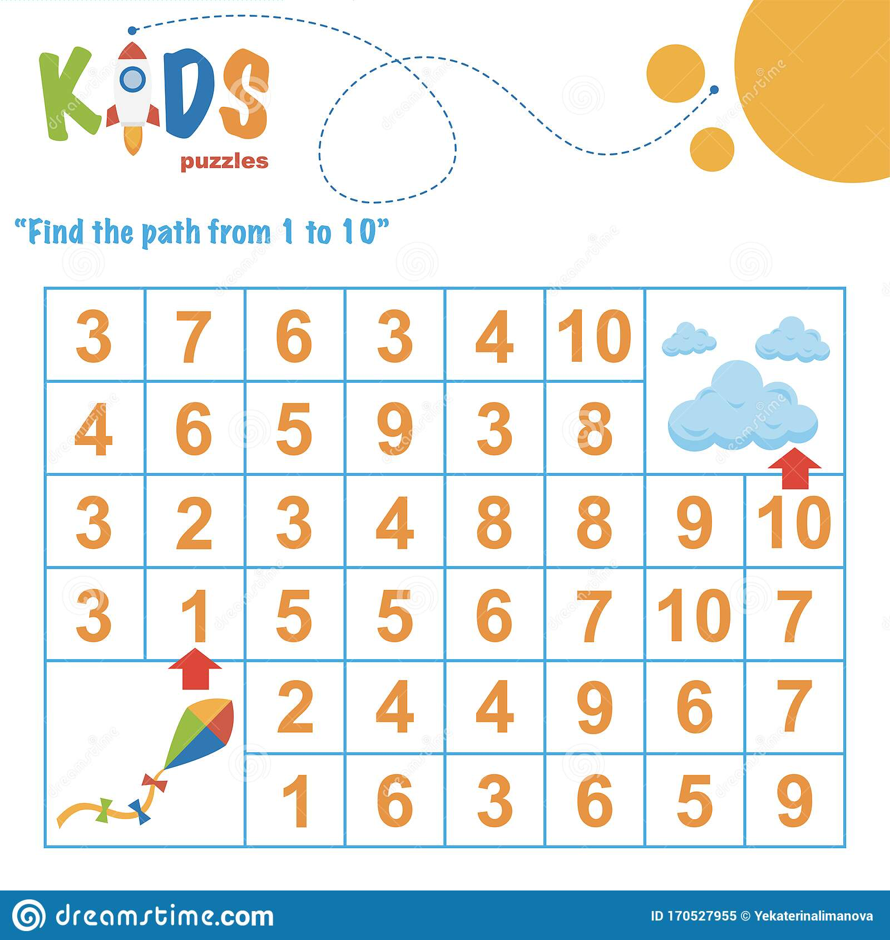

Thursday June 4, 2020

Vocabulary words of the day: shorter, seasons, transformation
Review letter: S
Book of the week:
ebook/youtube story of the week: Little Tree by Loren Long
Youtube link to story: https://youtu.be/HSrSmN1vtnI
1. If you were going to try to help Little Tree drop his leaves what would you do? Why? ?
2. Can you think of a time when things around you were changing but you wanted them to stay the same?What did you do?
3. Do you remember a change that made you uncomfortable or a change that made you excited?

Science Activity: Melt in the Sun
Place a variety of items in a muffin tin or in several small bowls or containers. Select some items that will melt when left in the sun and some that will not. Items that might melt in the sun include crayons, ice cubes, and marshmallows. Ask children how long they think it would take for the items to melt. An hour? Aday? Why?
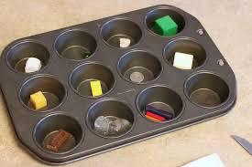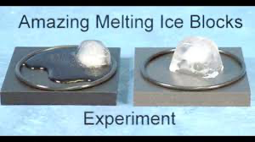
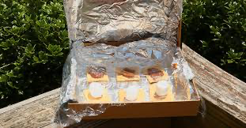

Computer/Technology Activity: Dance
Use a computer/ tablet or phone to pull up short video clips of dances (e.g. ballet or folk dances) that show how people may change the way they move their bodies and dance depending on how the music changes. Search for typical music that represents your culture. Invite your child to imitate the dances.

Examples :
Ballet https://youtu.be/zV1qLYukTH8
Mexican Folk Dance https://youtu.be/Rjw0AhiC0x0
West African Dance https://youtu.be/K9cPJsou6_c

Art Activity: My Favorite Season

Invite your child to talk about which one is their favorite season, Spring, Summer, Fall or Winter. Consider asking him/her these questions:
Why is ______ your favorite season?
What activities do you like to do during this season?
How would you dress to go outside during this season?

Invite your child to draw a picture of themselves during their favorite season.
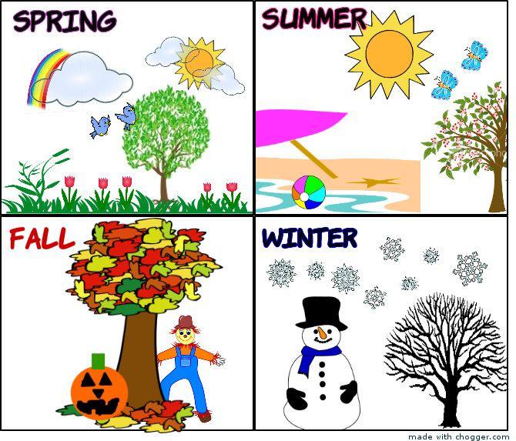

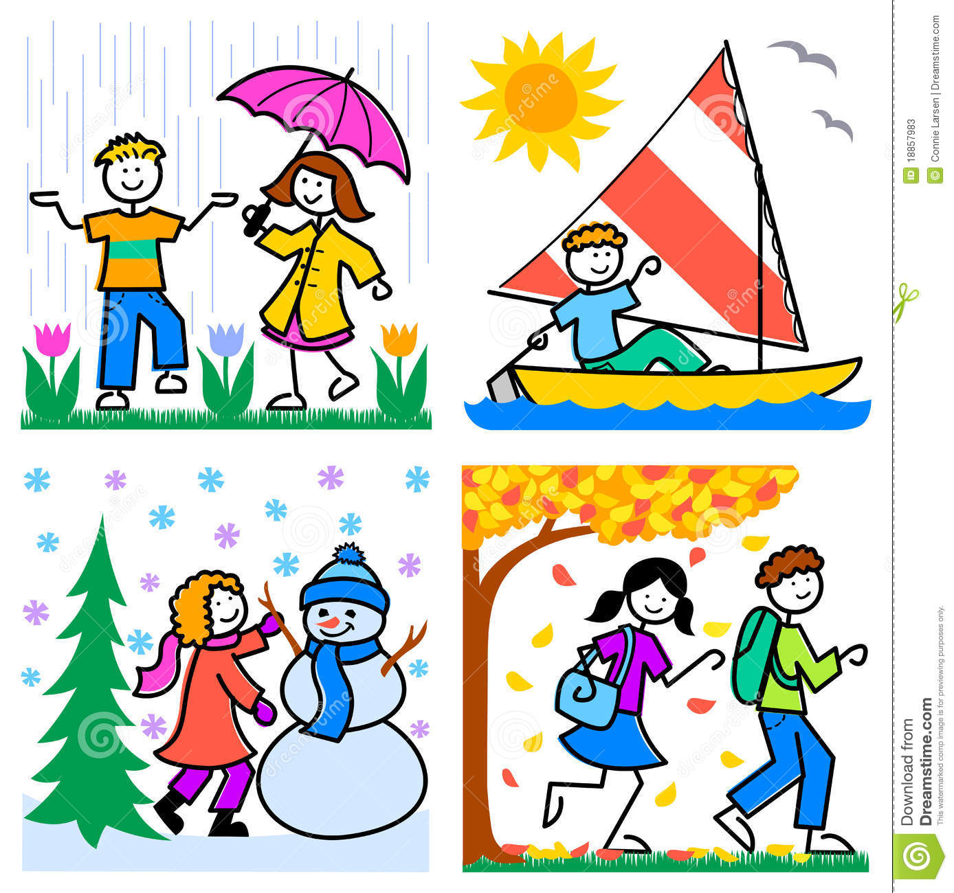

Friday June 5, 2020
Vocabulary words of the day: transition, weather
Review letter: S
ebook/youtube story of the week: Little Tree by Loren Long
Youtube link to story: https://youtu.be/HSrSmN1vtnI

Literacy Activity: Have your child imagine they are an illustrator and create their own vision of the book Little Tree and imagine what they would do if they were part of the story. How would they help Little Tree? Invite them to tell their own version of the story by drawing pictures and dictating dialogue.

Math Activity: Find the Path from 1 to 10
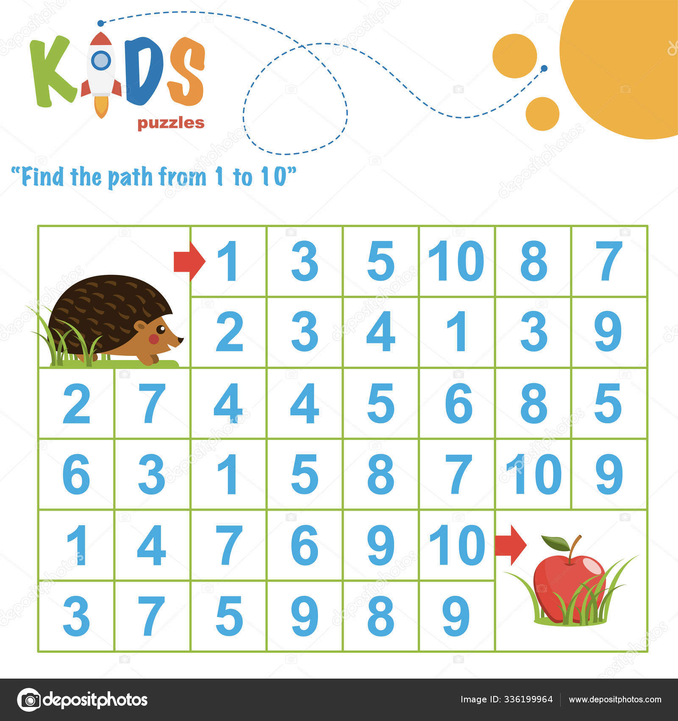

Writing Activity: Create letters Provide various materials such as twigs, straws, string, chopsticks, etc. and invite your child to transform these materials into letters. Challenge them to see how many letters they can create. Be sure to have printed letters available for children to reference throughout the activity.
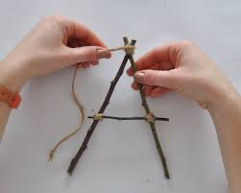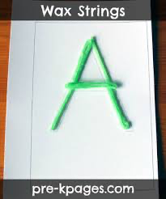
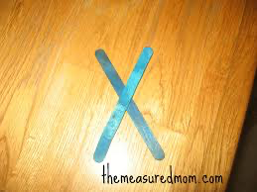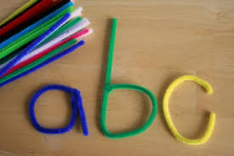
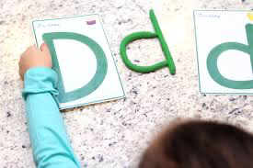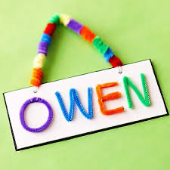
Fun activity sheets: These are some activities to consider if you want to add activities to the lesson plan.
