Get Your Motor (Skills) Running

A little give and take

Put a graspable object (such as a rattle) in your baby's hand and tug on it very gently. This activity helps build muscle as your baby resists your efforts.

Finger food fun
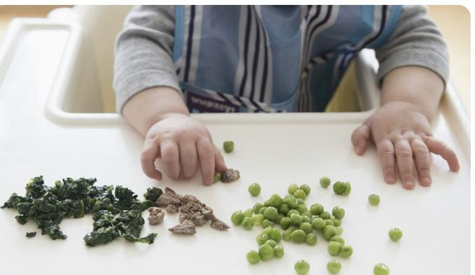

With the approval of your pediatrician, finger foods are great for fine-motor practice, making each eating experience a fun learning time. Encourage your baby to pick up bites of fruit, cereal, or vegetables. Demonstrate how to do this and praise every successful snack.

Tug of War 6 to 9 months
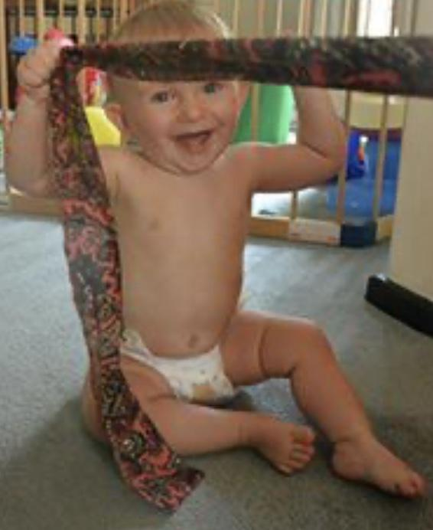

Material
Small clothing items (i.e. scarf, bib, washcloth, sock, etc.)

Directions
Place your infant on his or her back. Hold onto a piece of clothing or fabric about eight to 12 inches away from the infant’s nose and encourage him or her to grab it. Pull lightly so the infant tight- ens his grasp. Try hooking two bibs together. When the infant
pulls hard enough, they will pull apart. Be surprised and excited

Bring out the blocks
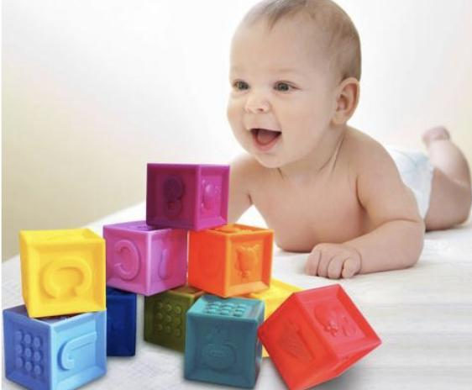

Material
Soft blocks or Small Cardboard boxes

Directions
Create a tower of blocks that is out of reach and encourage your little one to crawl and knock it down.

Take a stand 4-7 months
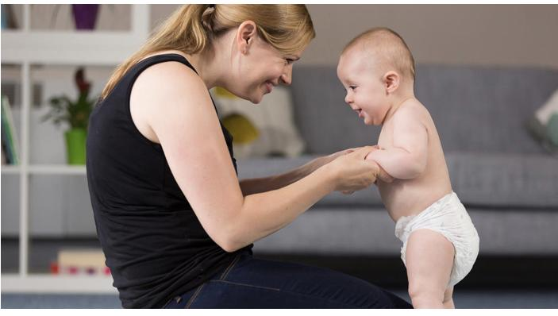

Directions
gently pull your baby to a standing position, and encourage him/her to bounce up and down with your support. You can sing to get your baby moving or you can play a song of your choice. This simple activity will help prepare your baby for walking.

