Activities to enhance Language.

Puppet play

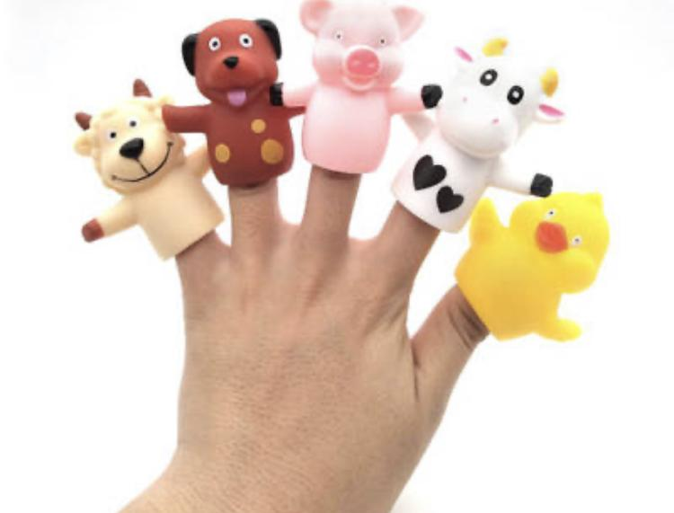
Material
Animal finger puppets

Directions
Sing the nursery rhyme old McDonald to your little one. When you come across each animal, make the sound and show the animal to your baby. This will help your baby connect the sound and the animal. You can also use the finger puppets to show you little one what each farm animal is if you're not into singing. Just use words like "The dog says woof-woof."

** If you do not have finger puppets at home. Below you will find a link where you can print out farm animals.
Animal puppet printable

Read Often
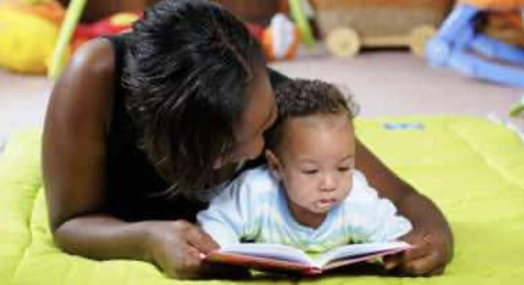

It's never too early to read to your infant. Look at picture books together, ones with bright colors and high-contrast patterns. He/ she will love listening to your voice and looking at the illustrations.

Head shoulders knees and toes
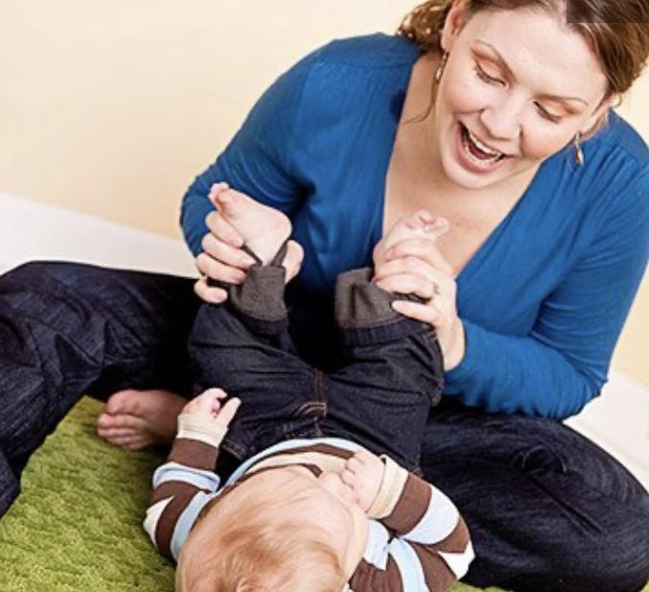
Name the parts of your baby’s body. Have fun by singing head shoulders knees and toes or by making up your own rhymes when you touch her fingers, nose and toes.

Name Objects
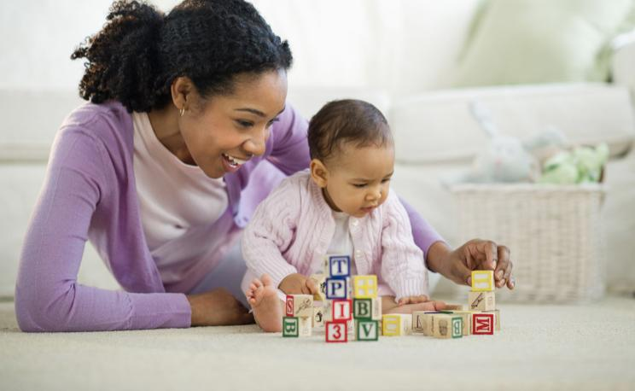
Name objects in your baby's environment. This includes people (Mama, Daddy, Grandma), animals (dog, cow, horse, bird), and objects (tree, flowers, chair). You can also create a family book that includes family photos of close family members.

Talk,Talk,Talk
Narrate your actions as you dress, feed and bathe your baby. Talk about what you’re doing and where you’re going. Also, when your baby makes sounds. Talk back to him, and say what he says. Pretend to have a conversation. This will help your infant learn about the inflections and intonations of conversation and will eventually respond to you in kind.

