Hello Parents,
I hope all is well. Here is our lesson plan for the week of (May 18- May 22 ,2020).
To continue to allow this transition to remain smooth during this time it’s best that we remain on a set schedule, the schedule that children are used to. Every day we should start off with circle time. During this time songs such as the alphabet and Mr.Sun , if you're happy and you know it should be sung with the children. A book of their choice should be read as well. After circle time is music and movement, during this time songs such as head shoulders knees and toes can be played. Following music and movement an activity can be completed. (Please allow your children to be creative, please remember that whatever activity that has been assigned doesn’t need to be perfect. It’s best we allow children to express themselves within their work) This month’s theme is Flowers.
https://youtu.be/R9sn7HZM7uY
Monday- Using real Flowers
Allow children to examine nature up close, and the flowers, colors, texture and scent provides a wonderful sensory experience.
Tuesday- Paper Plate Garden
Provide children with a paper plate, popsicle sticks, and paint. Encourage them to create their own colorful garden.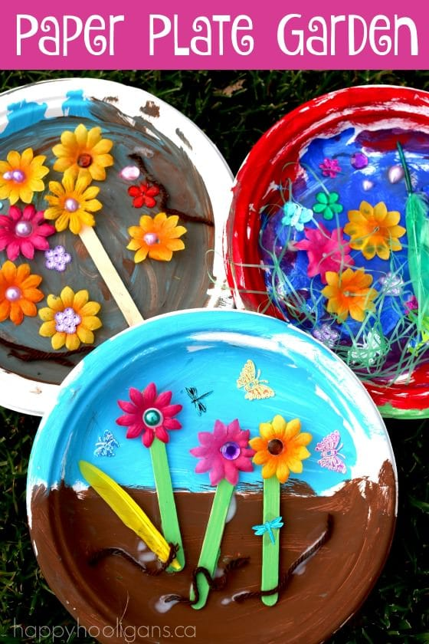

Wednesday- Paper Plate Flower
Provide children with paper plates and paint. Allow them to paint the paper plate and mix colors. While doing this activity you can name the colors their using while completing the project. You can also encourage them to use shapes as well.

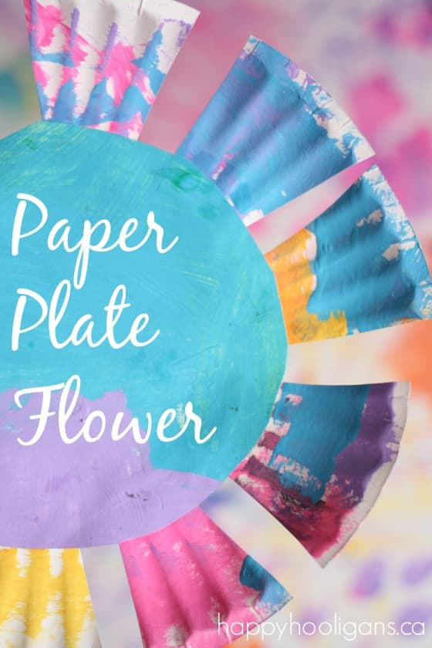

Thursday-Paper Plate Sunflower Craft
Provide children with paper plates, yellow paint or yellow crayons, glue sticks, and coffee beans or corn kernels. Encourage the children to paint or color the paper plate and glue the beans or kernels to the plate.
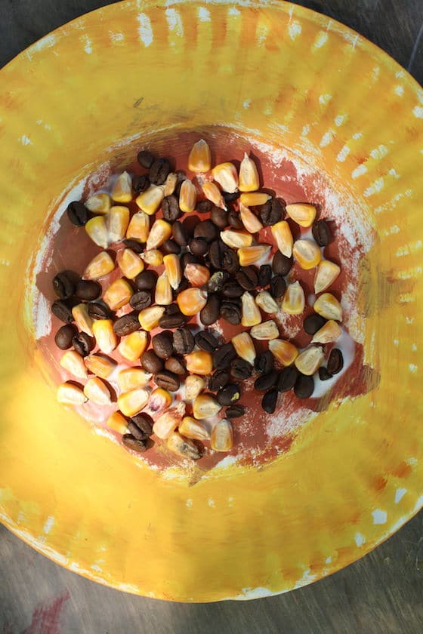

Friday- Let’s Plant
Below is a video is a fun video, you and you child can learn how to plant.
https://youtu.be/Lly75dEbXE8

