Mirror play
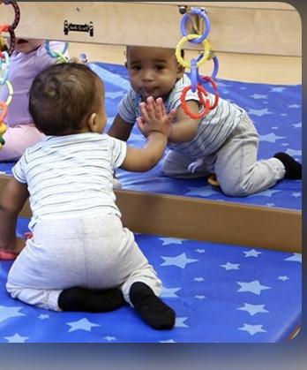

Material
Medium size mirror

Directions: Place a mirror in front of your infant and let your baby pat and poke at herself in the mirror. Smile and make faces together in the mirror.

The joy babies get by spotting their own reflection in a mirror also helps:

- Increase their ability to focus
- Begin to develop social skills
- Foster their curiosity
- Enhance their cognitive development (by introducing the concept of object permanence)

Family band 8-12 months

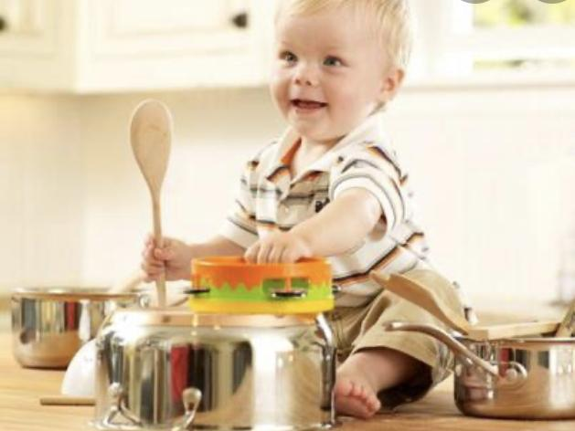

Materials
Blocks
Rattles
Wooden spoons
Paper towel roll etc.

During this stage, your baby will be interested in banging objects to make noise. Give your baby blocks to bang, rattles to shake, or wooden spoons to bang on containers. Show your baby how to bang as you sing their favorite song.

This fun activity will help your baby learn how to move their arms with intention, learn cause and effect, and eye-hand coordination.

Indoor obstacle course 8-10 months
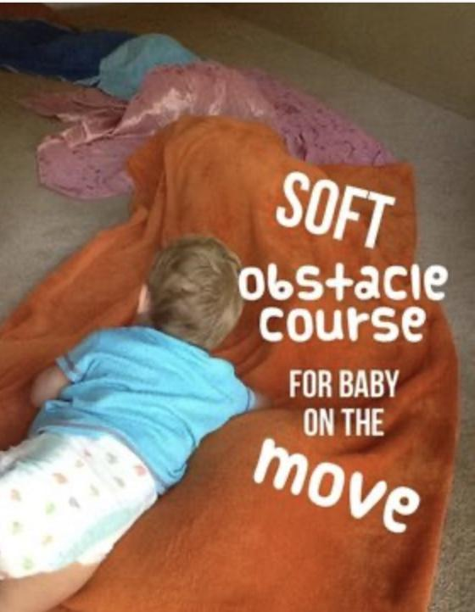

Material
Pillows
Blankets
Towels
Tablecloth etc.
( Try using different textures to enhance the learning experience)

Directions: Get a little creative and place pillows underneath blankets and towels etc. This activity will enhance your babies gross motor skills.

Tip of the week:

Getting your infant to roll over 4-6 months

Gently rolling your baby from tummy to back or back to tummy can help her figure out the movement. You can also tempt her into rolling by holding a toy or your face to the side just out of reach, so she has to roll to get to it. Also, tummy time is highly recommended. Tummy time helps your baby develop strong neck and shoulder muscles and promote motor skills.

