This week we will focus on Sensory activities. Research shows that sensory play builds nerve connections in the brain's pathways, which lead to the child's ability to complete more complex learning tasks. Sensory play supports language development, cognitive growth, fine and gross motor skills, problem solving skills, and social interaction.

Textile Egg Cartons

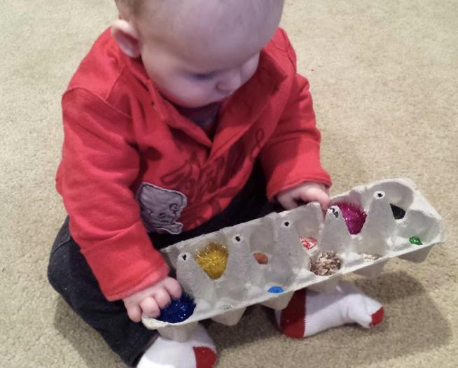

Materials
Glue gun
Scissors
Eggs carton
Bubble wrap
Cellophane
Pom poms
Cotton balls
Sandpaper etc.

Directions: Cut off the lid of the egg carton and past the sensory materials you gathered to the bottom of the egg carton. Once dried over night, hand it over to your little one and have he/ she explore each texture. As your baby explores each texture, talk about how it feels.

Finger paint with baby food
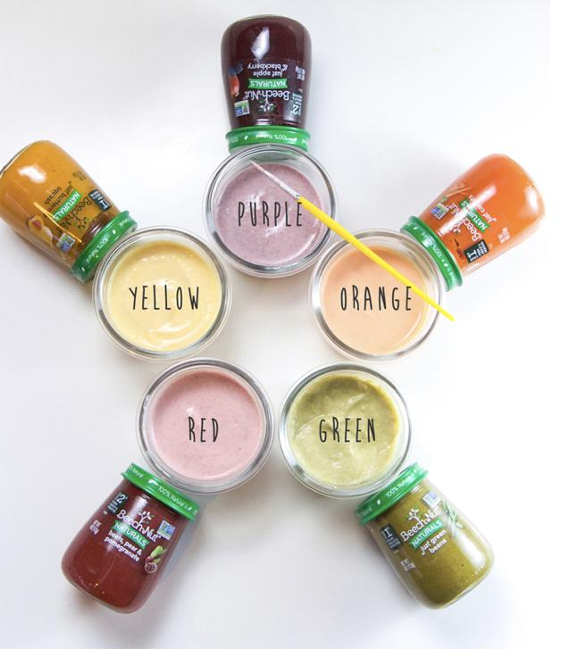

Material
Greek yogurt
Rice cereal
Baby food ex. Squash, Beats, carrots, Green peas etc.

Directions:

PINK FINGER PAINT

In a small bowl, mix together 2 tablespoons Greek yogurt, 1 tablespoon of beets, pear & pomegranate puree and 1 teaspoon rice cereal baby cereal until well blended.

YELLOW FINGER PAINT

In a small bowl, mix together 2 tablespoons Greek yogurt, 3 teaspoons of just butternut squash puree and 1 teaspoon rice baby cereal until well blended.

ORANGE FINGER PAINT

In a small bowl, mix together 2 tablespoons Greek yogurt, 1 tablespoon just carrot puree and 1 teaspoon rice baby cereal until well blended.

GREEN FINGER PAINT

In a small bowl, mix together 1 tablespoon Greek yogurt, 4 teaspoons just green bean puree and 2 teaspoons rice baby cereal until well blended.

PURPLE FINGER PAINT

In a small bowl, mix together 2 tablespoons Greek yogurt, 1 tablespoon just apple & blackberry puree and 1 teaspoon rice baby cereal until well blended.

** Once you’ve created the finger paint. Give your baby a piece of paper and a variety of baby food to create masterpieces. This activity helps him/ her develop fine motor control, and experience different textures. You can also try warming one up, and using that word while he/she paints. Then take one from the fridge and use the word cold.

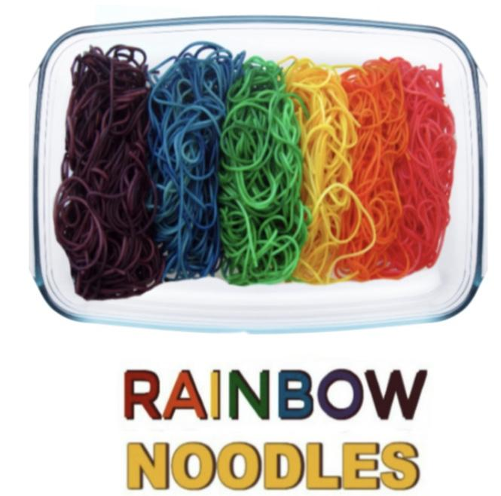

Materials
Cooked pasta noodles
Zip-seal bags
Food coloring
Vegetable oil
A play bin or container

Directions
- Begin by cooking your pasta noodles as normal, and then rinse them under cold water.
- Divide the noodles into bags, using one bag for each color of pasta that you wish to make.Add several drops of food coloring to each bag along with a drop of vegetable oil.
- The oil just helps to coat the noodles in color.
- Seal the bags and give them to kids to shake and squish.
- Continue to mix the bags until the noodles are fully saturated in color.
- Once the noodles are saturated, open the bags, and allow them to sit for 10-15 minutes so that the colors can seep into the noodles.
- Then, rinse the noodles under cold water to remove any excess food coloringThen, play can begin!

Once your noodles are all done. Place your noodles into a large bin or container, and the fun can begin! You can add objects of your choice for your little one to find.

** If you are concerned about stained hands you may want to use washable watercolors in place of food coloring. However, any staining from the food coloring will wash off of kids hands by days end.

