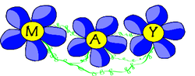
Hello Parent & Friends!
For the month of May the unit we will be learning is Exploration! The first big idea of Exploration is Care, children will have the opportunity to explore ideas related to caring for self, others and the world around us. The second concept of this Exploration is Growth, they will explore how things that grow and their role in influencing growth. For example, not only do babies grow, but baby animals grow as well. In this final part of the Exploration we will cover Change, children will explore change and their role in influencing change. In this Exploration, children explore how their actions and change. As in all Explorations, the goal is to help and the way they care for they self, others, and the children begin to explore ideas, think critically, and world around them can impact growth and change.
As Preschool teachers, we are providing your child with a home school connection. Here are some ideas to keep your child’s school schedule at home. Let's bring Ready Set Learn into your home!
Tip #1: Circle Time is the number one important activity to do during the morning. We go over our lesson for the day, the craft or activity that we would be doing, have the children move and stretch their bodies, help learn their ABC’s and the sound the letter makes.

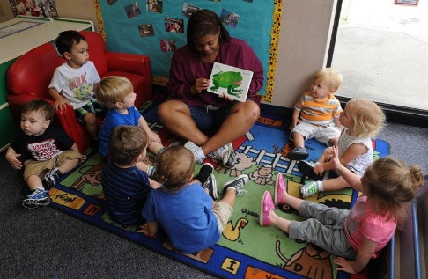

Tip #2: Create a monthly calendar with your child. During circle time we engage with the child in learning about the calendar. The student discusses the days of the week, sing the months of the year, and we talk about which days we are at home and school. We also go over our shapes, colors and numbers.

Tip #3: During circle time we also go over our mood of the day. Children also use their pictures checking if they're in school or at home.
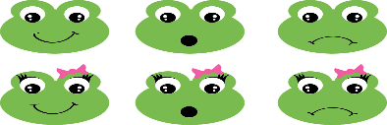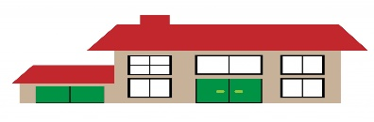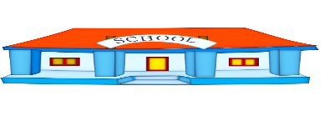
Care Activites:

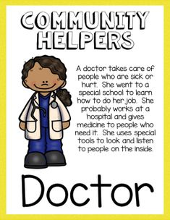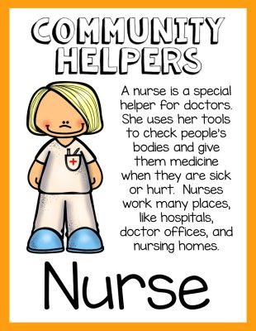
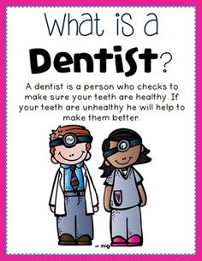

Week #1 Day 1: Band-Aid (Fine Motor Skill)
“My B has a boo-boo!”
Materials: Band-Aids, Letter B printout
What to do: Child will use band aids, pill band ads off and put it on the letter B

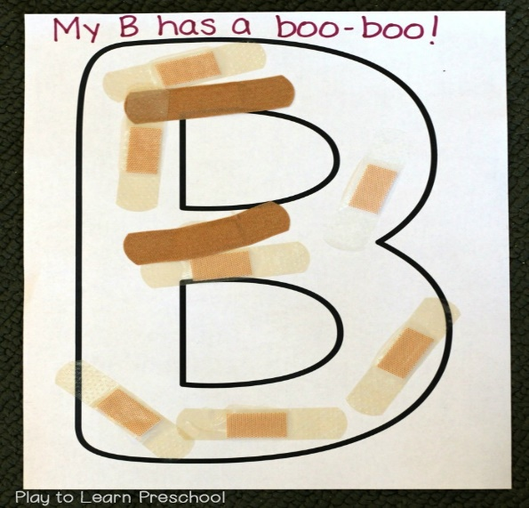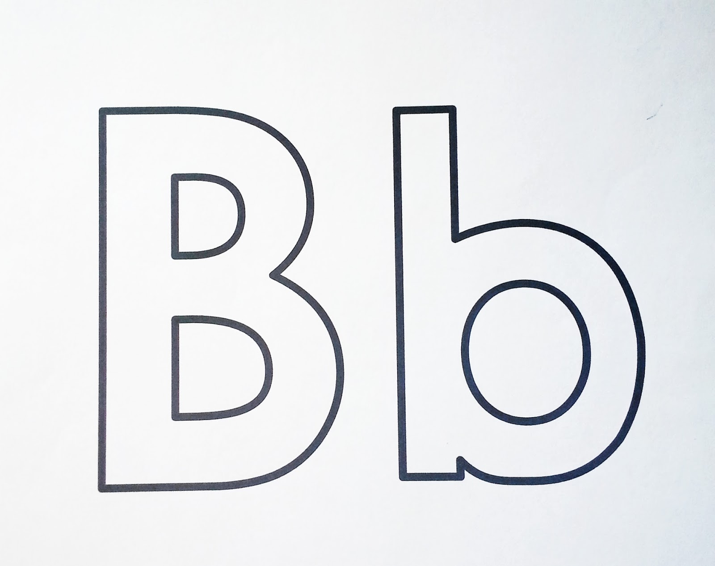
Week #1 Day 2: Q-Tip X-Ray
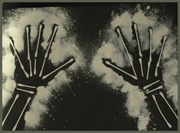
Materials: Black contruction paper, white paint, Q-Tps, White Crayon, Glue
What to do: Children will trace their hands on the paper with the crayon. Using the q-tips as pretend bones glue them on the paper. Use as many q-tips to fill in your hand. Explain this is how an X-ray would look of their hands, also that our hands have bones.

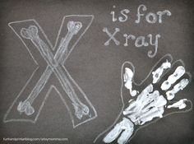
Week #1 Day 3: Happy and Sad Teeth
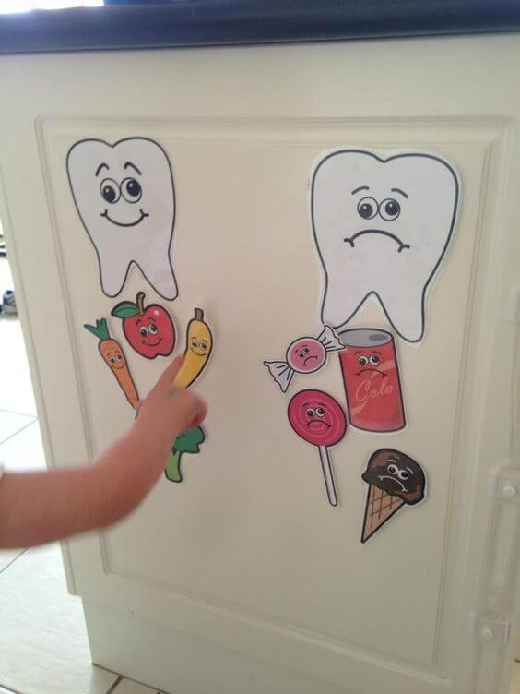
Materials: Scissors, Crayrons, Glue
What to do: Chidren will identify the good vs. bad food for their teeth

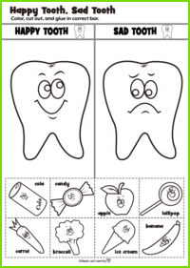

Week #1 Day 4: Apple Smiles
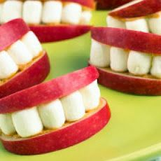
Materials: Apples, Marshmallows, Peanut Butter or Whipped Cream
What to do: Parent please cut into apple slices for your child, allow them to sread the peanut butter or whipped cream into one side of each apple slice. Add the marshmallow on the speard. Lastly on top add the side of spread into the marshmallow and your all done. Don’t forget to say cheese and smile at your next appointment at the dentist ;-) !

Week #1 Day 5: Brushing Your Teeth
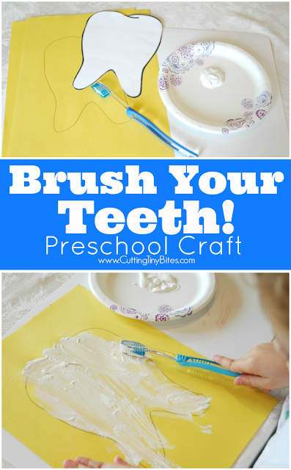
Materials: Any color contruction paper, Toothbrush, White paint and glitter
What to do: On the contruction paper trace the cut out of the tooth below. Using your tooth brush paint the tooth you traced on the paper. Add the paint to the toothbrush while brushing your tooth listen to Brush Your Teeth on Kids YouTube. Don’t forget to add your glitter to make that prefect smile! (Take a picture and say cheese!)
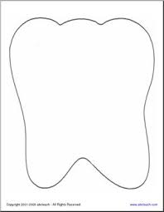
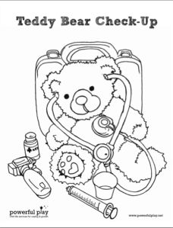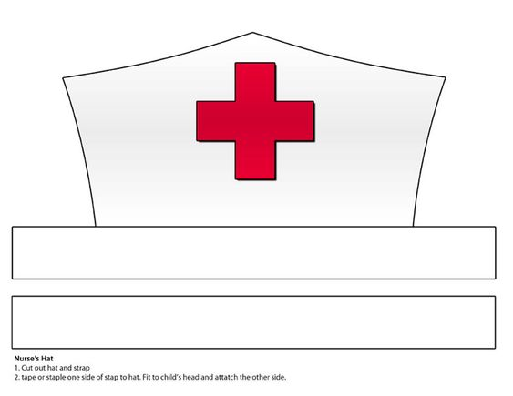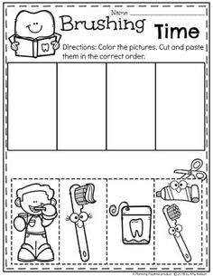
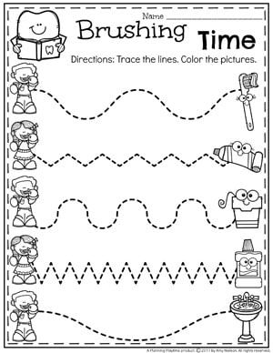
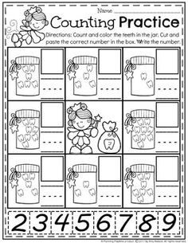
Growth Activites:
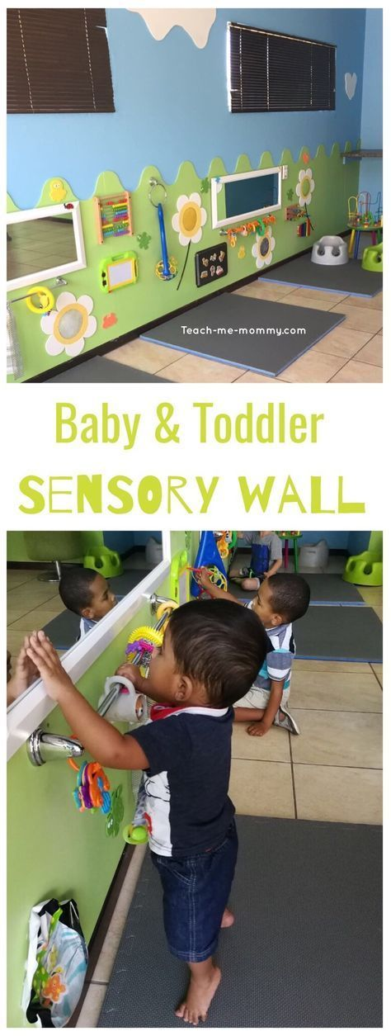

Week #2 Day 1: Look at Me

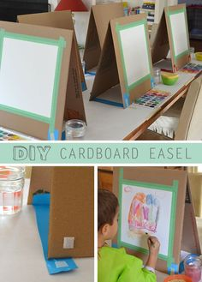
Materials: Mirrors, paper, crayons and markers,
What to do: Show your child a mirror. Invite them to look in the mirror and explore what they see. They may want to think about ways they look different now than when they were a baby. Use crayrons or markers to draw picture of themselves to create his photo
Week #2 Day 2: Photo Collage

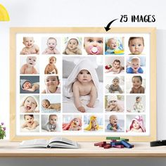
Materials: Photo from the age newborn until now, Glue, Contruction paper
What to do: Collect picture of you from birth to now, wih the siccors cut out as many picture and let your child add the pictures together on the construction paper.

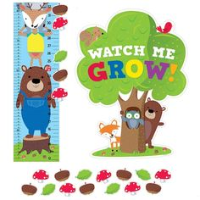

Week #2 Day3: Gaint Flower

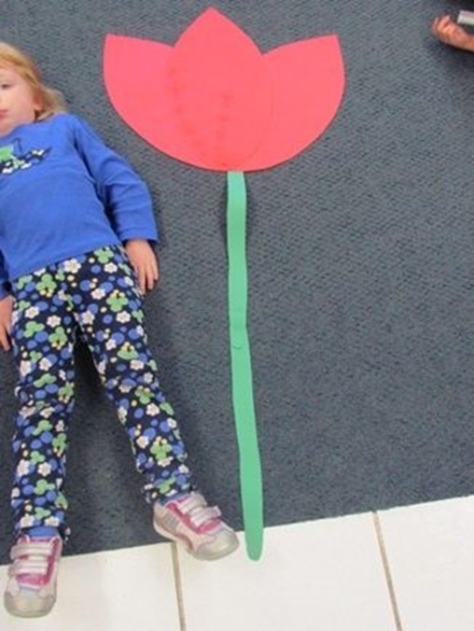

Maaterials: Construction paper (green and aother color of your choice) , scissors, crayrons, markers
What to do: Lay your child on the floor and measure how tall they are, using the green consruction paper cute a strip of green paper as the size of your child. Using the other paper make a flower of our choice it can be a rose, dasiy, tullip), color your flower with some pretty colors. Glue the flower and stem together.
Don’t forget to give it yto your mom for Mothers Day!

Week #2 Day 4:

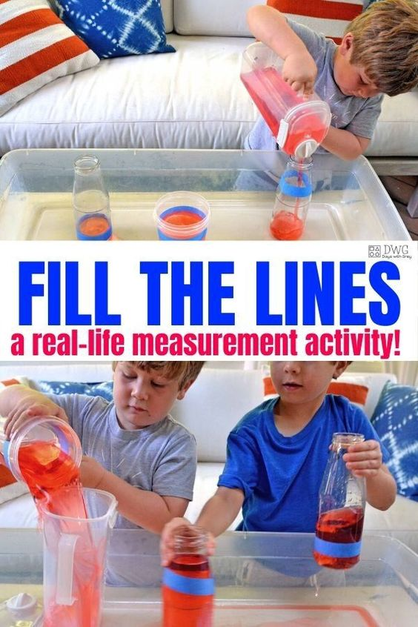

Materials: Clear cups of different sizes, tape, water

What to do: Show the children a couple of containers that are\various sizes. Invite children to explore the containers and water. They may want to explore filling the containers and then what happens when they add more water to the containers. Let them explore full and empty as they fill cups, pouring water into the cups to the line of the tape.

Week #2 Day 5: Mothers Day Activity

Materials: Egg carton (not foam), Scissors, Pipe cleaners – green, Ribbon, Buttons – I used white (paint them any color), Glue, Paintbrush, Construction paper

What to do: Cut up your egg carton. Each egg container area is going to be a flower bud. Cut right down the middle and remove the excess areas. Paint and let them dry (make sure to have 2-3 coats) Add the button in the middle of the egg carton. Trimmed pipe cleaners to the right length and tied them together for a stem. With your ribbon tide together to hold your flowers. Glue everything onto a construction paper
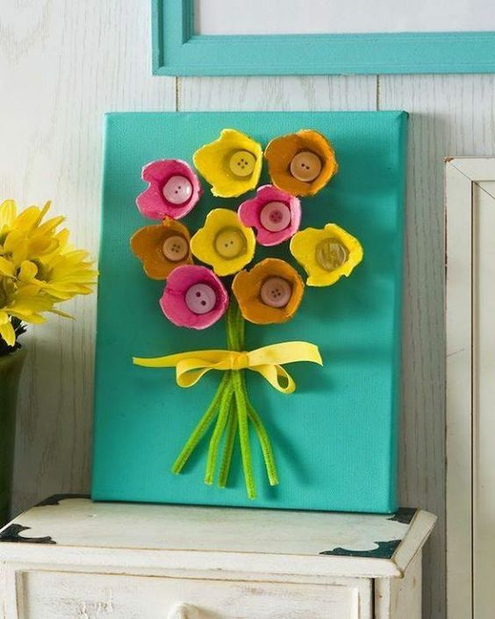

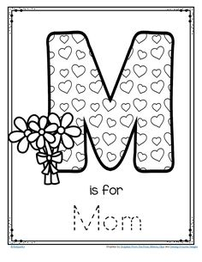

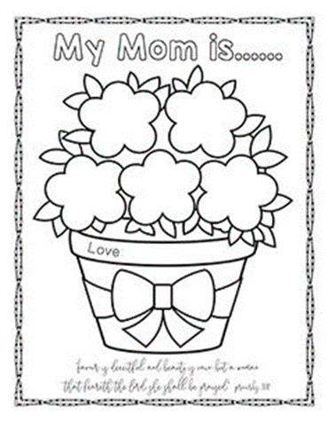

Change Activites:

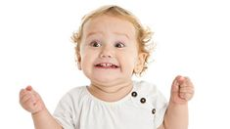

Week #3 Day 1: Mixing Colors
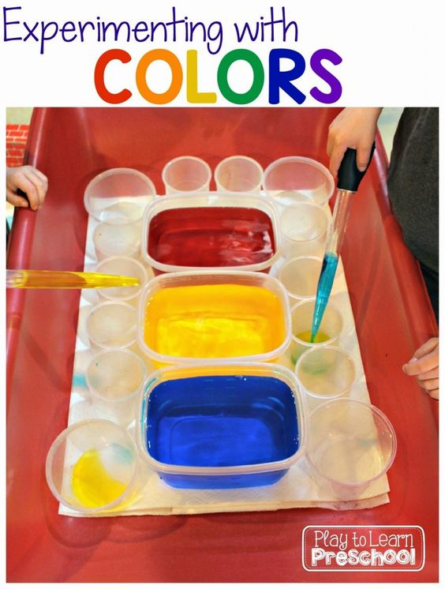

Materials: 3 big contaners, food coloring (red, yellow, and blue), eye doppers, water
What to do: You will be exploring what happens when you mix paint colors together. I provided bowls of primary colored water (red, yellow and blue), empty ice cube trays and small plastic eye droppers. We have used eye droppers for other projects so the students are familiar with them. They are a terrific way to strengthen hand muscles and improve the pincer grasp. It always excites the kids to see the new colors that they can make.

Week #3 Day 2: Painting Ice

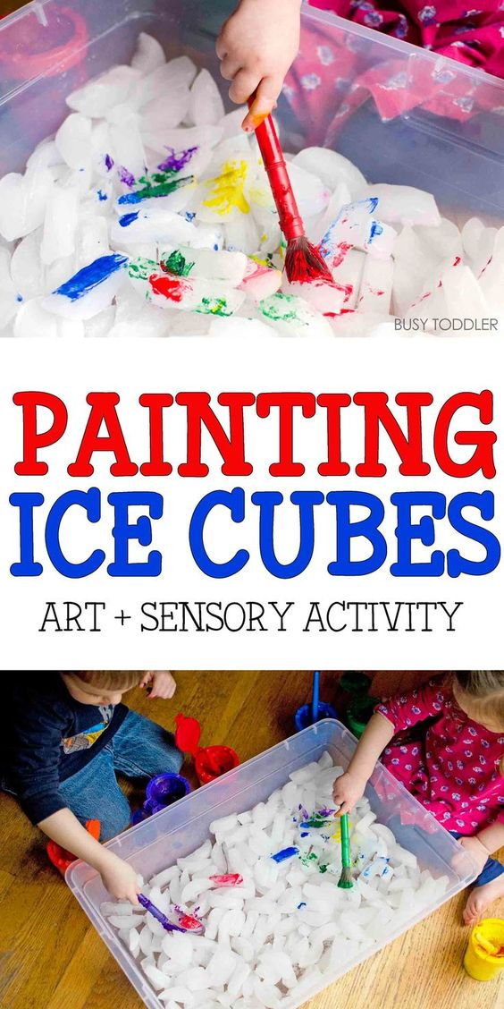
Mateials: Bin, Ice, paint, and paint brushes
What to do: Show the children the different colors of paint. Be sure to share that you will be exploring what happens when you mix paint colors together in the art center.

A fun sensory activity for toddlers and preschoolers; painting and sensory activity rolled into one; an easy indoor activity for toddlers;

Week #3 Day 3: Jello Playdugh
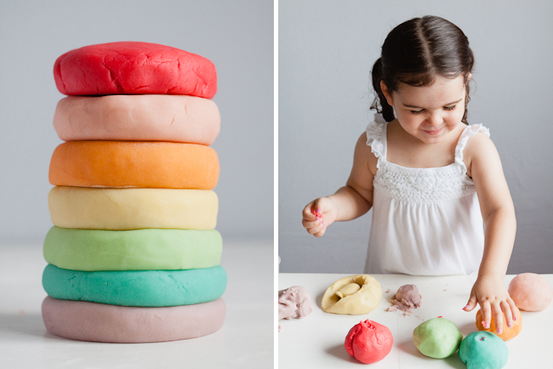
Materials: Flour – 1 cup, Warm water – 1 cup, Salt – 2 tbsp, Cream of tartar – 2 tbsp, Cooking oil – 2 tbsp, Jello – 1 3oz pack
What to do: (Cooking and Mixing) Mix all of the ingredients together in a small saucepan. Invite children to explore how the ingredients in the recipe change as they make the dough as well as what happens when they play with the dough. Here below is a video!
https://www.pinterest.com/pin/185069865924486553/feedback/?invite_code=46a352bdfa8f4e81b149abd110cf1d56&sender_id=470767104707039464

Week #3 Day 4: Bubble Lamp in a Bag
Materials: Ziploc (sandwich bag), ½ cup water, Food coloring, 1 ½ cups vegetable or baby oil
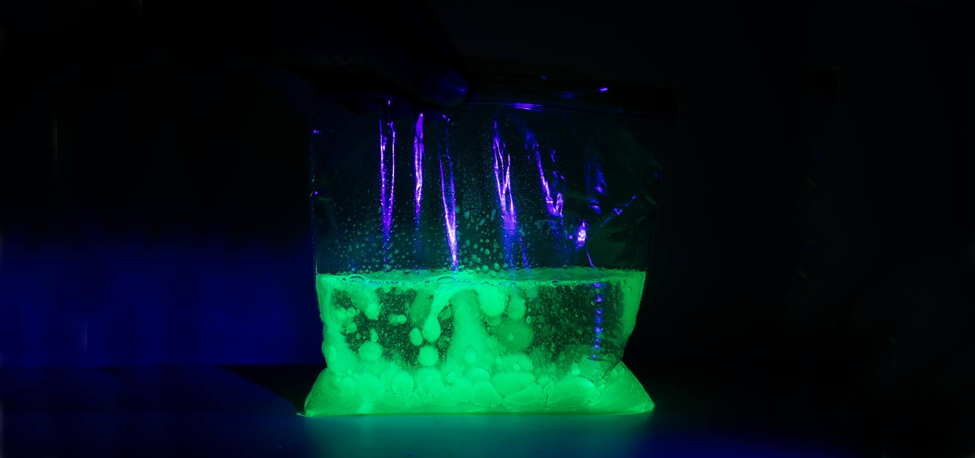
What to do:
- Mixing all materials
- Pour the ½ cup of water into a Ziploc (avoid filling the bag beyond half its size). Add two to three drops of food coloring and mix together.
- Pour 1½ cups of oil into the bag (avoid filling the bag beyond half its size) and firmly seal the bag. Observe what happens to the oil and the water.
- Break one antacid tablet into pieces (only use one tablet at a time). Drop the pieces into the bag. As the antacid dissolves, the sodium bicarbonate and citric acid react together, creating carbon dioxide gas bubbles. You made a bubble lamp! As the bubbles rise, they give a temporary lift to the water. As the bubbles burst at the surface, the water falls back down.
- To create a glowing bubble lamp, make fluorescent water with a highlighter. Use the highlighter (yellow or green work best) to color a paper towel sheet until it’s completely covered
- Soak the colored sheet in a ½ cup of water for 15 seconds, until all the color has been absorbed by the water and the towel is almost inkless.
- Remove and wring out the paper towel to get as much of the ink into the water as you can.
- Now repeat Steps 2-4 with the highlighter water in place of the food coloring water. For a glowing effect, add the antacid tablet pieces to the bubble lamp in a dark room. Point the black light at the bag and watch the glowing bubble lamp in action!
https://www.pinterest.com/pin/554646510358562626/
Week #3 Day 5: Jell-O Sand Play (Edible)
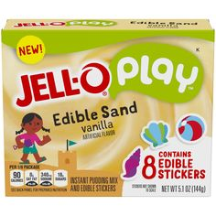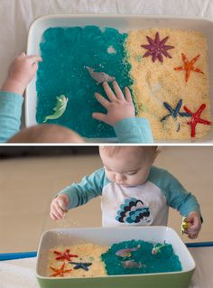

Materials: Mixing Bowl, Measuring cup, Milk, Jell-O sand box

What to do: Add Jell-O and 3 cups of milk into the mixing bowl with your whisker mix the two ingredients together for 2 mins. For 5 mins like it sit. Don’t forget to add your stickers in your sand. Remember the stickers are edible so let’s dig in!

https://www.youtube.com/watch?v=-1fb9hQYv4c

Fun Activities:

Week #4 Day 1: Glitter Germy Hand
Materials:
Free printable “Germy Hands Activity Sheet”
1 bottle hand sanitizer, 1 bottle colorful glitter
What to do: In a small bowl, combine hand sanitizer and glitter. Stir together the sanitizer and glitter and set aside. Ask them to trace their hands on the sheet, then draw what they think germs look like inside the outline of their hand. Ask to dip their hands into the sanitizer/glitter mixture so that their hands are coated, then have them rub their hands together until dry. Practice washing hands and see how long it takes to wash away germs
https://thesoccermomblog.com/glitter-germy-hands-experiment/?utm_medium=social&utm_source=pinterest&utm_campaign=tailwind_tribes&utm_content=tribes&utm_term=540716474_19768184_112125&utm_source=pinterest&utm_campaign=tailwind_tribes&utm_content=tribes&utm_term=843033460_35710958_112125&jwsource=cl

