June 1 – June 5
2020
Ice Cream

” The cold never bothered me anyway." — Frozen, "Let It Go”

Monday 01
YouTube: https://www.youtube.com/watch?v=Y4TD6lnW0gY <- Should I Share My Ice Cream Read Aloud

- Parent & Child Activity: Use the Alphabet chart provided or write out the Alphabet and point to each letter as you sing the Alphabet song with your child.
- Write your child’s name on a piece of paper and practice naming the letters in order.
- Make a daily weather observation (Sunny, Rainy, Cloudy, Etc.)
- Talk about shapes and their sides choose a shape and draw it on a paper allow your child to trace/color. (You may use shape chart provided)
- Practice counting 1-10 using small objects such as blocs, Coins, or Dried beans. SUPERVISE child as small items can be a choking hazard.

Math Ice-Cream Cone
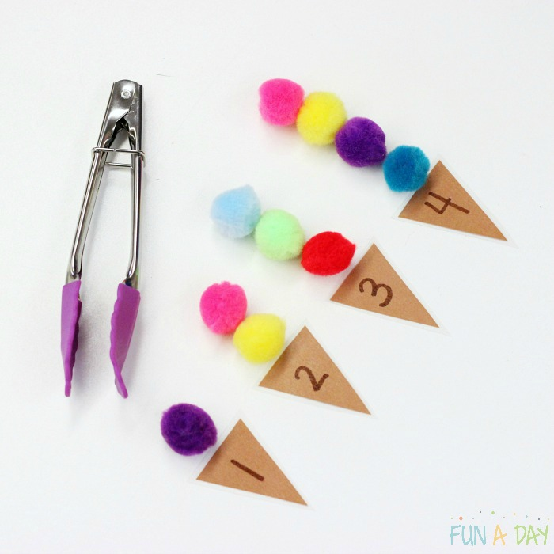

Using brown construction paper cut 10 triangles and label them 1-10. If you do not have access to any brown construction paper you may use a blank sheet of paper and allow your child to color the triangles using a brown crayons. Provide the child with some pom poms and have the child place the amount of pom poms that corresponds with the number on the cone using their hands or for more fun using small tongs.

Tuesday 02
YouTube: https://www.youtube.com/channel/UCLF1tXNG27yD-LXTREf5Ifg <- Watch Ms.B

Parent & Child Activity:
- Allow your child to select a book and read it to you (Please keep in mind that your child may not read the actual words, allow the child to make them up. Focus on appropriate page turning)
- Make a daily weather observation (Sunny, Rainy, Cloudy, Etc.)

Ice-Cream Alphabets
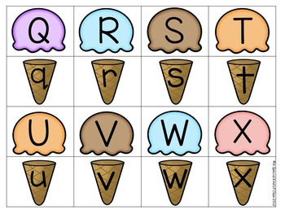
Using brown construction paper a couple of triangles and label them with the lower case letters of your child’s name. If you do not have access to any brown construction paper you may use a blank sheet of paper and allow your child to color the triangles using a brown crayons. Use a separate blank sheet and cut out circle’s or ice-cream scoops. Write the capital letters of your child name, have your child match each capital letter with the corresponding lower case letter.

Wednesday 03
YouTube: https://www.youtube.com/watch?v=zPb2IOGKQII Click to see video of activity

Parent & Child Activity:
- Write your child’s name on a piece of paper and practice naming the letters in order.
- Talk about shapes and their sides choose a shape and draw it on a paper allow your child to trace/color.
Making Ice Cream
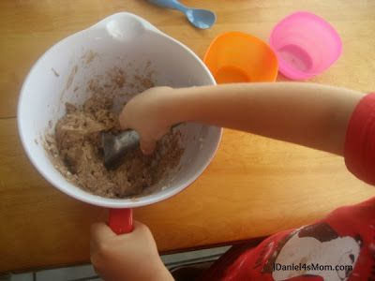

INGREDIENTS
½ cup whole milk
½ cup cream
¼ cup sugar
½ teaspoon vanilla extract
1 cup rock salt
Ice
2 Ziplock bags

INSTRUCTIONS
- Add ½ cup whole milk, ½ cup cream, 1.4 cup sugar, and 1.2 teaspoon vanilla extract to a mixing cup and stir until well combined. Add the mixture to a small zipper bag. Now, this is very important. You will shake the bag so please be sure that it is fully closed and a good quality.
- Fill the second bag with a handful of ice and about half of the rock salt.
- Place the smaller bag with all the mix closed into the second bag with ice. (Bag inside bag)
- Now the fun part! What better way to earn your ice cream than a few minutes of exercise Wrap the bag on a towel, because it is freaking cold, and shake it for 5 minutes or until the liquid in the smaller bag turns into ice cream.
- You can scoop it out and enjoy.

Thursday 04
YouTube https://www.youtube.com/watch?v=LM0uQrX3d0A Click to hear story about Ice-Cream

- Parent & Child Activity: Use the Alphabet chart provided or write out the Alphabet and point to each letter as you sing the Alphabet song with your child.
- Write out the numbers 1-10 and practice counting, be sure to also ask the child to name the number sporadically to help them actually learn the numbers. (Use chart provided or write the numbers on a blank sheet of paper)
- Make a daily weather observation (Sunny, Rainy, Cloudy, Etc.)
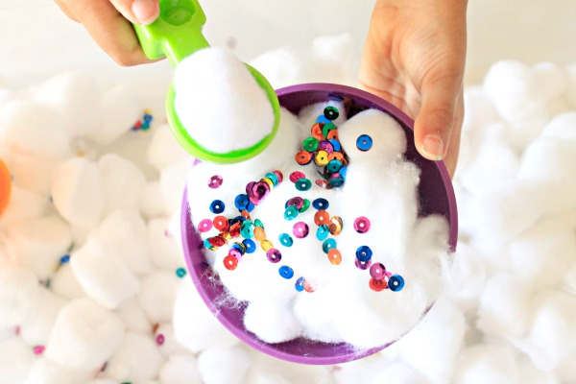

Dramatic play
After looking at YouTube read aloud about ice cream. Allow your child to gather some cotton balls as “Ice-cream scoops” using a spoon or a scooper, you may use pieces of construction paper, sprinkles, confetti or even food coloring to allow your child to decorate the ice cream as they wish.

Friday 05
You Tube: https://www.youtube.com/watch?v=5KHCKlEK348 Click to hear Ms.B singing Five Frogs

- Parent & Child Activity: Use the Alphabet chart provided or write out the Alphabet and point to each letter as you sing the Alphabet song with your child.
- Write your child’s name on a piece of paper and practice naming the letters in order.
- Make a daily weather observation (Sunny, Rainy, Cloudy, Etc.)
- Talk about shapes and their sides choose a shape and draw it on a paper allow your child to trace/color. (You may use shape chart provided)
- Practice counting 1-10 using small objects such as blocs, Coins, or Dried beans. SUPERVISE child as small items can be a choking hazard.

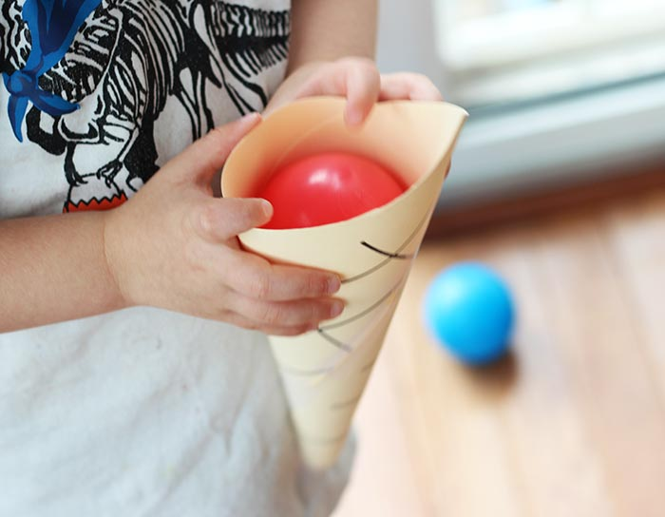
I share My Ice Cream game

Using a blank sheet of paper or a brown construction roll the paper into a cone shape, making sure that the opening is wide enough for your ball to fit. Be sure to secure the edges with clear tape, if you do not have access to a ball you may use another sheet of paper and simply crumple it into a ball. Talk to your child about the importance of friendship and how it feels good to share with friends. Pass the Ice cream along to every family member in the household while seeing the song

“ share my ice cream with (Name).
( Name ) shares his/her ice cream with ( 2 name).( Continue to repeat for all members)

(Once all the names have been mentioned you all say together)
I scream, we all scream, we all love our ice scream!”

