Happy week 9 of online distance learning student/families

Welcome to the third week of the Babies Unit. This third week is a continuation of last week’s lesson plan. We continue exploring the question “What can we learn about animal babies?” Since this lesson has been implemented since last week, now is a good opportunity to take some time out of our daily lessons to implement an Assessment that would have been done in class, but that now can be done at home. This assessment is meant to tell you how many letters, numbers, colors and shapes your child knows and which ones we’ll need to work on. It is a great tool to monitor progress and adjust lessons accordingly to make sure they are going to be ready to enter Kindergarten next School year.

The Assessments will include
*Recognizing letter names
*Difference between uppercase and lowercase letters
*Communicating letter sounds
*Writing Uppercase and Lowercase letters
*Shapes and Color Recognition

Unit Title: Babies
Essential Question: What are babies?
Focus Question:What can we learn about animal babies?
Monday May 18, 2020
*Parents if you can, please take pictures of your child's
completed work/activity and sent it to Google Classroom or email us!
https://classroom.google.com/u/0/c/NzcwMTQ1MTkyODRa

Vocabulary words of the day: Bird, Nestling (a bird that is too young to leave its nest), Hatching.
MORNING ROUTINE:
Circle Time Morning Songs:
- Good Morning Song: https://www.youtube.com/watch?v=TFVjU-dsIM8
- Days of the week: https://www.youtube.com/watch?v=HtQcnZ2JWsY
- Weather: https://www.youtube.com/watch?v=Jn7uAsLWXpk
- Letter of the Week: H for hatching and habitat https://youtu.be/PUI5-AphjMg

Book of the Week: Over in the Meadow by Ezra Jack keats
YouTube link to story: https://youtu.be/oj4sGa_gw1Y
Level 1: Recall
Here are some questions to consider with your child after reading the story the first time:
- What are some of the animal babies that lived in the meadow?
- What are some of the animal homes, or habitats, in the meadow?
- How many little turtles did the mother turtle have?
Gross motor Activity:
Children should exercise in a fun and interactive way everyday. Click the youtube links you and your child can both engage in a singing and movement activity that both will enjoy.

Youtube Link:
https://www.youtube.com/watch?v=XqZsoesa55w&list=PLtFelfZ3jQZDFIgmaqU8aBOvB6oTjZQGm&index=7

https://youtu.be/fpD9kRyBn8o
AScience Activity: Memory
Create a memory game from pictures of animal babies and adults. Children can match animal babies to adults. Children who are ready can also attempt to write or copy the names of the animals they find. Choose any of the printables below, print and cut the pictures. If there’s no access to a printer, assist your child in drawing the pictures and writing the names of the animal. This could be a project to do throughout the week.
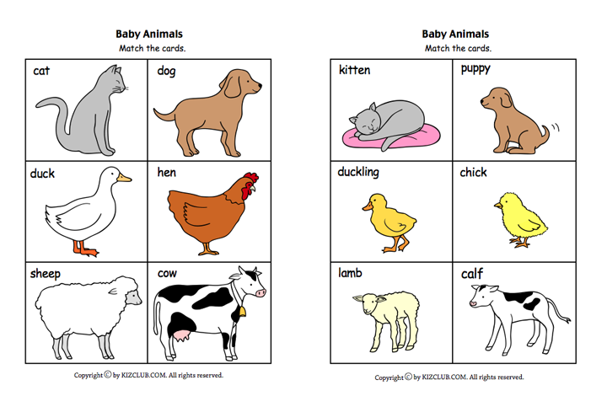
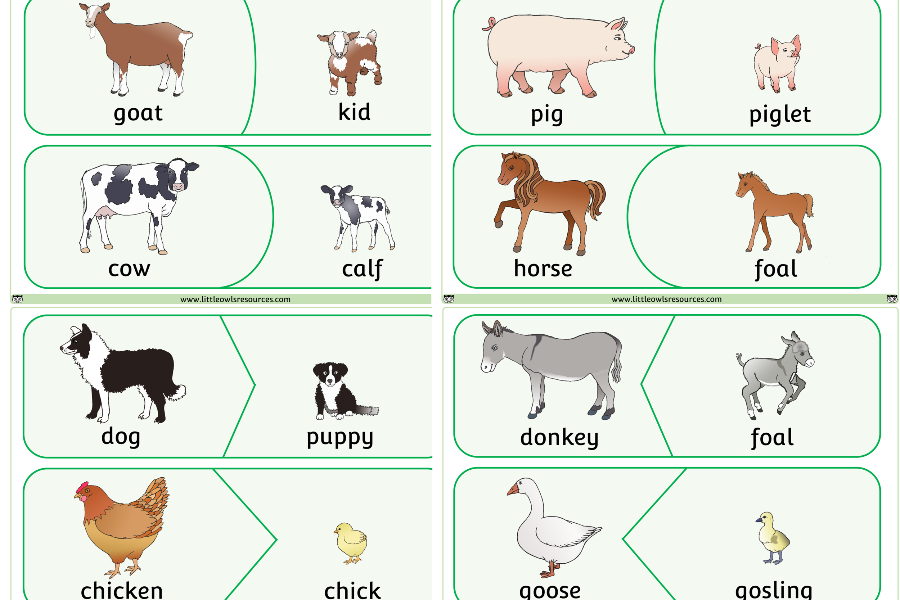

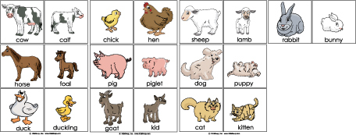

Assessment 1: Letter Recognition, Uppercase and Lowercase
*It's important to start the Assessment during a time of the day in which your child is calm, not tired, distracted or stressed. Do not pressure your child to answer correctly while doing the assessment.
*Invite your child to identify the name of each letter from right to left A, E, I (Do not do it in alphabetical order)
*Circle the letters your child Does Not Identify correctly, try not to correct your child while doing the Assessment.
*If you can, please take pictures of your child's Assessment results and send it to Google Classroom or email us. https://classroom.google.com/u/0/c/NzcwMTQ1MTkyODRa
*This information will be discussed during the Virtual Parent Teacher Conference next week to come up with an individual plan to work on during the next couple of months to ensure your child will be ready for Kindergarten.

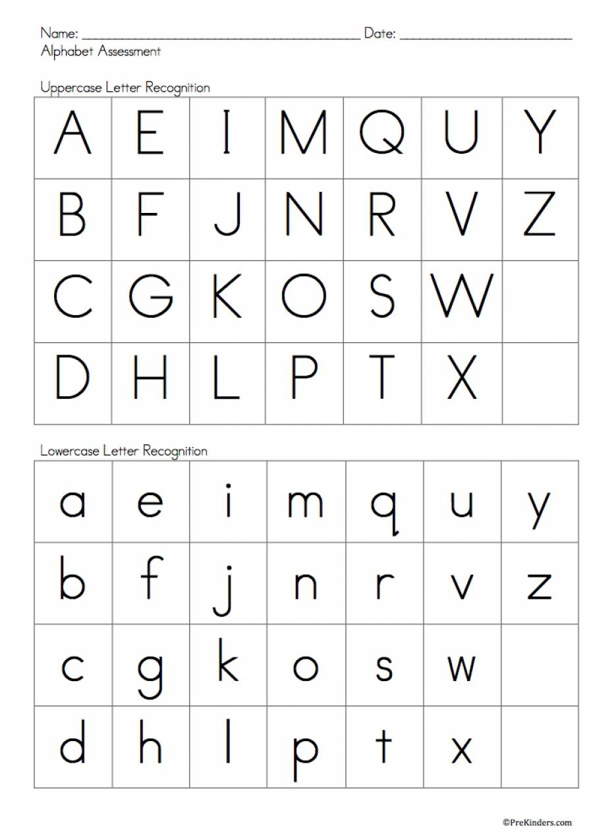

Tuesday May 19, 2020
*Parents if you can, please take pictures of your child's completed work/activity and send to Google Classroom or our email

Vocabulary words of the day: Hatchling (a young animal that has recently emerged from its egg), Fledgling (a young bird that has just fledged),
Letter of the week: H for hatching and habitat https://youtu.be/PUI5-AphjMg

Morning Routine:
Circle Time Morning Songs:
- Good Morning Song: https://www.youtube.com/watch?v=TFVjU-dsIM8
- Days of the week: https://www.youtube.com/watch?v=HtQcnZ2JWsY
- Weather: https://www.youtube.com/watch?v=Jn7uAsLWXpk
- Letter of the Week: https://www.youtube.com/watch?v=Wa_9FdUyrJ0

Book of the Week:
Book of the Week: Over in the Meadow by Ezra Jack keats
YouTube link to story: https://youtu.be/oj4sGa_gw1Y
Level 2: Skill/Concept
Questions to ask once the story has ended:
- What is a meadow?
- What do you notice about the numbers in this book?
- If there were another page in this book, how many animal babies would there be on this page? Why?
Have your child draw a picture according to what they respond to one out of the two questions and record your child’s response. * Please take a photo of child’s photo along with which question they are responding to, and what your child’s response was to the image they drew according to their response.

Art Activity
Play-Doh Animal Babies Invite your child to use Play-Doh to create the animal babies they are studying. Show baby pictures from the internet for the children to reference as they create. Use the names of the animal babies frequently throughout this activity. Children can also use Play-Doh to create objects related to the animal babies such as food, homes, etc. Ask your child to tell you about their animal and add this as dictation to their project or invite him/her to add their own writing.
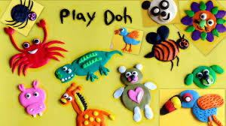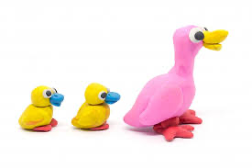
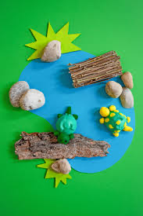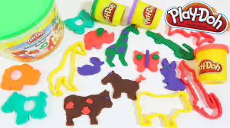

Math Activity: Complete the worksheets below
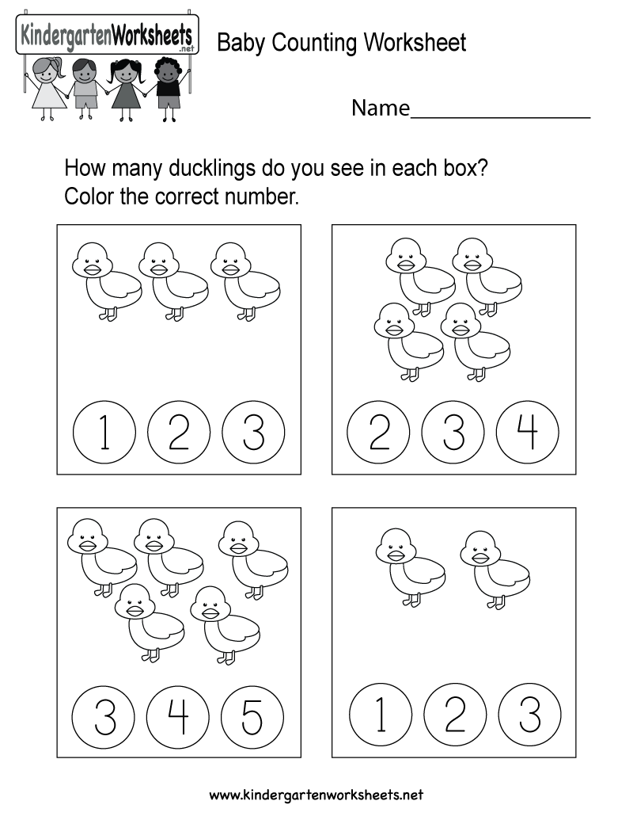
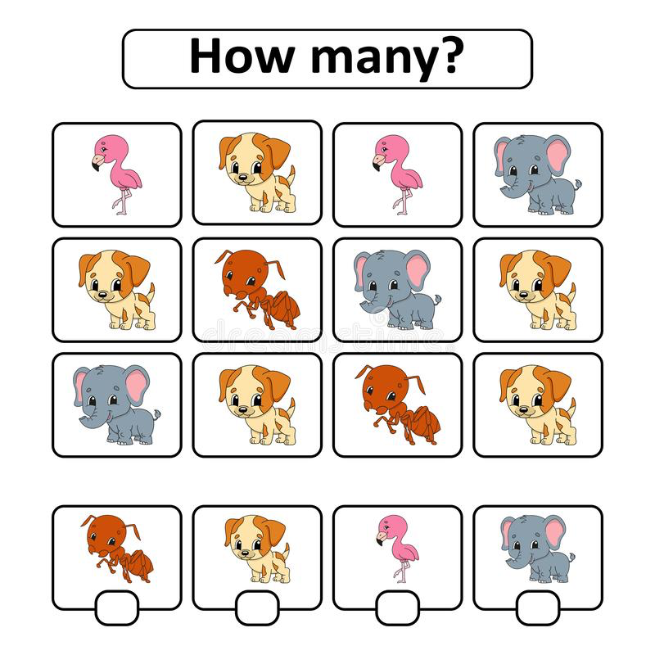

Gross Motor Activity: Children should exercise in a fun and interactive way everyday. Click the youtube links and you and your child can both engage in a singing and movement activity that both will enjoy.
Youtube Link:
https://youtu.be/GSDxhF6GIUU
https://youtu.be/fpD9kRyBn8o

Assessment 2: Writing Skills, Uppercase and Lowercase
*Invite your child to write the letters in alphabetical order, Uppercase and then Lowercase.
* Some children might need to look at the letters in order to complete this assessment, if that is the case use the last two worksheets where they can “copy” each letter.
*If you can, please take pictures of your child's Assessment results and send it to Google Classroom or email us. https://classroom.google.com/u/0/c/NzcwMTQ1MTkyODRa
*This information will be discussed during the Virtual Parent Teacher Conference next week to come up with an individual plan to work on during the next couple of months to ensure your child will be ready for Kindergarten.

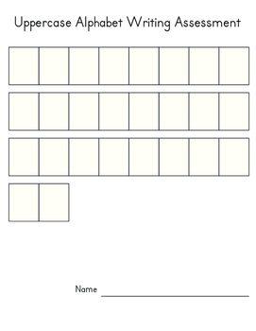
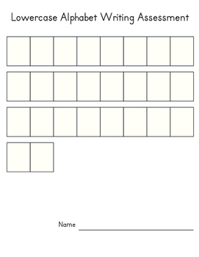
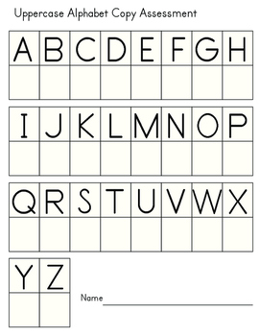
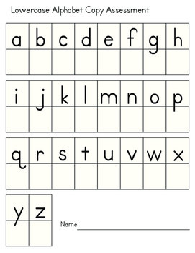Wednesday May 20, 2020
*Parents if you can, please take pictures of your child's
completed work/activity and sent it to Google Classroom or email us!

Vocabulary words of the day: nest, brood (a family of young animals, especially of a bird, produced at one hatching or birth.
Review letter: H for hatching and habitat https://youtu.be/PUI5-AphjMg

Morning Routine:
Circle Time Morning Songs:
- Good Morning Song: https://www.youtube.com/watch?v=TFVjU-dsIM8
- Days of the week: https://www.youtube.com/watch?v=HtQcnZ2JWsY
- Weather: https://www.youtube.com/watch?v=Jn7uAsLWXpk
- Letter of the Week: https://www.youtube.com/watch?v=Wa_9FdUyrJ0

Book of the Week:
Book of the Week: Over in the Meadow by Ezra Jack keats
YouTube link to story: https://youtu.be/oj4sGa_gw1Y
Level 3: Strategic Thinking
- Why did the mother animal tell the little animals what to do?
- There are two kinds of birds in this book: bluebirds and crows. What is the same about them? What is different?
- The bees live in a beehive. Who do you think made the beehive?

Ocular Motor Control Activity:
This refers to the ability of the eyes to work together to follow and hold an object in the line of vision as needed. Make a simple worksheet and have your child use a highlighter to find all the letters . (See worksheet packet or see picture below as an example) Review the sound and distinguish the difference between uppercase Y and lowercase y.
Youtube link for the H song: https://youtu.be/PUI5-AphjMg

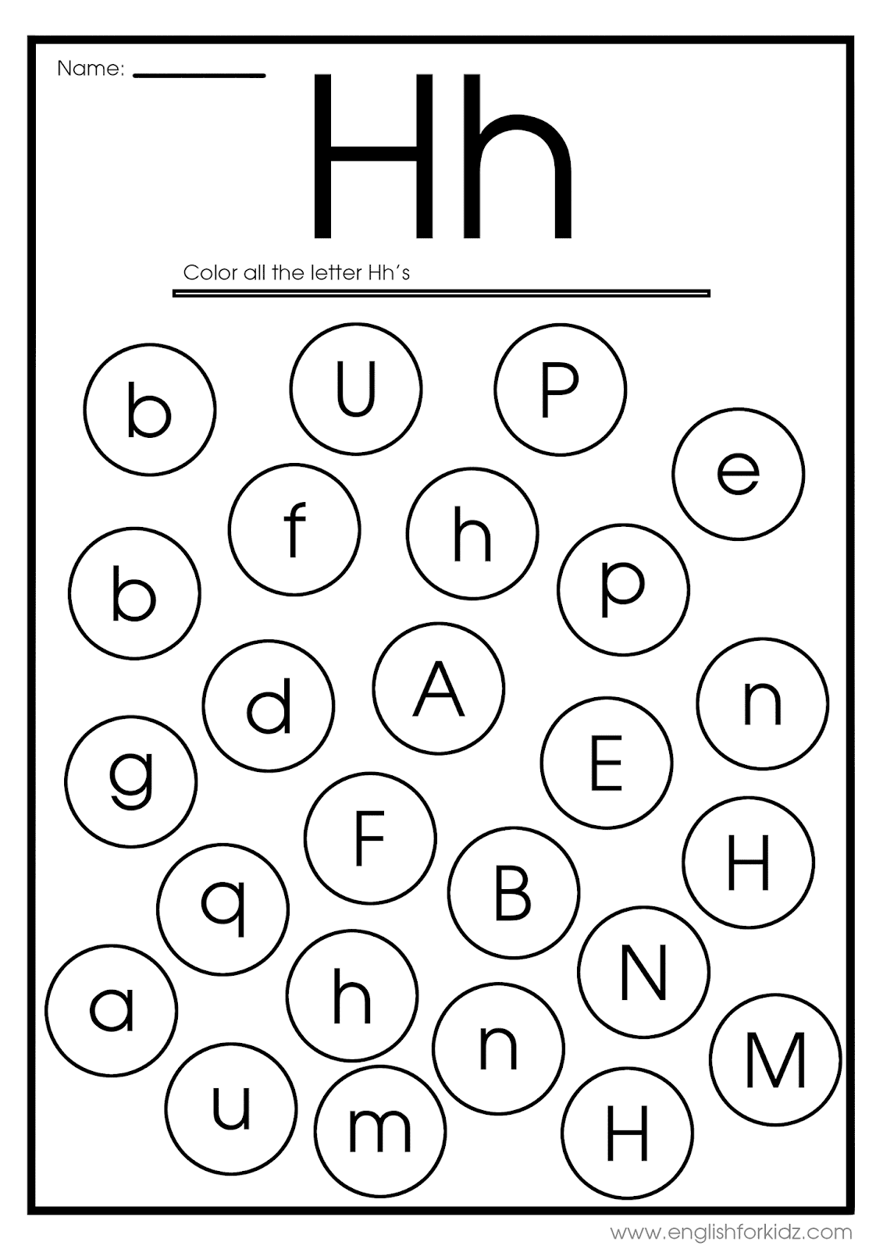

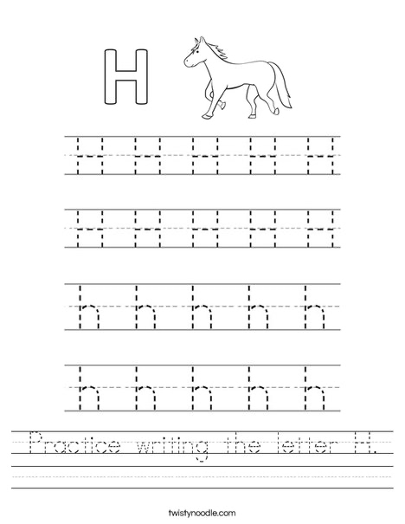

Technology Activity:
Invite your child to use the computer or tablet as a tool to assist in their animal baby investigations. Assist them in using a search engine to gather information about their animal babies or to answer specific questions they may have about the babies.
Examples:
Use Google to find baby animal pictures
Use YouTube to find songs about baby animals
Use Microsoft Word to type baby animal names
Assessment 3: Letter Sound
*Invite your child to identify the sound of each letter
*Circle the letters your child Does Not Identify correctly, try not to correct your child while doing the Assessment.
*If you can, please take pictures of your child's Assessment results and send it to Google Classroom or email us. https://classroom.google.com/u/0/c/NzcwMTQ1MTkyODRa
*This information will be discussed during the Virtual Parent Teacher Conference next week to come up with an individual plan to work on during the next couple of months to ensure your child will be ready for Kindergarten.

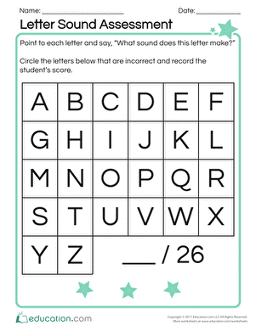

Thursday May 21, 2020
*Parents if you can, please take pictures of your child's
completed work/activity and send to Google Classroom or email us!

Vocabulary words of the day: incubation
Review letter: H for hatching and habitat thttps://youtu.be/PUI5-AphjMg

Morning Routine:
Circle Time Morning Songs:
- Good Morning Song: https://www.youtube.com/watch?v=TFVjU-dsIM8
- Days of the week: https://www.youtube.com/watch?v=HtQcnZ2JWsY
- Weather: https://www.youtube.com/watch?v=Jn7uAsLWXpk
- Letter of the Week: https://www.youtube.com/watch?v=Wa_9FdUyrJ0

Book of the Week:
Book of the Week: Over in the Meadow by Ezra Jack keats
YouTube link to story: https://youtu.be/oj4sGa_gw1Y
Questions to ask after the story has ended:
- In this book, the mother animals told the little animals what to do. What are some of the things the adults who take care of you tell you to do? Why?
- If you were in the meadow?

Art Activity: Animal Babies:
Invite your child to use recycled materials around the house to create the animal babies they are studying. Supply pictures of these animals for the children to reference as they create. Use the names of the animal babies frequently throughout this activity. Your child can also use recycled materials to create objects related to the animal babies such as food, homes, etc. Ask your child to tell you about their animal and add this as notes to their project or invite them to add their own writing.
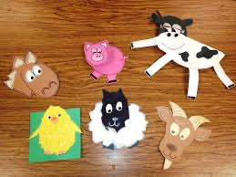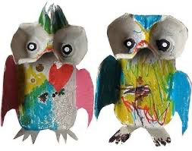
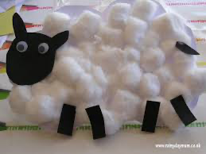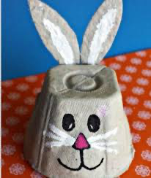

Gross motor Activity:
Move like an Animal: Invite your child to move like the animal babies they are studying.

YouTube links to this activity
https://youtu.be/nQLWJQqBm44
https://youtu.be/VoSrZ_lE8eQ

Assessment 4: Number Recognition
*Invite your child to identify numbers from 1 to 20
*Circle the numbers your child Does Not Identify correctly, try not to correct your child while doing the Assessment.
*Invite your child to count from 1 to 20 (you can clap with your child as they count) Did your child skip any number? Which number or numbers were skipped?
*If you can, please take pictures of your child's Assessment results and send it to Google Classroom or email us. https://classroom.google.com/u/0/c/NzcwMTQ1MTkyODRa
*This information will be discussed during the Virtual Parent Teacher Conference next week to come up with an individual plan to work on during the next couple of months to ensure your child will be ready for Kindergarten.

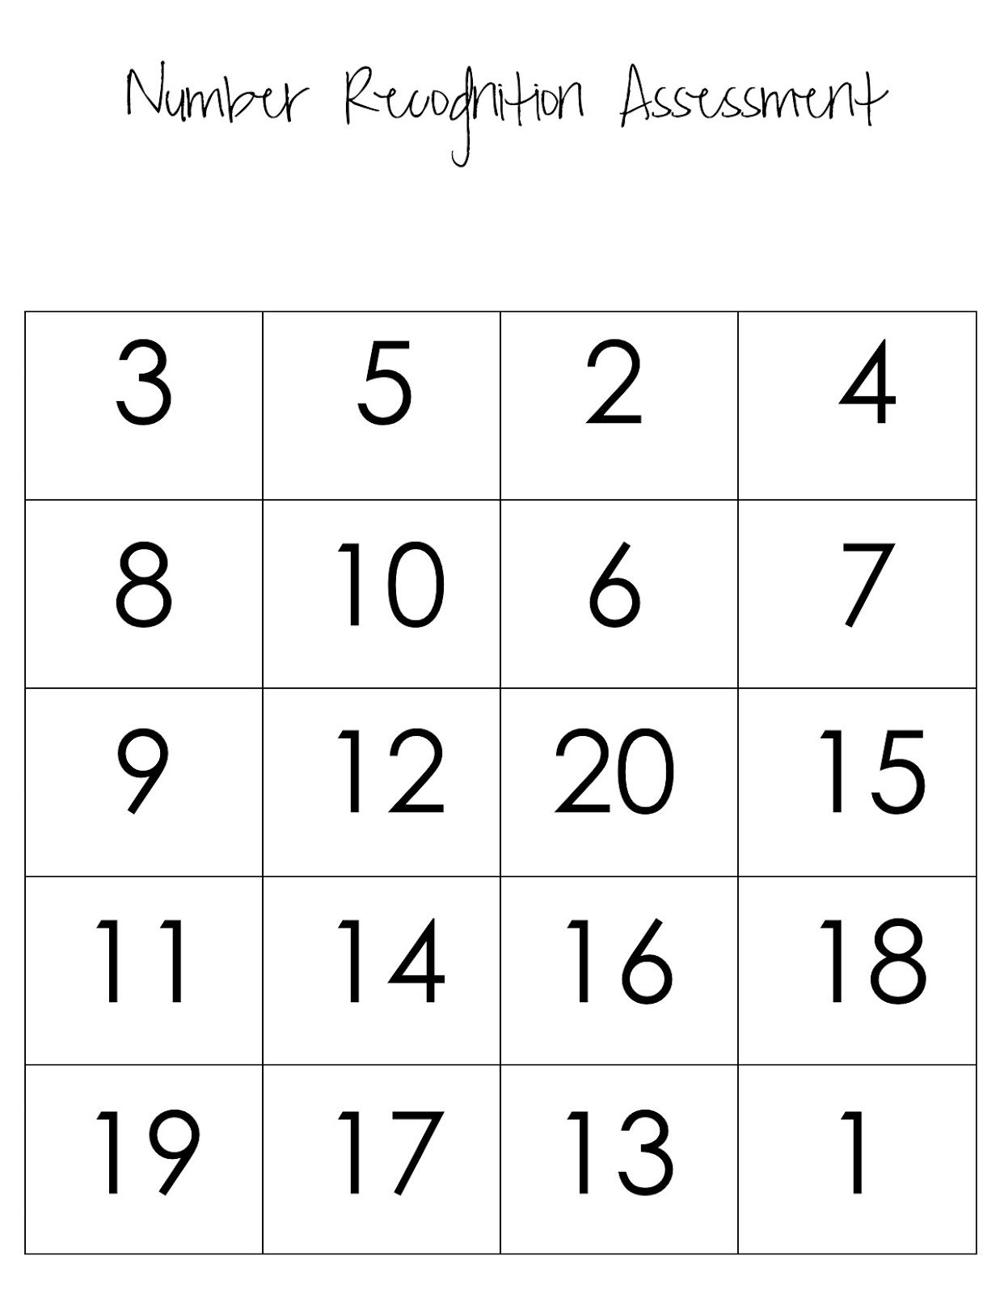

Friday May 22, 2020
*Parents if you can, please take pictures of your child's
completed work/activity and send to Google Classroom or email us!

Vocabulary words of the day: zoologist (an expert in or student of the behaviour, physiology, classiffication and distribution of animals.)
Morning Routine:
Circle Time Morning Songs:
- Good Morning Song: https://www.youtube.com/watch?v=TFVjU-dsIM8
- Days of the week: https://www.youtube.com/watch?v=HtQcnZ2JWsY
- Weather: https://www.youtube.com/watch?v=Jn7uAsLWXpk
- Letter of the Week: https://www.youtube.com/watch?v=Wa_9FdUyrJ0

ebook/youtube story of the week: Stellaluna by Janell Cannon
youtube link to story: https://www.youtube.com/watch?v=Af15LVV5IMg
Questions to ask at the end of the story:
- Pip wondered how the birds and Stellaluna can feel so different and be so alike. What do you think? How is that possible? How are you different/similar to someone else?
- Ask your child what the character could do differently or ask them what they might do if they were in the place of the main character.

Assessment 5: Shape Recognition
*Invite your child to identify the shapes below
*Circle the shapes your child Does Not Identify correctly, try not to correct your child while doing the Assessment. You can also write the name given by your child under each shape.
*Some children might know more shapes than the ones in the Assessment. Which other shapes do they know? __________________________________________
*If you can, please take pictures of your child's Assessment results and send it to Google Classroom or email us. https://classroom.google.com/u/0/c/NzcwMTQ1MTkyODRa
*This information will be discussed during the Virtual Parent Teacher Conference next week to come up with an individual plan to work on during the next couple of months to ensure your child will be ready for Kindergarten.
Shape Reference Names for parents:
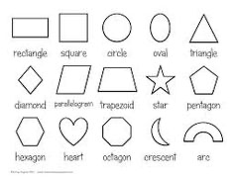

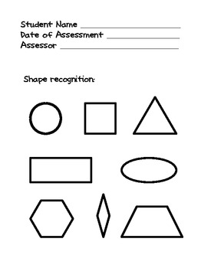
Assessment 6: Color Recognition
*Invite your child to identify the colors below
*Circle the colors your child Does Not Identify correctly, try not to correct your child while doing the Assessment.
*If you can, please take pictures of your child's Assessment results and send it to Google Classroom or email us. https://classroom.google.com/u/0/c/NzcwMTQ1MTkyODRa
*This information will be discussed during the Virtual Parent Teacher Conference next week to come up with an individual plan to work on during the next couple of months to ensure your child will be ready for Kindergarten.

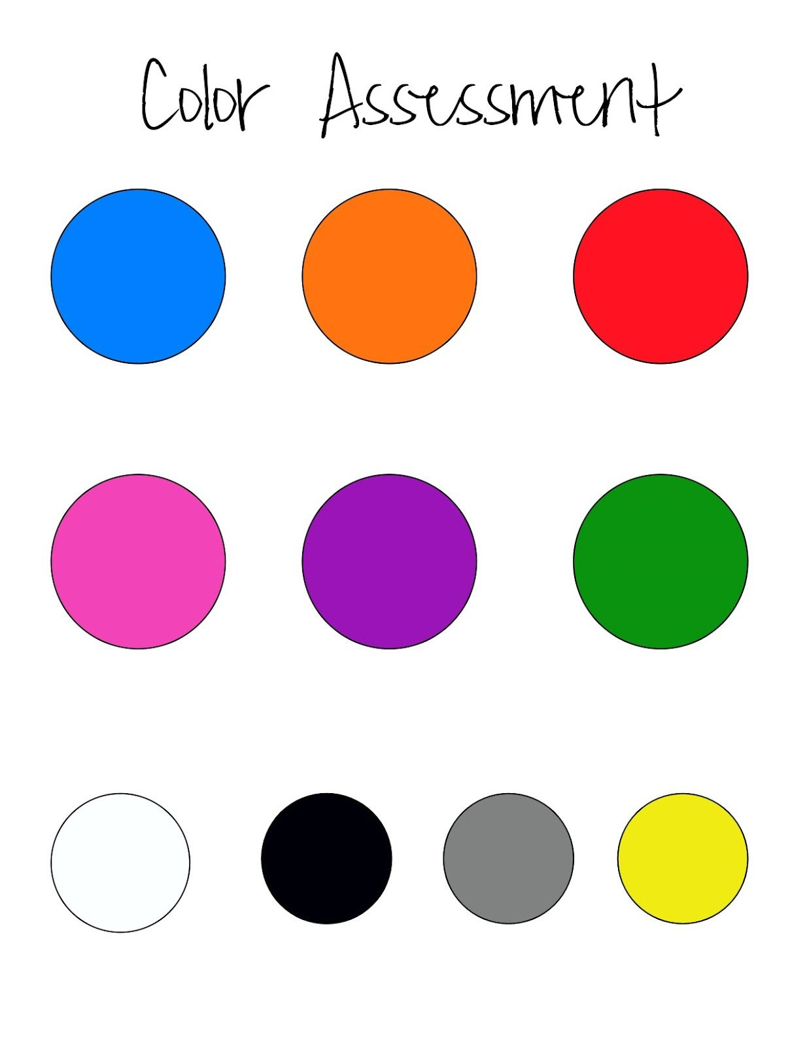

Assessment 7: Optional Assessments
*As we continue to stay home during this quarantine, we could use this time as an opportunity to teach our children some important information, like their full name, full name of mother and father (believe it or not, when I asked children in the classroom to tell me the names of their parents, many answered by saying that their names were Mom and Dad)
*Some children might be ready to learn their address and phone number too, as well as the use of 911 in case of an emergency.
*This is an optional assessment and you can add more questions if you want.
*This Assessment should be implemented as questions, like an informal interview. Write down any answer your child gives and do not pressure them to give any right answer.

- What’s your full name?____________________________________

- How old are you?________

- What’s your Mother’s full name? ____________________________

4. What's your Father’s full name? ______________________________

5. Where do you live? What’s your address? _________________________

