Happy week 7 of online distance learning student/families

I hope that you and your families are all well! Parents Remote Learning Survey:DOE has developed a Remote Learning Survey in collaboration with Panorama Education to gather feedback about the experiences of your children and families with remote learning over the last few weeks. The survey launches this week and will continue until Friday, May 1. To access the survey, visit schools.nyc.gov/RLsurvey. If parents/guardians do not have access to the internet to complete the survey online, they can call 311 for more information about how to take the survey via phone. Also, channel 13 will be broadcasting instructional Programming for NYC children. Welcome to the first week of the Babies Unit. In the first week, children establish their understanding of human babies by considering the question, “What do human babies need?” Activities in this week help children express what they already know and extend their learning through play, literature and discussion. Throughout this unit there are opportunities for children to discuss, write about and learn what babies need.We've also provided various learning activities to keep our students busy while at home throughout the upcoming days. Thank you so much families for being so involved and interactive with facetime calls and phone calls. We will continue our same schedule moving forward which is Monday, Wednesday and Friday calls will continue to begin at 11am- 12:30am. Parents if you haven't done so please check out google classroom. It's a safe space to upload photos of your child and their work as well as a place to find interactive resources while at home.
Please feel free to reach out to us with any questions or concerns through email at
Ms. Janae: Janaeuribe@gmail.com
Ms. Chrys: Chryshulalezcano@gmail.com

All families can visit the nearest DOE District School to pick up grab-and-go breakfast starting at 7:30 AM and lunch starting at 11:30AM. Families can find the nearest District School by visiting https://www.nycenet.edu/schoolsearch or calling 311.

Best,
Ms.Janae & Ms. Chrys

Unit Title: Babies
Essential Question: What are babies?
Focus Question:What do human babies need?
Monday May 4, 2020
*Parents if you can, please take pictures of your child's
completed work/activity and send to Google Classroom or email us!

Vocabulary words of the day: adopted, appointment, baby, bassinet, bib, bottle, born
Book of the Week:
ebook/youtube story of the week: Everywhere Babies by Susan Meyers
youtube link to story: https://www.youtube.com/watch?v=7qd2fRyaC68
* Parents review with your child what an author is and what an illustrator is.
-Author writes the story, illustrator draws & paints the pictures in the story.
Level 1: Recall
Before reading the book below, here are some questions to consider with your child:
1.When and where are babies born?
2. What are some ways babies are carried?
3. What are some noises that babies make?

Literacy Activity
Provide pictures of babies making a variety of expressions. Ask children to look at the baby faces, make these expressions themselves and think about how each baby might be feeling and why. Ask them to share their responses. Record their answers, or let children write their own answers if they are ready. Can you make these faces? Take a few pics and share!
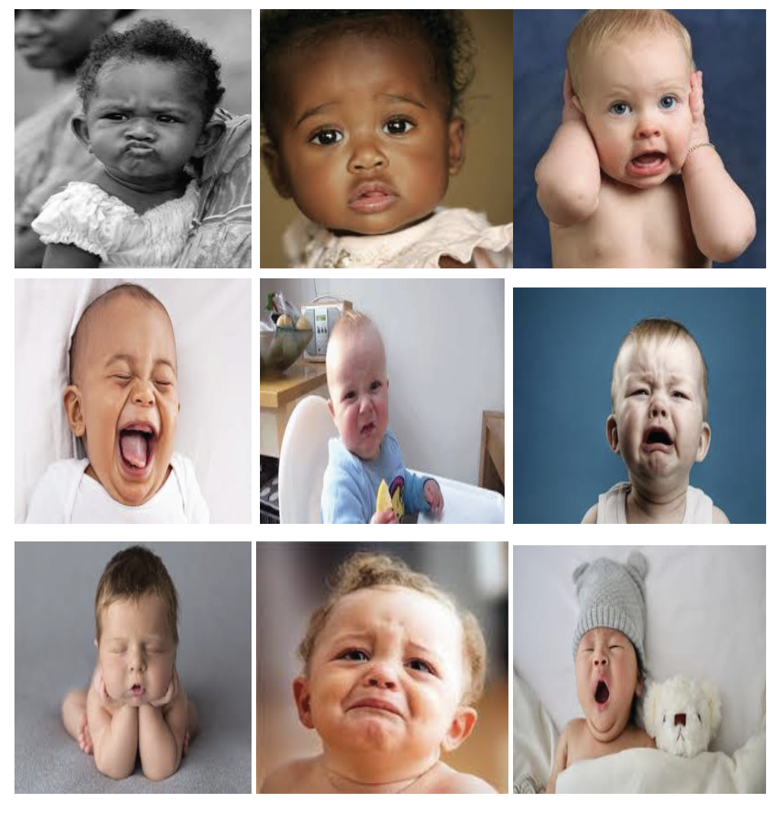

Gross motor Activity:
Children should exercise in a fun and interactive way everyday. Click the youtube link and you and your child can both engage in a singing and movement activity that both will enjoy.

Youtube Link:https://www.youtube.com/watch?v=WX8HmogNyCY
https://www.youtube.com/watch?v=WX8HmogNyCY

Arts & Craft Activity:
Baby Portraits:
Have you and your child find a picture or pictures from when they were babies. Invite them to look at the pictures and draw or paint a picture of themselves as a baby. As children observe and consider their pictures, engage them in discussion about the details they notice in the pictures. What has changed about the way they look now compared to when they were babies? Why? Ask children whose families do not provide pictures to consider what they think they looked like when they were babies and create a portrait accordingly. What do they think their hair looked like? Their eyes? Did they have chubby cheeks?
Take a picture of their drawing and their baby picture please!
PK.CKW.4 (Social Studies): Develops an understanding of how people and things change over time and how to relate past events to their present and future activities.

Math & WritingActivity : this week we are going to focus on the number 10.
Have your child count how many Babies they find. Do not tell them how many they are looking for. Have your child write on a piece of paper “ I see __ babies” If they counted correctly he/she should have counted 10 babies and wrote “ I see 10 babies.” You can assist with the writing and make sure they write the number 10 on there on. 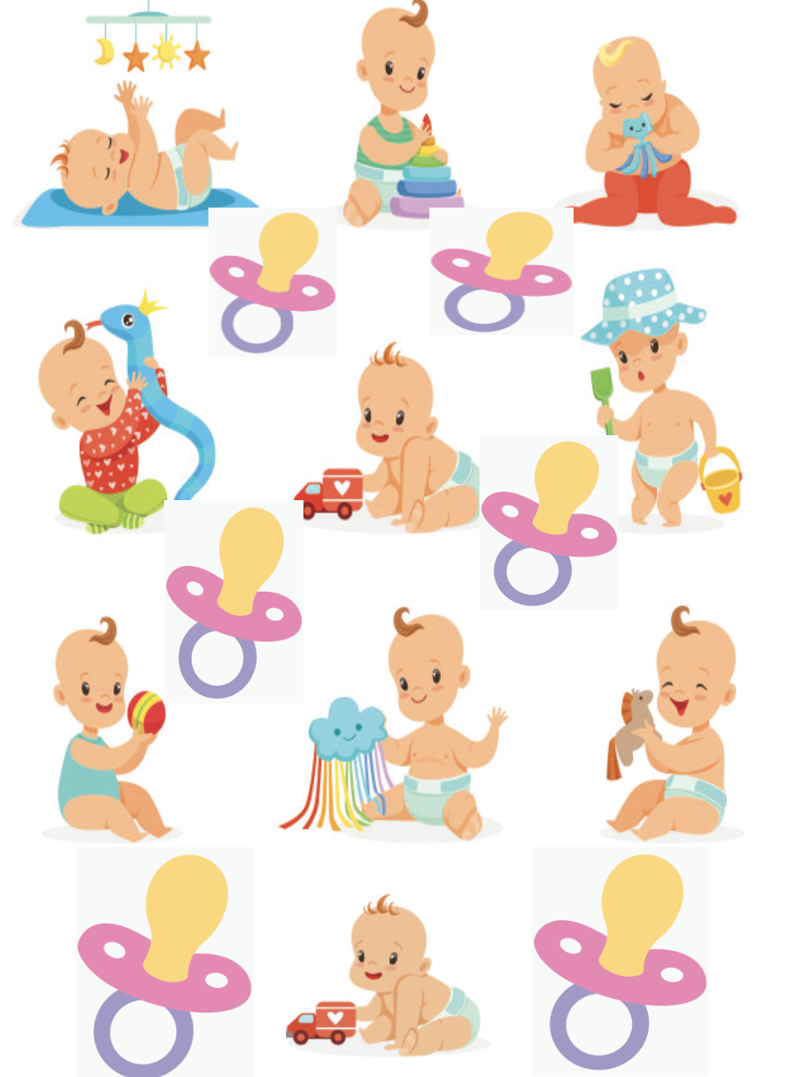

Tuesday May 5, 2020
*Parents if you can, please take pictures of your child's
completed work/activity and send to Google Classroom or our email

Vocabulary words of the day: care, car seat, clothing, cradle, crib, cry,
Letter of the week: I

Morning Routine:
Book of the Week:
ebook/youtube story of the week: Everywhere Babies by Susan Meyers youtube link to story: https://www.youtube.com/watch?v=7qd2fRyaC68

Level 2: Skill/Concept
Questions to ask once the story has ended:
1. Every day, everywhere babies are rocked. Why do you think people rock babies?
2. Every day, everywhere babies are kissed. Why do you think people like to kiss babies?
3. Every day, everywhere babies make friends. How do babies make friends?
Have your child draw a picture according to what they respond to one out of the two questions and record your child’s response. * Please take a photo of child’s photo along with which question they are responding to, and what your child’s response was to the image they drew according to their response.

Science Activity: What’s in the Box Game…?
In a feely box, place items such as a baby brush, a bar of baby soap, a cotton ball, a pacifier, a rubber teether and a rattle, etc. Have your child and if you have other children take turns feeling an item in the box and guessing what it is by its feel. Take Pictures.
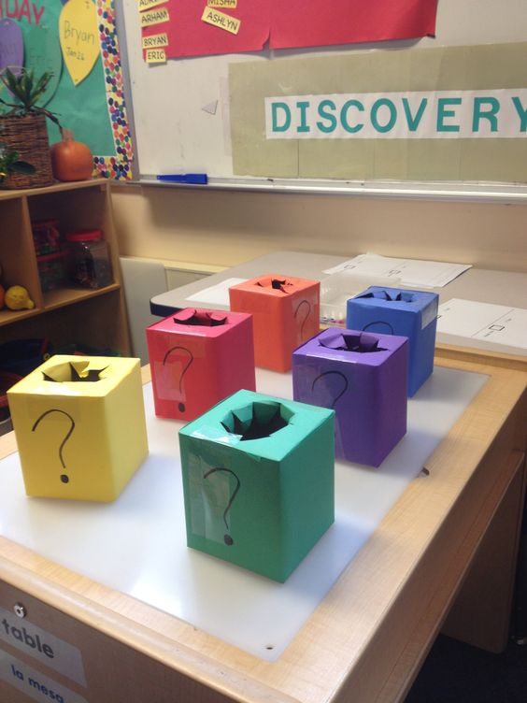

Dance and Movement: Finger play sing along
Five Little Babies…
Five little babies were playing together one day.
One saw a ball, and so he crawled away.
Four little babies were playing together one day.
One saw a rattle, and she crawled away.
Three little babies were playing together one day.
One saw a kitty cat, and he crawled away.
Two little babies were playing together one day.
One saw a teddy bear, and she crawled away.
One little baby was playing by himself one day.
He cried and his mommy came and took him away.

Art Activity:
Bottle Painting…Mix together paint and water and allow your child to squeeze or drip paint to make creative pictures. Share your creativity!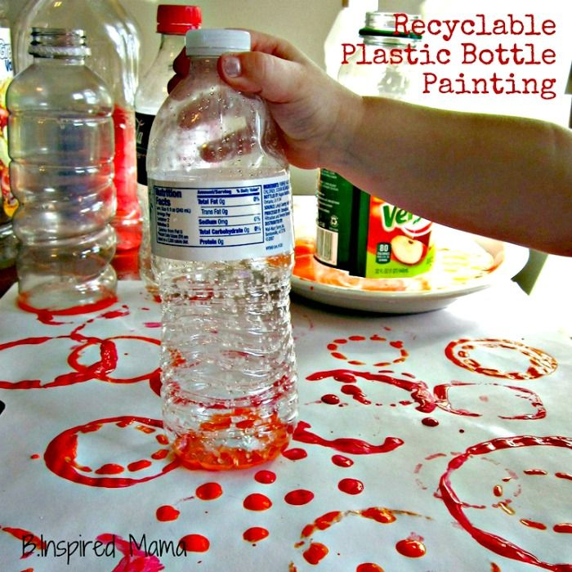
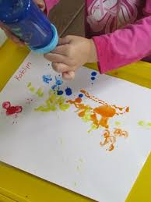
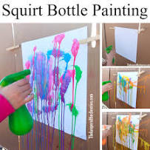

Ocular Motor Control Activity:
This refers to the ability of the eyes to work together to follow and hold an object in the line of vision as needed. Make a simple worksheet and have your child use a highlighter to find all the letters I. (see picture below as an example) Review the sound and distinguish the difference between uppercase I and lowercase i.
Youtube link for the I song: https://www.youtube.com/watch?v=b_gJVJvOA3Q
“I is for Infant” :"infant" is typically applied to young children under one year of age.
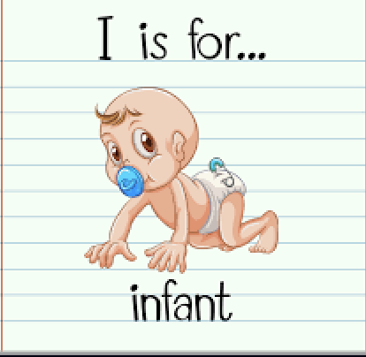
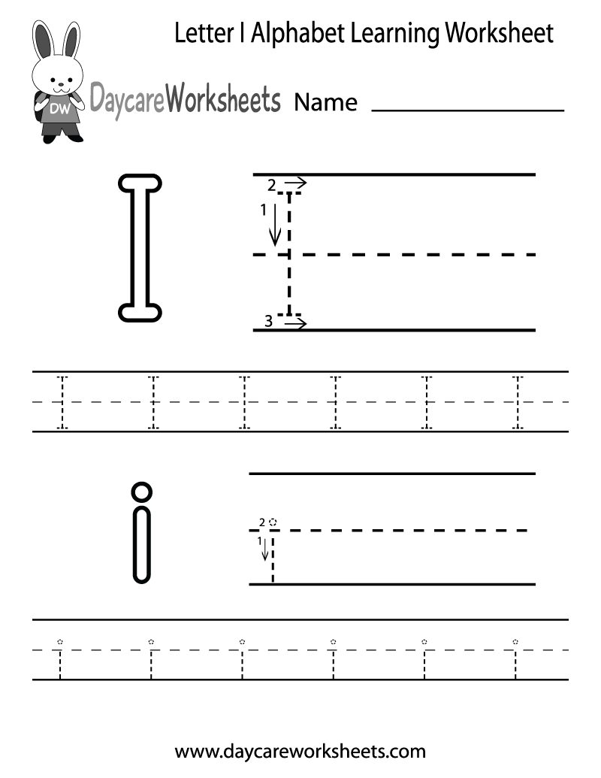

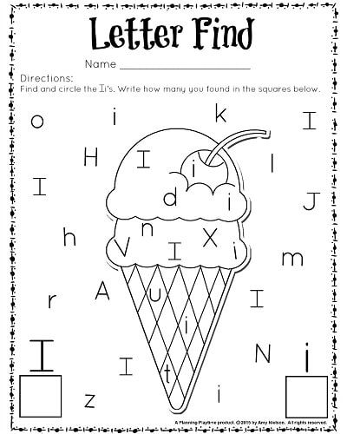

Cooking Activity:
Make Baby Food:
Talk with your child about what types of food they think babies eat and why. Invite your child to create baby food in. This can be done by pureeing steamed fruits or vegetables in a blender. Consider inviting your child to help you follow an existing recipe to create the baby food or to write their own baby food recipes.
Questions to ask: Why do you think we are adding...? What would happen if...? What do you notice as we do this? How does it smell? How does it feel? What does it look like? How does it taste? What does this remind you of?

PK.AL.4: Exhibits curiosity, interest and willingness in learning new things and having new experiences.
Youtube video:https://www.youtube.com/watch?v=owe8fXMokJ8

Computer/ Technology activity:
Toddle: Share videos of babies just learning to walk. Ask the children to reflect on what the baby might be thinking as s/he is just starting to walk.
PK.AL.4: Exhibits curiosity, interest and willingness in learning new things and having new experiences.
Youtube video: https://www.youtube.com/watch?v=z2WwdHoxnoY

Wednesday May 6, 2020
*Parents if you can, please take pictures of your child's
completed work/activity and send to Google Classroom or email us!

Vocabulary words of the day: diaper, gentle, hospital, infant
Review letter I

Morning Routine:
Book of the Week:
ebook/youtube story of the week: Everywhere Babies by Susan Meyers youtube link to story: https://www.youtube.com/watch?v=7qd2fRyaC68

Level 3: Strategic Thinking
1.Why do you think babies usually crawl before they walk?
2.What do you think babies think about when they are learning to walk?
3.When babies first start to walk they fall a lot. How do you think that makes them feel?

Science activity:
How Much Water Can a Diaper Hold? Supply a diaper, water and tool for children to use to pour water onto the diaper such as a pipette or measuring spoon. Invite your child to pour water onto the diaper, predict how much water the diaper can hold and keep track of how much water they can add before the diaper leaks. Graph the results or have children who are ready attempt to create their own graph. Use the word diaper frequently throughout this activity to help children learn this vocabulary word. Additionally, guide children in considering why babies need diapers and what other things babies need.
PK.CKW.2 (Science): Tests predictions through exploration and experimentation.

Music and Movement:
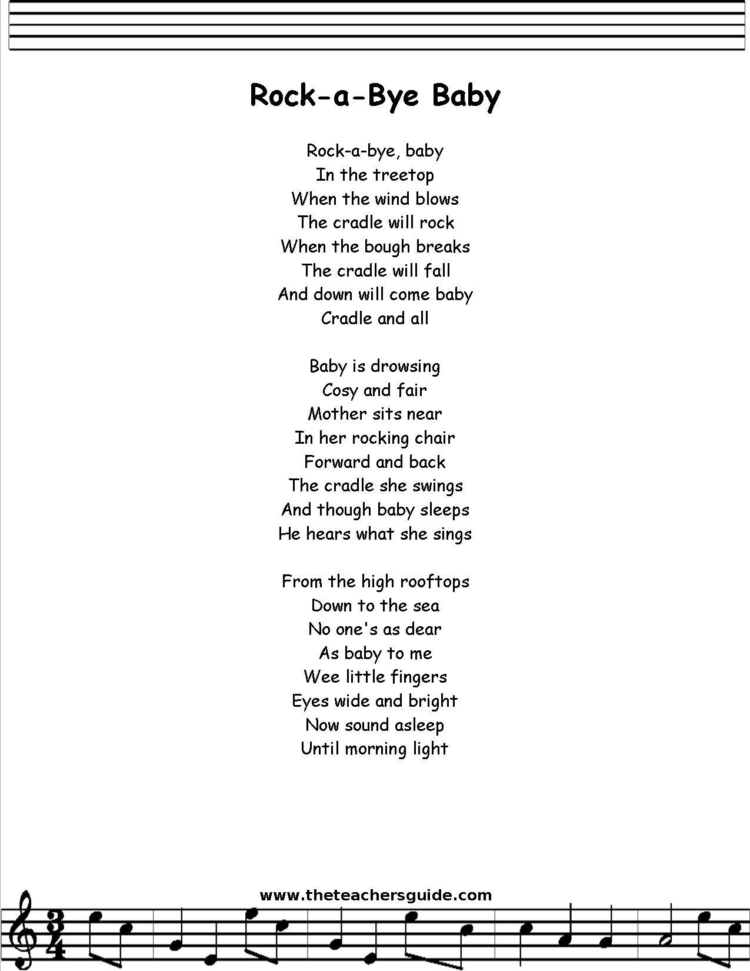Lullabies: Listen to and sing a variety of lullabies such as Lavender’s Blue, Little Boy Blue and All the Pretty Horses or lullabies gathered from children’s families. Lullabies can also be played at nap or rest time.
PK.CKW.4 (The Arts): Responds and reacts during musical activities.
Below is a lullaby you and your child can sing together. It's important to acknowledge and discuss with your child the importance of the tone of your voice and how a loud voice versus a soft voice can make someone feel when singing a lullaby.
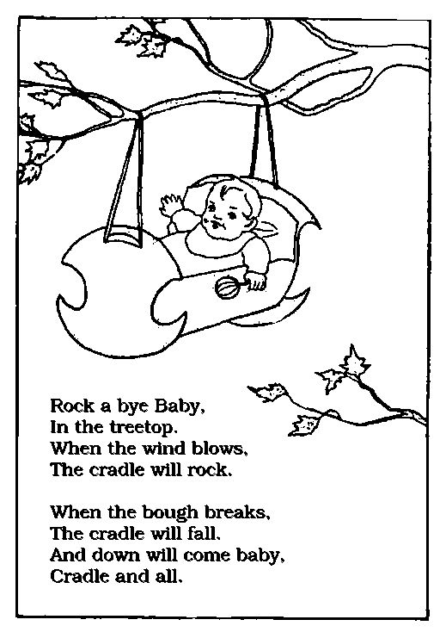
Gross motor Activity:
Play ebook/youtube story:Hush! A Thai Lullaby by Minfong Ho
youtube link:https://www.youtube.com/watch?v=0lAidD8k1lk

Gross motor activity:
Move Like a Baby: Provide pictures of babies that show their physical development from laying on their backs with their feet in the air to rolling over, crawling, to toddling and finally to walking. Create a game with a baby doll laying down and using differnet techniques with walking around a sleeping baby such as tip toeing, crawling etc.
PK.PDH.4: Combines a sequence of large motor skills with and without equipment

Math Activity:
A baby needs its mommy, match it sheet: Follow the directions on the worksheet below. Draw a line from each baby to it’s parent.
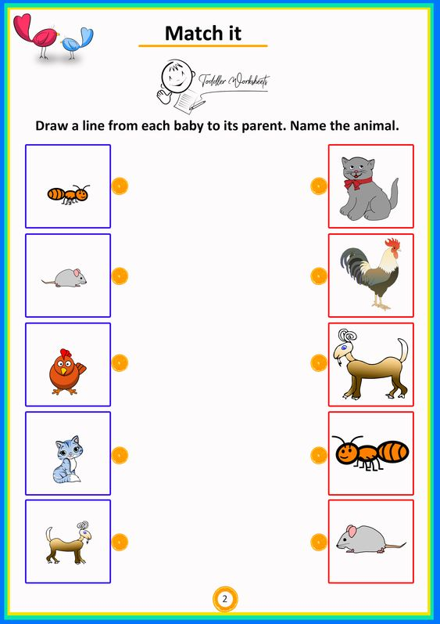

Thursday May 7, 2020
*Parents if you can, please take pictures of your child's
completed work/activity and send to Google Classroom or email us!

Vocabulary words of the day: lullaby, newborn, nursery, nurture, parent
Review letter: I
Book of the week:
ebook/youtube story of the week: Everywhere Babies by Susan Meyers youtube link to story: https://www.youtube.com/watch?v=7qd2fRyaC68
Level 4: Extended Thinking
1.Babies are growing. How are you growing?
2.In this book, babies make friends with puppies, kittens, young people and old people. How do you make friends?

Water play:
Baby Bath: Add child-safe soap, baby dolls and washcloths to water in the bathtub or sink. Invite your child to give the babies a bath and consider why babies need help to wash or take a bath. Model using vocabulary words such as baby, infant, newborn, gentle and tiny as you interact with the children in this activity.
PK.PDH.8: Demonstrates awareness and understanding of healthy habits.

Fine Motor/ Writing Activity:
Letter Blocks: Supply small letter blocks. Assist children in exploring the sounds of the letters and invite children to use the blocks to create words or names such as their own names, the names of their classmates or the names of people in their families.

PK.CLL.3 (Reading Standards: Foundational Skills): Demonstrate emergent phonics and word analysis skills.

Gross motor Activity:
Play ebook/youtube story:Bah! Said the Baby by Jennifer Plecas.
youtube link:https://www.youtube.com/watch?v=1is2r9m21SI

Quiet Music: Invite children to play instruments quietly in a manner that might calm a baby or encourage a baby to go to sleep. Remind students about tones of voice now introduce tones of sounds to them. Helping them recreate a soothing lullabye tone using materials found at home.
PK.CKW.3 (The Arts): Expresses oneself by engaging in musical activities.

Art Activity:
Baby Rattles: Provide recycled materials and beans or seeds for children to use to create their own baby rattles. Use the word rattle frequently throughout this activity to help children learn this vocabulary word. Children can think critically about the structure of the rattle as well as how to decorate the rattle so it would be appealing to a baby; allow them to explore this task creatively.
PK.AL.2: Actively engages in problem solving

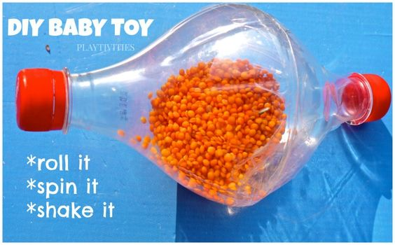

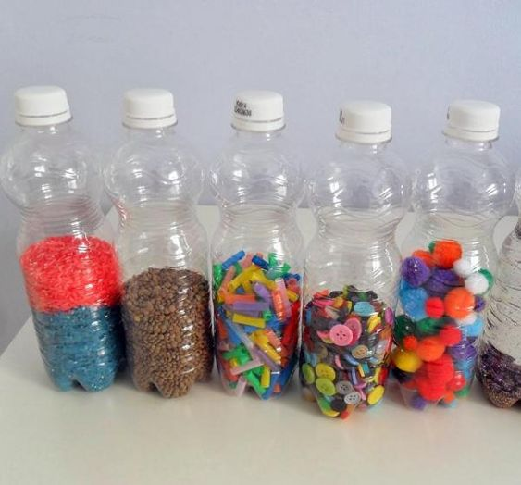
aFriday May, 8 2020
*Parents if you can, please take pictures of your child's
completed work/activity and send to Google Classroom or email us!

Vocabulary words of the day:pediatrician, premature, rattle, sleep, stroller, swaddle
Review letter: I
ebook/youtube story of the week: Everywhere Babies by Susan Meyers youtube link to story: https://www.youtube.com/watch?v=7qd2fRyaC68
Have your child imagine they are an illustrator and create their own vision of everywhere babies and examine the facial expression of the babies they draw along with essentials needed for the baby if they were the illustrator of the book Everywhere Babies by Susan Meyers.

Math Activity:
Share with your child that babies are measured right after they are born. Babies are also measured frequently to keep track of how much they grow.Provide a few baby dolls and tools for measuring (cotton balls, math cubes,blocks, rulers) and invite children to measure and record the length of each baby.
PK.CKW.1 (Measurement and Data): Identify measurable attributes of objects such as length and weight. Describe them using correct vocabulary (e.g., small, big, short, tall, empty, full, heavy and light.)

Art Activity:
Baby Powder Paint: Add baby powder to paint. Encourage children to notice the smell as they use the paint. Talk with children about why people might use baby powder with babies. Be mindful of allergies when implementing this activity.
PK.PDH.1: Uses senses to assist and guide learning

Gross Motor Activity:
Gross motor Activity:
Play ebook/youtube story: Ask your child which story was their favorite this week and read/re-play the story for your child.
youtube link: stories from this week

1.ebook/youtube story of the week: Everywhere Babies by Susan Meyers
youtube link to story: https://www.youtube.com/watch?v=7qd2fRyaC68

2. ebook/youtube story:Hush! A Thai Lullaby by Minfong Ho
youtube link:https://www.youtube.com/watch?v=0lAidD8k1lk

3. Play ebook/youtube story:Bah! Said the Baby by Jennifer Plecas.
youtube link:https://www.youtube.com/watch?v=1is2r9m21SI
*Refer to gross motor worksheet for active activity to engage in with your child
Dramatic Play:
While at Home: Turn the Dramatic Play area into a home and invite your child to play with baby dolls; help your child consider how to care for babies and what their day-to-day activities might entail.
PK.CKW.5 (The Arts): Participates in a variety of dramatic play activities to represent fantasy and real life experiences.

Fun activity sheets:

