Hello Parents!

Below are tips that mirror the work we do at school with your child. We hope that these tips are helpful.

TIP #1: Create a monthly calendar WITH your child (IT DOES NOT NEED TO BE FANCY)using regular white paper and writing the days of the week. The students discuss the calendar daily during circle time. The teachers ask the students, “What month are we in?” Then we sing the months of the year song-look up on youtube- We then sing the days of the week song-Look up on youtube-

TIP #2: During circle time we also discuss our “mood of the day.” Below is a photo of our mood chart. Simply ask your child, “how do you feel today?” “What’s another word for emotions? (Feelings) Below is an example of our feelings chart:

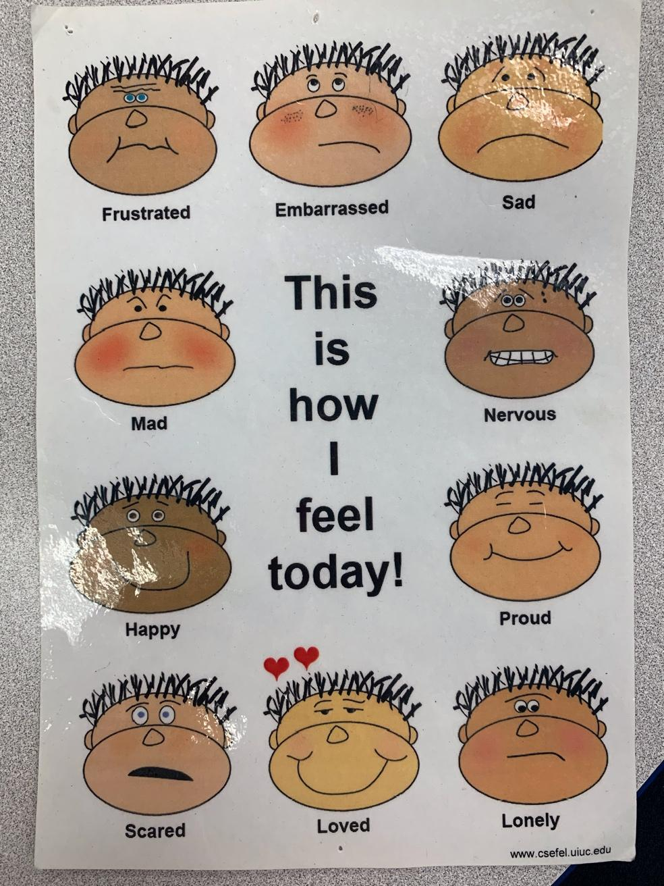
TIP# 3: ABC phonics is another activity we do during circle time. Listening to this YouTube link helps the children learn their ABC’S and to learn the sounds the letters make as well. Please look up words for the current letter that your child is studying. ROOM 1 is currently transitioning to letter H and ROOM 4 is transitioning to letter I. (ABC PHONICS LINK: https://youtu.be/hq3yfQnllfQ)

TIP #4: A very important activity to do during the morning is Dance and movement. Having the children stretch out and move their bodies will have them ready to tackle the day! These are the titles to songs you can look up on YouTube:
- Walking Walking featuring Noodle Pals
- Listen and Move
- Walking Song
- Freeze Dance
- One little Finger
- The Butterfly Stages
  - https://youtu.be/1EQeYA5Qbic

TIP #5: Meditation is extremely helpful for the children! It helps the students relax and focus. In our class we tend to set a timer for 1 minute while listening to meditation music on YouTube.
———————————————————————————————————————————
We are currently learning about Care in our unit! Here are some books you can look up on YouTube with your child:
- I Can Save The Earth
  - https://youtu.be/2Mkwhe6LOBo
- Some Pets
  - https://youtu.be/XOGSedNnjVI
- The Magic of Sharing
  - https://youtu.be/ghS_W5bWFaU
- Be Kind
  - https://youtu.be/kAo4-2UzgPo
- Earth Day Every Day!
  - https://youtu.be/qvdhsn-BFDI
- Dog’s Colorful Day
  - https://youtu.be/BmnzXC3Dw7o
- Learning Friends: Fox and Penguin Take Turns
  - https://youtu.be/AKNdRxoDLKw

- The Skin You Live In
  - https://youtu.be/W_Bjz1xFteQ
- Strictly No Elephants
  - https://youtu.be/M5WJMs2x_XM

Netflix shows/movies that have the CARE theme:
- Veggie Tales
- Lil Baby Bum
- Flowering Hearts
- Jake & The Neverland Pirates
- Daniel the Tiger

While watching these shows and reading these books please ask your child what type of changes/differences they see in the show/movie/book. Remind them that there are many changes happening at all times!

VOCABULARY WORDS:

FRIENDS

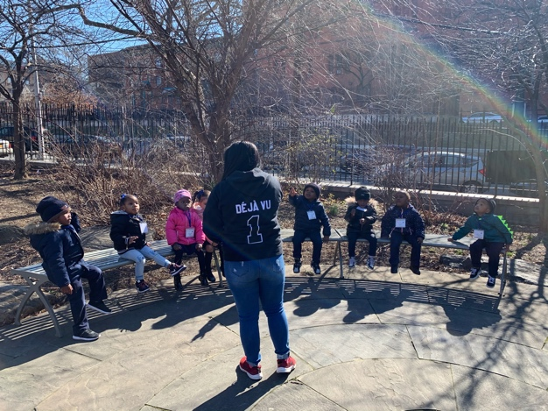
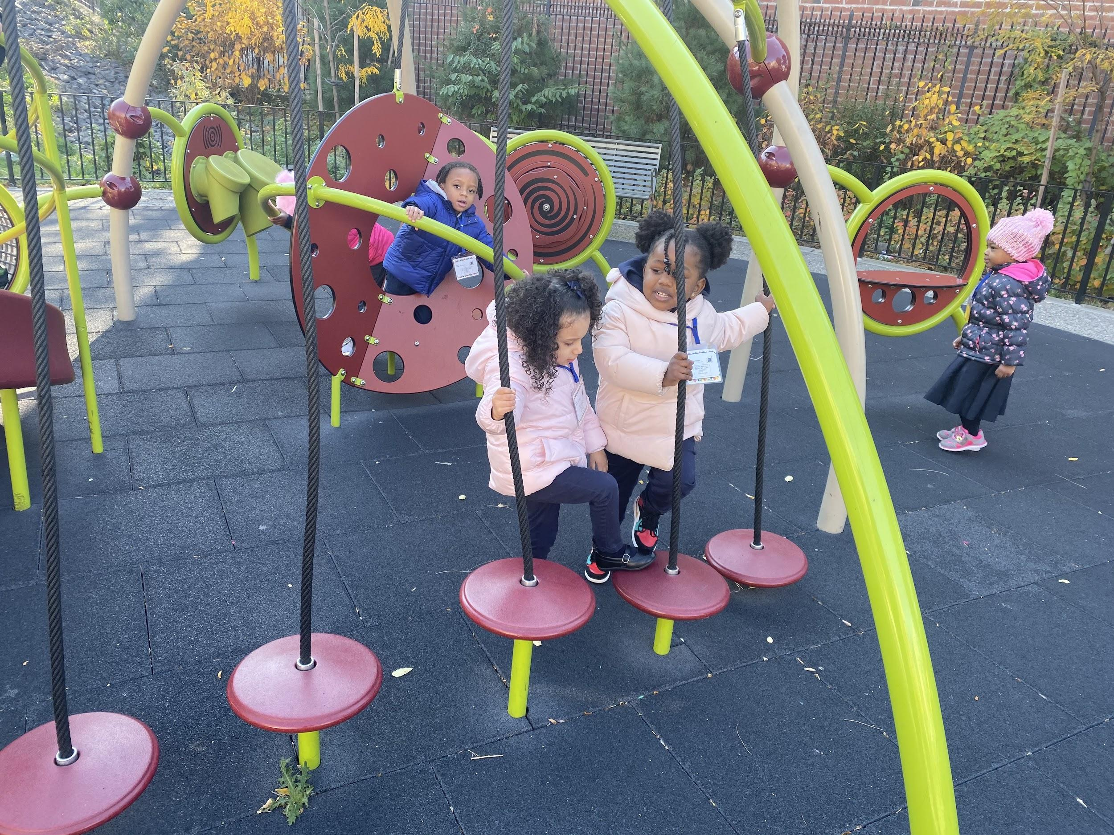

CARE
Here we have some friends caring for strong teeth and bones by cleaning their teeth and eating healthy meals ! :)

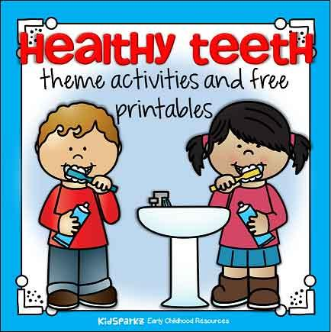

Here we have some friends caring for each other by sharing ! :)
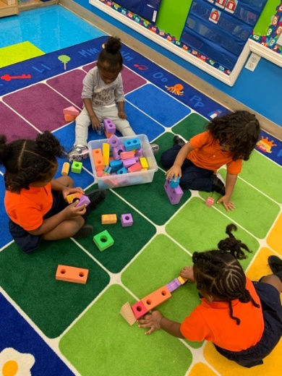
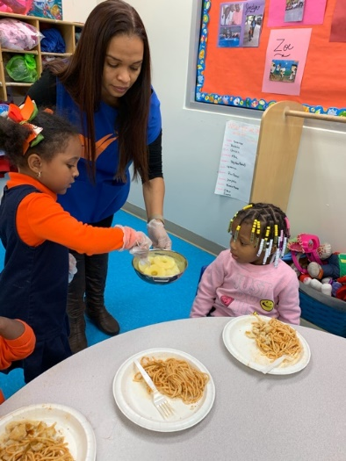

Here we have some friends caring for their mind by meditating and teaching one another ! :)

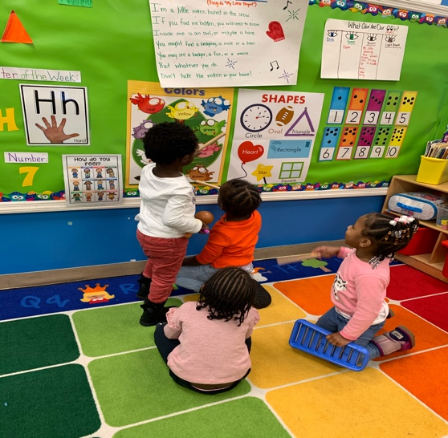
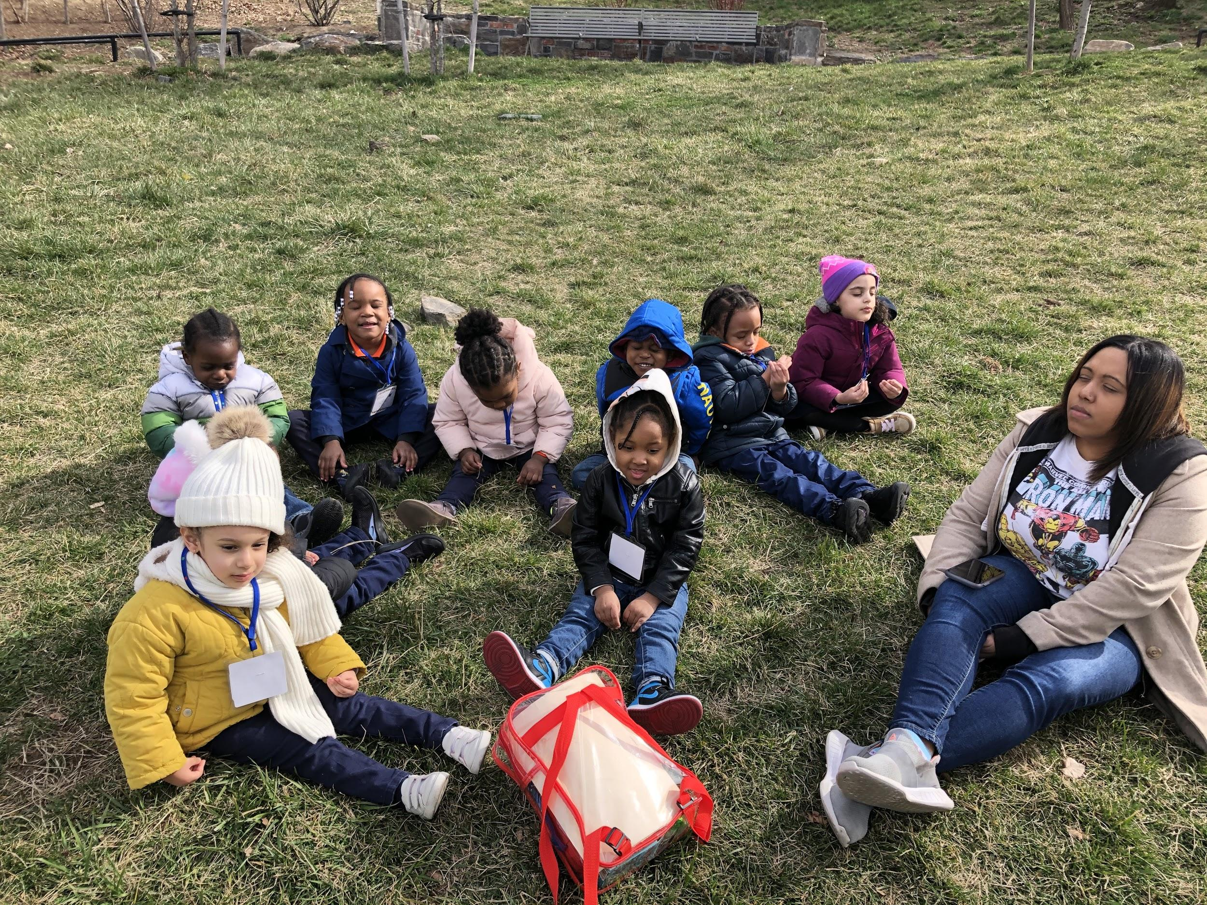

LOVE
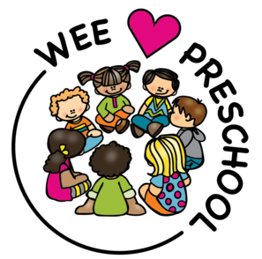
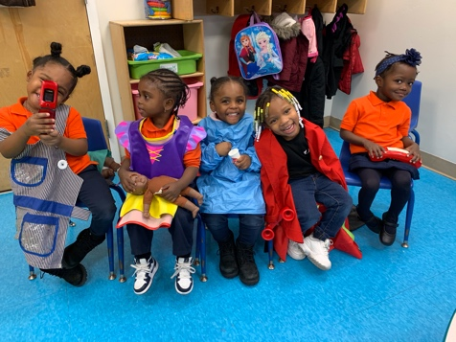

ACTIVITIES:

CLEANING PENNIES WITH KETCHUP?!
Materials: pennies + ketchup

This activity is used to help emphasize the importance of taking care of your body by eating moderately. Explain to your child that ketchup should be eaten moderately and not all the time in order for our bodies to be healthy. :)

WATCH: https://www.youtube.com/watch?v=WhAgQEr1LOE

WHATS IN YOUR LUNCH BAG?
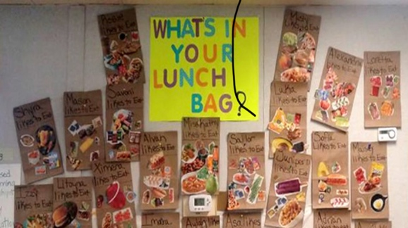
Materials: brown paper bag + magazines/food flyers + scissors + glue
Students will use the magazines/food flyers to pick out healthy lunch they would take to school or on a trip. If you have play food as well, you can use that. Parents, please help the students cut around their lunch choices. Than, students will use the glue sticks and paste them on the brown lunch bag provided. Please watch the video below to learn all the food groups.

WATCH: https://youtu.be/L9ymkJK2QCU

OUR STOMACH DO WHAT?
Materials: Ziploc bags, foods that mash well (goldfish, juice, canned corn/string beans, and/or cooked pasta in bowls with spoons), paper, markers

Parents, please take two ziploc bags and label one “BEFORE” and the other “AFTER”. Have your child take the spoon and place each item in both bags and please SEAL it. They will then use the markers and draw what they think their food would look like on one of the papers labeled before. Than, pour the other half of each items in the “AFTER” bag. Proceed to smash the bag and this is the fun part so enjoy it! When they are done, please have them explain what their food looks like in their stomach so that they may see the difference before they eat it and how it digests. They can use their other piece of paper to draw how it looks.

BRUSH, BRUSH, BRUSH THOSE TEETH!
Materials: toothbrush + paper + crayons

Before watching these videos ask your child why they believe it’s important to brush their teeth and record their responses! After your child watches these videos, ask them why taking care of their teeth is important and have them illustrate an image of their pearly white teeth!

WATCH: https://www.youtube.com/watch?v=aOebfGGcjVw
WATCH: https://www.youtube.com/watch?v=hDZXSMU2lAk

BRUSH YOUR TEETH!
Materials: yellow construction paper + white paint + toothbrush

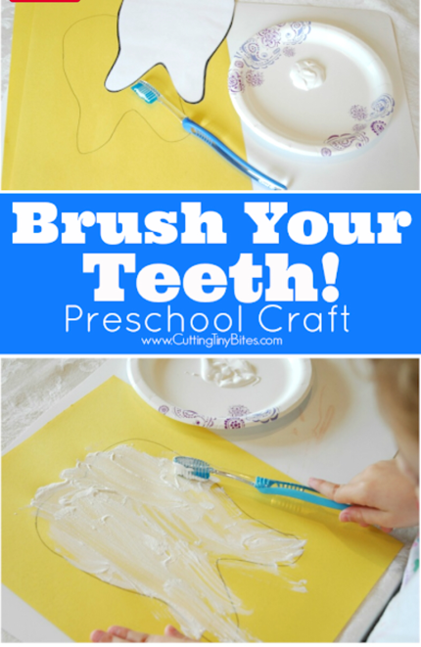
Parents, please help your child draw or trace a tooth onto the construction paper. Please refer to the video they saw yesterday and review why we are supposed to brush every single day. If we don’t, our teeth can become yellow or stained if we don’t take care of them. Next, show them how their teeth are supposed to look while using the toothbrush and white paint to brush their tooth. After, please take part in some free paint with the toothbrush and explore more colors.

LET’S TAKE CARE OF OUR BODY!
Materials: music + little feet

For this activity, students will watch this exercise video and try their best to get their body moving! After they are done exercises, have students reflect on how they feel post-workout and have them draw a picture of them working out! :)

WATCH: https://www.youtube.com/watch?v=oc4QS2USKmk

ANIMALS IN ACTION!
Materials: music + feet

For this activity, students will follow simple exercises pertaining to the animals movements. This will be another great way to get there body moving throughout the day. Ask them how did they feel doing it? Strong, funny, colorful, etc. While, they are mimicking the movements they are also getting a chance to see the animals in their own habitats. After the exercise, have your child paint their favorite animal and how they take care of their habitat.

Q-TIP “BONE” PAINTING:
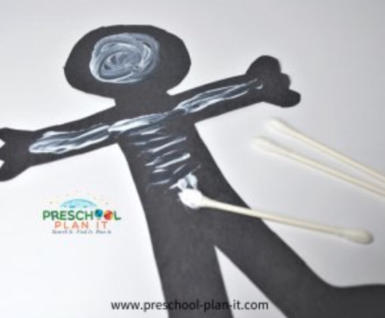
Materials: black construction paper cut out skeleton + white paint

Parents, please cut out a small body and have your child use a q-tip and white paint. Your child will hold the q-tip, dip into the white paint, and paint skeletons on the cut out body. While they are painting, please talk to them about how many bones in their body and in animals, as well, after watching this video.

WATCH: https://youtu.be/vRuh9aBwUdM

TAKING CARE OF OUR MIND!
Materials: paper + markers

Most students love to meditate. Meditation is such an important part of the day which is why we meditated everyday during circle time. This activity allows your child to center themselves and set intentions for the day. After meditation, please ask your child to draw an image of where they’d like to be that very moment. Students usually drew either parks, beaches, or in a pool.
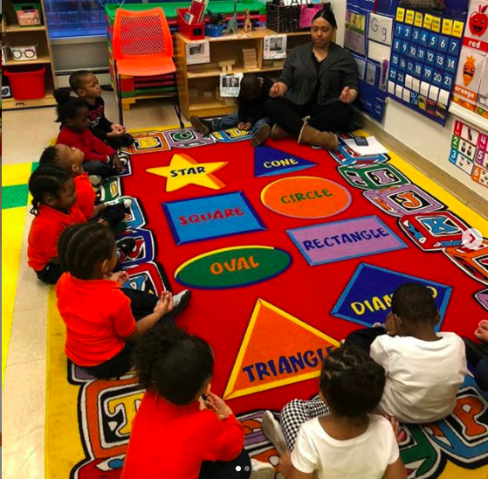
WATCH: https://www.youtube.com/watch?v=Bk_qU7l-fcU

WHY SHOULD WE TAKE CARE OF OUR ROOM/HOUSE ?
Materials: paper + crayons

This activity is very important for students because it allows them to take care of their belongings and to continue great practices as they grow older. After your child watches the video ask them how they can be more mindful in trying to pick up after themselves. Please record their answers! Additionally, have your child If you can, print out the coloring activity below. The other portion of this activity is to please have your child look around the house for any of their belongings and have them pick up after themselves. Please set a timer and let us know how long it took for them to complete this activity. :)

OPTION 2: If you don’t feel like doing the first option please have your child listen to this story of Adam keeping his room tidy, and have them illustrate their favorite part of the story.

WATCH: https://www.youtube.com/watch?v=851Df6MD0cI
STORY ABOUT ADAM!: https://www.youtube.com/watch?v=qbWnKVdw42k
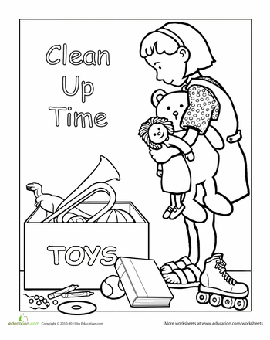

FAMILY KINDNESS JAR:
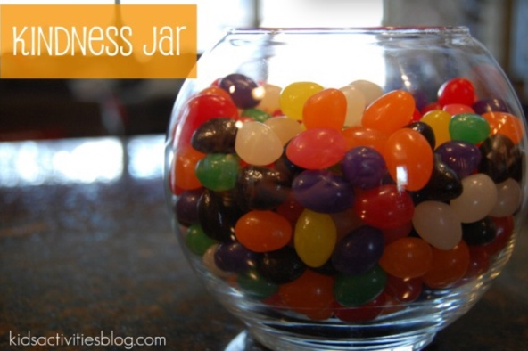
Material: jar + beans

Students will use a bag of beans to put in the family kindness jar when they do or say something nice. For example, if they helped clean up their toys, say something nice to a family member or friend, share, giving hugs, etc. Parents if you could also participate so that they can see everyone is on the same page. Please explain to them when they do an act of kindness they are showing everyone in their home that they care about them and their home.

HOW CAN WE TAKE CARE OF OUR ENVIRONMENT?
Materials: recyclable items + worksheet

Fresh and funny, Michael Recycle will entertain young and old while gently imparting an important message about recycling and environmental awareness.
A special section of Go Green Tips (from Michael Recycle himself) encourages all kids to become environmental superheroes! Please explain to your child the importance of recycling. If recycling works for your household, perhaps start that process with your child, too! :)

WATCH: https://www.youtube.com/watch?v=pJweMxEhjlU

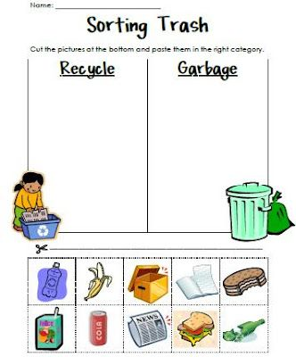
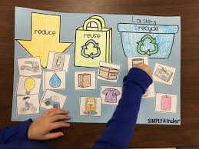

EGG CARTON TREE:
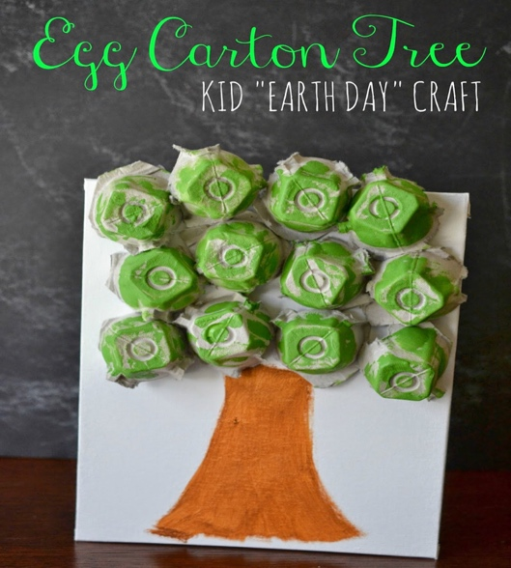
Materials: green & brown paint + white paper + paint brush + cutout egg cartons

Parents, please cut out each individual egg holes from the carton. Students will use the green paint and paint each one. While you are waiting for that to dry, use the brown paint to create a trunk for the tree. After that dries, you can use the green painted holes from the carton and glue them on to the construction paper to create a recyclable tree.

RECYCLABLE BIRD HOUSES:
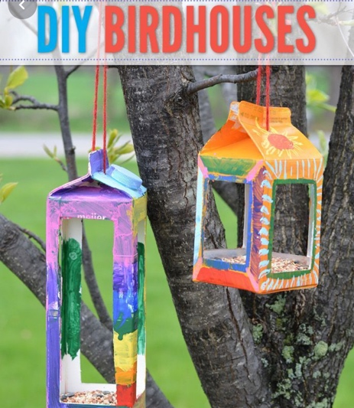
Materials: empty milk carton + different colored paint + paint brushes + string

Parents, please cut out the rectangles on each side of the carton. Your child will use the paint brush and use different colors to create their own birdhouses that you may hang up by your window or on a tree in a park near you. Parents, please poke a hole on top of the carton so that your child may fit the string in between to hang. Also, please explain how these recyclable milk carton could be used for something to help the community. Than, fill it with bird food and bird watch!

TAKING CARE OF ANIMALS!
Materials: paper + crayons

For this activity, students are to learn the importance of taking care of animals! After your child watches this video ask them, what ways can you take care of animals? Please record their answers. :) Afterwards, have your child illustrate an image of a pet that they would love to have or of a pet that they do have! Please share these pictures with us! :)

WATCH: https://www.youtube.com/watch?v=p-bPoQw19a4

DOG’S COLORFUL BONES:
Materials: different colored dog bones + pet bowl (regular) + toy dog (optional)

While reading a “Dog’s Colorful Day”, have your child put each colored bone that matches the colored spot on each page. This will help with their color recognition and show teach them how we take care of a dog and what they need to survive. After they throw all the bones in the bowl, have them count how many they have in English and Spanish. This will also help with number sequences.

PET PAW PRINT ART:
Materials: paint + animal toys + paper
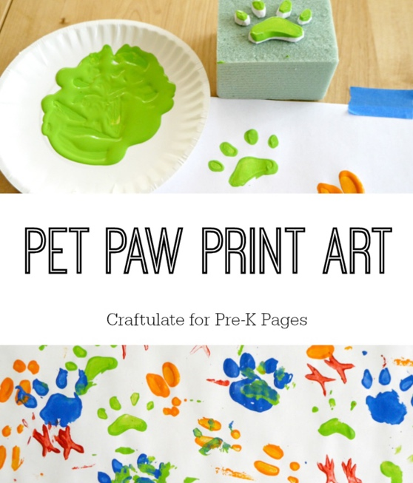
Student will use their animals as stamps to create pet paw prints on construction paper. This will help with their fine motor skills. Please explain how each animal has different size foot and how they move. Get creative and use different colors and animals!

TAKING CARE OF MY BODY (PART 2):

Materials: paper + crayons

Prior to watching the video below, please ask your child, “what are ways you take care of your body?” Please record responses and watch the video below. After watching the video, please ask your child the same question again and record those responses as well !

WATCH: https://www.youtube.com/watch?v=afVm7H4eQV4

After completing the aforementioned things please have your child illustrate what they enjoy doing the most that is part of taking care of their body (ex. Brushing their teeth, washing their hair, etc.). Please share these illustrations with us! :)

READ-ALOUD!
Materials: paper + markers

WHAT IF EVERYBODY DID THAT read aloud for children shows us what happens when everyone decides to break the rules. Think it's no big deal? Oof! The world becomes a messier, ruder, dirtier place! It's a growing up KidTime StoryTime about spreading GOOD behavior and making the world a better place!
After listening to the story please ask your child what their favorite part of the book is and have them draw it.

OPTION 2: After reading the story ask your child what are ways we can make our earth better and have them illustrate a picture of what they shared (example: picking up trash from the ground, recycling, )

WATCH: https://www.youtube.com/watch?v=811dQ_OisK0

SHARED ART:
Materials: paper + markers + timer (on phone) + two or more people

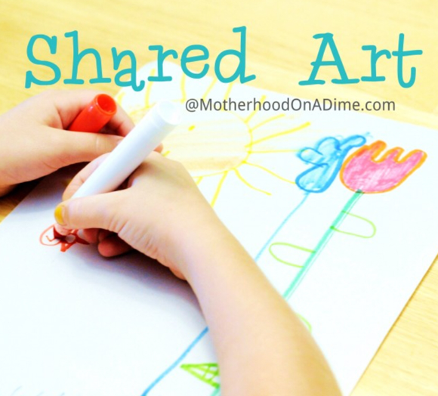
Parents, if possible to have two more people for this activity including you and one other person with your child. This activity we will use a piece a paper and markers and pass the picture around to continue to add what the previous person has made. To pass the paper to each person, you will use the timer for 2-3 minutes for the little friends and a 3-4 for the big friends. While passing, parents please explain to importance of sharing with their family/friends in different environments. This is a good activity to encourage conversation and maybe a discussion on what someone likes or doesn’t like in the drawing.

SHARING IS CARING!
Materials: snacks + story

For this activity try to share a snack/lunch with your child and if possible, have them serve the snack/lunch for you! Prior to sharing snacks/lunch please listen to the story LLAMA LLAMA TIME TO SHARE and have your child draw their favorite part of the story. Please share their illustrations! :)

WATCH: https://www.youtube.com/watch?v=OTR9aV3bIWU

SHARING IS CARING (PART 2):

For this activity have your child read/listen to the following stories below ! After they listen to the stories please have them take a second to let you know ways they share everyday! Please record their answers and let us know what they said. The students are welcomed to draw their favorite parts of any or ALL of the books they listened to. If possible, have your child look at their toys and decide which toys they’d like to share-donate to other kids that may be in need. If this is something you’d like to do with your child let me know ( Ms. A) and I'll set up arrangements for donations. Thank you! :)

https://www.youtube.com/watch?v=COf5RowE9vA
https://www.youtube.com/watch?v=5JLB0hUD14Y
https://www.youtube.com/watch?v=A4Mm78KHHi8

