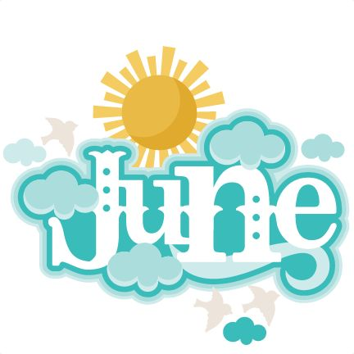

Hello Parents and Friends!

For the month of June we will continue learning about Exploration. The topic for this month is Change, children will explore change and their role in influencing change. In this exploration, children will explore how their actions and change. The goal is to help and the way they care for themselves, others. The children begin to explore ideas, think critically and how the world around them can impact growth of and change.

As preschool teachers, we are providing your child with a home school connection. Here are some ideas to keep your child’s school schedule at home. So let’s bring Ready Set Learn into your home!

Tip #1: Circle time is the number one important activity to do during the morning. We go over our lesson for the day, the craft and activities that we will be doing, going over ABC’s, shapes, numbers

Tip #2: ABC’s phonics is another activity we do during circle time. Listening to this YouTube link helps the children learn their ABC’S and to learn the sounds the letters make as well.
ABC PHONICS LINK: (https://youtu.be/hq3yfQnllfQ)

Tip #3: Create a monthly calendar with your child. During circle time we engage with the children while learning. The students discuss which month we’re in, the days of the week, which days were in school vs home.

Tip #4: During circle time we also discuss our “mood of the day.” Below is a photo of our mood chart. Simply ask your child, “how do you feel today?” “What’s another word for emotions? (Feelings) Below is an example of our feelings chart:

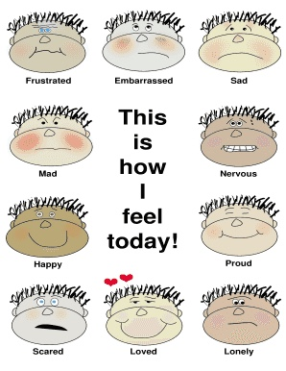

Seasons

Week #1 Monday: Fruit Loops Seasons Tree

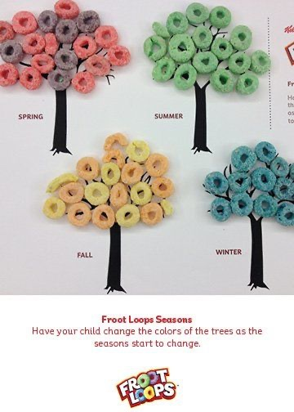
Materials: Fruit Loops, Construction paper, glue, brown marker

What to do: Parents, please help your child draw 4 trees. Afterwards, label each tree with the different seasons of the year. The divided fruit loops are to go on each tree in order to represent the season. If you do not have any fruit loops just color in each tree with crayons or use any other objects around the house that may be glued on.

Week #1 Tuesday: Q-Tip Painting

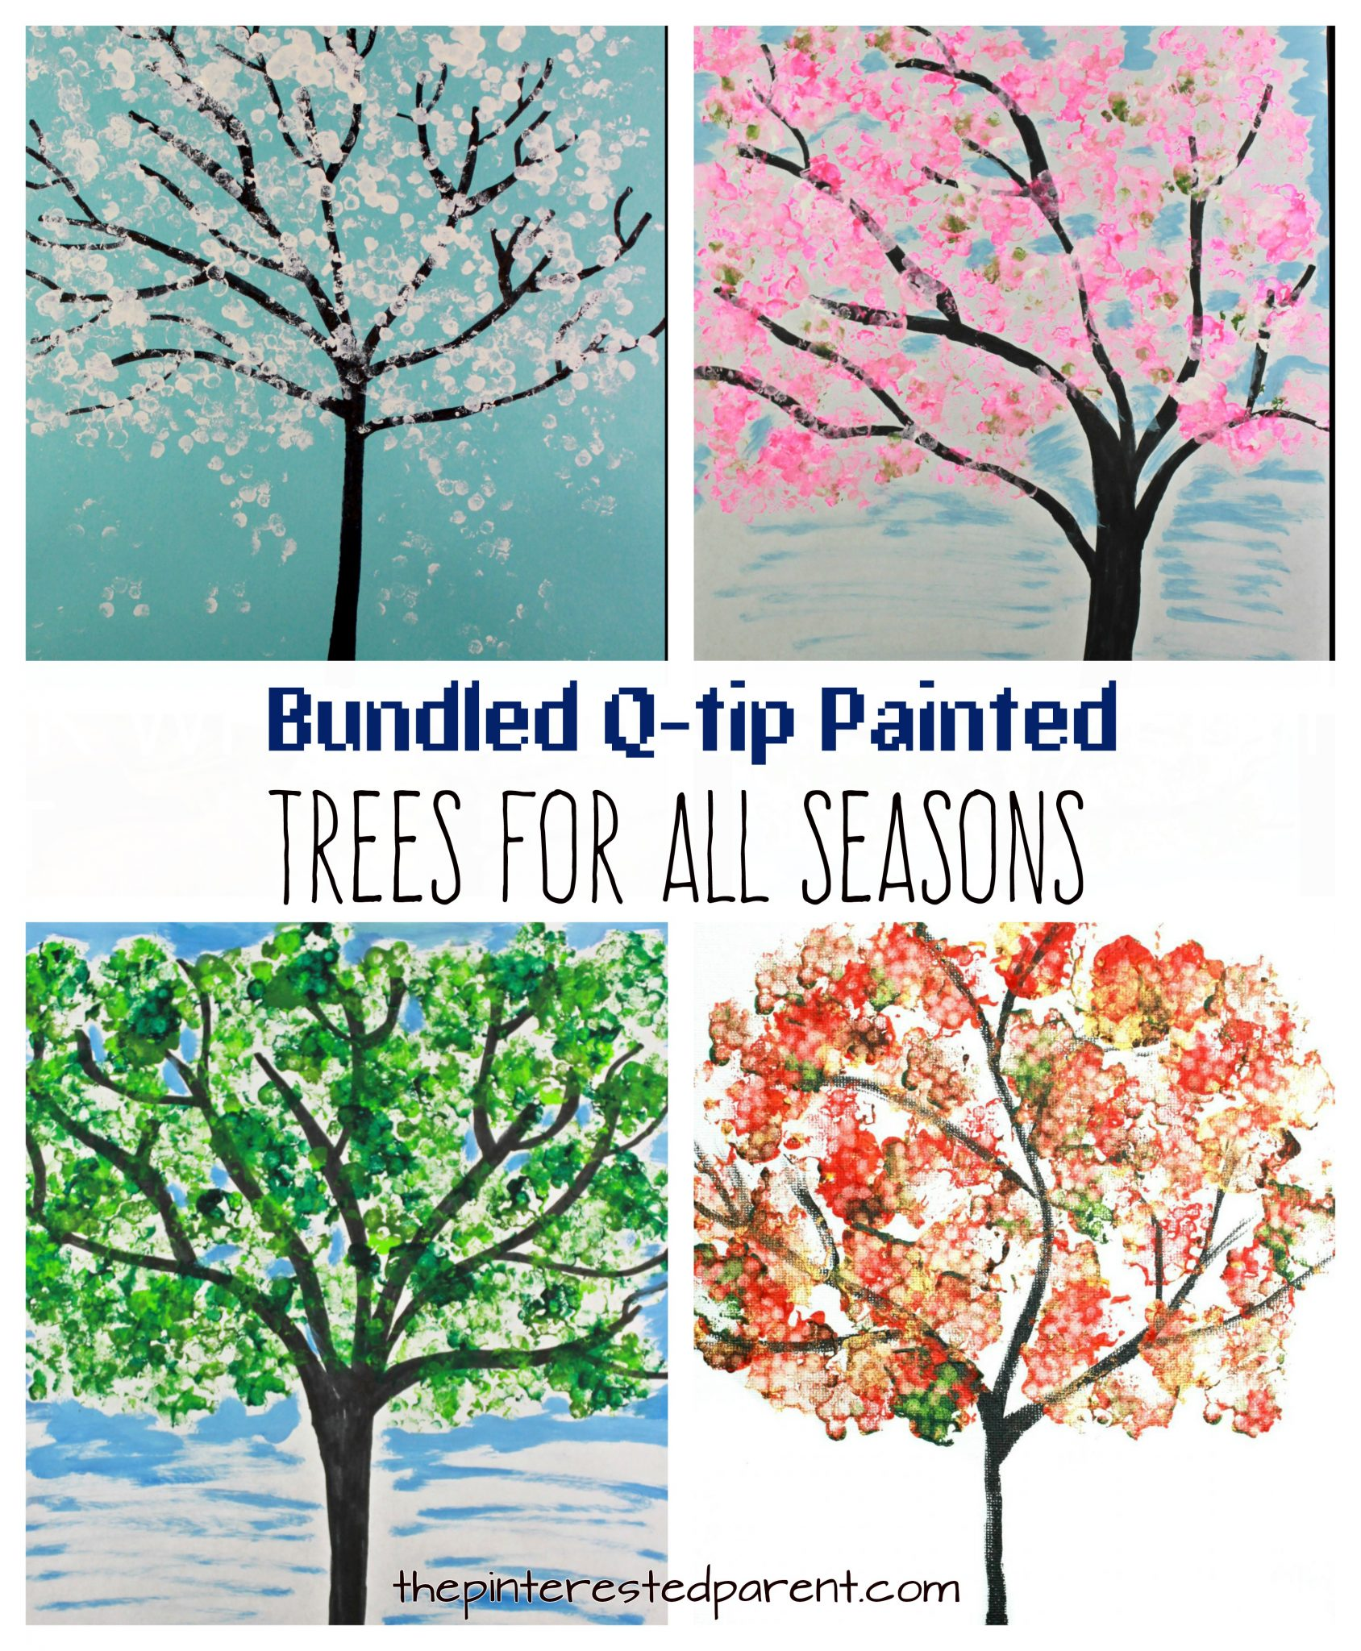

Materials: q-tips, paint, construction paper
What to do: Students will use white, red, green and orange paint to create the four seasons change throughout the year. The q-tips will be used in an up and down motion to create snowflakes for winter, flowers for spring, leaves for summer, and yellow/orange leaves for fall. This will also help with their fine motor skills.

Week #1 Wednesday: Rain Cloud Name Craft

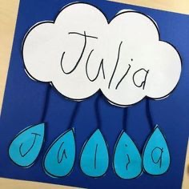

Materials: Blue crayon or marker, construction paper
What to do: Write each child's name on the cloud. Have your student write one letter from their name on each raindrop. Cut and glue to spell the name.

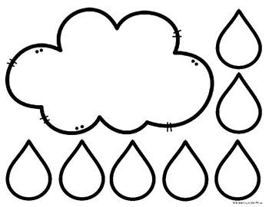

Week #1 Thursday: Weather Change

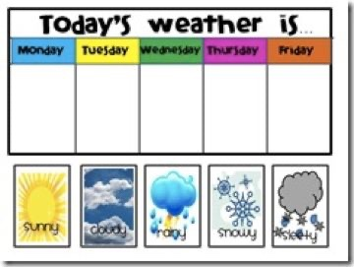

Materials: Construction paper, crayons and markers
What to do: Have your child record the weather of each day of the week Monday through Friday. Have them draw pictures of the weather for each day. Make sure to ask them if they notice any change in the daily weather!

Week #1 Friday: Paper Bag Seasons Book

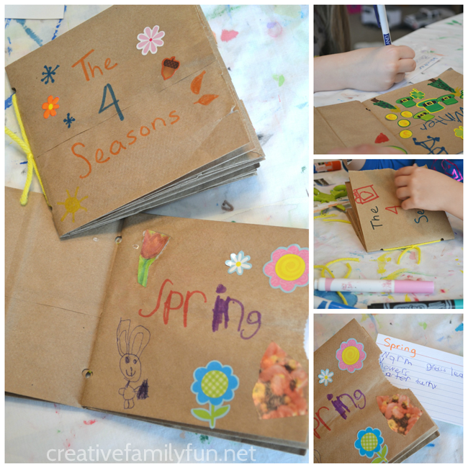

Materials: 3 paper bags, crayons, markers
What to do: Using paper bags creates a book of the four seasons. Have the child paste or color images related to each season. This can be from painting flowers for Spring or beach balls for Summer on each page.

Circle of Life

Week #2 Monday: Life Cycle of a Butterfly

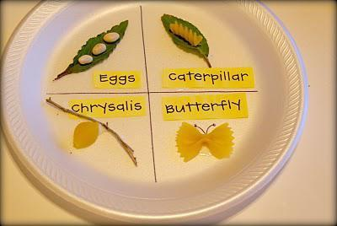

Materials: Paper plate, marker, pasta noodles (bow tie, shell, rottoni), bean
What to do: Parents, grab a plastic plate for your child to add the images above. Have them watch this youtube video (https://youtu.be/O1S8WzwLPlM ) titled LIFE CYCLE OF A BUTTERFLY.

Week #2 Tuesday: Life Cycle of a Frog

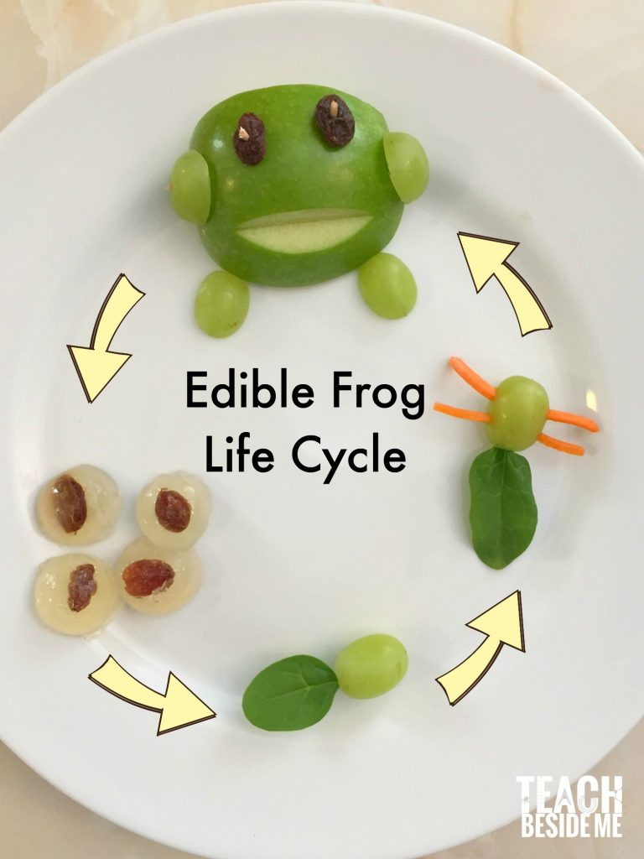

Materials: Green apple, green grapes and raisins, (toothpick if needed)
What to do: Steps
- Edible frog eggs. I used raisins
- Tadpoles. For this I used green grapes and small baby spinach leaves. I just poked the stem of the spinach into the end of the grape to make the long tail. If it does not go in easily, use a toothpick to make the hole bigger.
- Froglets. I just added some little pieces of shredded carrots in for the legs. I poked the holes for the legs with toothpicks first to make it easier to put the carrot pieces in.
- Adult frog, I used a slice of a green apple, green grapes, raisins and toothpicks. You’ll want to make the kids aware of the toothpicks when they are eating them! I broke the toothpicks in half to fit them in better.

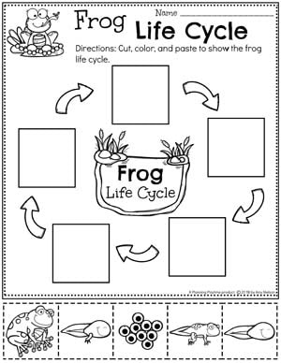

Week #2 Wednesday: Baby & Now

Example: My son Karon 😁

Materials: Construction paper, markers, two photos (infant & now),
What to do: Fold paper in half, on the top left side of the paper write baby and the other now or present. Glue your photos on each side of the paper.
In this activity your child will begin to understand how they have changed over time. Show a picture of yourself from when you were a baby to now. Parents ask questions and talk to your child about how they have changed since they were a baby. For example, Do you remember when you were a baby? What things have changed? Could you walk when you were a baby?

Week #2 Thursday: Giant Sunflower Craft

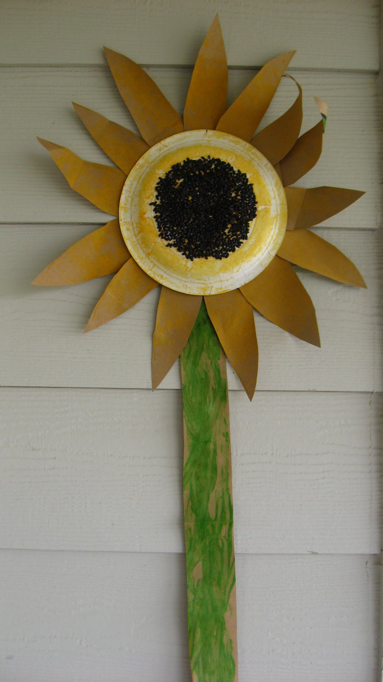

Materials: Paper bag, a paper plate, some black rice, glue, yellow and green paint, a marker, scissors, a bath sponge and double stick tape.
What to do: Steps
- Start by cutting open your grocery bag and drawing a long stem along one edge and multiple petals on the rest of it.
- Cut the stem outline out and have your child paint it green. My son loved using the roller paints for this because it was so easy to make long straight lines. Let dry.
- Paint the petals with the bath sponge. I find that when we are painting a large surface it’s much better to use a big tool that covers easily.
- Paint the bottom of the paper plate with the yellow paint too. Let dry.Cut out the stem and petals
- Add glue to the center of the paper plate. More is better so this is a great time to have your child control the glue.
- Add the rice by dumping the whole dish on. Let dry. This actually dried to the touch pretty fast.
- Flip the plate upside down and use the double stick tape to tape the petals on. Tape the stem.

Week #2 Friday: Ice Cream in a Bag

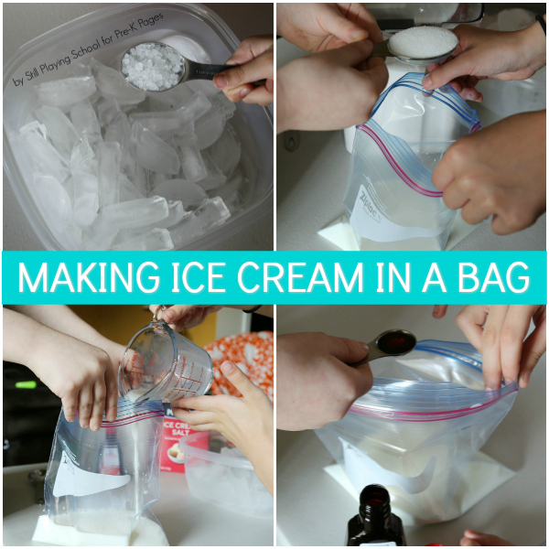

Materials: Whole milk, heavy cream, or half and half, Sugar, Vanilla, Ice, Kosher salt or ice cream salt, Plastic freezer bag, Plastic container, Spoons and bowls, Sprinkles (optional but fun!)

What to do: Steps
- Fill the plastic container most of the way with ice. Invite the children take turns sprinkling about 6 tablespoons of kosher or ice cream salt all over the ice.
- Pour one cup of whole milk, half and half, or heavy whipping cream into the plastic freezer bag. We used whole milk. Add two tablespoons of white sugar. Invite the children to help to practice fine motor skills! Finally, add a teaspoon of pure vanilla extract.
- An adult should get most of the air out of the plastic bag and zip it closed. Be sure that the bag is sealed tightly!
- Put the freezer bag with the ingredients into the container with the ice. Top with more ice if needed. Put the lid on the container and allow your child to shake the container. You can also slide it back and forth on a flat surface such as the table or the floor.
- Take turns shaking up the ice cream for about 10 to 15 minutes.
- Invite the children to add toppings (like sprinkles) if desired! Enjoy!

Emotions

Week #3 Monday: Happy and Sad face

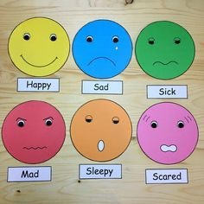

Material needed: small paper plate or circle paper shape, crayons, any craft stick and a mirror.

What to do: Encourage your child to look at the mirror and draw a happy face. Then on the other side of the plate encourage your child to draw themselves with a sad face and glue the craft stick on the bottom. They turn their “faces” to show the side that corresponds to the question. For example; you need to go to bed early. Are you happy or sad? They can turn their “faces” to show the way it makes them feel.

Week #3 Tuesday: Emotions Play Dough

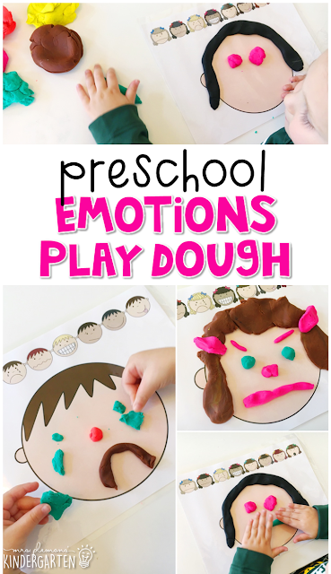

Materials: Play Dough, construction paper or any paper you have and a pencil or market.
What to do: Help your child to draw a big circle to create their own face or a family member. Then use Play Dough to create the expression of the faces for example; used play Dough to do the eyes, the nose, mouth hair, eyebrow etc. can be a happy, sad, crying face etc.

Week #3 Wednesday: Painting Feelings

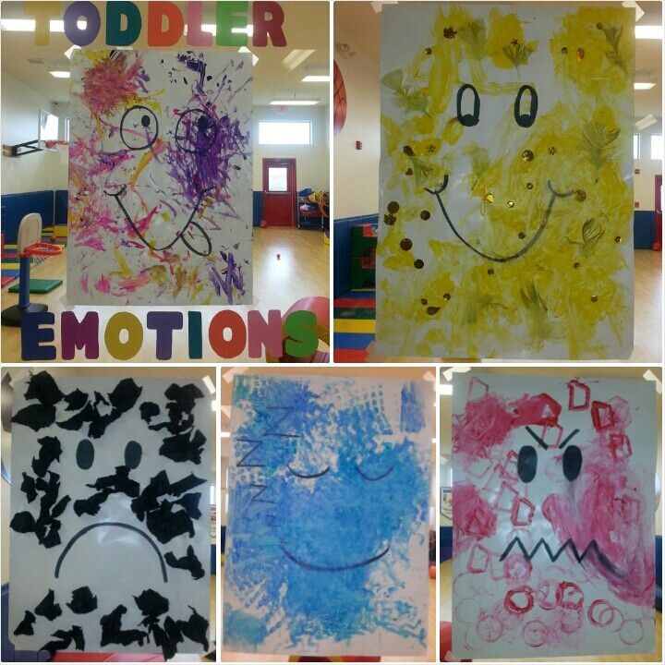

Materials: paint, brushes and paper.

What to do: This is a completely free art choice, just let them paint! But when they are done, ask them to name their picture with a feeling. Let’s name our pictures with a feeling. When you were painting, ask questions about how you were feeling, happy, sad, angry, scared etc. and why? Talk about how their feelings change while painting.

Week #3 Thursday: Fruit loop Towers

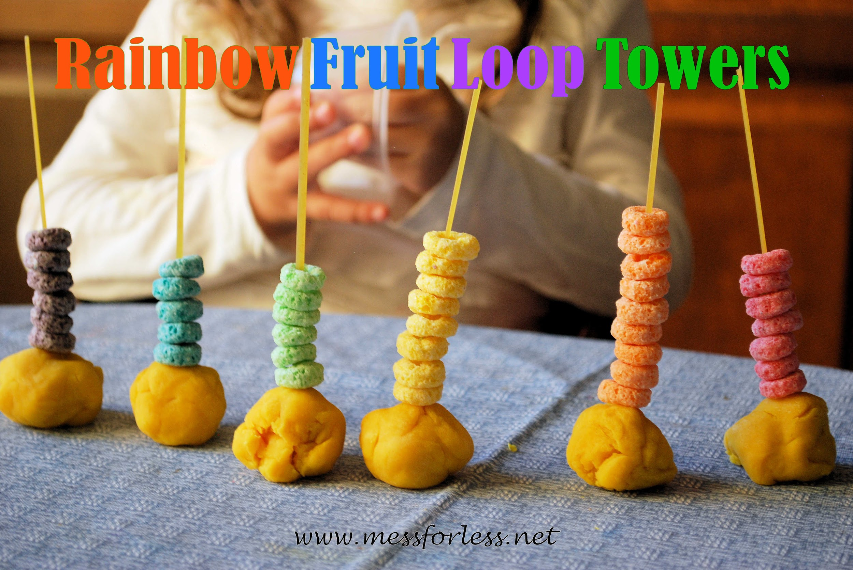

Material: Pasta/ spaghetti, cheerios, and play dough.

What to do: Have your child build a ball with the play dough then place the spaghetti inside the play dough, standing up straight, Now let have fun inserting the cereals through the spaghetti and build a big tower.

Week #3 Friday: Cool Dads

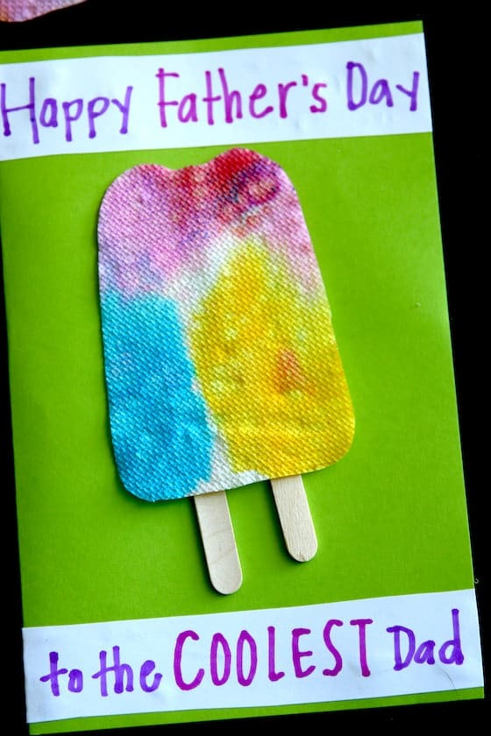

Materials: Paper towels, scissors, glue, popsicle sticks, construction paper, markers, crayons

What to do: Steps
- To dye your paper towels, drip watercolors all over them like we did here. Note: If your watercolors are too dark at full strength, dilute them with a bit of water to get light, bright, popsicle colors.
- When your paper towels are dry, cut out your popsicle shapes.
- Fold a piece of card stock in half to make your card.
- Glue two wooden popsicle sticks to the front of the card and glue your colorful popsicle over top.
- Write a “COOL” message for dad!

Change

Week #4 Monday: Spaghetti Cutting

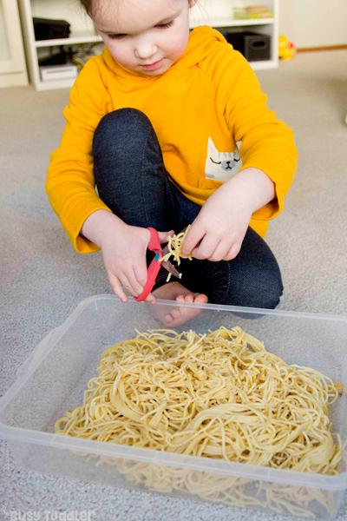

Materials: Cooked spaghetti noodles, bin and scissors

What to do: Boil spaghetti and after cool pour it into a bin and allow the child to cut through it. This activity helps improve how a child holds and uses scissors.

Week #4 Tuesday: Snowstorm Jar

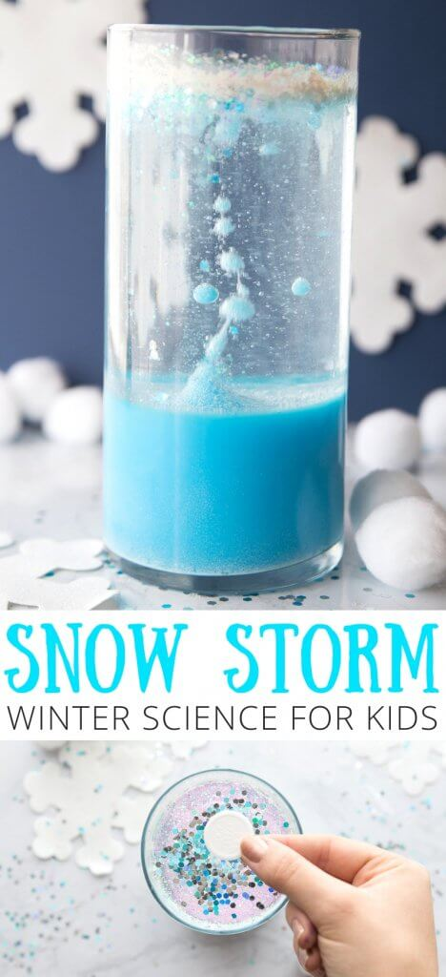

Materials: 1 cup water, 2.5 cups baby oil, glitter silver, white, and/or blue, 1 tablet Alka-Seltzer, 3 Tbsp craft paint white, food coloring blue, optional, mason jar quart-size, stir stick or spoon

What to do: Steps
- Fill your jar about three-fourths full with baby oil.
- In a separate bowl, blend water and a few tablespoons of white paint.
- Add as much glitter and blue food coloring to the oil as you’d like, and then top off the jar with your water and paint mixture.
- Drop your Alka-Seltzer tablet into the jar, take a step back, and watch the glittery snowstorm! https://b-inspiredmama.com/snowstorm-jar-science-experiment-kids/

Week #4 Wednesday: Heavy or light Measuring Weight

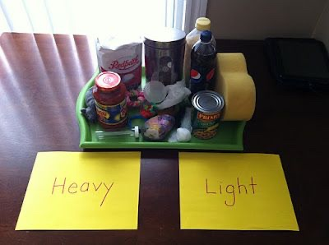

Material: for this activity you can collect any material that you have in the house, for example pencil, leaf, glue bottle, cotton ball, cup etc.

What to do: Allow your children to touch and feel the item first, then ask if the leaf is heavy or light? Is a pencil heavier or lighter than a glue bottle? And Why.

Week #4 Thursday: Ice Cube Paint

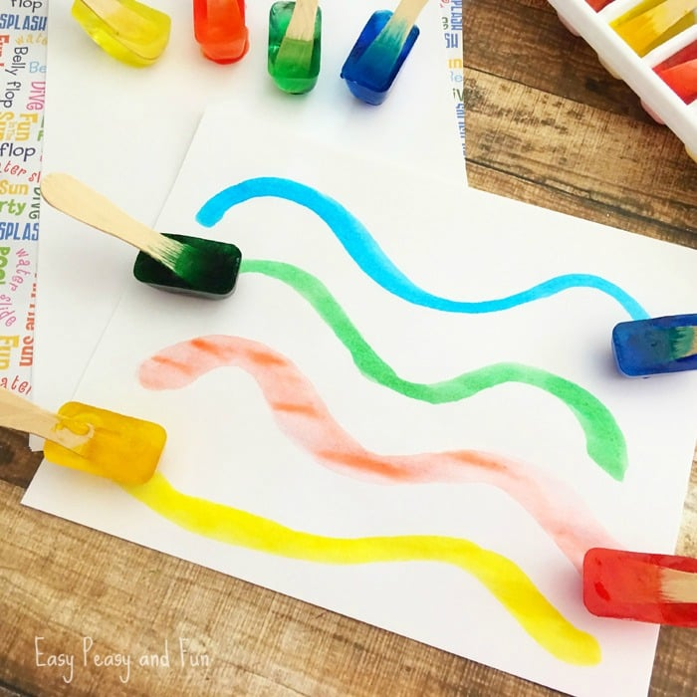

Materials: water, ice cube tray, food coloring, popsicle sticks, construction paper, timer

What to do: Have your child fill up the ice tray with water and add different colors of food coloring. Add the popsicle sticks to the ice cubes. Have your starter ready once you put it in the freezer. In about 1&½ hours take it out of the freezer and one the construction paper you guys can paint.

Week #4 Friday: Fingerprint Numbers

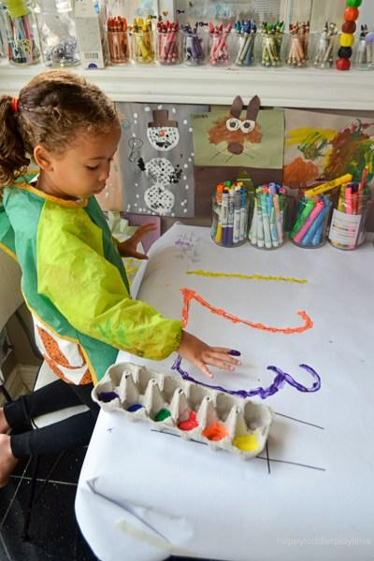

Materials: Large construction paper, paint, black maker

What to do: Using washable paint placed on a plate and trace any number onto a piece of paper. Then have them use their fingers to trace the number.

https://happytoddlerplaytime.com/fingerprint-numbers/?utm_medium=social&utm_source=pinterest&utm_campaign=tailwind_tribes&utm_content=tribes&utm_term=507964062_18126136_3921

