Happy week 4 of online distance learning student/families of class 213,

I hope that you and your families are all well! Attached are documents for you to utilize the week of April 13-April 17. This month we will be learning about plants. Week two of the plants unit we will focus on what are plants?, What do plants need and where do we find them? This unit is interactive and a great deal of fun and can be incorporated throughout daily household activities. We've also provided various learning activities to keep our students busy while at home throughout the upcoming days. Thank you so much families for being so involved and interactive with facetime calls and phone calls. We will continue our same schedule moving forward which is Monday, Wednesday and Friday calls will continue to begin at 11am- 12:30am. Parents if you haven't done so please check out google classroom. It's a safe space to upload photos of your child and their work as well as a place to find interactive resources while at home.
Please feel free to reach out to us with any questions or concerns through email at
Ms. Janae: Janaeuribe@gmail.com
Ms. Chrys: Chryshulalezcano@gmail.com

Reminders:
Remote Learning
DECE is working to determine the need for devices to support remote learning.

For families: The DOE has devices available to lend families to support their child’s remote learning. Priority will be given to students most in need, and students in upper grades. Completing a survey does not guarantee the provision of a device. Families who wish to request a device should fill out this Remote Learning Device Request form. The DOE will follow up with families who complete the survey pending device availability. This may take some time as the DOE works through all survey responses. Please encourage families to complete the survey so that we can have an accurate sense of the need. If a family does not know their child’s OSIS number needed to complete the form, they should enter their child’s date of birth and then the number 0. For example, for a child born on January 1, 2016, the family should enter “010120160”.

For questions, please contact EarlyChildhood@schools.nyc.gov.

All families can visit the nearest DOE District School to pick up grab-and-go breakfast starting at 7:30 AM and lunch starting at 11:30AM. Families can find the nearest District School by visiting https://www.nycenet.edu/schoolsearch or calling 311.

Best,
Ms.Janae & Ms. Chrys

Unit Title: Plants
Week: 2
Essential Question: How do plants grow and why are they important?
Focus Question: What do plants need and where do we find them?

Monday April 13 , 2020
*Parents please take pictures of your child's completed work/activity and email to: Janaeuribe@gmail.com or Chryshulalezcano@gmail.com

Vocabulary words of the day: garden, ground, lawn, park, patio, yard

Morning Routine:
Write down and document your child’s responses...
Before reading the book below, here are some questions to consider with your child:
1.What do plants need?
2. Where do we find plants?
*Help your child make the connection to the study of water in the last unit and how plants need water

ebook/youtube story of the week:The Curious Garden by Peter Brown
youtube link to story:https://www.youtube.com/watch?v=6SHmN-wXykU
* Parents review with your child what an author is and what an illustrator is.
-Author writes the story, illustrator draws & paints the pictures in the story.
Science Activity
Sweet Potato Vines: Insert toothpicks in a spoke fashion around the middle of a sweet potato or regular potato. Rest the toothpicks on the top of a jar, with the bottom half of the potato in water. Place in a lighted area & watch the vine & roots grow.
Example: 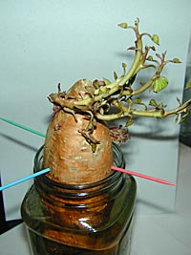

Questions to ask your child while conducting experiment:
What did you observe here/when ____?
What did your sense of sight tell you about the potato?
What will you try next?
I wonder what would happen if we put a potato in a cup with no water and no toothpicks? How do you know? How could we find out?
PK.CKW.5 (Science): Observes and describes characteristics of living things.

Fine Motor/ Writing Activity: 4
Creating patterns, swirls, squiggles and zig-zags with buttons, children will have so much fun playing with this fine motor work station. Children enjoy hands-on activities and the bright colours and buttons are so engaging and motivating for children. You will need coloured card, marker pen and assorted buttons or any household items like dry rice or beans. If you do not have buttons, you may like to use gemstones, string, stones, pebbles, bottle tops, pompoms, shells or other small tokens for this activity.
Example :
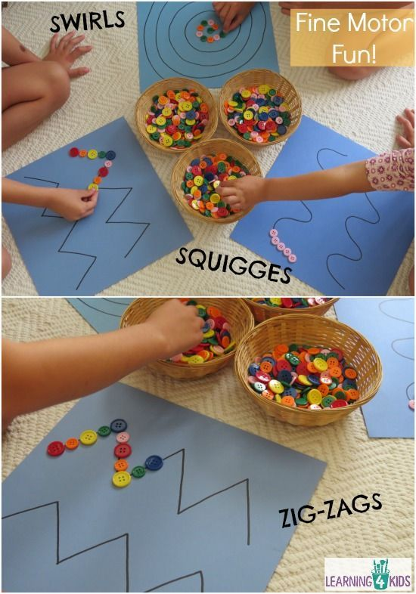

Gross motor Activity:
It's YOGA TIME: By practicing yoga poses, children can learn how to exercise, develop confidence, and concentrate better. Click the youtube link and you and your child can both engage in a calming and soothing activity.
Youtube Link: https://www.youtube.com/watch?v=X655B4ISakg
PK.PDH.2: Uses sensory information to plan and carry out movements.
Arts & Craft Activity:
Plant Stamps or fruit/ vegetable stamps: Provide parts of plants, fruit or vegetables such as flowers, leaves, seeds and invite your child to dip them into a small amount of paint and press them onto a piece of paper similar to a stamp.
Example: 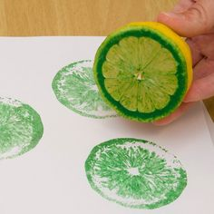

PK.CKW.1 (The Arts): Expresses oneself and represents what s/he knows, thinks, believes and feels through visual arts.

Math:
Seed Patterns: Provide an assortment of seeds as well as a large flat surface and invite children to create patterns with the seeds. These seeds can be any kind lentil, sunflower seeds, beans etc. Explain that a pattern is made up of a core unit that repeats (for example: red, blue… red, blue… red, blue). 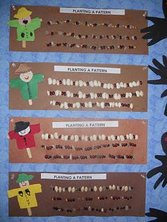

* Parents below are questions to consider asking your child while doing this activity.
I notice that you ____. What do you notice? What happened when you ____? Why do you think that happened? If I want to ____, what should I do? Tell me about ____. How do you know? Tell me why ___.
PK.CKW.2 (Operations and Algebraic Thinking): Duplicate and extend (e.g., what comes next?) simple patterns using concrete objects.

Tuesday April 14, 2020
Vocabulary words of the day:courtyard, environment, farm, field,
Letter of the Week “T”
Morning Routine:
ebook/youtube story of the week:The Curious Garden by Peter Brown
youtube link to story:https://www.youtube.com/watch?v=6SHmN-wXykU

Questions to ask once the story has ended:
Level 1: Recall
1. Where did the garden start growing?
2.Where did the garden spread?
3.What did Liam do in the winter?

Have your child draw a picture according to what they respond to 1 out of the three questions and record your child’s response. * Please take a photo of child’s photo along with which question they are responding to, and what your child’s response was to the image they drew according to their response.

PK.CLL.1 (Speaking and Listening Standards): With guidance and support, participate in collaborative conversations with diverse partners about pre kindergarten topics and texts with peers and adults in small and large groups.

Ocular Motor Control Activity:
This refers to the ability of the eyes to work together to follow and hold an object in the line of vision as needed. In the worksheet below have your child use a highlighter to find all the letters “T”. Review the sound and distinguish the difference between uppercase T and lowercase t.
Youtube link for the T song:https://www.youtube.com/watch?v=HHEqOLZ0hr4

Complete worksheet below:
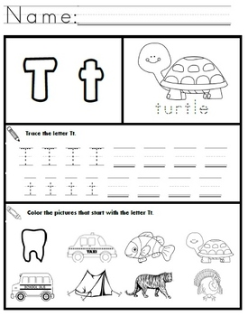

Gross motor Activity:
Play ebook/youtube story:The Carrot Seed by Ruth Krauss:
youtube link:https://www.youtube.com/watch?v=-zsv_vImOr8

Wheelbarrow Walk Fun Gross Motor Activity:Wheelbarrow Walk is a Fun Gross Motor Activity. It is a great activity for working on coordination and arm strength. It's also a fun activity for burning energy indoors.

Computer/Technology Activity:
Plants Around the World: Pull up pictures of plants that grow in different parts of the world or may be novel to the children. For example, succulents, palm trees and cattails may be plants that children in New York City do not see on a regular basis. Invite children to take notes while they look at different types of plants. For example, they can draw pictures of what they see or write letters they hear in the names of plants they hear or see on the screen. Provide various types of paper commonly used for note taking such as lined paper, post-it notes etc.

PK.CLL.2 (Writing Standards): With prompting and support, use a combination of drawing, dictating, or writing to compose informative/explanatory texts in which they name what they are writing about and supply some information about the topic.

Math: Read or listen to ebook: Ten Red Apples by Pat Hutchins.
Youtube Link: https://www.youtube.com/watch?v=rzR57dI-7FE
Cut out small apples from paper about the size of the apples in the book. Invite your child to use them as they read or retell this story.
PK.CKW.3 (Counting and Cardinality): Understand the relationship between numbers and quantities to 10; connect counting to cardinality.

Wednesday April 15, 2020
Vocabulary words of the day:botanist, bouquet,floral arrangement, florist,
Review letter T

ebook/youtube story of the week:The Curious Garden by Peter Brown
youtube link to story:https://www.youtube.com/watch?v=6SHmN-wXykU

Questions to ask once the story has ended:
Level 2: Skill/Concept
1.How does the city look at the beginning of the book? How does the city look at the end of the book?
2.Do you prefer the way it looks at the beginning or the end? Why? The book says that Liam didn’t feel like a gardener at first but after a while he did. Why do you think that happened?
3. Other people in the city decided to be gardeners too. Why do you think they wanted to be gardeners?

Music Activity:
Display images that correspond with the Song:
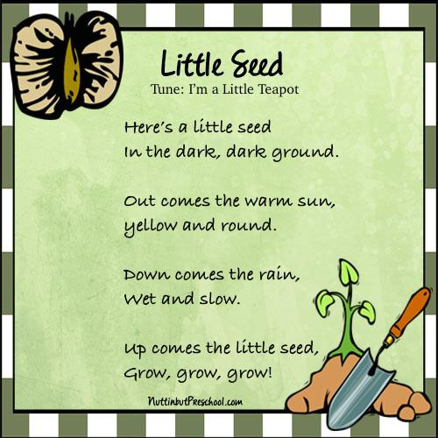

PK.CKW.5 (Science): Observes and describes characteristics of living things.
PK.AL.1: Actively and confidently engages in play as a means of exploration and learning.

Math Seed Sort
Provide an assortment of seeds and beans as well as trays or containers for sorting. Children can sort by seed color, size, design or by categories of their choosing. If children need assistance in determining categories for sorting, model sorting for them, sharing your thoughts and sorting criteria aloud as you work. You can also have your child use tweezers to sort the seed to help with their fine motor skills.
PK.AL.5: Demonstrates persistence.

Gross motor Activity:
Play ebook/youtube story:Wiggling Worms at Work by Wendy Pfeffer
youtube link:https://www.youtube.com/watch?v=AJOdHUb8JKA

Throwing Skills Game: is our homemade version much like the game Ring Toss or Quoits but using homemade paper rings as the rope and chair legs are the target stand. Throwing skills such as underarm throwing is a fundamental movement skill that should be practised and encouraged in the early years. Throwing the Ring Game is so simple to make and set up and is a great way for children to have fun while developing these important gross motor skills.The chair legs of a dining chair or classroom chair are perfect for throwing these homemade rings onto.

Example below:
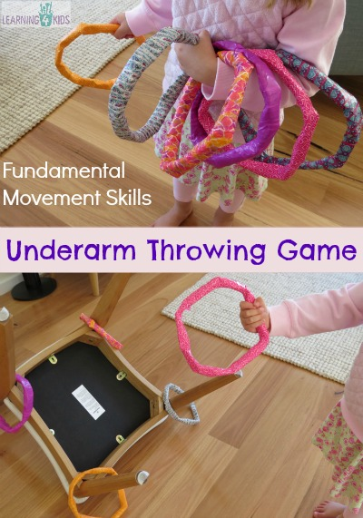

**Parents please submit photos of your nature walk along with the notes your child took while on the walk. If you don’t want to go out you can look and observe plants you see from your window.

Math Activity: Colorful spring Garden
Count the petals on each flower in the garden. Then color the flowers according to the key provided on the worksheet.
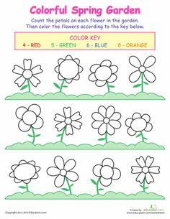
Thursday April 16, 2020
Vocabulary words of the day: lawn, nature, , terrarium, botanist,
Review letter T
ebook/youtube story of the week:The Curious Garden by Peter Brown
youtube link to story:https://www.youtube.com/watch?v=6SHmN-wXykU
Questions to ask once the story has ended:
Level 3: Strategic Thinking
1.Do you think the people in the city felt different after there were many gardens and plants growing in the city? Why or why not?
2.How do plants and gardens make you feel?

Science Activity:
Review and re-create a Plant Diagram and show your child a real plant. With your help, help your child put together a plant diagram such as the one created below:
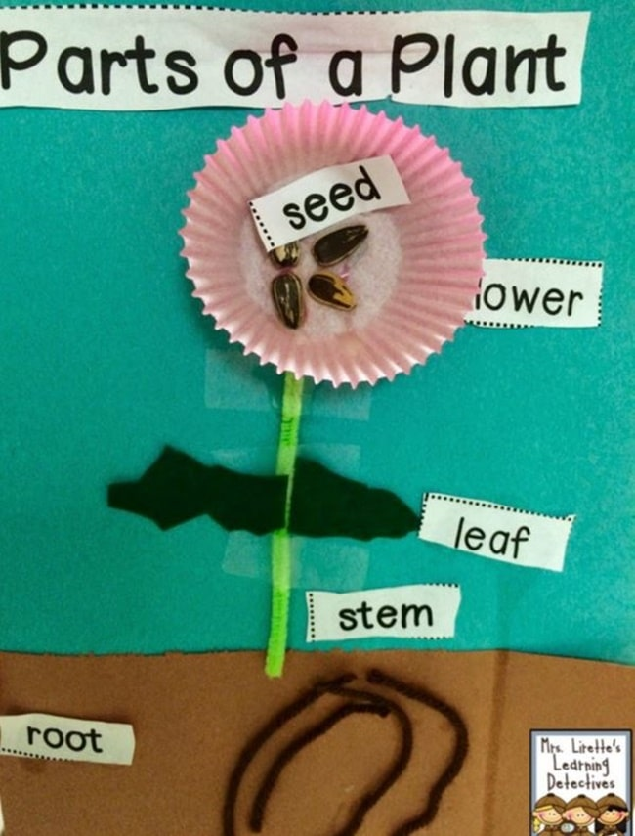

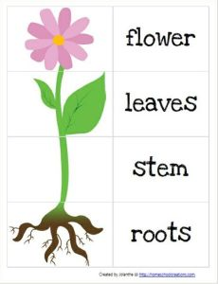
With this diagram have your child cut out the names of the parts of the plant and place the name of the plant to its correct location on the plant.
Ljskool.com
Below is a helpful youtube link for parents: https://www.youtube.com/watch?v=DfphkUwDbGU
. PK.CKW.5 (Science): Observes and describes characteristics of living thing

Fine Motor/ Writing Activity:

Toothpick Punch
To do this activity, cut squares of construction paper (I cut mine 6×6 inches). Draw a numeral, letter, or simple shape with a Sharpie. I placed a stack of these papers in the fine motor center, along with toothpicks and a carpet square. Children place the paper on the carpet square and use the toothpick to punch holes all along the black lines. When they are done, they can hold their paper up to the light and see the light shining through the holes. Kids enjoy it and it’s great fine motor practice!
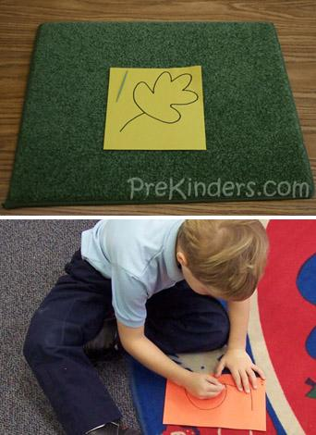

Gross motor Activity:

CROCODILE IN THE WATER!Draw two parallel lines (or use rope, string, ribbon or tape) that are far enough apart for your child to be able to "walk" one line with her feet and the other with her hands. Then help your child draw a silly old crocodile in the center.

THE STORY

Rock the Croc sleeps all day in the river. But when he's awake, he loves to tickle fingers and toes! The only way to get past Rock is to stay on the banks of the river (the lines). Can you get down river without waking up Rock the Croc?

WHY DO IT?

This game creates additional challenges and fun…

1. STRENGTH & BALANCE. Holding this "all fours" position gives the body and brain another new sensation of balance while building muscle strength.

2. MIDLINE DEVELOPMENT. Doing something different with the top half of the body from the bottom half helps develop full body coordination.

3. FOCUS & CONCENTRATION. Creating a little story line around the activity shifts the focus to the "mission" and adds incentive for accomplishing the task.
Example: 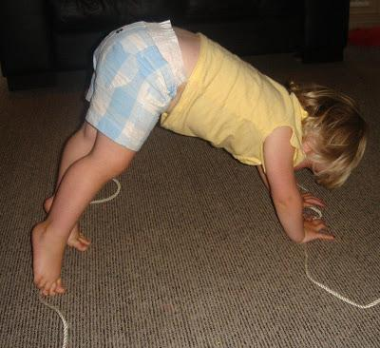

Cooking Activity:

Taste Test: Invite children to sample a variety of fruits and vegetables. Create a chart for them to record their favorites. Use the word edible frequently throughout this activity to help children learn this vocabulary word.

PK.SED.1: Recognizes himself/herself as a unique individual having his/her own abilities, characteristics, feelings and interests.

Literacy Activity: Fine motor skills
When a certain amount of body stability has developed, the hands and fingers begin to work on movements of dexterity and isolation as well as different kinds of grasps. Complete the letter “T” worksheet below.
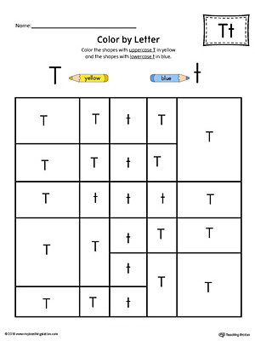

Friday April 17, 2020
Review all vocabulary words of the week:botanist, bouquet, courtyard, environment, farm, farmer, field, forester, floral arrangement, florist, garden, gardener, greenhouse, ground, landscape, lawn, nature, nursery, park, patio, terrarium, vegetation, yard
Review letter T

ebook/youtube story of the week:The Curious Garden by Peter Brown
youtube link to story:https://www.youtube.com/watch?v=6SHmN-wXykU

Level 4: Extended Thinking
1.Can you be a gardener? Why or why not?
2.If you were going to grow a garden, what would you need? What would you do?
Have your child imagine they are a gardener and create a picture of their own garden ask your child open ended questions such as what would you plant in your garden and why?

Science Activity:
Regrow Vegetables: Some vegetable scraps such as carrot tops, scallions and celery (base) can be regrown by placing them in water. Put each vegetable in a small bowl or container, add a small amount of water and put in a location where the vegetable will get plenty of natural light. Invite your child to predict, observe and record what happens through drawing and writing.
PK.CLL.3 (Approaches to Communication): Demonstrates that he/she understands what they observe.

Fine Motor/ Writing Activity:
This simple craft activity is not only a great recycled craft, it’s a wonderful way to let your child practice those fine motor skills with cutting and coloring. Your Fine Motor Skills Man or Woman doesn’t have to look anything like ours, but it’s a great place to start until your creativity kicks in.
Materials Needed:
- Empty toilet paper roll
- Safety scissors
- Colored pencils or crayons
- Markers
- Optional: Ribbon, glitter, glue, jewels, stickers, et
** Complete the following activity below.

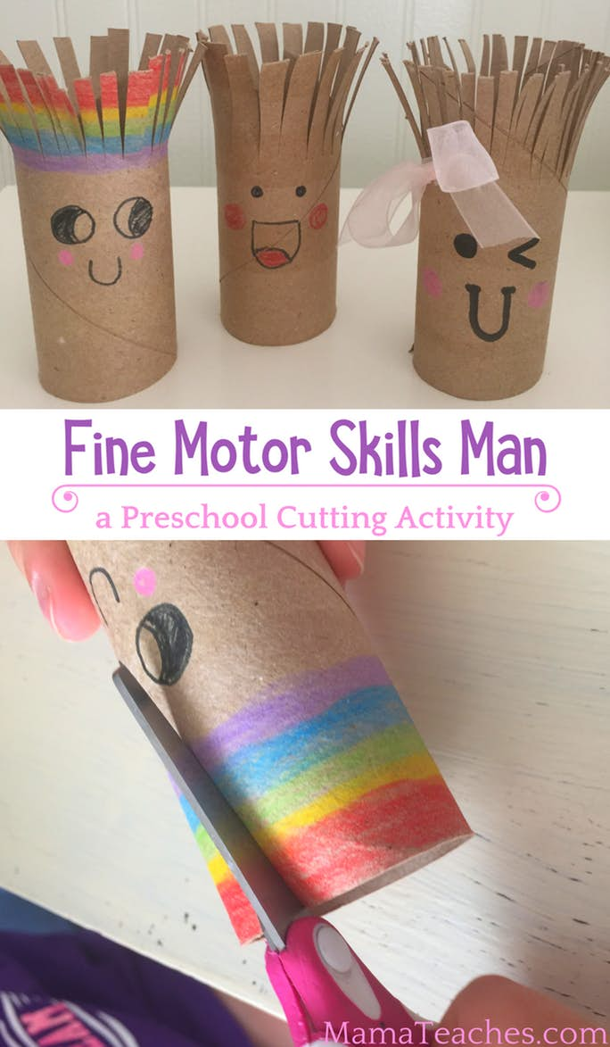

Gross motor Activity:
Play ebook/youtube story: Ask your child which story was their favorite this week and read/re-play the story for your child.
youtube link: stories from this week

1.ebook/youtube story of the week: The Curious Garden by Peter Brown
youtube link to story:https://www.youtube.com/watch?v=6SHmN-wXykU

2. ebook/youtube story:he Carrot Seed by Ruth Krauss:
youtube link:https://www.youtube.com/watch?v=-zsv_vImOr8

3. ebook/youtube story:Wiggling Worms at Work by Wendy Pfeffer
youtube link:https://www.youtube.com/watch?v=AJOdHUb8JKA

Straw Javelin Throw: The idea is to use a drinking straw and launch it through the air to see who can get it the furthest! Use bowls and set up a point system. The closest bowl was worth 5 points, next one was worth 10, then 15, and on until 25. Our goal was to see who could throw the straw javelin the furthest and collect the most points.

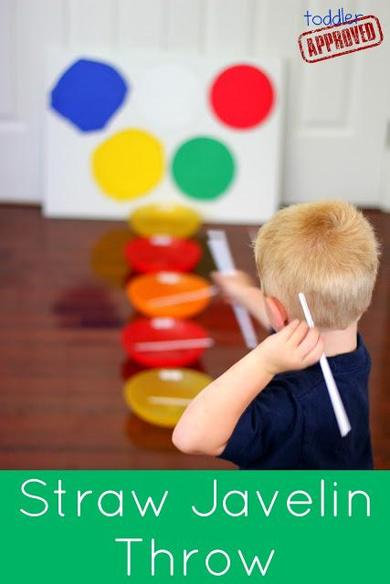

Art Activity:

Fork FLowers:We love getting creative with our paintings! We’ve tried painting with toothbrushes, marbles and even magnets while in class and maybe at home so why not try painting with forks? It turns out, forks make a wonderful stamp to easily create beautiful flowers! The colorful flowers of summer might be wilting, but we have all of the colors in this painting! Choose your favorite to make a bouquet, or mix and match with different colors.
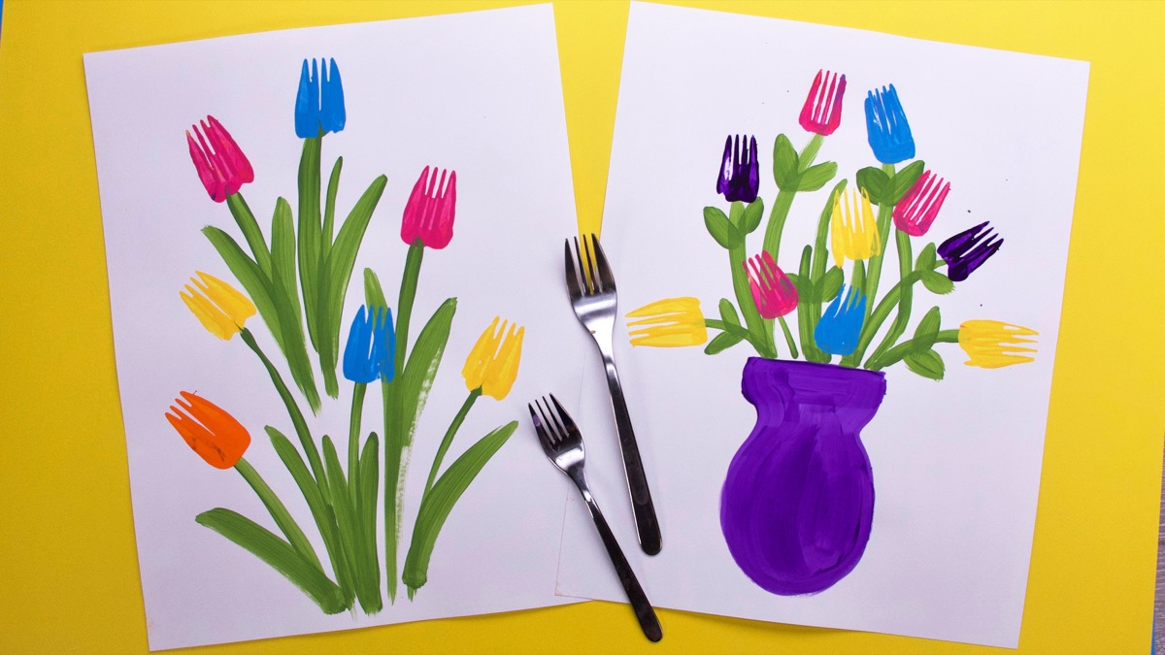
For this craft, you’ll need:
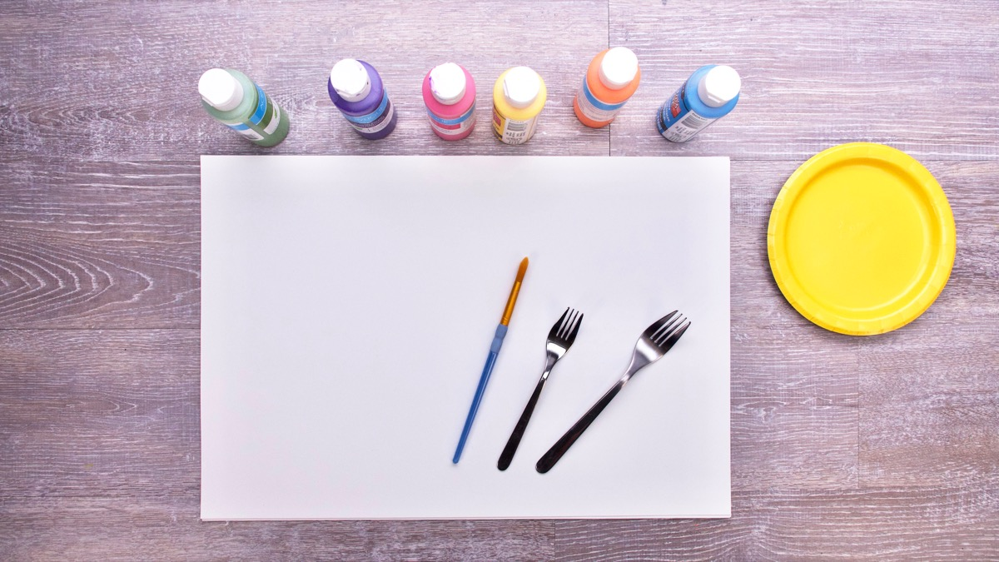
- white paper
- craft paint
- a paint brush
- paper plate or something to squeeze the paint onto
- small and large fork
Steps:
1. With a paint brush, paint the stems and leaves with green paint. You can also paint a vase for your bouquet of flowers, if you like!
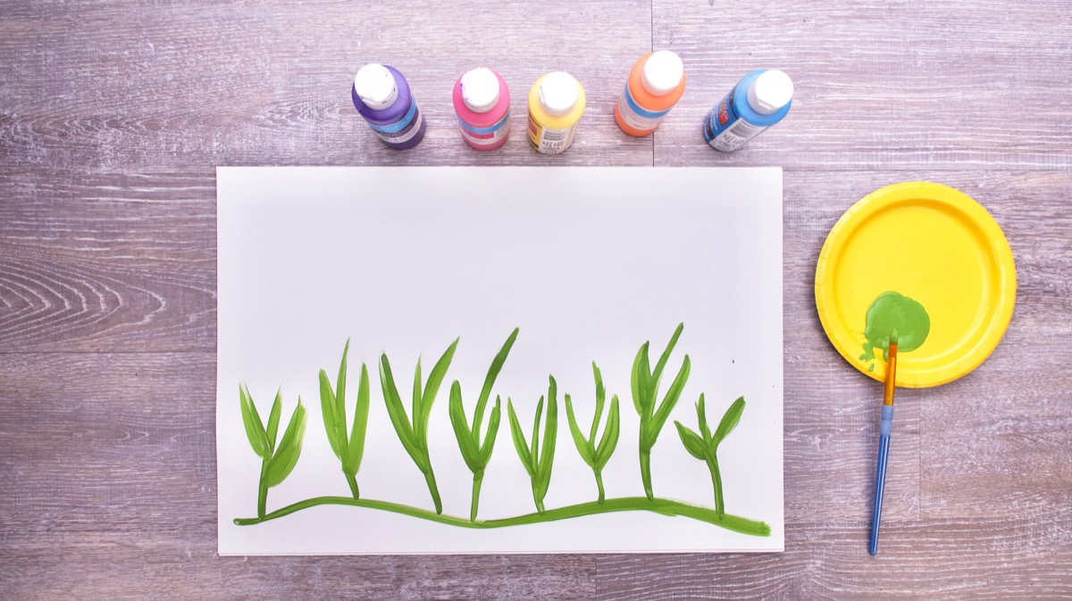
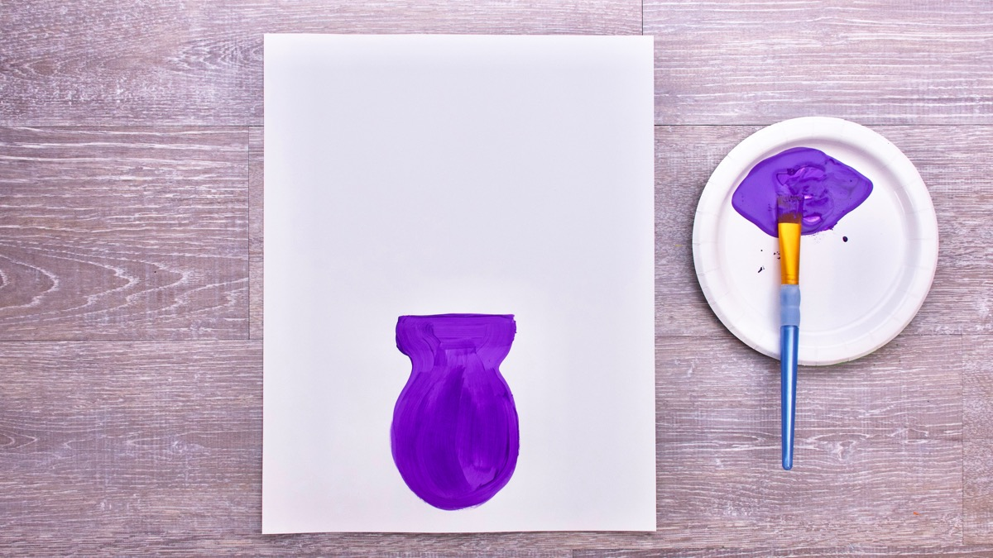
2. Squeeze different colors of craft paint onto a paper plate, or whatever you are using.
3. Dip your fork into the colored paint and stamp away! Wipe your fork clean when switching colours.
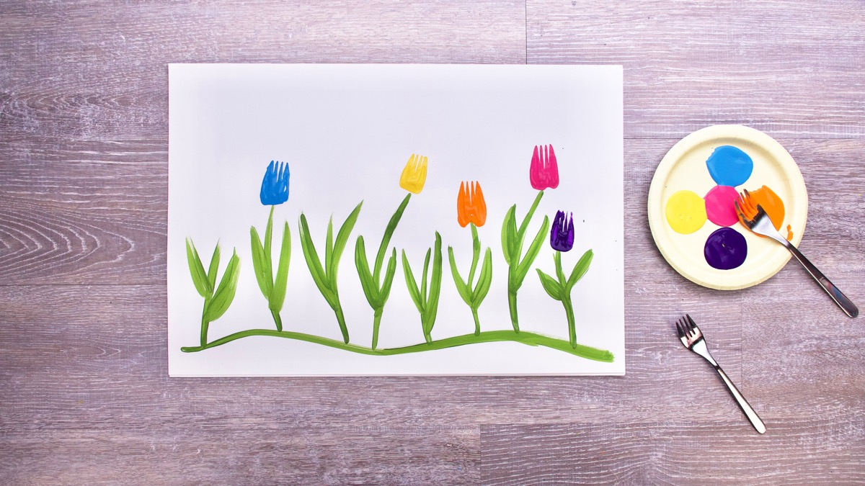
Try experimenting with other things as stamps and see what kind of flowers they make. A spoon would be a great stamp for the center of a flower, and your fingertips would make wonderful petals! Try different things, explore different colors, and have fun painting flowers!

PK.CKW.1 (The Arts): Expresses oneself and represents what s/he knows, thinks, believes and feels through visual arts

Math:
Plant Memory: Matching game is a concentration-style educational memory game for kids and adults to experience the colorful amazing Flowers.
This set of flower memory games can be used in several ways and are durable, so your child can use it for hunts, matching games, sorting, and memory games. Kids of all ages and grades can enjoy this memory game along with their parents, grandparents as it’s going to activate some areas of their brain responsible for memory acquisition which therefore can help improve your memory.

