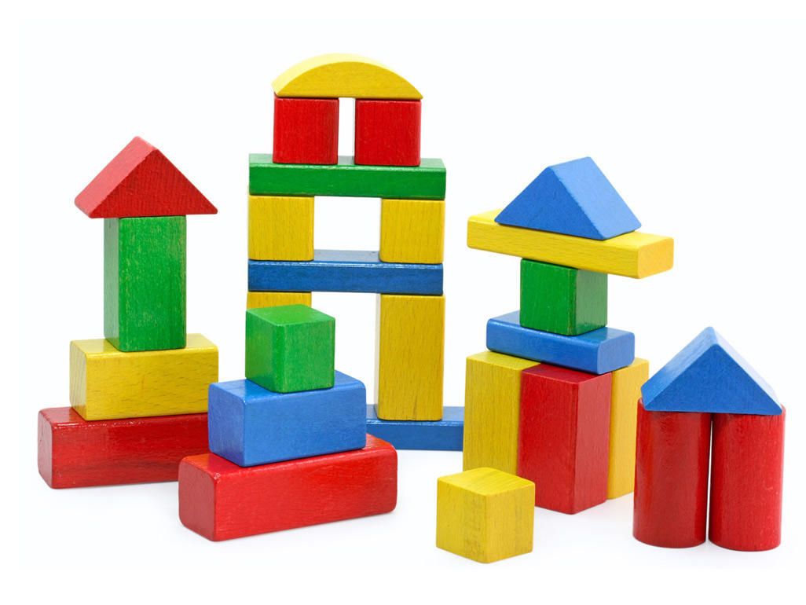
Invite children to build a structure with wood blocks and structures with cardboard or foam blocks. Invite children to push the blocks over and notice which blocks are easier to move. Invite children to build a small, simple structure and invite children to try to move it without tipping it over. If it does tip over, invite them to rebuild it and try again.
As children stack blocks encourage them to count each block as they stack them.

Read aloud: When I build with blocks by Niki Alling https://www.youtube.com/watch?v=TUEKcOf8KE8
Block city: https://www.youtube.com/watch?v=v6SGnsGF0WA
Ask which blocks are the heaviest? Which block is the lightest? What color are the blocks? Can we sort by color? Can we sort by color?
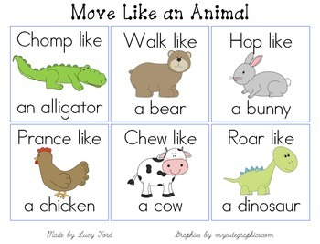
Supply animal costumes or clothing at home such as fabric with animal prints and animal ears. Invite children to pretend to be an animal of their choice and move like animals.
Dance along: https://www.youtube.com/watch?v=CT86Dl442jA
https://www.youtube.com/watch?v=4aVO_31rNQw
read aloud: brown bear brown bear what do you see
polar bear polar bear what do you see
Letter of the week M: make a collage of things that start with the letter M.
Using popsicle sticks create the letter M

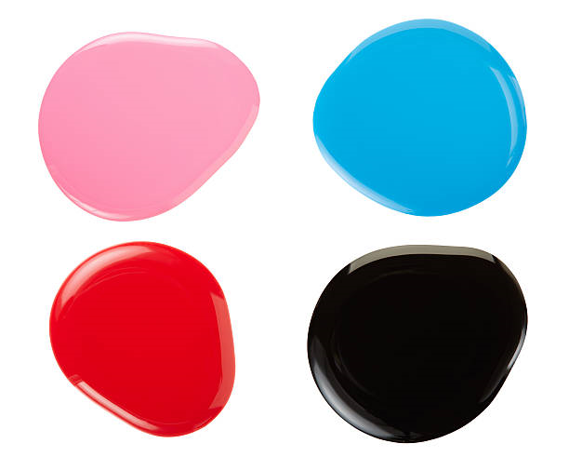
On a tabletop, place small puddles of paint. Invite children to move the paint by blowing on it using a straw or not using a straw.
Questions: what happen to the paint? who made the paint move? What colors do you see? Do the colors touch together?
Read aloud: https://www.youtube.com/watch?v=Qfrf-5WpXks
https://www.youtube.com/watch?v=ie9jyUtmIKs
Writhe the letter M on paper and using cotton balls or balled up paper create the letter M.

Supply a box with hole on top and opening on the side. Invite them to drop objects through the hole into the box and look through the hole to see the objects move. Then sort the objects by size and color also count the objects as you drop them into the box.
Did the objects fall slowly?
Did the objects fall quickly?
Read aloud: https://www.youtube.com/watch?v=FmZCQfeWjeQ
https://www.youtube.com/watch?v=9xxyZSdYEmM
Sing along: https://www.youtube.com/watch?v=RNUZBHlRH4Y

Using construction paper cut out the letter M and create a monster face with crayons or markers and craft paper.

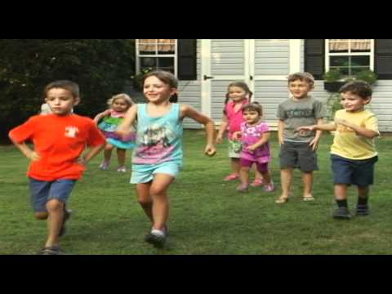

Create visuals that represent go and stop such as red and green sign. Let the children know that you will be playing a game where you will go and stop. Tell them when you lift the green sign that means go and they should move their body. When you lift the red sign, say it means stop and they should stop moving. Children will need some time to understand and comprehend the rules of the game. If they do not stop moving when requested, allow them to continue to move their bodies.

Read aloud: https://www.youtube.com/watch?v=FmIr8xnU7uw
On lined paper parents write the letter M with dotted lines have children trace the letter M with a crayon or marker.

