Greetings Parents,
We hope all is well. Here is our lesson plan for the week of (April 13-17,2020). To continue to allow this transition to remain smooth during this time it’s best that we remain on a set schedule, the schedule that children are used to. Every day we should start off with circle time. During this time songs such as “Good morning how are you and “Days of the week” should be sung with the children. After a book of their choice should be read as well. After circle time is music and movement, during this time songs such as “The wheels on the bus, and Baby shark” should be played and acted out with the children. Following music and movement an activity can be completed. (Please allow your children to be creative, please remember that whatever activity that has been assigned doesn’t need to be perfect. It’s best we allow children to express themselves within their work) This week we will continue with the theme Empty and Full.
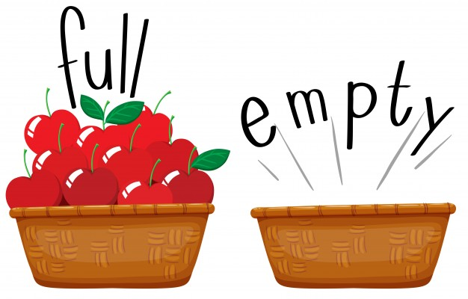

* NOTE FOR PARENTS
During this weeks activities narrate their actions, and talk with them through the experiences using languages such as EMPTY & FULL.

Monday- Fill The Bag & Count
1.Provide children with a sandwich bag and cotton balls. Open the bag and ask them to fill the bag with five cotton balls. While doing so count with them one by one while placing the cotton balls in the bag. Once the bag is filled with the five cotton balls, ask them to remove three. Then count with them of how much more cotton balls are in the bag. You will notice how simple this activity is but how focused your child will become. You can continue this activity with different items of your choice as well.
2.
Completing Puzzles
Provide your child with a puzzle, remove the pieces and encourage them to complete the puzzle. 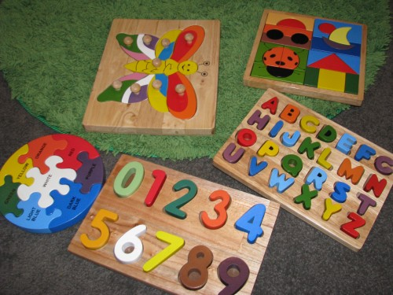

Tuesday- Water Play
1.Provide children with two big bowls, fill one bowl with water. Provide cups and invite children to explore full and empty as they fill cups, pour the water into the other bowl.
2. Story Time
”Ten In The Bed” is a book parents that you can find on line and read to your children this week.
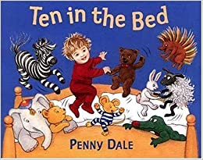
Wednesday- Lets Work Out
1.Sing “baby shark”, “head shoulders, knees and toes”, or “open shut them”. (The children love these songs) While singing these songs the children has the opportunity to stretch their bodies and get a form of exercise.
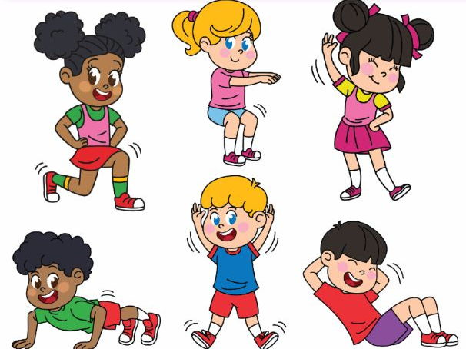

Story Time
2. “ The Hungry Caterpillar” is a book parents that you can find on line and read to your children this week.

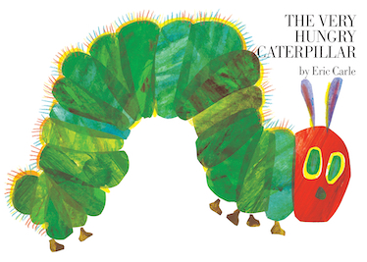

Thursday-Bath Time
1.During this week before bed invite the children to a warm bath, show how the tub is empty, allow them to bring there “bath toys” into the bath with them showing them that the tub is now full.

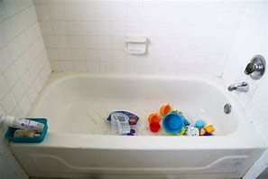

Lets Build
2. Provide children with blocks/ legos and encourage them to build towers. 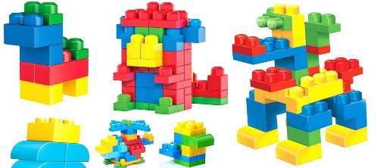
Friday- What’s Your Name
1.Write the letters of your child name on a sheet of paper. Sound out and point to each letter of their name with them. You can also sing “get up and dance” in this song the child name is called and they get up and dance. This song is also fun for music and movement.
Example “I have a friend name Zoey and Zoey is her name, get up and dance Zoey”(The child will then get up once their name is called and begin to dance.)

2. Draw out different shapes on a sheet of paper, color them in. Next go over the name and color of the shape with the child. This will help them to recognize different colors and shapes.
Example- Karon, please point to the RED Heart.
