Hello Parents,
I hope all is well. Here is our lesson plan for the week of (April 6-10,2020). To continue to allow this transition to remain smooth during this time it’s best that we remain on a set schedule, the schedule that children are used to. Every day we should start off with circle time. During this time songs such as “Good morning how are you and “Days of the week” should be sung with the children. After a book of their choice should be read as well. After circle time is music and movement, during this time songs such as “The wheels on the bus, and Baby shark” should be played and acted out with the children. Following music and movement an activity can be completed. (Please allow your children to be creative, please remember that whatever activity that has been assigned doesn’t need to be perfect. It’s best we allow children to express themselves within their work) This week theme will be Empty and Full. 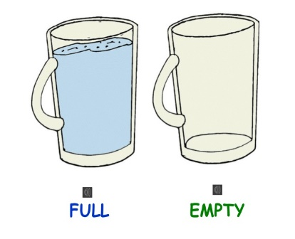

* NOTE FOR PARENTS
During this weeks activities narrate their actions, and talk with them through the experiences using languages such as EMPTY & FULL.

Monday- Let’s Clean Up
While after enjoying themselves children can be invited to cleaning up after themselves which can also be a learning activity.
Provide a large box where the toys will go back in. Have the children look around for toys they can put back in the box to make it full. 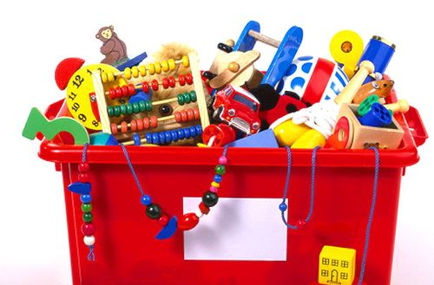

Tuesday- Dramatic Play
While pretending to cook children can be encouraged to help you add ingredients into a bowl. (Water, flour, sugar) 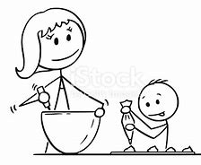

Wednesday- Fill & Empty My Bag
Provide children with their backpacks(lunch bag) and allow them to fill them up with their favorite snack. When lunch time arrives they can be encouraged to empty out their bag and enjoy their snacks and lunch with you.
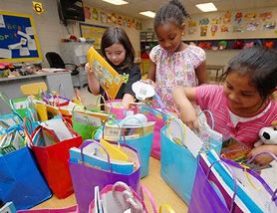

Thursday-Bath Time
During this week before bed invite the children to a warm bath, show how the tub is empty, allow them to bring there “bath toys” into the bath with them showing them that the tub is now full.
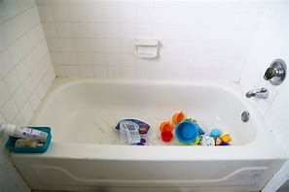

Friday-Coloring
On a “empty” sheet of paper provide the children with different colored crayons, encourage the children to color the whole sheet, making the sheet “full” of colors. 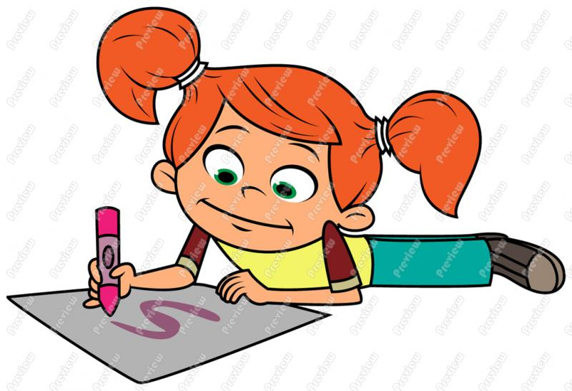

Extra Activity-Cotton Balls & Numbers
Provide children with a bowl filled with cotton balls. Encourage them to transfer the cottons balls into a bag, while doing so, count each cotton ball that are removed.

