Gross motor Disney frozen yoga
https://www.youtube.com/watch?v=xlg052EKMtk

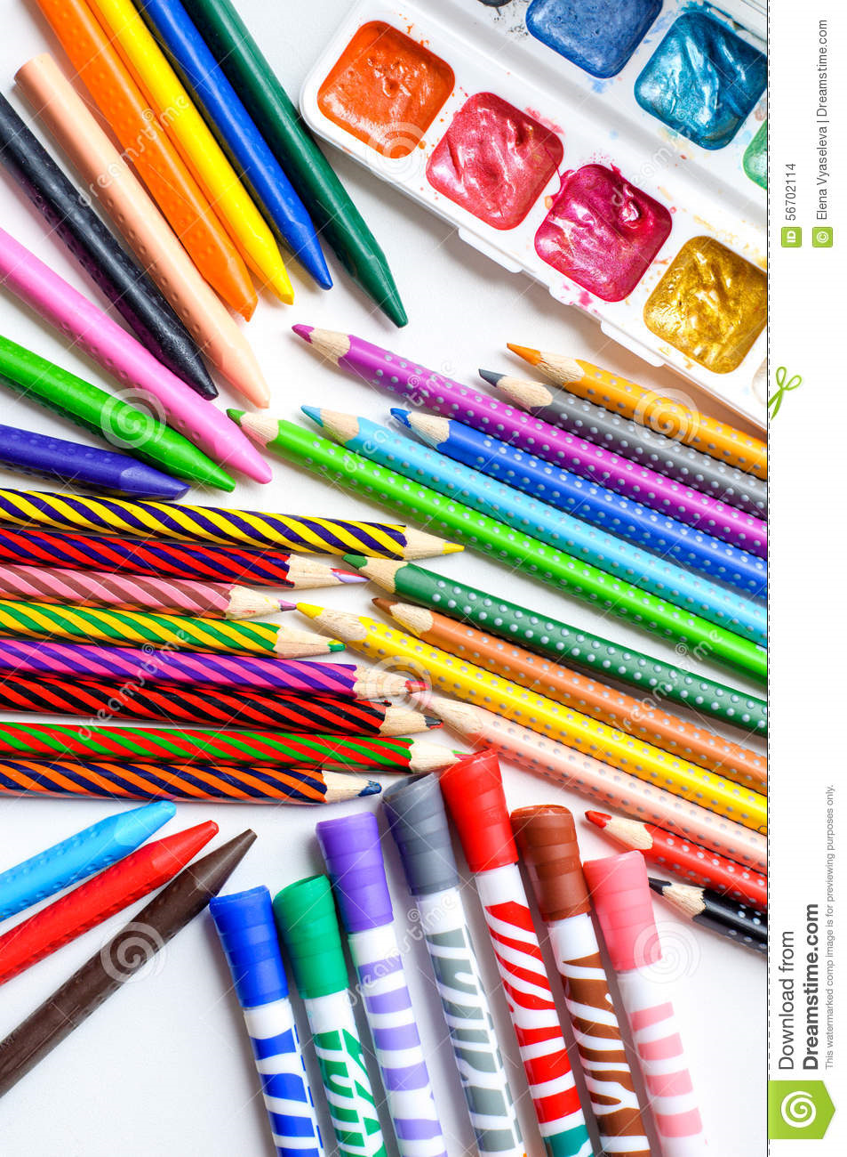
Supply paper, markers or crayons. Invite children to color or draw and discuss the marks they are making by moving their arms.

Letter of the week is A
Make a collage of things that start with the letter A

Gross motor Disney frozen yoga https://www.youtube.com/watch?v=xlg052EKMtk
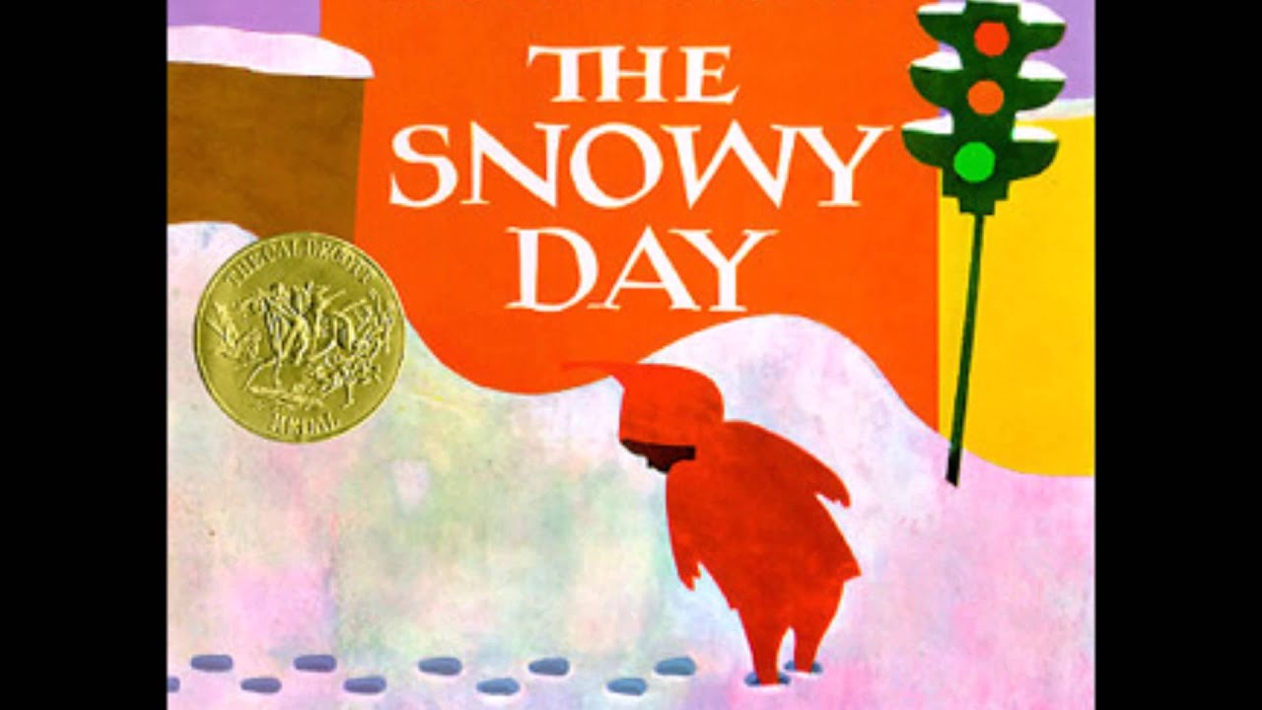
Introduce the book The Snowy Day by Ezra Jack Keats. Make goop and supply sticks or using cotton balls as pretend snow. Invite children to move the sticks through the snow like Peter.
Story: https://www.youtube.com/watch?v=FmZCQfeWjeQ&t=80s
Using the letters in your name count how many letter A’s you can find?

Gross motor Disney frozen yoga https://www.youtube.com/watch?v=xlg052EKMtk

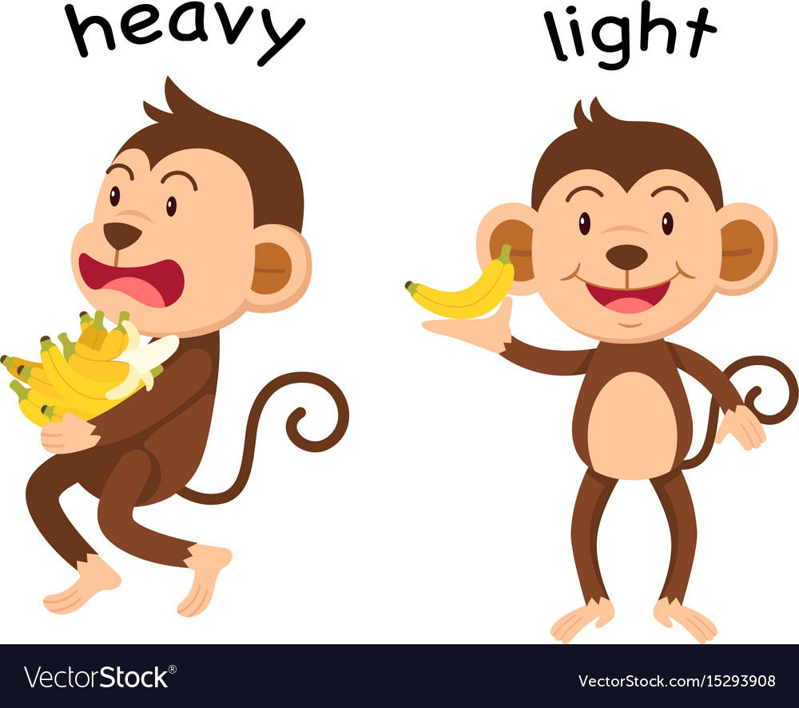

Supply items that are different weights such as feathers and small vehicles. Invite children to drop them at the same time and see if they move at different speeds.

Letter of the week A: parents draw the letter A on a piece of paper and have your child trace the letter with their finger first then trace it with a crayon or marker,

Gross motor Disney frozen yoga https://www.youtube.com/watch?v=xlg052EKMtk
Letter of the week A: parents have your child pronounce the letter A as long “a” sound as in ate or “uh” as in above.
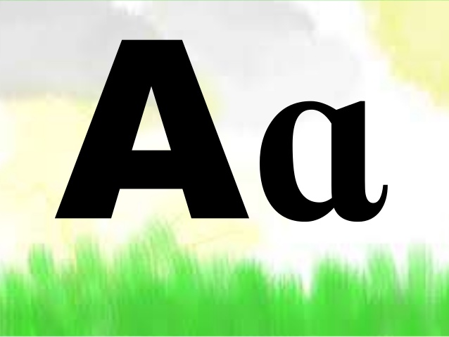
Parent draw the letter A on a large piece of paper and then cut small slits on the lines of the letter A. then have your child use a string or a piece of yarn and lace it through the slits.

Video: https://www.youtube.com/watch?v=Ijs5PWJ86AY

Gross motor Disney frozen yoga https://www.youtube.com/watch?v=xlg052EKMtk

Video: https://www.youtube.com/watch?v=fwdL6gC7kVQ

Using popsicles sticks create an upper-case letter A

