Tugging lid ( Hand eye coordination)
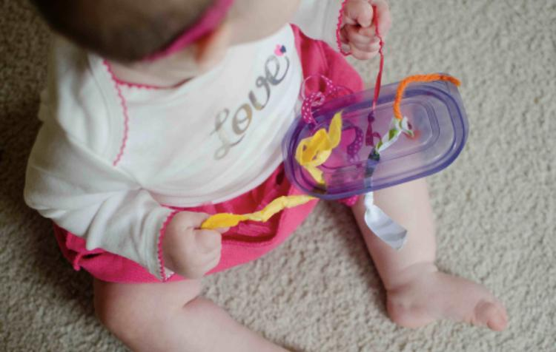

Material:
- Tupperware lid
- scissors
- ribbon

Directions: Get an old Tupperware lid and punch some holes in it with a pair of scissors. Once you punched a few holes in the lid, thread ribbon in the holes and knot both ends. This will make it easier for your little one to tug on one side and the ribbon will come through.

Sensory bags
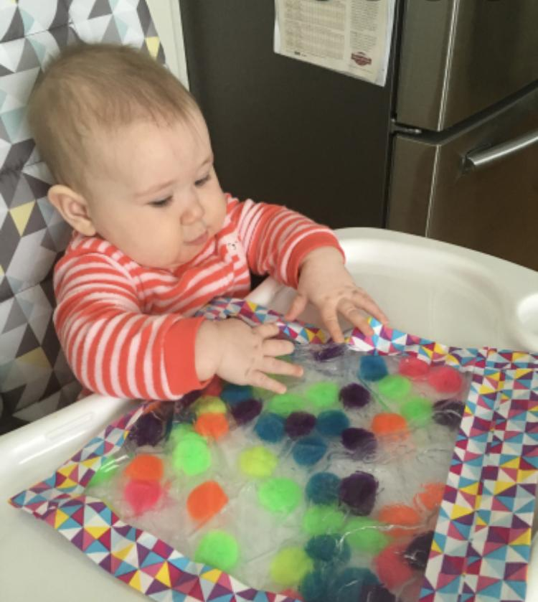

Material:
- Hair gel
- Food coloring
- Ziploc bag
- Tape
- Small objects Ex. Pom poms, googly eyes etc.

Directions: Squeeze Gel into Ziploc bag and add a few drops of food coloring. Once you get your desired color. Add the object you chose into the Ziploc and zip it close. After zipping it closed, tape the edges of the bag to ensure that the gel does not leak out. Once the edges of the ziplock bag are secured. You can sit with your little one and have them squeeze the bag and explore the different textures. Another way your child can enjoy this activity is by tapping the sensory bag on your child’s high chair or on the floor so they can manipulate it that way as well.

Peek A-Boo/Hide-and-seek
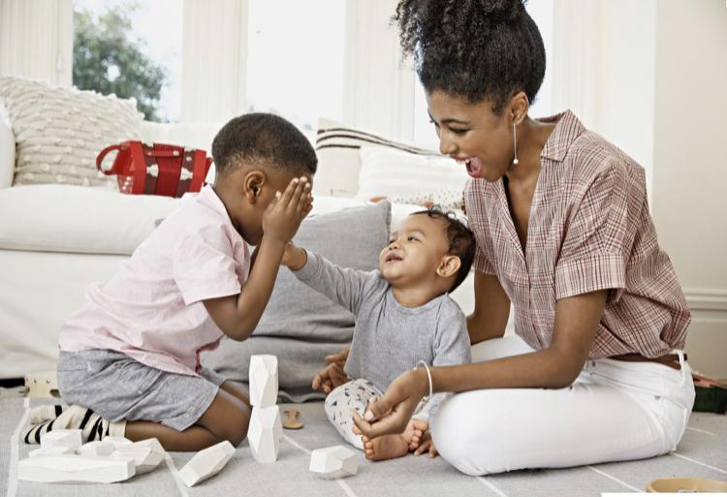

These two fun simple games keep your little one engaged while learning object performance.

What is object permanence? Object permanence is the understanding that objects continue to exist even when they cannot be seen, heard, touched, smelled or sensed in any way.

