**Gross Motor Activities**

**Push and pull**

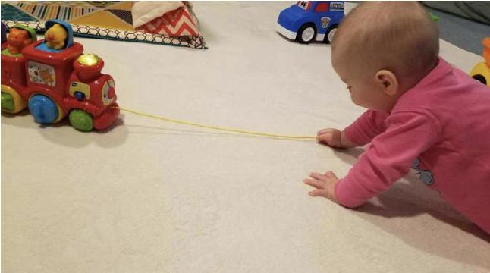

Material:

* Toy with wheels
* String

Directions: Attach string on a toy of your choice and encourage the baby to pull the string and then push the toy away.

*Prior to handing the string to your little one, model the play.

**Roll the ball**



Material:

* Small/Medium ball

Directions: Sit your baby in front of you and roll him/her a ball. Make sure you show your baby how you’re rolling the ball. Then encourage her baby to roll the ball back to you. Clap and sing, or tell “yaaay, you rolled the ball!” When your baby does throw the ball away.

**Crunch and rip the magazine**

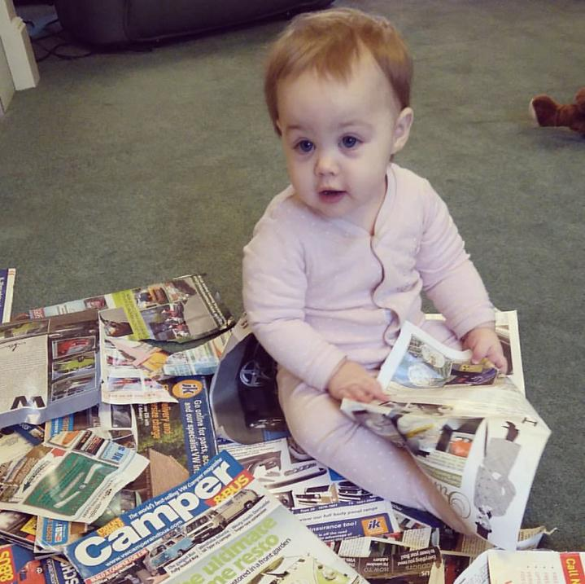

Material:

* Magazine

Directions: Give your baby one of those sturdy magazines and let him/her crunch and rip pages of the magazine. Ripping out pages of the magazine requires strong muscles in your babies arms! It’s a great practice of arm muscle as well as those belly muscles. If your baby can’t sit by himself/herself yet, put a nursing pillow behind, or sit behind your baby for support.

**This activity is meant to be supervised. DO NOT let your baby eat the paper – choking hazard!**