Unit 8 Plants: children move from exploring the properties and uses of water to observing and learning about different kinds of plants. As we prepare to teach this unit, let’s consider how different kinds of plants are part of our children’s daily lives.
FOCUS: What are some different types of plants?

Monday April 20, 2020
*Parents if you can, please take pictures of your child's
completed work/activity and send to Google Classroom: https://classroom.google.com/u/0/c/NzcwMTQ1MTkyODRa

Vocabulary words of the day: bush, cactus, evergreen
Letter of the week: T
eBook/YouTube story of the week: “An Orange in January” by Dianna Hutts Aston
YouTube link to story: https://www.youtube.com/watch?v=3FfZL8BSyak
Level 1: Recall
Questions to ask once the story has ended:
- Where was the orange at the beginning of the book?
- Where was the orange at the end of the book?
- How did the orange get from the tree to the grocery store?

Music and Movement
Learn the letter T: https://www.youtube.com/watch?v=1yl9p--gElU
Yoga Time-On the farm: https://www.youtube.com/watch?v=YKmRB2Z3g2s
PK.CKW.7 (The Arts): Expresses what s/he knows, thinks, feels and believes through dance and creative movement.

Math Activity
Adding Numbers with Seeds: Write the number 8. Provide seeds for your child to place on the number 8. Talk with your child and ask them to show you eight fingers. Finding the total, or sum, by combining two or more numbers. Example: 5+3= 8 is an addition. On a piece of paper draw a circle and put 5 seeds then draw the plus sign. Make another circle and put 3. Say to your child “you have 5 seeds and now where going to add 3 more. How many seeds do we have all together? Have your child count all the seeds. Try one more 4+4=8
PK.CKW.3 (Counting and Cardinality): Understand the relationship between numbers and quantities to 10; connect counting to cardinality.

Art Activity:
Tell your child: Fruits and trees do seem to go hand in hand. After all, oranges and apples do grow on trees. So do many other fruits. Do you know any other fruits that may grow on trees? Here are some fruits that grow on trees: apricots, cherries, lemons, limes, coconuts, grapefruits, mangos, nectarines, peaches, pears, persimmons, plums, and pomegranates, to name just a few! But that’s not all the fruit watch the video link below and make your fruit tree. What is your favorite fruit that grows on a tree? Remember at lunch we always at fruit!!!! Invite your child to draw, paint, or make a collage to make a fruit tree.
YouTube video: https://www.youtube.com/watch?v=S_6T-vO2QMU
PK.CKW.1 (The Arts): Expresses oneself and represents what s/he knows, thinks, believes and feels through visual arts.

Tuesday April 21, 2020
*Parents if you can, please take pictures of your child's
completed work/activity and send to Google Classroom: https://classroom.google.com/u/0/c/NzcwMTQ1MTkyODRa
Vocabulary words of the day: Introduce the letter “T”
What starts with the letter T? did you say tree? Great job
Letter of the week: T
eBook/YouTube story of the week: “An Orange in January” by Dianna Hutts Aston
YouTube link to story: https://www.youtube.com/watch?v=3FfZL8BSyak
Questions to ask once the story has ended:
- The book says, “The petals fell away and the orange began to grow into what it was meant to be.” What was the orange meant to be?
- How did the boy get the orange?

PK.CLL.5 (Speaking and Listening Standards): Add drawings or other visual displays to descriptions as desired to provide additional detail.

Music and Movement
Tree Pose: https://www.youtube.com/watch?v=bG4ValU7TmI
Yoga Time-On the farm: https://www.youtube.com/watch?v=YKmRB2Z3g2s
Green grass grows all around: https://www.youtube.com/watch?v=AkAOeIMypg8

PK.CKW.7 (The Arts): Expresses what s/he knows, thinks, feels and believes through dance and creative movement.

Science Activity:
Can you make a tree stand? In this simple project, cardboard from a cereal box and a toilet paper tube are turned into a cute free-standing tree.

Materials needed:
- Green cardstock or cardboard from a cereal box (or other stiff paper)
- A tube from a roll of toilet paper
- Green paint
- Brush
- Safe Scissors
- Optional: red paper circles and glue, glitter, markers, tiny pom-pom spheres, etc.
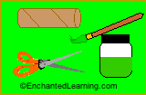
- Make the tree trunk: Cut two 1/2 inch slits in the tube, one on each side (this is where you will insert the paper treetop)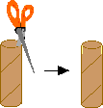
- Using stiff green cardstock (or thin cardboard from a cereal box), cut out a large treetop
- When the paint is dry, add decorations to the tree if you like. And don't forget to sign it.
- If you used non-green cardboard, paint the treetop green. Let it dry
- To turn your tree into a fruit tree, paint fruit on it or cut out small colored paper circles and glue them onto the treetop.

Did your tree fall or did it stand tall?
PK.CKW.5 (Science): Observes and describes characteristics of living things.

Computer Technology Activity:
Ask your child What is a plant? Then explain to your child: Plants are living things that grow on land or in water. They can be in the snowy mountains slopes to dry, hot deserts, plants can survive almost anywhere on the Earth. All plants make their own food, taking energy from sunlight. Unlike animals, plants cannot move from place to place, and most are rooted in the ground.

Click the link to watch a video on “Types of Plants” https://www.youtube.com/watch?v=LW0jUbKcn1I

Can you find different types of plants: Trees, Scrubs, Vines, and Herbs?
Try to Screenshot your findings and send it please
PK.CKW.5 (Technology): Uses the knowledge of technology to increase learning.

Wednesday April 22, 2020
*Parents if you can, please take pictures of your child's
completed work/activity and send to Google Classroom: https://classroom.google.com/u/0/c/NzcwMTQ1MTkyODRa

HAPPY EARTH DAY !!!
Vocabulary words of the day: herbs, seaweed, succulent
eBook/YouTube story of the week: “An Orange in January” by Dianna Hutts Aston
YouTube link to story: https://www.youtube.com/watch?v=3FfZL8BSyak

Questions to ask once the story has ended:
Level 3: Strategic Thinking
1. The boy shared the orange. Why do you think he did that?
2. How do plants and gardens make you feel?

Writing Activity:
Letter Name tree: What letters are in your name? Parents please help your child make leaves using paper or construction paper. Cut the leaves. Then have them write each letter of their name on a leaf. After making the leave have them draw the bark of the tree to glue their leaves on!!! If they are capable of writing their first name without help you can teach them their last name and add the leaves on the bottom.
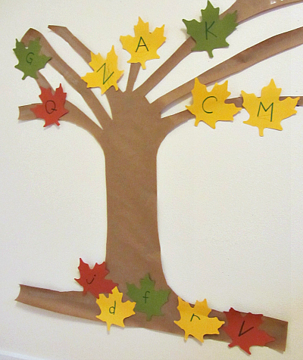

Fine Motor/ Writing Activity:
Write the letter of the week T: Ask your child to think about names related to plants. Example: Tree, Tulips. What other words do you think that start with T? paretns help your child write them.

PK.CLL.2 (Language Standards): Demonstrate command of the conventions of standard English grammar and usage when writing or speaking.

Art activity
Since it is Earth day lets celebrate!
The Earth has been around for billions of years! Wow that’s a lot of years! Get creative and create the earth as you see it! How can you help the Earth? How can you help where we live? Please send pictures and write your child’s response to share for Earth Day!
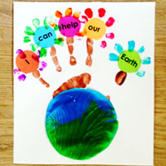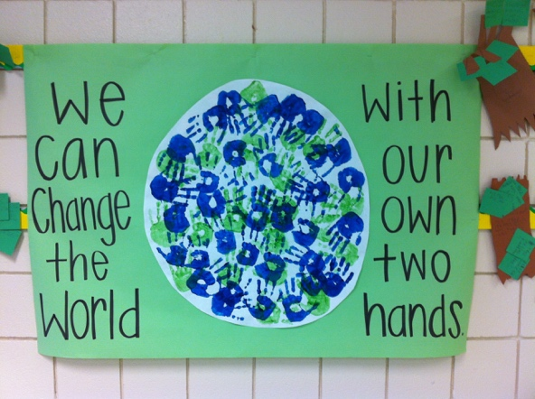

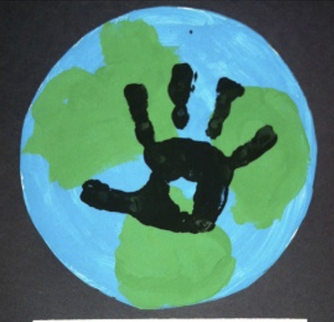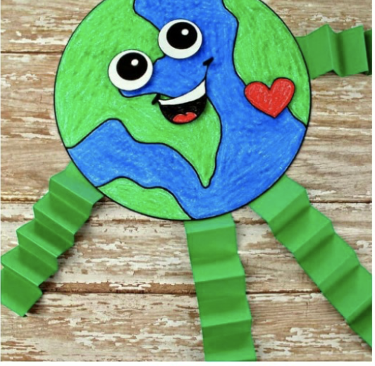

Thursday April 16, 2020
*Parents if you can, please take pictures of your child's
completed work/activity and send to Google Classroom: https://classroom.google.com/u/0/c/NzcwMTQ1MTkyODRa
Vocabulary words of the day: tree, weeds, vegetables,
Review letter: T
eBook/YouTube story of the week: “An Orange in January” by Dianna Hutts Aston
YouTube link to story: https://www.youtube.com/watch?v=3FfZL8BSyak

Questions to ask once the story has ended:
Level 4: Extended Thinking
- The illustrator of this book, Julie Maren, used curly lines to show the wind. Why do you think she did that? How would you show wind in a picture?
- How did Julie Maren illustrate the sun? Why do you think she did that? How would you show the sun in a picture?
Music and Movement:
Enzo the bee Yoga: https://www.youtube.com/watch?v=nqQN4ugzj_g
What’s the weather song: https://www.youtube.com/watch?v=Jn7uAsLWXpk

Art activity:
Look outside your window: What is the weather today? Is it sunny, cloudy, rainy, snowing? Draw a picture of todays weather and explain what you made.
Parent please write their response but let them write the word SUN, CLOUD, RAIN, OR SNOW. How do you feel? How does the weather make you feel?
K.CKW.2 (The Arts): Responds and reacts to visual arts created by themselves and others.

Math Activity:
Let’s make a flower! Draw a two flowers without the leaves on a piece of paper. Use noodles, seeds, cereal or whatever items you have. Count 8 seeds. Glue them to the flower as petals. Now Count 7 seeds and glue them to the other flower as petals. Which flower has more? Circle the flower that has more.
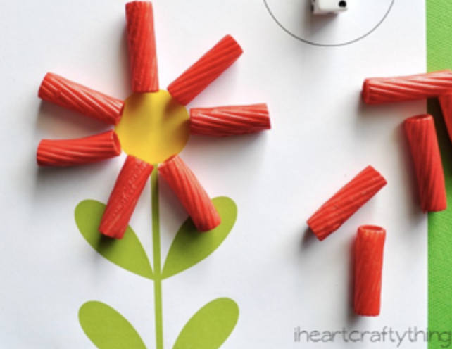
PK.CKW.3 (Counting and Cardinality): Understand the relationship between numbers and quantities to 10; connect counting to cardinality.

Reading activity
Chicka Chicka Boom Boom
YouTube Video: https://www.youtube.com/watch?v=VdrTXRD090U
Since we are practicing the Letter T for tree
Can you find a few items in your home that start with the letter T? Have your child look around and tell you which items start with the letter T. Help them search around. What does T sound like?
Example: table, tv, toy, tablet, a pets tail, towel etc.

Friday April 17, 2020
*Parents if you can, please take pictures of your child's
completed work/activity and send to Google Classroom: https://classroom.google.com/u/0/c/NzcwMTQ1MTkyODRa

Vocabulary words of the day: water lily, tree
Review letter: T
eBook/YouTube story of the week: “An Orange in January” by Dianna Hutts Aston
YouTube link to story: https://www.youtube.com/watch?v=3FfZL8BSyak
Level 4: Extended Thinking
- The illustrator of this book, Julie Maren, used curly lines to show the wind. Why do you think she did that? How would you show wind in a picture?
- How did Julie Maren illustrate the sun? Why do you think she did that? How would you show the sun in a picture?

Music and Movement:
Enzo the bee Yoga: https://www.youtube.com/watch?v=nqQN4ugzj_g
What’s the weather song: https://www.youtube.com/watch?v=Jn7uAsLWXpk

Today is catch-up work day! Any work/activities you were unable to complete you can do it today! Don’t forget to load all your work onto Google classroom.

