Unit 8 Plants: children move from exploring the properties
and uses of water to observing and learning about different kinds
of plants. As we prepare to teach this unit, let’s consider how
different kinds of plants are part of our children’s daily lives.
FOCUS: WHAT DO PLANTS NEED AND WHERE DO WE FIND THEM?

Monday April 13, 2020
*Parents if you can, please take pictures of your child's
completed work/activity and email to: Creativesoulsllc@gmail.com

Vocabulary words of the day: farm, garden, water, sunlight
Letter of the week: G
eBook/YouTube story of the week: “The Curious Garden” by Peter Brown
YouTube link to story: https://www.youtube.com/watch?v=6SHmN-wXykU
Level 1: Recall
Questions to ask once the story has ended:
- Where did the garden start growing?
- Where did the garden spread?
- What did Liam do in the winter?

Music and Movement
Yoga Time-On the farm: https://www.youtube.com/watch?v=YKmRB2Z3g2s
Curious Garden Song: https://www.youtube.com/watch?v=MqAv8Aw2J7c
PK.CKW.7 (The Arts): Expresses what s/he knows, thinks, feels and believes through dance and creative movement.
Art Activity
3D Plants: Invite children to used recycled materials such as cardboard boxes or tubes, clean containers, to create three dimensional plants. Show pictures of plants for children to reference as they build their own plants. Encourage children to name the plants and make their own labels for them.
PK.CKW.1 (The Arts): Expresses oneself and represents what s/he knows, thinks, believes and feels through visual arts.

Math Activity:
Seeds in a Strawberry: Cut out several paper strawberries. Add a number to each one and ask children to put the same amount of seeds on each strawberry. This can also be implemented with another types of fruit, petals on a flower, or leaves on a plant. Encourage your child to write their own numbers.
PK.CKW.3 (Counting and Cardinality): Understand the relationship between numbers and quantities to 10; connect counting to cardinality.
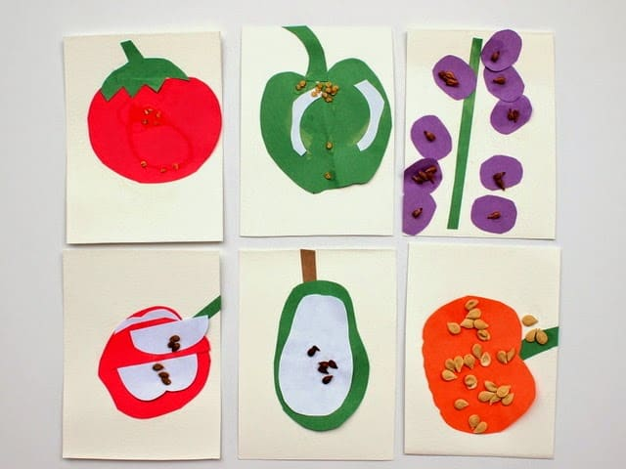
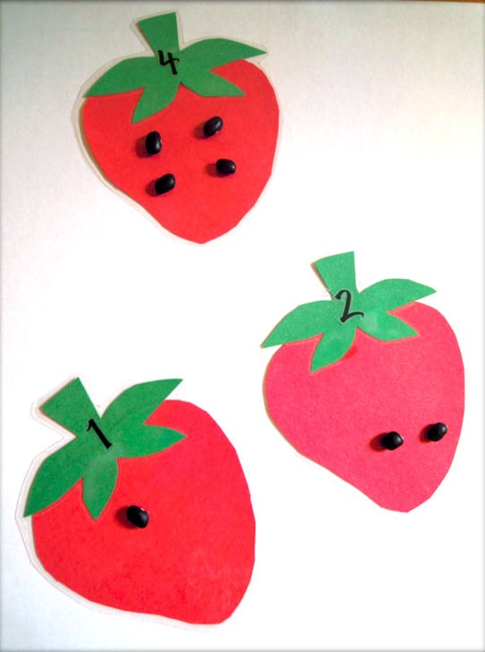

Tuesday April 14, 2020
*Parents if you can, please take pictures of your child's
completed work/activity and email to: Creativesoulsllc@gmail.com
Vocabulary words of the day: Introduce the letter “G”

eBook/YouTube story of the week: “The Curious Garden” by Peter Brown
YouTube link to story: https://www.youtube.com/watch?v=6SHmN-wXykU
Questions to ask once the story has ended:
- How does the city look at the beginning of the book?
- How does the city look at the end of the book?
- Do you prefer the way city looks at the beginning of the book or the end? Why?

Have your child draw a picture of the city!

PK.CLL.5 (Speaking and Listening Standards): Add drawings or other visual displays to descriptions as desired to provide additional detail.

Music and Movement
Yoga Time-On the farm: https://www.youtube.com/watch?v=YKmRB2Z3g2s
Curious Garden Song: https://www.youtube.com/watch?v=MqAv8Aw2J7c
PK.CKW.7 (The Arts): Expresses what s/he knows, thinks, feels and believes through dance and creative movement.

Science Activity: Grow Beans in a Bag
- Materials needed:
- A plastic zip top baggie (you can use a sandwich size baggie, but a quart-size baggie works, too.)
- One paper towel
- A few bean seeds (you can use dry beans from the pantry like pinto, black, lentil, kidney etc.)
- Fold up the paper towel so that it fits easily inside the plastic baggie. Wet the paper towel and slipped it into the baggie.
- Place the beans inside the baggie right on top of the paper towel and seal the bag.
- Sit by the window and watch it grow it will take a while! Do not throw it out please be patient.

Observe the beans together with your child. what the bean look like? How does it smell? How does it feel? After observing the bean, they can write or draw about it.
PK.CKW.5 (Science): Observes and describes characteristics of living things. 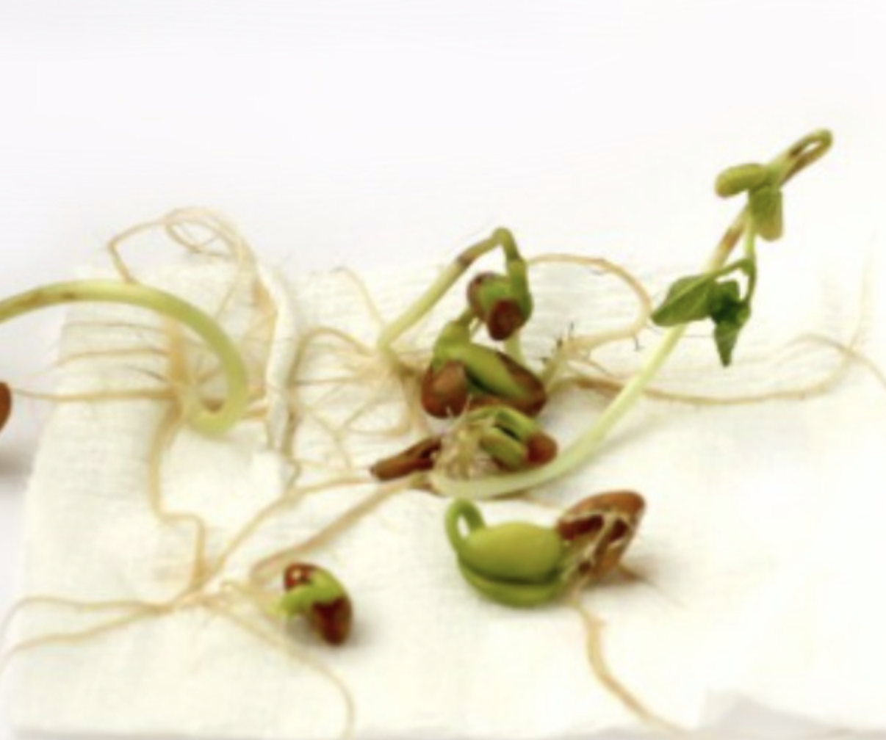 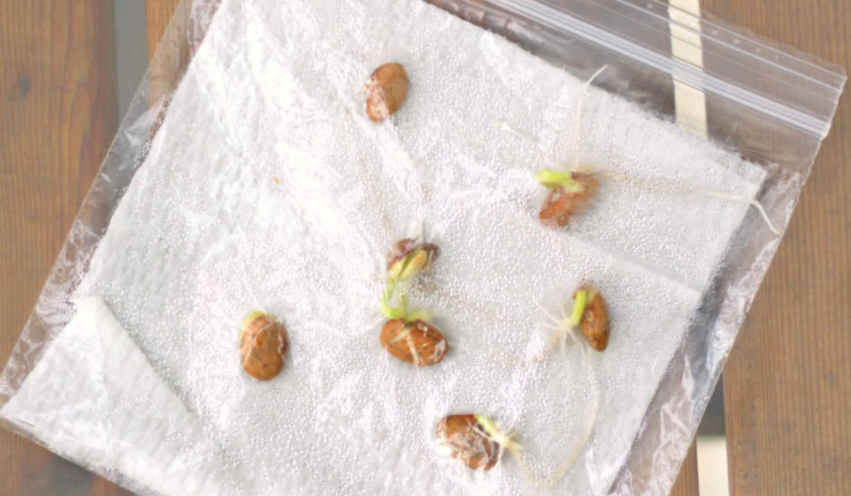

Music and Movement:
Plant Song: Share the song below with your child. Sing or chant
it multiple times inviting your child to join in as he/she feels
comfortable. Consider adding gestures to the song as well.

Plants need soil,
Plants need light.
Water plants so they
grow right.
If you want your plants to
grow,
This is what you need to
know.
Plants need soil,
Plants need light.
Water plants so they
grow right.

PK.CKW.5 (Science): Observes and describes characteristics of
living things.

Arts & Craft Activity:
Plants grow everywhere. They grow on land, in the ocean, in lakes and rivers, on mountain tops, and in the desert. Even Antarctica, perhaps the harshest climate in the world, has two flowering plants.
Draw a picture of where you see plants grow.
PK.CKW.2 (The Arts): Responds and reacts to visual arts
created by themselves and others.

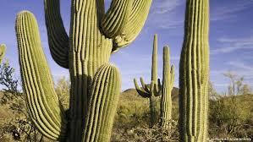
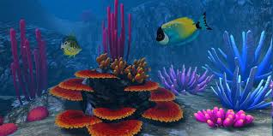

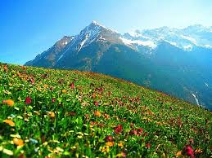

Wednesday April 15, 2020
*Parents if you can, please take pictures of your child's
completed work/activity and email to: Creativesoulsllc@gmail.com

Vocabulary words of the day: landscape, lawn, nature
eBook/YouTube story of the week: “The Curious Garden” by Peter Brown
YouTube link to story: https://www.youtube.com/watch?v=6SHmN-wXykU

Questions to ask once the story has ended:
Level 3: Strategic Thinking
1. Do you think people in the city felt different after there were many gardens growing in the city? why or why not?
2. How do plants and gardens make you feel?

Cooking Activity:
Play dough Prints: Invite your child to help create a batch of play dough. As you prepare the play dough talk with him/her about how the ingredients came from plants such as how the flour was grown, harvested and ground. After the dough is complete, allow your child to use parts of plants such as leaves, stems, flowers etc. to create prints in the dough.
For instructions please see YouTube link: https://www.youtube.com/watch?v=jv73CEzY1jg

PK.CKW.1 (Science): Asks questions and makes predictions based on observations and manipulation of things and events in the environment.

Fine Motor/ Writing Activity:
Write the letter of the week G: Ask your child to think about names related to plants. Who plants the seeds? Where do you plant the seeds? (garden, gardener, grass, greenhouse, ground, grow) Write the names of their findings on a piece of paper and invite your child to copy the letter under the one you wrote. Some
children might be able to just write the letters after you spell each letter for them.

PK.CLL.2 (Language Standards): Demonstrate command of the conventions of standard English grammar and usage when writing or speaking.

Thursday April 16, 2020
*Parents if you can, please take pictures of your child's
completed work/activity and email to: Creativesoulsllc@gmail.com
Vocabulary words of the day: botanist, bouquet, courtyard
Review letter: G
eBook/YouTube story of the week: “The Curious Garden” by Peter Brown
YouTube link to story: https://www.youtube.com/watch?v=6SHmN-wXykU

Questions to ask once the story has ended:
Level 4: Extended Thinking
1.Can you be a gardener? Why or why not?
2. If you were going to grow a garden, what would you need? What would you do?
Write down your child’s response and have them draw a picture based on question #2

Computer and Technology activity:

Plants Around the world: Pull up pictures of plants that grow in different parts of the world or may be novel to the children. For example, succulents, palm trees and cattails may be plants that children in New York City do not see on a regular basis. Invite children to take notes while they look at different types of plants. For example, they can draw pictures of what they see or write letters they hear in the names of plants they hear or see on the screen. Provide various types of paper commonly used for note taking such as lined paper, post-it notes etc. Children can draw or write what they find and use these pictures and notes to influence their work.

YouTube video to watch: https://www.youtube.com/watch?v=vEeHj7wzyg8
PK.CLL.2 (Writing Standards): With prompting and support, use a combination of drawing, dictating, or writing to compose informative/explanatory texts in which they name what they are writing about and supply some information about the topic.

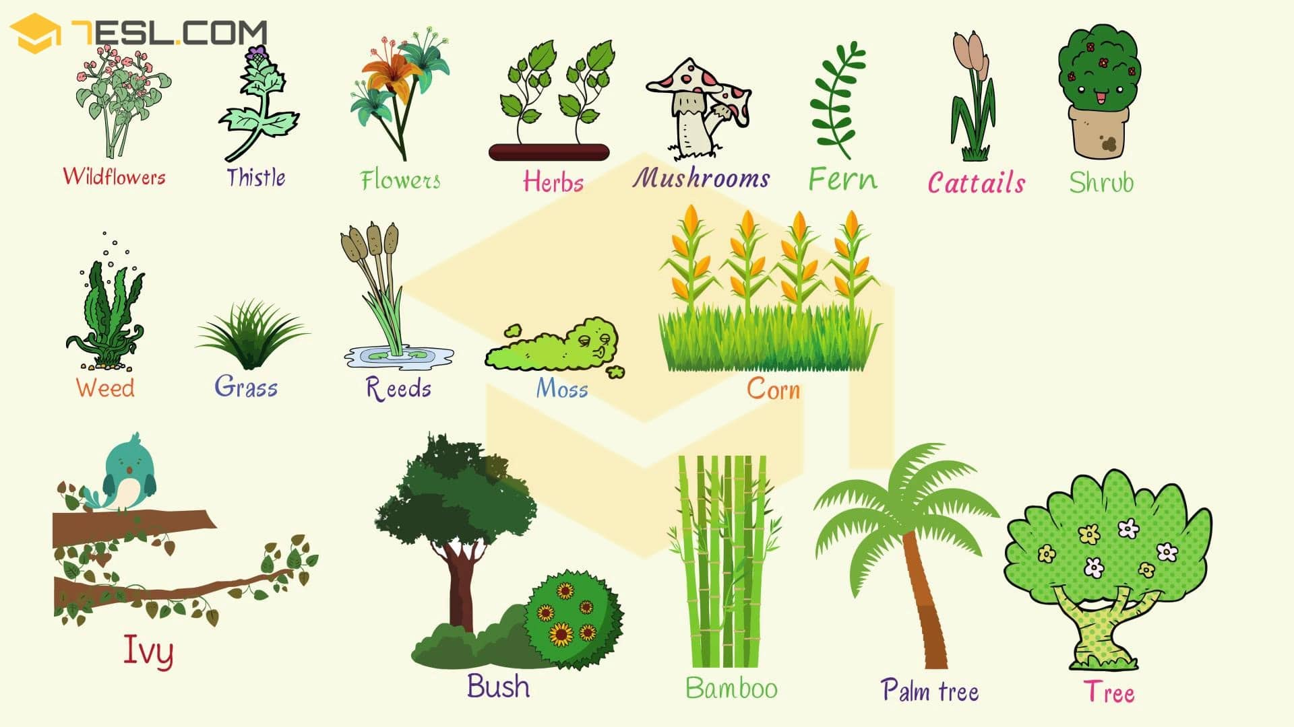

Math Activity:
Counting Garden: This is a great way for kids to work on their listening skills while practicing counting as well as learning cause and effect: plant a seed, grow a flower.
Materials needed:
- Colored Paper
- Popsicle Sticks
- “Garden” container (or two plastic cups)
- Glue and/or tape
- Rice/Sand/Lentils, etc.
- Big Seeds or beans for “planting”
Using the colored paper create ten flowers. Number each flower and attach it to the top of a popsicle stick. Create a divided garden so that one side is filled with sand/rice/lentils to hold up the flowers and the other side is bare so you can hear seeds drop. You could also use two plastic cups (one empty and one partially filled with rice). Involve your child in whichever parts of the crafting process are appropriate.
PK.CKW.3 (Counting and Cardinality): Understand the relationship between numbers and quantities to 10; connect counting to cardinality.

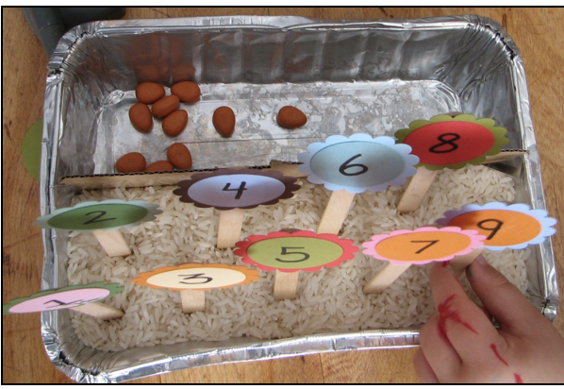
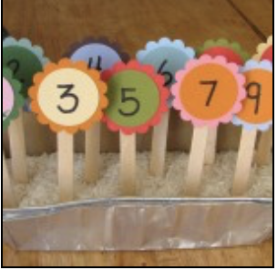

Music and Movement
Yoga Time-On the farm: https://www.youtube.com/watch?v=YKmRB2Z3g2s
Curious Garden Song: https://www.youtube.com/watch?v=MqAv8Aw2J7c
PK.CKW.7 (The Arts): Expresses what s/he knows, thinks, feels and believes through dance and creative movement.

Friday April 17, 2020
Vocabulary words of the day: park, patio, terrarium, environment
Review letter G
eBook/YouTube story of the week: “The Curious Garden” by Peter Brown
YouTube link to story: https://www.youtube.com/watch?v=6SHmN-wXykU

Music and Movement
Yoga Time-On the farm: https://www.youtube.com/watch?v=YKmRB2Z3g2s
Curious Garden Song: https://www.youtube.com/watch?v=MqAv8Aw2J7c

Math Activity:
How Many seeds do you need? You can use rice, dry beans, or seeds.
PK.CKW.3 (Counting and Cardinality): Understand the relationship between numbers and quantities to 10; connect counting to cardinality.

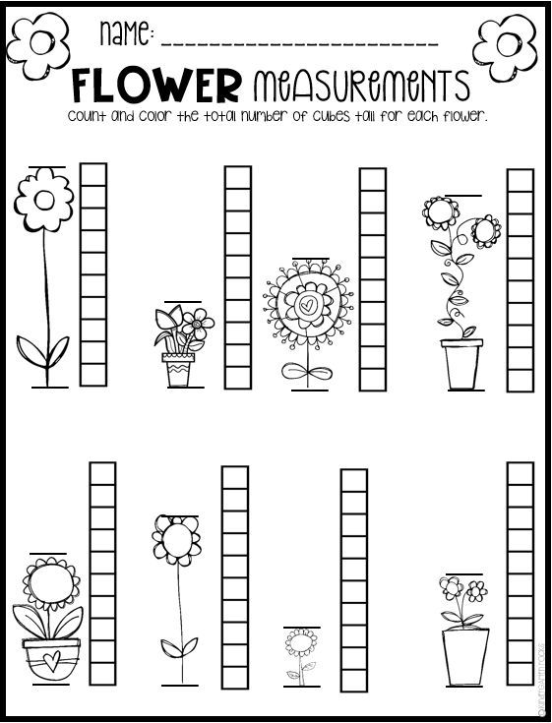

Reading/ Writing activity
“Lola Plants a Garden” by Anna McQuinn
YouTube Video: https://www.youtube.com/watch?v=OC7qurRN37A
After you watch the read aloud video create your own garden book just like Lola!
You can use different construction paper or writing paper and fold it in half to make a book. You can great creative use whatever materials you have at home. (ribbons, glitter, buttons, beads, etc.) You can even glue seeds on your flowers you draw. You can draw a garden with different vegetables, fruit and seeds! Have fun its your own Garden!
Below I created Garden Book using what I have here at home.
K.CKW.1 (The Arts): Expresses oneself and represents what s/he knows, thinks, believes and feels through visual arts.
PK.CLL.2 (Approaches to Communication): Demonstrates he/she is building background knowledge.
PK.CLL.2 (Reading Standards for Literature): With prompting and support, retell familiar stories.

