Hello Parents!

As Preschool teachers, we are providing your child with a home school connection. Here are some ideas to keep your child’s school schedule at home. Let’s bring Ready Set Learn into your home!

Tip #1: Circle Time

-Youtube Kids: Dance Your Sillies Out, Party Freeze,

Tip #2: Make a monthly calendar

- During circle time your child engages in learning about the calendar.

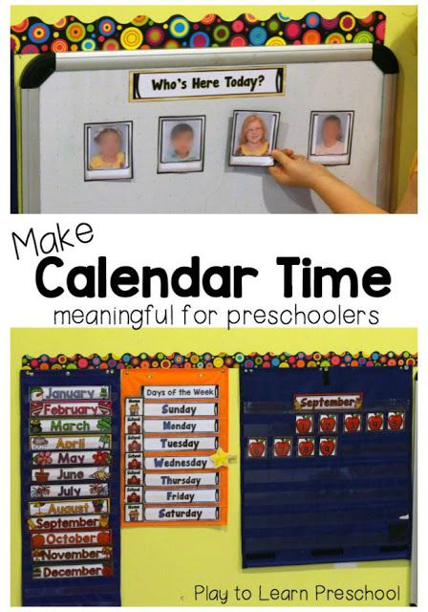

Tip #3: Go over Shapes, Numbers, Colors

Below are some more activities and experiments you and your child can do at home.

**Arts & Crafts:**

**Activity Week#1 Day 1**

**Flower Cotton Balls**

1.Children can be given cotton balls and explore the softness of the material.

2.Children can be encouraged to paint with water and cotton balls. (Place a sheet of colored construction paper on a table or hard area, fill a bowl with water, soak a few cotton balls with different paint colors and hand them to your child). Take one in your hand and start dabbing it on the construction paper and create a flower.

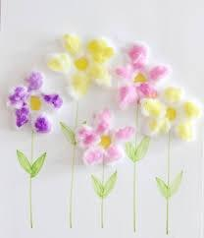

**Activity Week#1 Day 2**

**Identifying Shapes of Color**

1.Draw out different shapes on a sheet of paper, color them in. Next go over the name and color of the shape with the child. This will help them to recognize different colors and shapes.

Example- Ms. J , please point to the RED Heart!

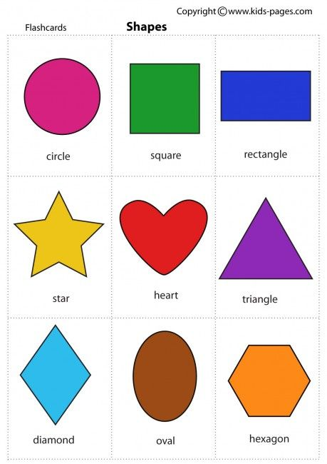

**Activity Week #1 Day 3**

**Sticker Line-Up Fine Motor Activity**

1.On a 3 foot long construction paper draw a mix of zig-zag, curly, loopy, and swirly lines down the center of the paper.

2.Use stickers to “trace” the line. Children peeling the stickers from their sheet and lining them up on the paper.

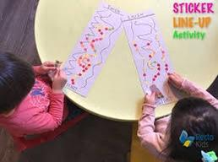

**Activity Week #1 Day 4**

**Baby Oil Sensory Bag**

1. Oil and water sensory bags- This here is another mess free science activity. You can create this sensory bag with a 1-gallon freezer bag, duct tape, baby oil, water, and liquid food coloring.(Place the water and oil in the freezer bag, seal it and tape the top of the bag where it should be sealed so that no liquid will come out of the bag) For your children you can allow them to squish and shake and explore. Allow them to break large bubbles into smaller ones with their fingers.

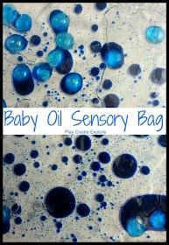

**Activity Week #1 Day 5**

**Coloring**

1.On an “empty” sheet of paper have your child create a picture with different colored crayons, encouraging the children to color the whole sheet, making the sheet “full” of colors.

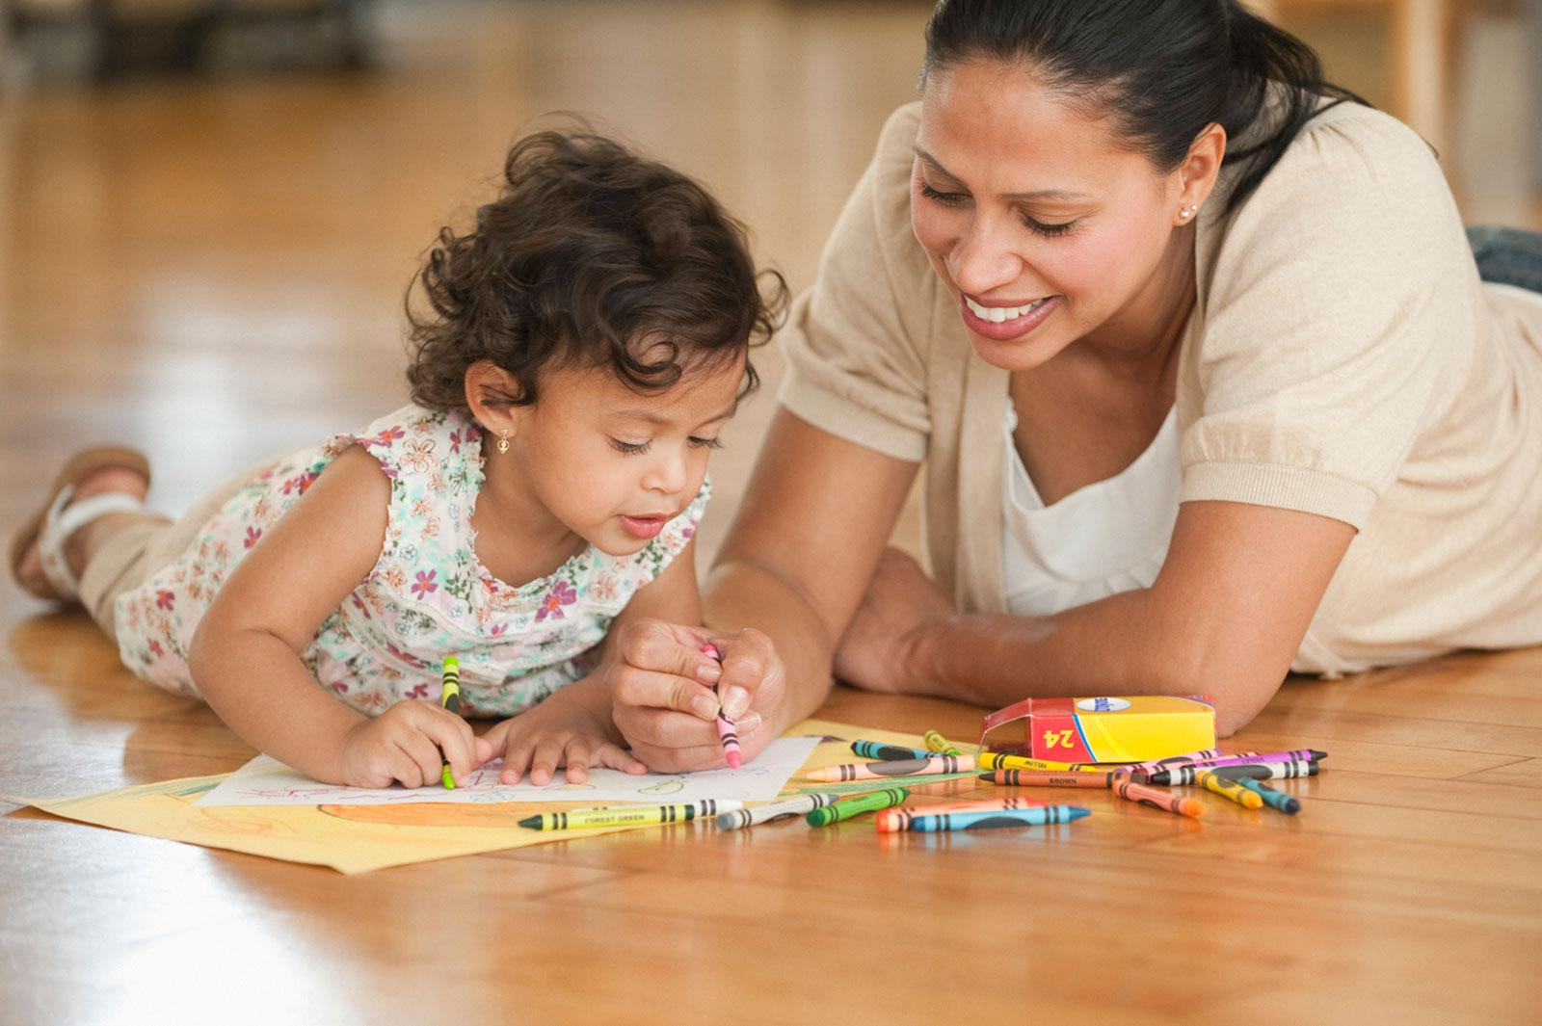

**Activity Week #2 Day 1**

**Color Toys**

1.Have your child collect different color toys or items in the house and put them in a big bin. Going over the different colors have the sort of different color toys on the color construction paper. This is helping your child to really THINK with easy activities like color sorting!

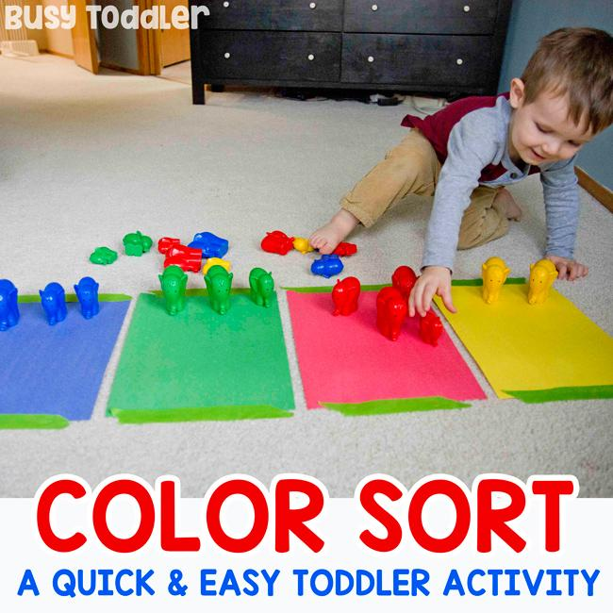

**Activity Week #2 Day 2**

**Sensory Paint Bag**

1.Squeeze some blue paint into the left hand side of the bag. Squeeze some yellow paint into the centre of the bag, making sure it doesn't mix with the blue paint. Add some red paint into the right hand side of the bag. Do up the zip, then spread the paint out using your hand.

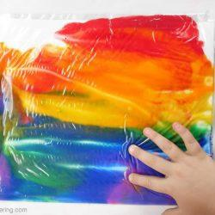

**Activity Week #2 Day 3**

**Fill The Bag & Count**

1.Provide children with a sandwich bag and cotton balls. Open the bag and ask them to fill the bag with five cotton balls. While doing so count with them one by one while placing the cotton balls in the bag. Once the bag is filled with the five cotton balls, ask them to remove three. Then count with them of how much more cotton balls are in the bag. You will notice how simple this activity is but how focused your child will become. You can continue this activity with different items of your choice as well

2.**Cotton Balls & Numbers**

Provide children with a bowl filled with cotton balls. Encourage them to transfer the cottons balls into a bag, while doing so, count each cotton ball that are removed

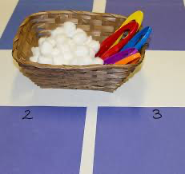

**Activity Week #2 Day 4**

**Color Collages**

1.Children can be encouraged to paste different color and materials that are cut out for them and paste them to a sheet of paper.

2. In this activity as well children can practice their numbers whole counting how many toys are in each bin after separating them from hard and soft

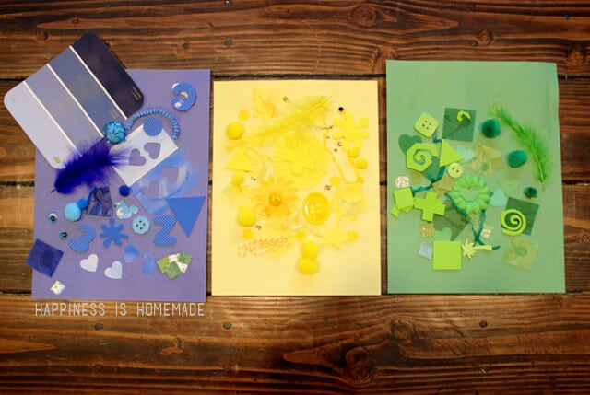

**Activity Week #2 Day 5**

**Moon Sand Sensory**

Recipe

1.1/4 cup baby oil for every 2 cups of flour.

To fill our plastic container, we did 8 cups of flour and 1 cup of baby oil.You want to mix it well to break up any balls of baby oil that form.

We are storing it in an air tight container when not in use

2.For the coconut oil version, combine 1/3 a cup coconut oil (heated in microwave until liquid) for every 2 cups of flour. Just like the version above, I make 2-3 times this amount to fill out sensory bin

