Hello Parents,

I hope all is well. Here is our lesson plan for the week of (April 20-24,2020).

To continue to allow this transition to remain smooth during this time it’s best that we remain on a set schedule, the schedule that children are used to. Every day we should start off with circle time. During this time songs such as the alphabet song, open shut them, if you're happy and you know it should be sung with the children. A book of their choice should be read as well. After circle time is music and movement, during this time songs such as head shoulders knees and toes can be played. Following music and movement an activity can be completed. (Please allow your children to be creative, please remember that whatever activity that has been assigned doesn’t need to be perfect. It’s best we allow children to express themselves within their work) This week the theme will be Hard and Soft.

1.Noticing

Take a walk to part of the house where the children can run around on both hard and soft surfaces such as the floor and a small mat or rug.As children explore, talk about how the different surfaces feel.

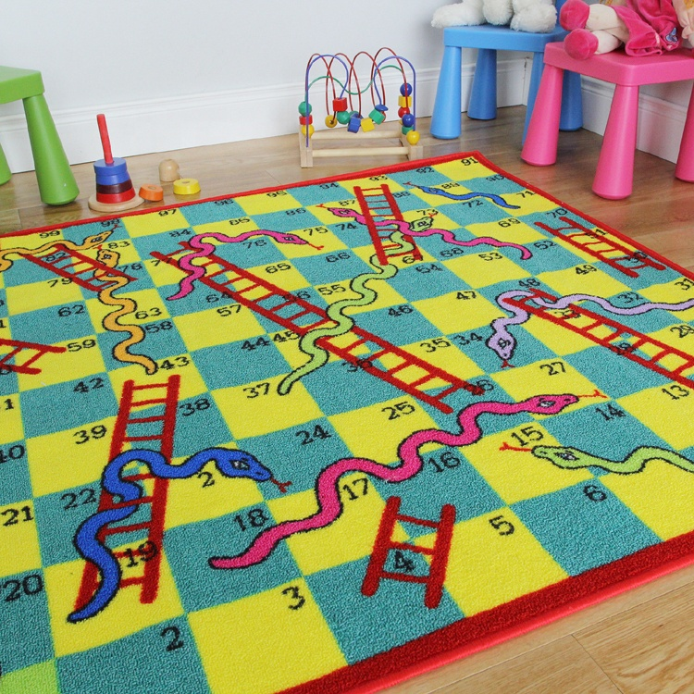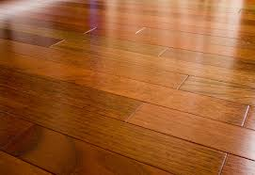

2. Dramatic Play

Invite children to play with you. Share that you are going to visit your somebody, then let them know that you have to knock softly first and then knock hard. Model knocking soft and hard and to continue wherever you go visit a friend you allow them to practice knocking the door soft and hard.

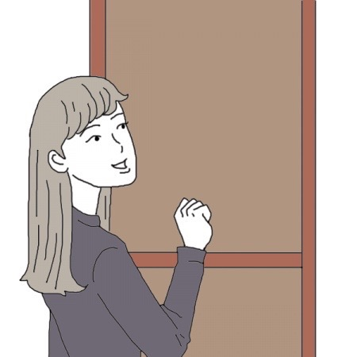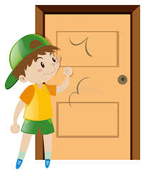

3. Food

Allow children to have two different types of food. One has to be hard and the other one has to be soft ( Banana, Cheerios) or anything of your preference. Have children and yourself take a bite of the soft item first and share with them that it has a soft texture and then take a bite of the hard item and share with them that it has a hard texture.

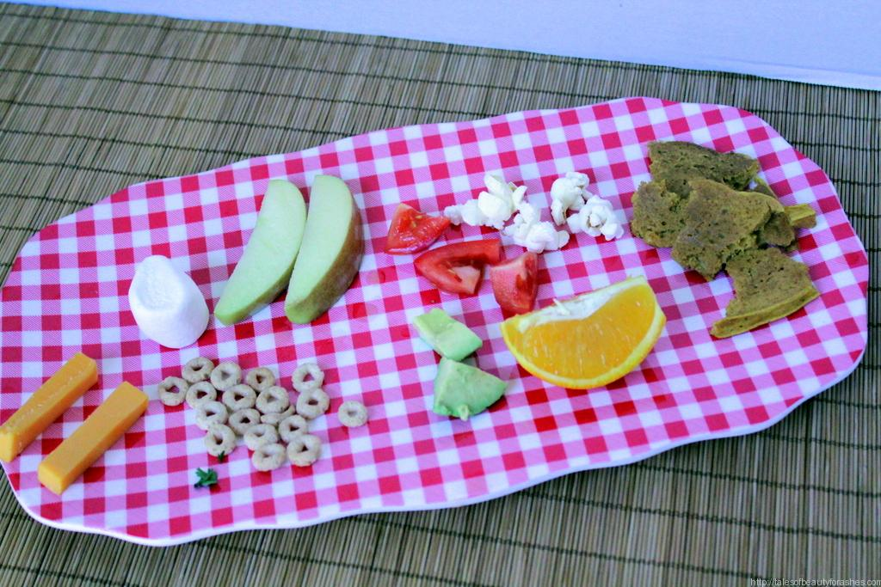

4. Bath Time

Before bed, invite the children to a warm bath, fill up the tub with water and place a sponge in the water and allow them to bring their “bath toys” into the bath with them showing them that the tub now has soft and hard items in it.

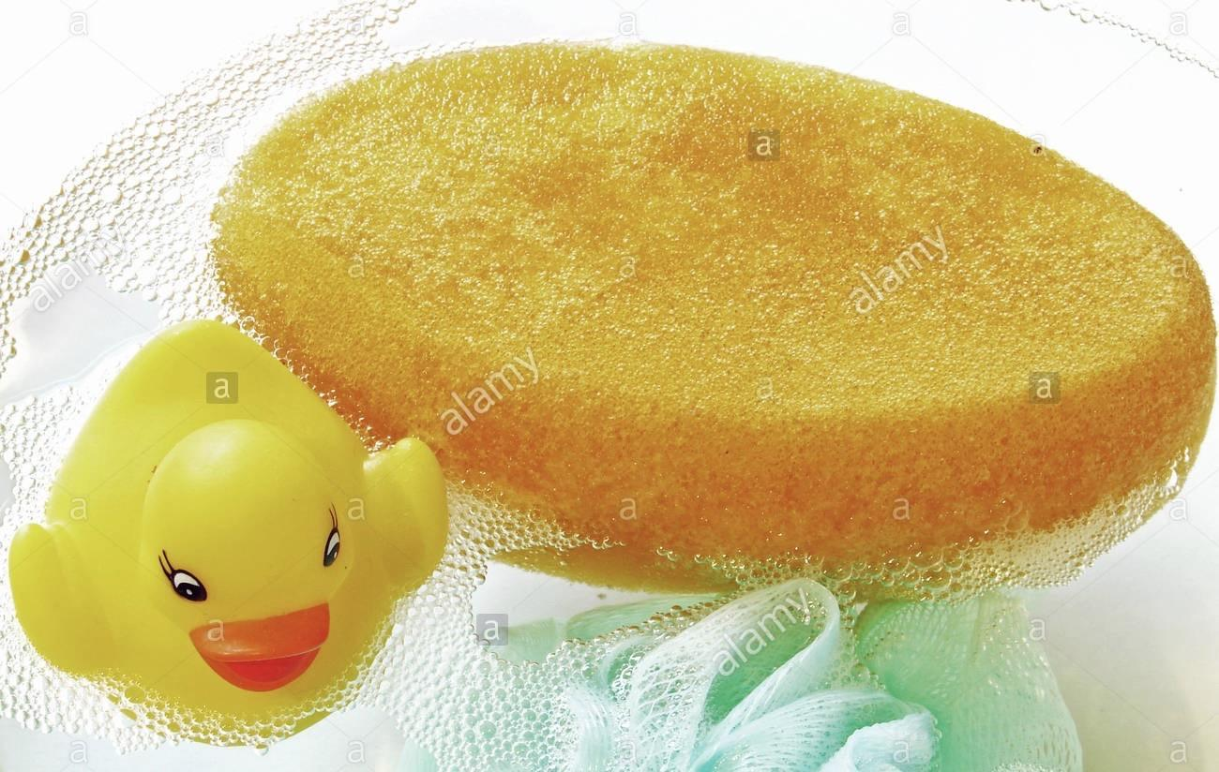

5. Sorting

Get 2 containers or plates, label them (Soft, Hard) if you can and gather some soft and hard toys or any small objects around the house and with your help allow your child to sort them. Let children get a feeling of the textures in order for them to differentiate. Lastly help children count items in each container.

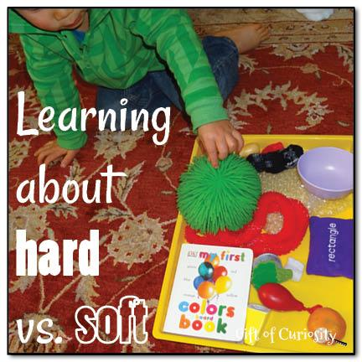

* NOTE FOR PARENTS

Narrate their actions, and talk with them through the experiences using languages such as SOFT & HARD.

**Youtube Video**

https://www.youtube.com/watch?v=llba0FPeWRQ