Hello Parents,
I hope all is well. Here is our lesson plan for the week of (April 27- May 1,2020).
To continue to allow this transition to remain smooth during this time it’s best that we remain on a set schedule, the schedule that children are used to. Every day we should start off with circle time. During this time songs such as the alphabet song, open shut them, if you're happy and you know it should be sung with the children. A book of their choice should be read as well. After circle time is music and movement, during this time songs such as head shoulders knees and toes can be played. Following music and movement an activity can be completed. (Please allow your children to be creative, please remember that whatever activity that has been assigned doesn’t need to be perfect. It’s best we allow children to express themselves within their work) This week the theme will be Tall and Short.

1.In Front of the Mirror
Have children stand in front of a mirror with a you or an older sibling and narrate to them that they are short and the other person is tall.
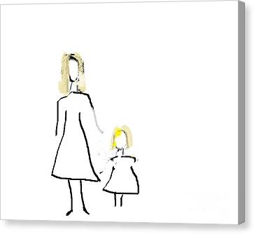

2. Dramatic Play
Invite children to play with you. Grab 2 dolls or teddy bears and let children know that they are sisters or friends & that they are walking and conversing with one another, but that one is short & the other one is tall. Just a form of continuation of the tall and short lesson.
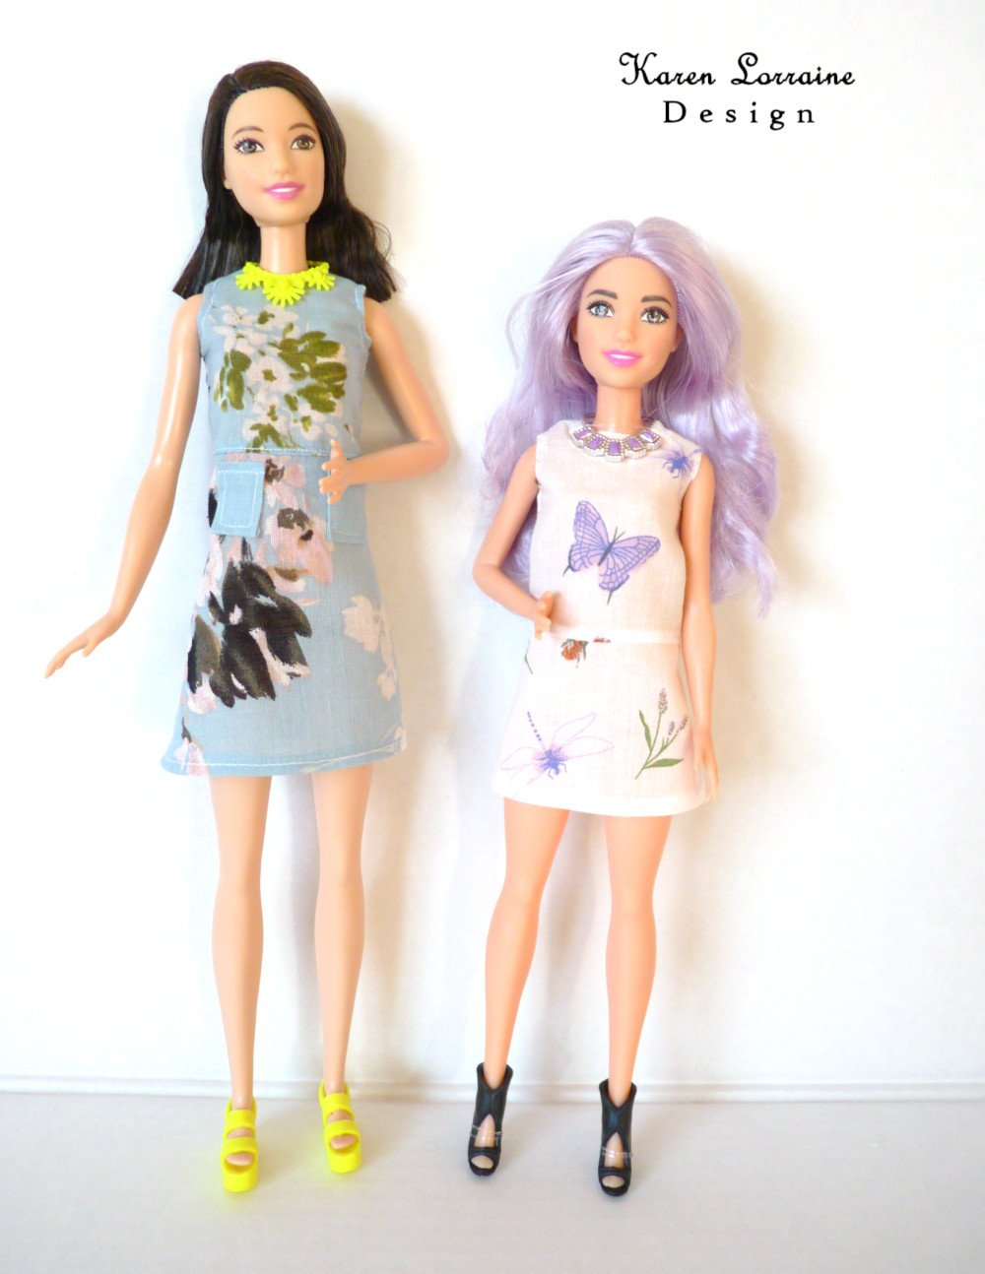

3.Cups
Allow children to have two different cups (MUG & TUMBLER). One has to be shorter and the other one has to be tall or anything of your preference. Have children try asking the child which one is taller and which one is shorter. If they get it correct praise them and if they get it in correct just guide them through it.

4. TALL & SHORT Youtube Video
https://www.youtube.com/watch?v=wo12otyX80k
Have children watch the youtube video in order for them to get a better understanding of the concept of short and tall.
5. Sorting
Gather different items in the housing that are short and tall and place them all together in one place, then have children sort which ones are short and which ones are tall.
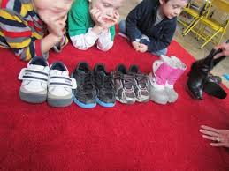

* NOTE FOR PARENTS
Narrate their actions, and talk with them through the experiences using languages such as TALL & SHORT.

Youtube Video

https://www.youtube.com/watch?v=wAPAFpzBTTw
https://www.youtube.com/watch?v=T1vH7eYQZkg

