HELLO FAMILIES OF ROOM 205 I HOPE ALL ARE DOING WELL AT THIS TIME, HERE IS OUR LESSON PLAN FOR THE WEEEK APRIL 27- May 1st, 2020. THIS WEEK THEME IS MOVEMENT SO LET’S MOVE OUR BODIES THROUGH OUT THE WEEK IN DIFFERENT WAYS. THE LETTER OF THE WEEK IS A. WHAT SOUND DOES THE LETTER L MAKE? CAN WE THINK OF WORDS THAT START WITH THE LETTER L?

Morning Exercise https://www.youtube.com/watch?v=L_A_HjHZxfI

Supply a box with hole on top and opening on the side. Invite them to drop objects through the hole into the box and look through the hole to see the objects move. Then sort the objects by size and color also count the objects as you drop them into the box.
What did you notice?
Read aloud: From Head to Toe by Eric Carle
https://www.youtube.com/watch?v=9xxyZSdYEmM
Sing along: Open Shut Them https://www.youtube.com/watch?v=RNUZBHlRH4Y

Letter of the week L
What sound does the letter L make?

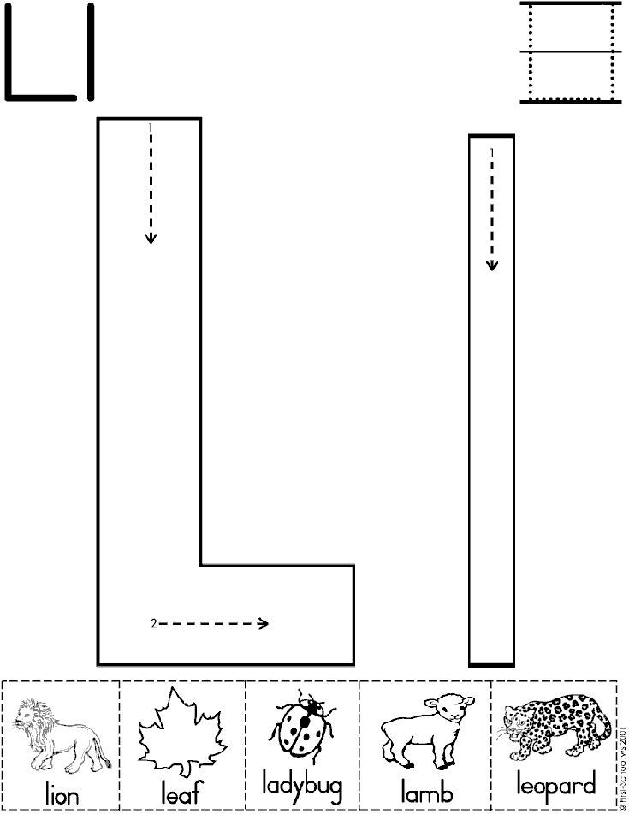

Morning exercise https://www.youtube.com/watch?v=L_A_HjHZxfI

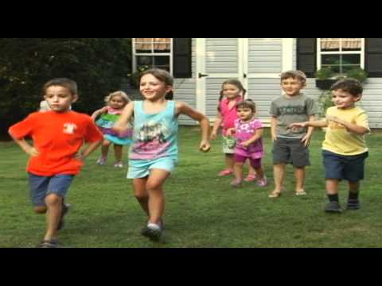

Parents can make red and green signs with their children. Let the children know that you will be playing a game where you will go and stop. Tell them when you lift the green sign that means go and they should move their body. When you lift the red sign, say it means stop and they should stop moving. Children will need some time to understand and comprehend the rules of the game. If they do not stop moving when requested, allow them to continue to move their bodies.

Dance along: red light green light https://www.youtube.com/watch?v=a-npmDGK1Dc
Red means Stop green means Go https://www.youtube.com/watch?v=t14dIUgrEhA

Read aloud: How do you Dance? By Thyra Heder https://www.youtube.com/watch?v=FmIr8xnU7uw
On lined paper parents write the letter L with dotted lines have children trace the letter L with a crayon or marker. 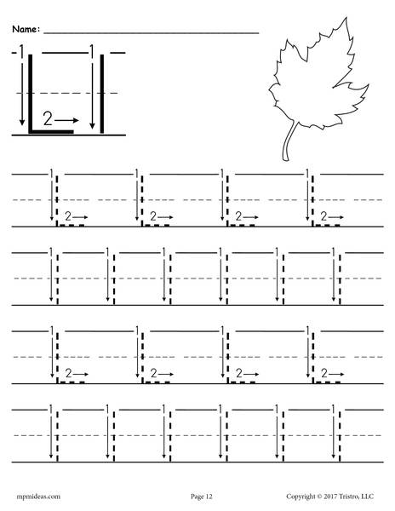

How many letter L’s do we have in our name?
Circle them with a red crayon?
With parent’s help make a Letter L book color the pictures first. When coloring the pictures use back and forth motion. Practice staying in the lines by starting at one line , slowing going across to the other, and then back again then try it a little faster.
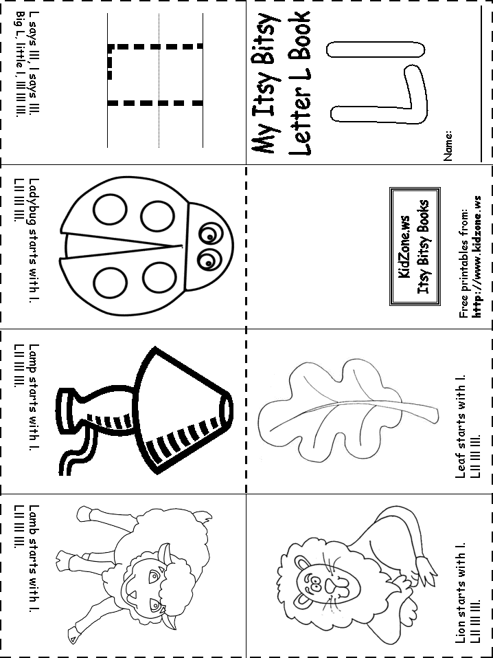

Morning exercise https://www.youtube.com/watch?v=L_A_HjHZxfI

Supply paper, markers, or crayons. Invite children to color or draw and discuss the marks they are making by moving their arms.

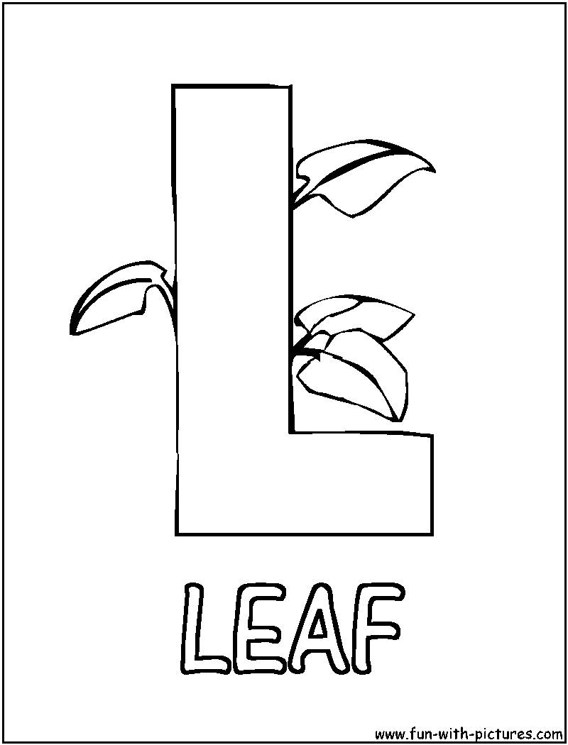

MORNING EXCERSICE https://www.youtube.com/watch?v=L_A_HjHZxfI

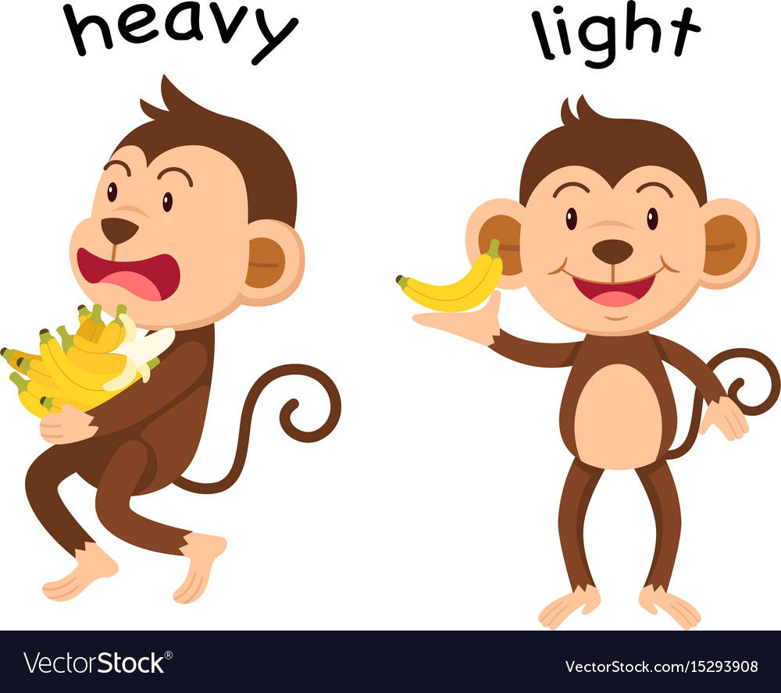

Supply items that are different weights such as feathers and small vehicles. Invite children to drop them at the same time and see if they move at different speeds.
Which item moved the fastest?
Which item moved the slowest?
Which item is the heaviest?
Which item is the lightest?

Color the pictures that start with the letter L below
How many pictures start with the letter L?
