April 6 – April 10
2020
Unit: Spring

“Spring is when you feel like  whistling even with a shoe full of  slush”  -Dough Larson | 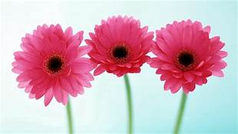
Monday 6

Read Seeds Germination instructions sheet or view the video below & create your own.
https://www.youtube.com/watch?v=8QXF-6zXHfU
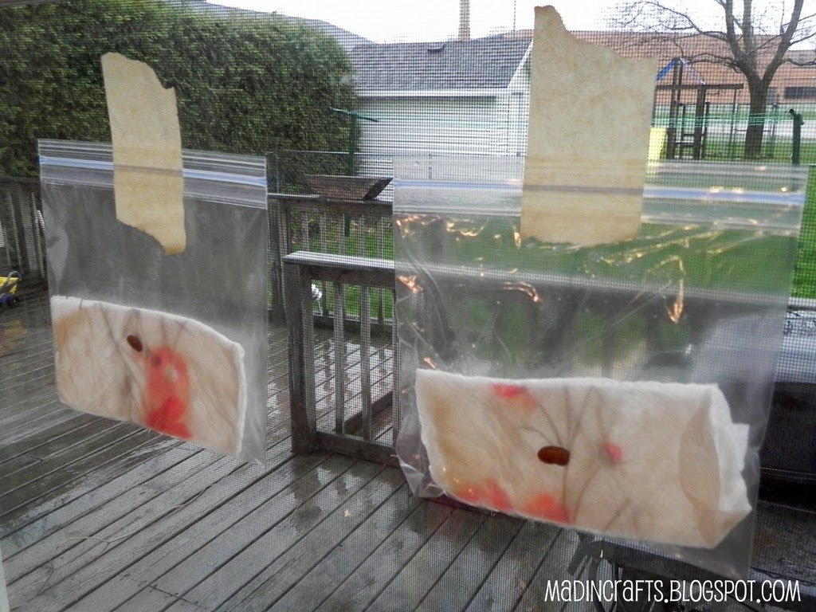
For this activity you will need a seed, paper towel and a zip log bag.
Follow the steps below
- Wet a folded paper towel it should hold a fair amount of water, but not be dripping wet.
- Slip the paper towel into a baggie. Place one bean seed between the towel and the bag.
- Place the baggie in a sunny place such as the window.
- Check each day for progress. Send pictures to Ms.B of stages or of final stage.

Tuesday 7
Book reading: AND THEN IT'S SPRING By Julie Fogliano
YouTube: https://www.youtube.com/watch?v=R8Dm5_kt8uU
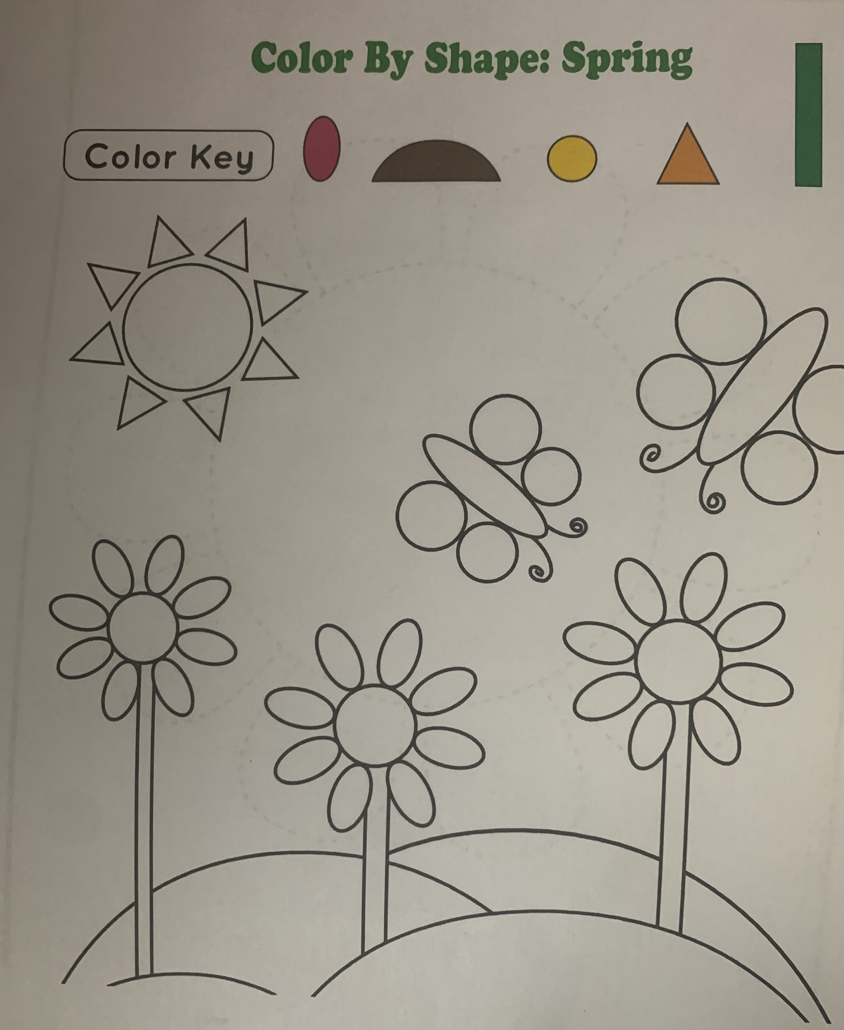
Parent & Child Activity: Print the color by shape worksheet. Provided the child with pink, brown, yellow, orange and green crayons/marker or color pencils. Hand a color one by one to the child as you ask them to find the shape that correspond to each color.
For example: Find all the circles and color them yellow.
Find all the triangles and color them orange.
Note : If you do not have access to a printer, you may draw several of different shapes on a blank sheet of paper and continue the activity as mentioned. Keep in mind you can also draw different pictures that have use of different shapes, such as a house using squares, triangles and circles. You can also draw a bunny using rectangles, circles and a oval.

Wednesday 8
Book reading: Parts of flower video
YouTube: https://www.youtube.com/watch?v=HuKa57OJ_iA

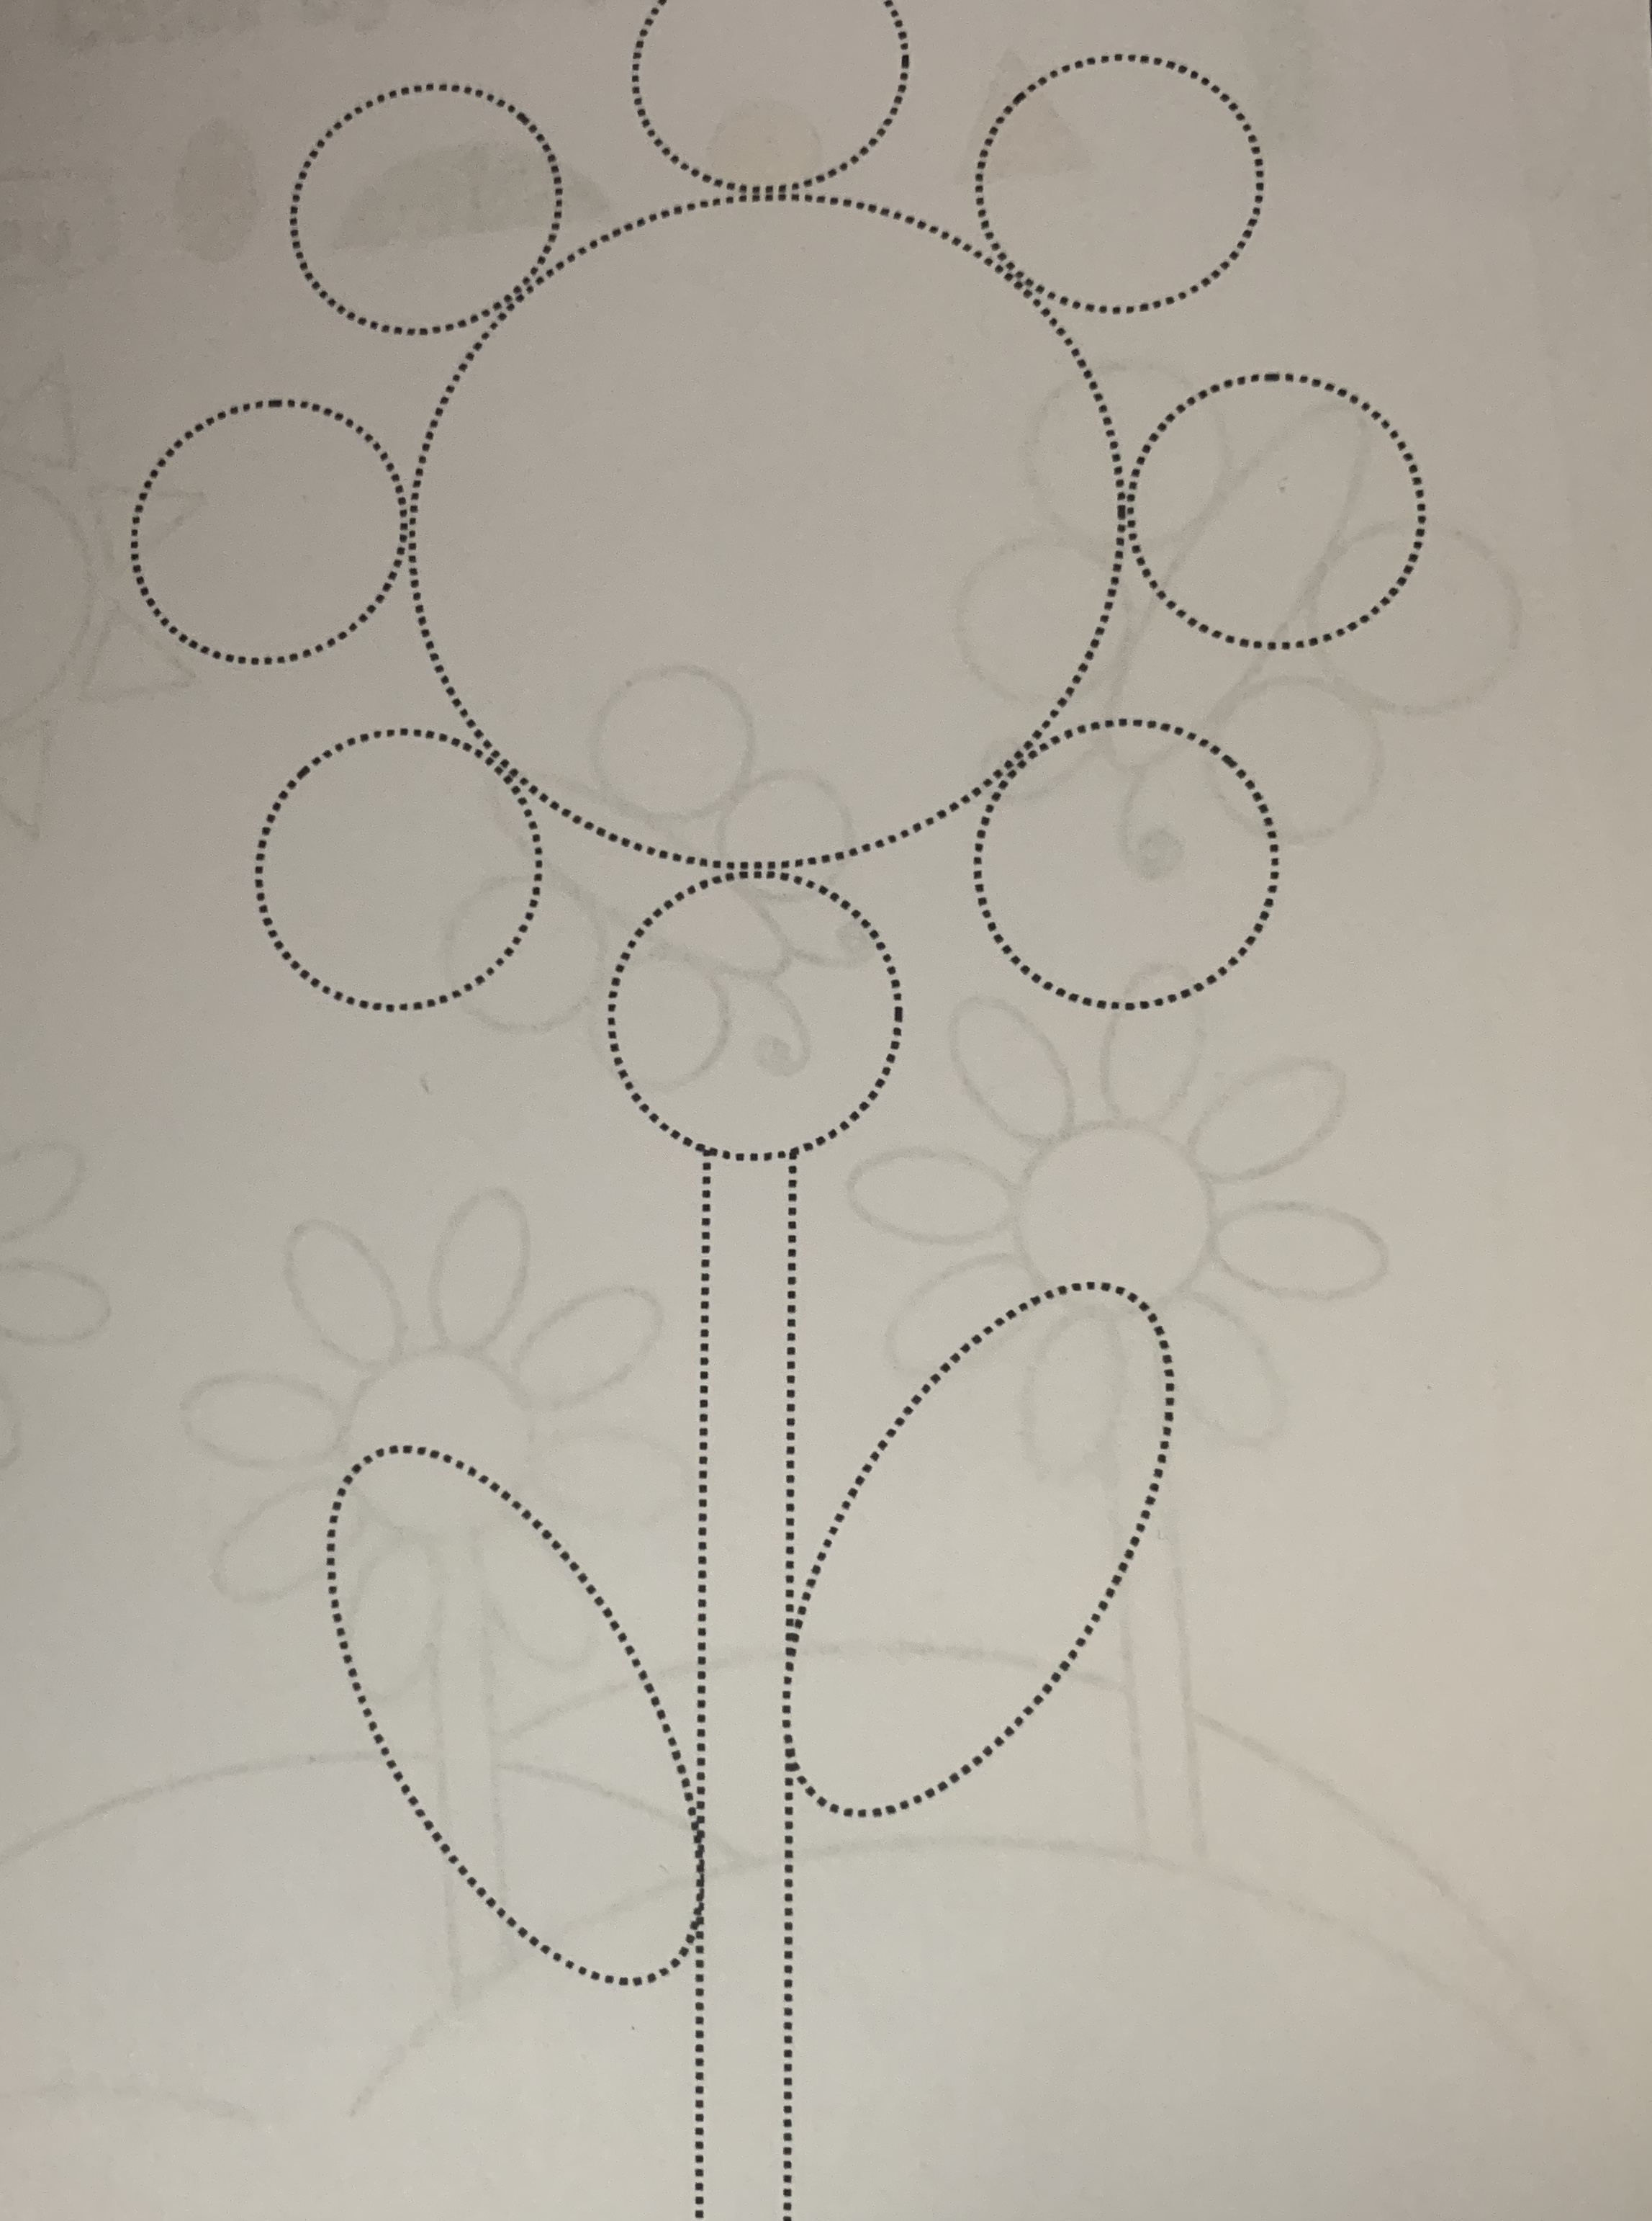
Parent & Child Activity: Print out the dotted flowers worksheets. Allow the child to trace each flower & color.
Once finished ask the child
What color did you use?
How are the flowers different?

Note: If you do not have access to a printer, you may draw on a piece of paper two different types of flower dotted style. Allow your child to continue the activity as you would above.

Thursday 9
Book Reading: Planting a Rainbow by Lois Ehlert
YouTube: https://www.youtube.com/watch?v=sti3PXBeVag

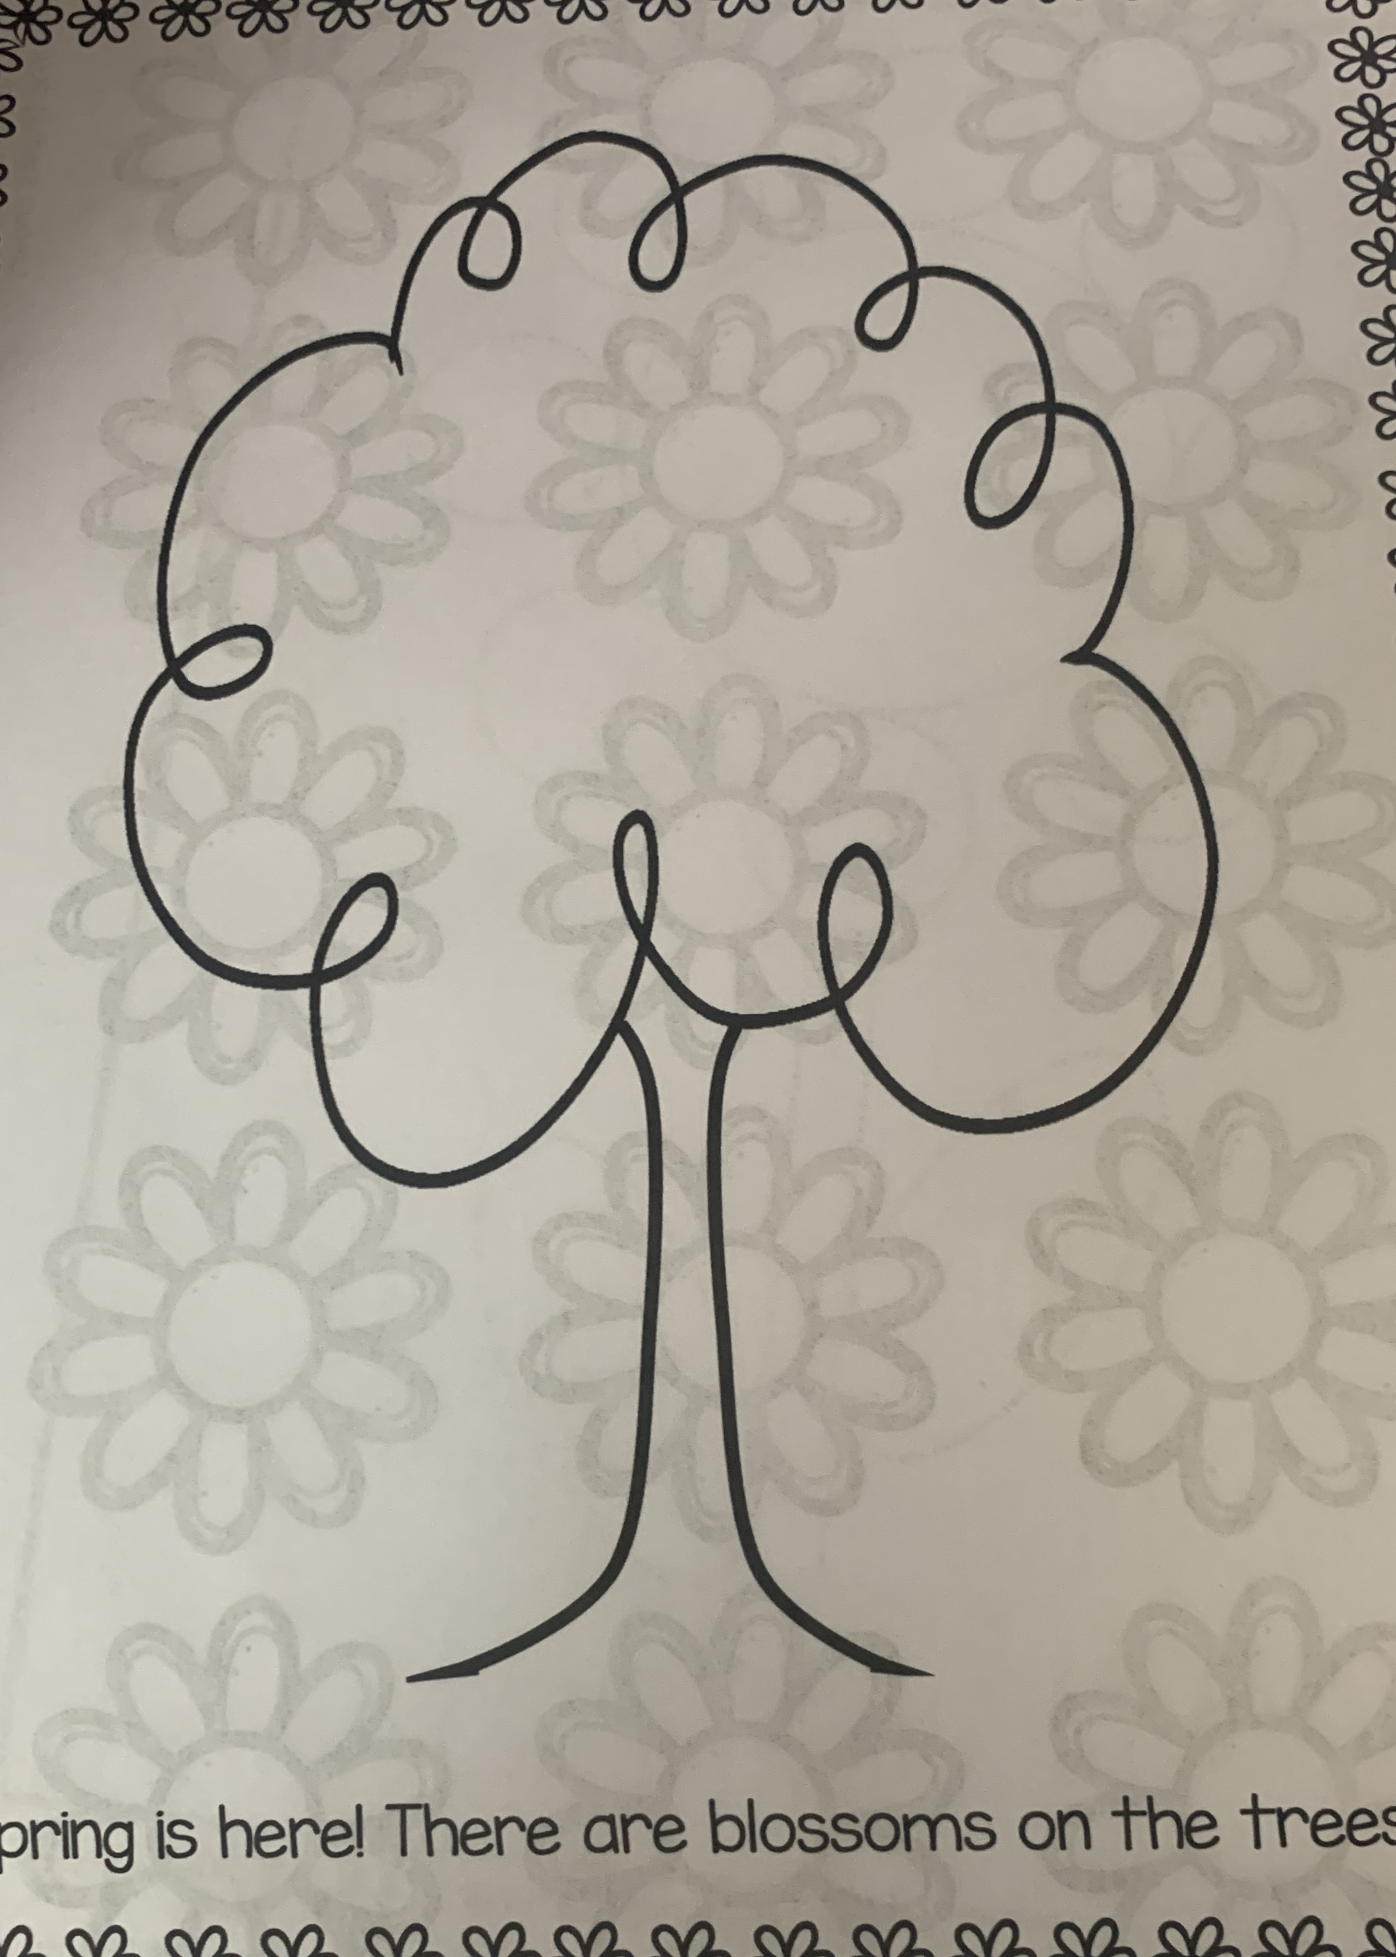
Parent & Child Activity: Print out the Blossom Tree & Flowers activity. Have the child color the tree and flowers with the color of their choice. Cut out the flowers and allow the child to glue them to the tree.

Note: If you do not have access to a printer, you may trace the child’s hand on a blank sheet of paper. Have the child draw circles to create flowers on each fingertip and color.

Friday 10
Book Reading : The Very Hungry Caterpillar – Eric Carl Animation
YouTube: https://www.youtube.com/watch?v=75NQK-Sm1YY
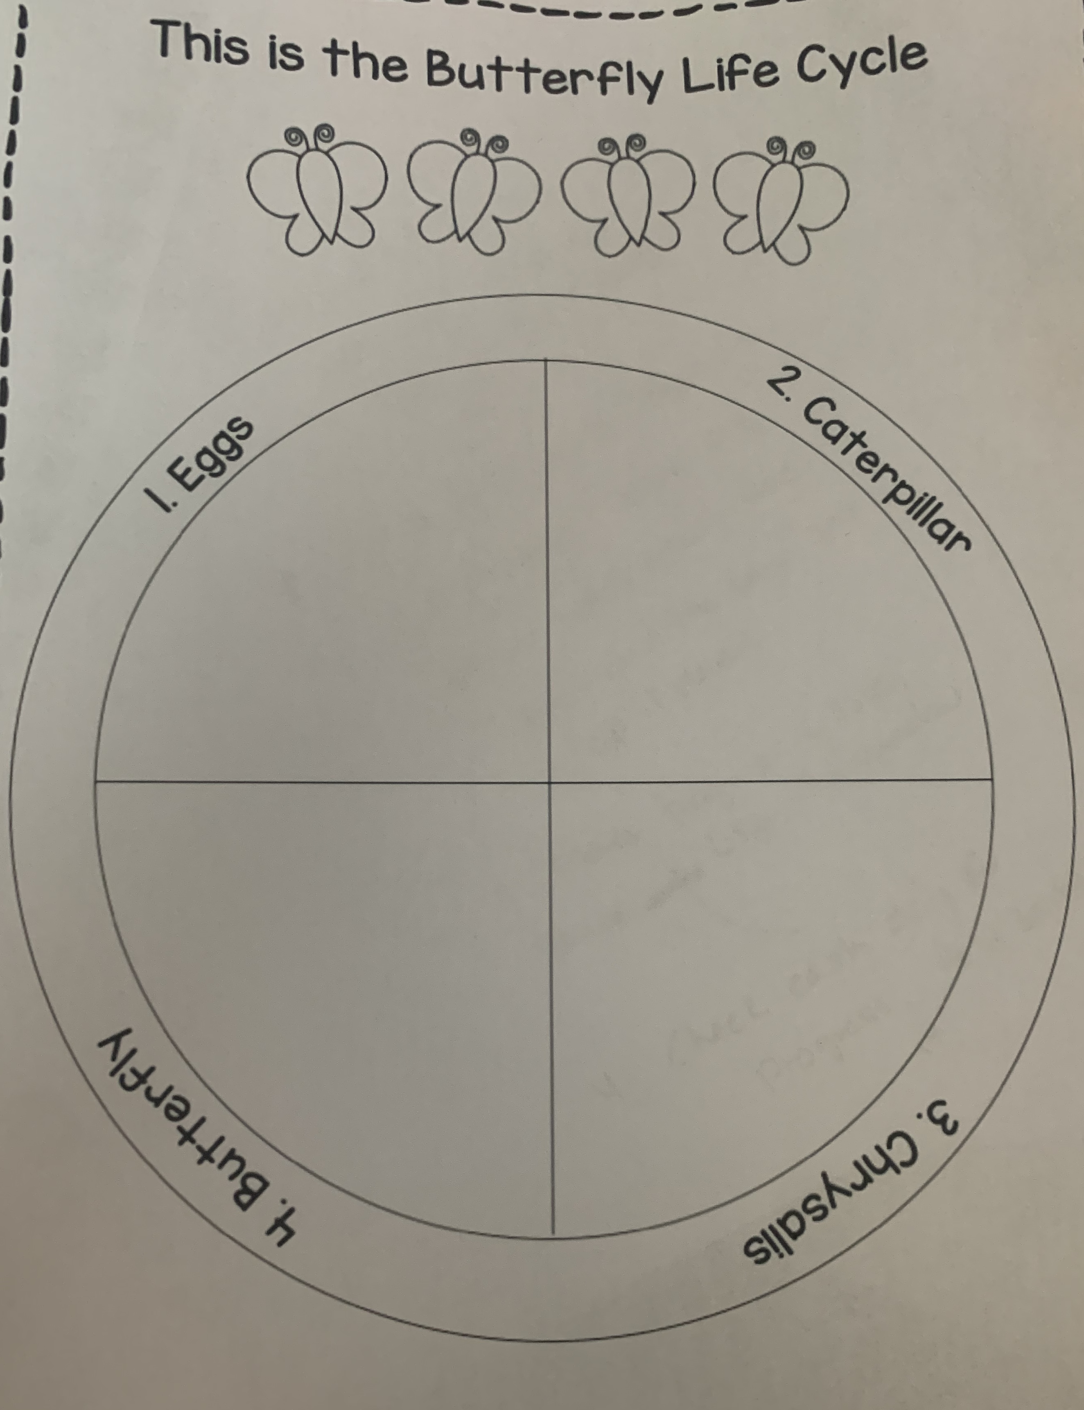
Parent & Child Activity: After watching the read aloud video, Have your child draw in the Butterfly worksheet each steps of the butterfly life cycle. When drawing allow your child to refer back or to look at the picture of each stage.
- Draw a egg
- Draw a Caterpillar
- Draw a Chrysalis
- Draw a Butterfly
Parents/Guardians keep in mind to allow the child to do the drawings themselves. It does not have to be perfect.

Once finished. Send a picture to Ms.B if you wish.

