April 13 – April 17
2020
Unit: Spring

“Just when the caterpillar thought the  World was over, it became a beautiful  butterfly”  -Tansama | 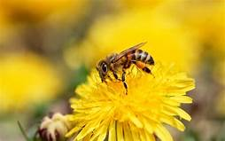
Monday 13
Book Reading: Pooh’s Scavenger Hunt
YouTube: https://www.youtube.com/watch?v=MsW9JWu-0bA
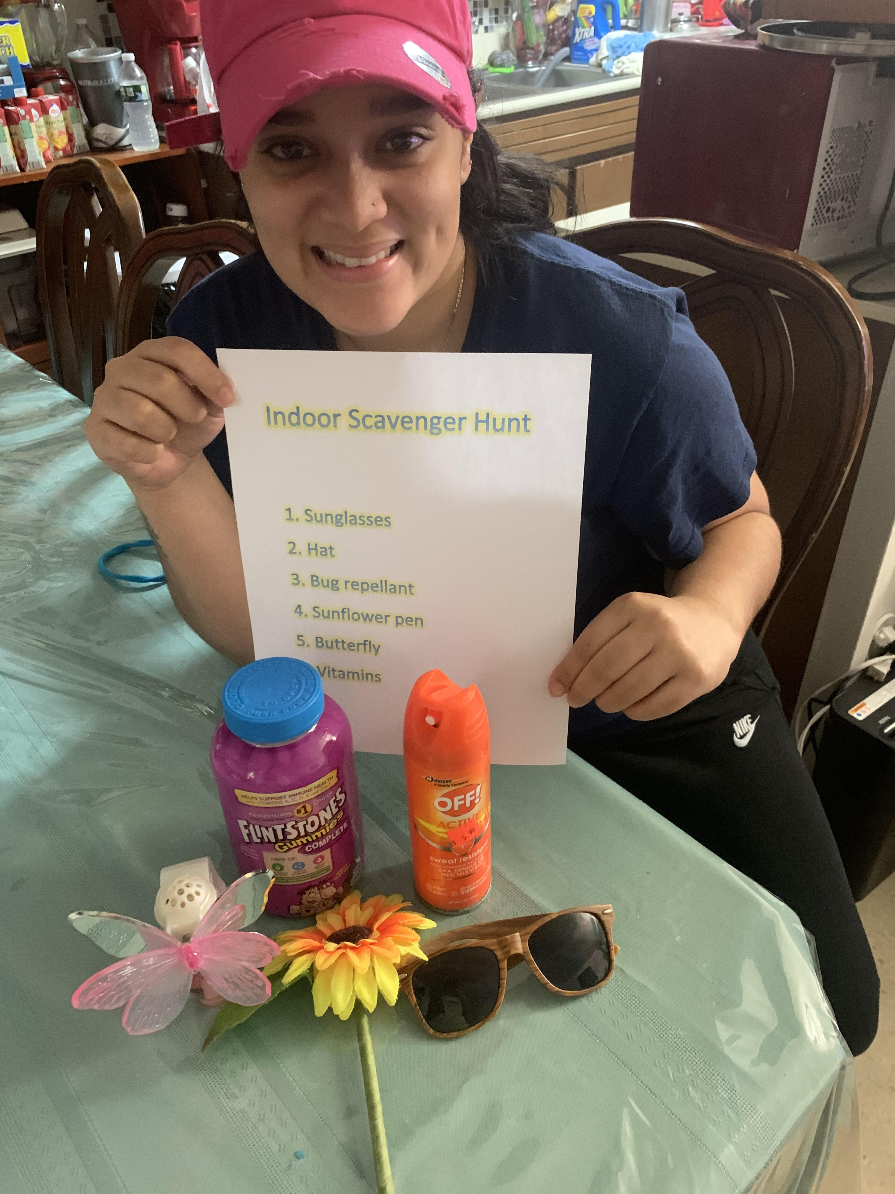
Parent & Child Activity: Indoor Scavenger Hunt
If you have insect toys use this for your scavenger hunt if not you may gather objects of any kind (that represent springtime such as a pair of sunglasses or a hat) take a picture of each object on your cell phone or make a list of the objects. Hide the objects around the house and have the child go on a scavenger hunt to find the objects that are on the list you created.

Once you have found all the objects, place them on the table and have a conversation on what each thing is used for. Take a picture and send it to Ms.B

Tuesday 14
Book reading: Pete the Cat and the cool caterpillar by: James Dean
YouTube: https://www.youtube.com/watch?v=T3zsR1V82wk
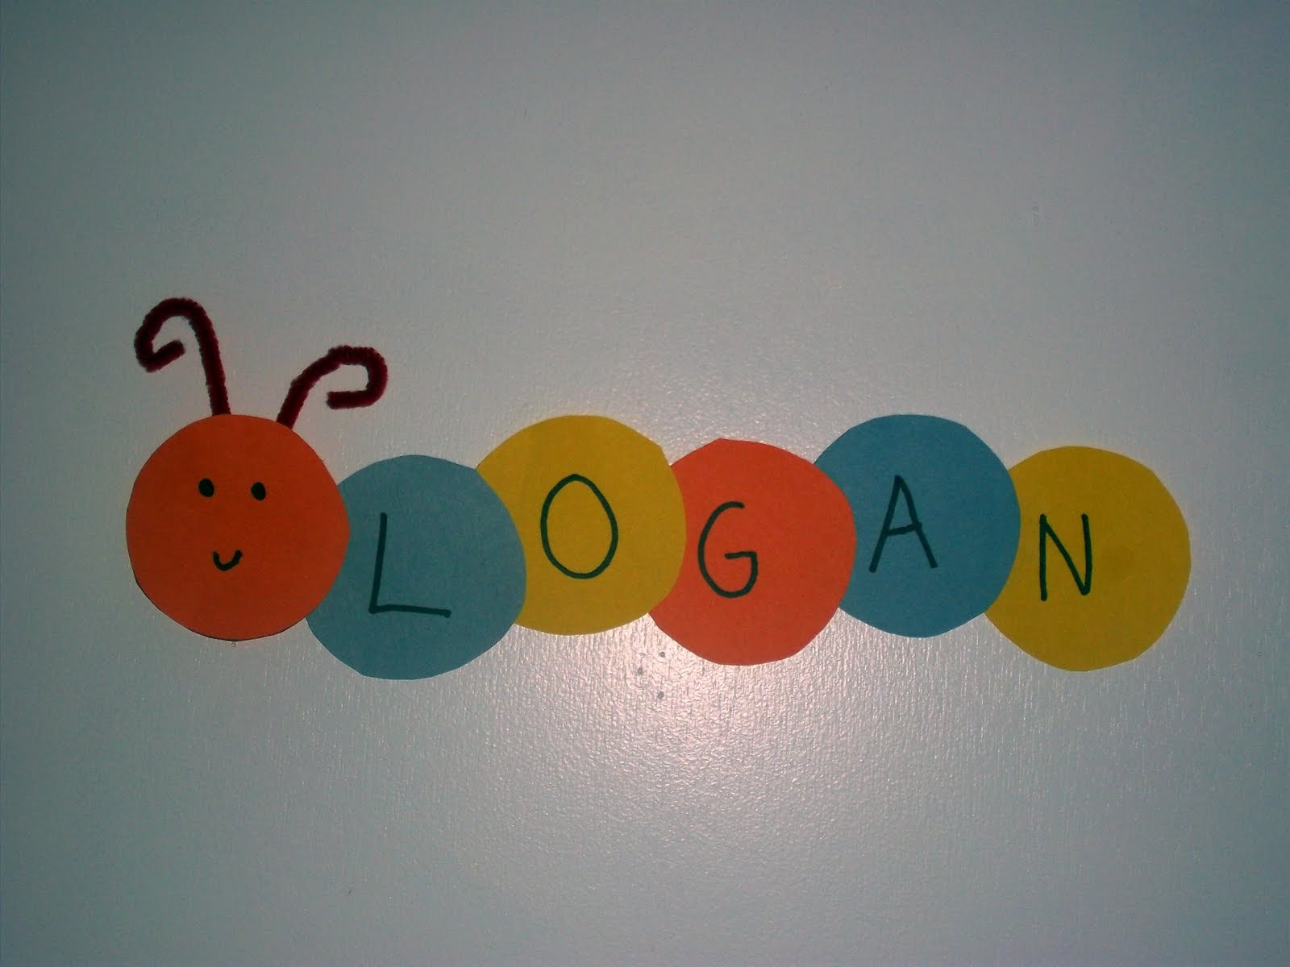
Parent & Child Activity: Using a blank sheet of paper cut out circles for each letter found in the child’s name. Write out a letter in each circle dotted style. Allow the child to trace the letters and color as they like. Help the child put together the circles to spell out their name and create a caterpillar. Talk about the letters you see and what sound they make. At last draw a face to complete the caterpillar.

Wednesday 15
Book reading: Bug Hunt by: Tom Story
YouTube: https://www.youtube.com/watch?v=7nL7On2gBkw
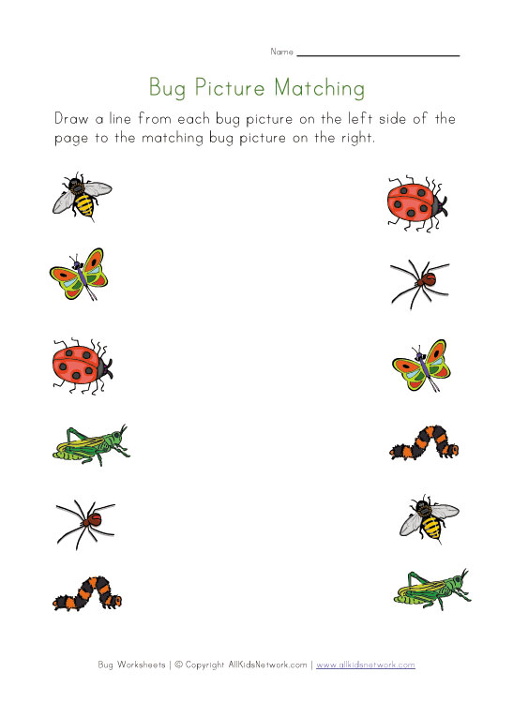

Parent & Child Activity: Print out the bug matching activity. Together talk about the different types of bugs the young girl found in the reading. Talk about the types of bugs that you in the worksheet, allow the child to use a pencil/marker or crayon to draw a line to the bugs that match.

Note: If you do not have access to a printer: You may talk about the different bugs found in the reading, you may also pause the video and have the child tell you what they know? How many legs do each bug have? How many eyes? etc

Thursday 16
Book Reading: The Very Hungry Spider
YouTube: https://www.youtube.com/watch?v=YeNioRkm29w

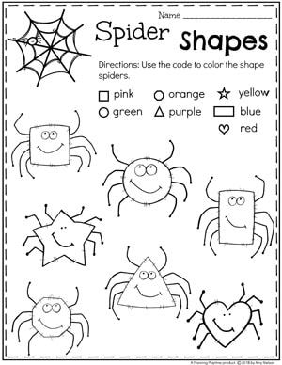
Parent & Child Activity: Print out the spider activity, use the code to color the shapes of the spiders.

If you do not have access to a printer: You may use a blank sheet of paper and draw different types of shapes, add legs to each shape and draw a face to give it a spider look. Provide the child with crayons/markers or color pencils and give tell the child a color for each shape. Notice if the child is able to find the shape and color it with the color you mentioned. Example tell the child “Color the squared spider blue”

Friday 17
Book Reading: The Very Hungry Caterpillar – Eric Carl Animation
You Tube: https://www.youtube.com/watch?v=75NQK-Sm1YY
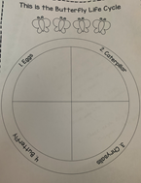
Parent & Child Activity: After watching the read aloud video, Have your child draw in the Butterfly
worksheet each steps of the butterfly life cycle. When drawing allow your child to refer back or to
look at the picture of each stage.
1. Draw a egg
2. Draw a Caterpillar
3. Draw a Chrysalis
4. Draw a Butterfly
Parents/Guardians keep in mind to allow the child to do the drawings themselves. It does not have
to be perfect.
Once finished. Send a picture to Ms.B if you wish.

