Hello Parents!

I hope everyone is well and safe during this time. As you all know we will not be returning back to school until further notice. The initial April packet that was submitted to you only covered up until April 20th. This packet was created for the students to finish the Plant unit.

The teaching points for the month remain the same:

- What are plants?
- What do plants need and where do we find them?
- What are some different kinds of plants?
- Why are plants important?

If possible, you can print this packet out.

Name:__________________________________________

Circle the plant that is different.

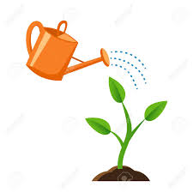

Circle the plant that is the tallest.

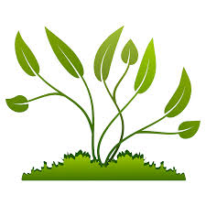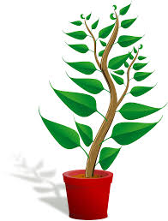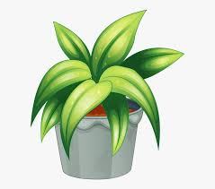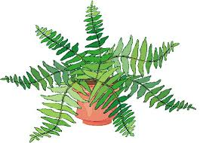

Circle the plant that is the shortest.

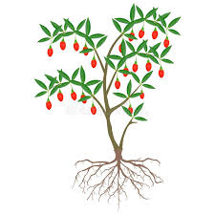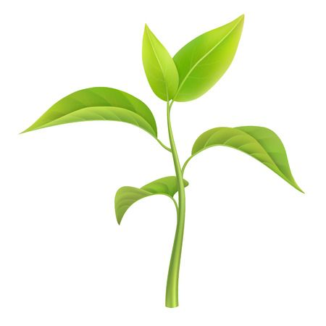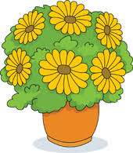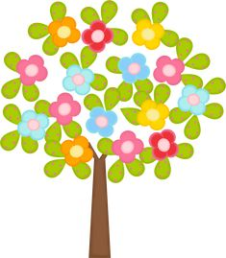

Create your own garden at home

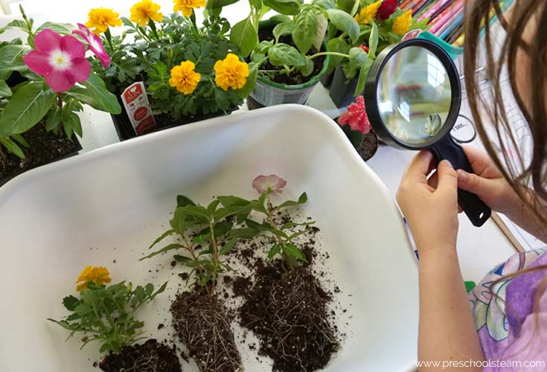

Flowers may be purchased in a supermarket. Then take the flowers out of the flower pot and explore the soil, leaves, flower and roots. Have your child touch the soil to experiment with different textures. Next, your child may pour water on the soil to see what happens. Flowers may be repotted.

Exploring vegetables & fruits that have seeds

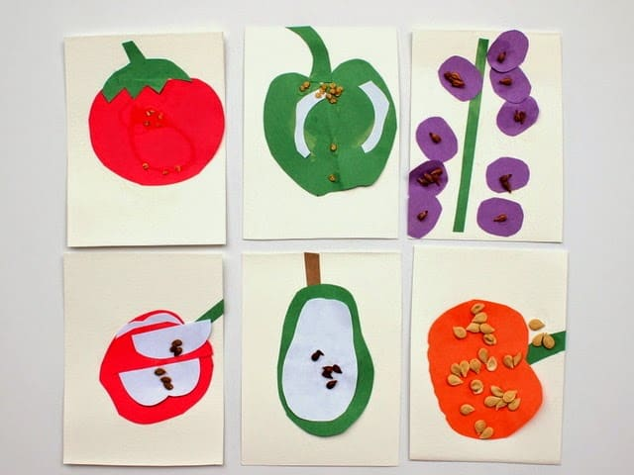
Before you begin painting, cut open a vegetable such a cucumber. With your child count how many seeds it has. Wash the seeds and set them aside for the art project. Next, using construction paper, help your child paint a picture of vegetables and fruits that have seeds. See picture above. Once they are done painting their fruits and vegetables, place the seeds on the paintings!

Splat Art
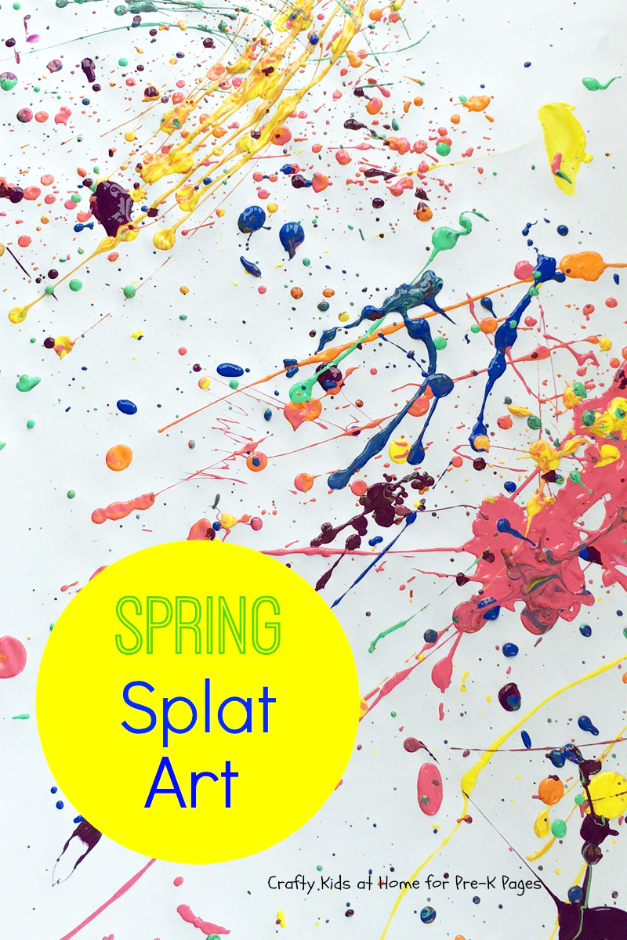

Cover as many surfaces as you can, lay out the supplies (Construction paper, cardstock paper, magazine paper, newspaper) and stand back. Using different color paint, splat the paint with your hands or a paint brush. It might be messy, but it’s fun and beneficial in many areas of your preschooler’s development.

Create a Sensory Bin

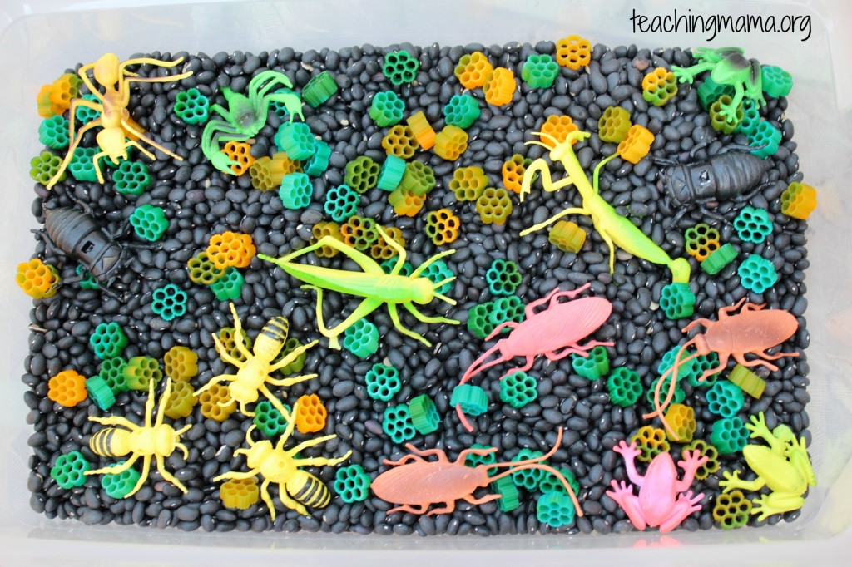

Let your child’s imagination flourish with a bug and flower sensory bin. Items listed below to create this bin:
- black beans
- colored Fiori noodles to look like flowers
- plastic bugs, creatures, and frogs (you may add any toy you’d like to add to this bin, it does not have to be frogs or bugs)

Flower Petal Counting

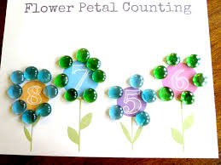

With your child draw out flowers, write a number in the middle of the flower as shown above. Using any house hold items such as cheerios or beans help your child place 8 beans to the flower that has the number 8 etc.

Letter Ff/ Letra FF

Children will paste pictures that start with the letter Ff

Los niños pegarán imágenes que comienzan con la letra Ff

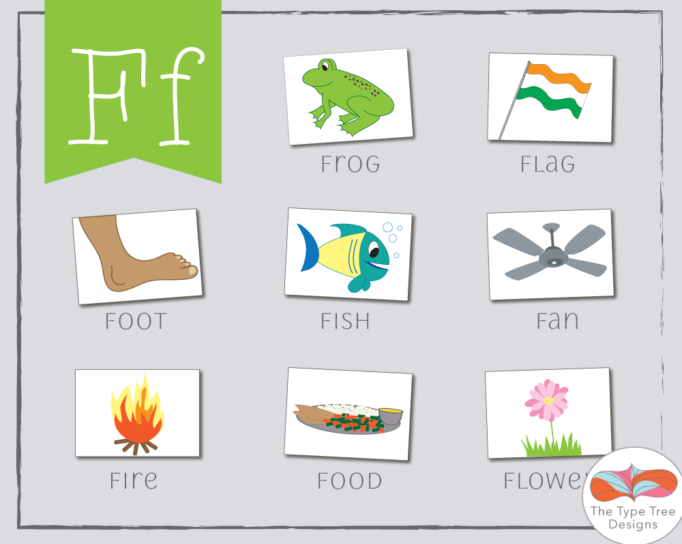

Large Flower Acitivity

Children must draw a big flower in a paper with all the parts. On the flower, children must-do small ball with any type of paper and paste it on it.

Los niños deben dibujar una flor grande en un papel con todas sus partes. Deben rellenar la flor, con bolita pequeña (ellos saben hacerlas) con cualquier tipo de papel y pegarla en la flor.
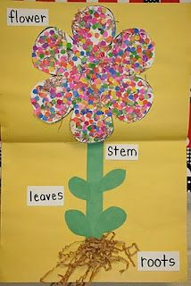

Tracing Hands

*Children will trace they hand in a paper, count their fingers and right the number on the top.

*Nino trazará sus manos, contará sus dedos y luego escribirá los números en la parte arriba de los dedos.

