Explore textures in a treasure basket.

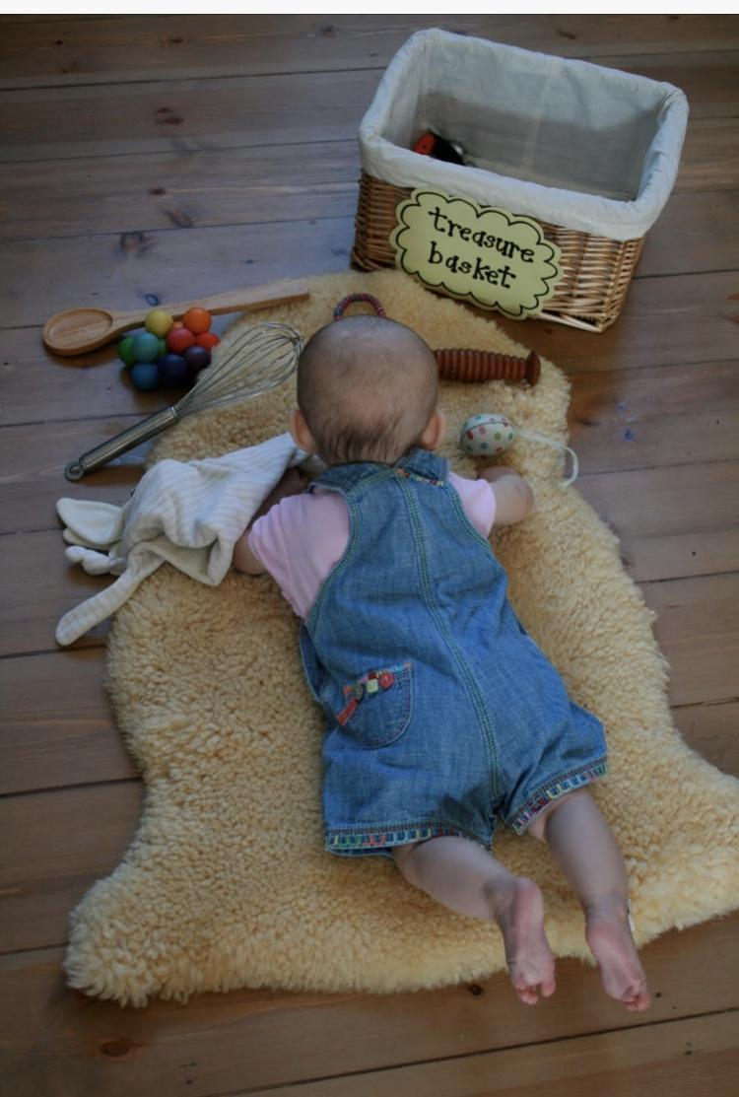

Find a small/medium basket and place a wide range of objects both natural and man-made that will stimulate all of the senses and that can be used as open-ended tools for exploration and imagination.

Tummy time painting. 5Months+
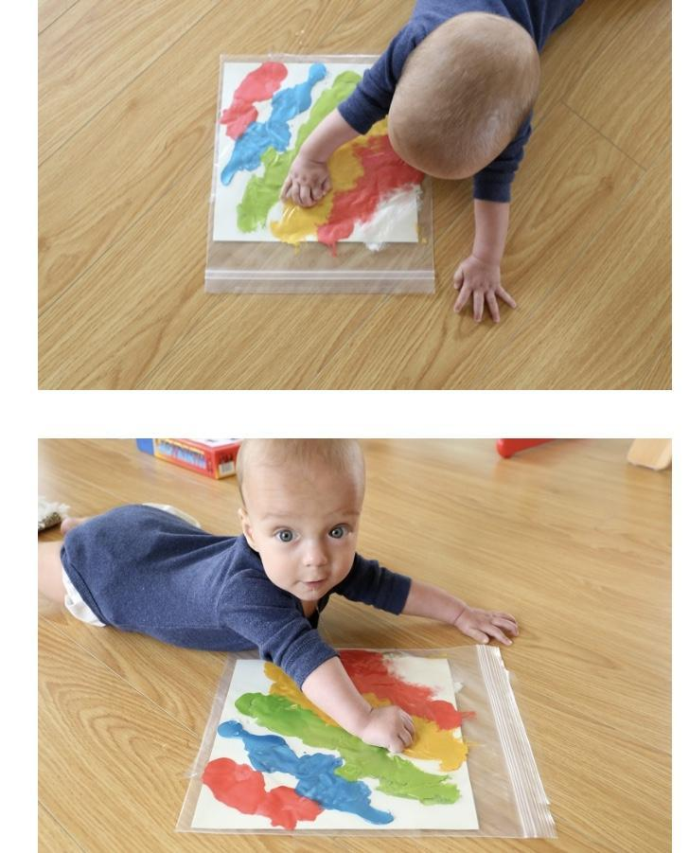
Supplies
- Ziploc bag
- White paper
- Paint of your choice
- Tape
- Scissors
Directions- Cut the white paper to the size of the Ziploc bag and squirt some paint directly onto the page. After squirting the paint on the paper, carefully slip the paper inside the bag and zip the Ziploc bag shut. Once zipped tape the Ziploc bag on the floor and place your child right below the bag on their belly. After your child is done with their masterpiece. Carefully cut open the sides of the bag and lift it out so It could dry.

Pom-pom drop. 6Months+ ( Fine Motor skills)
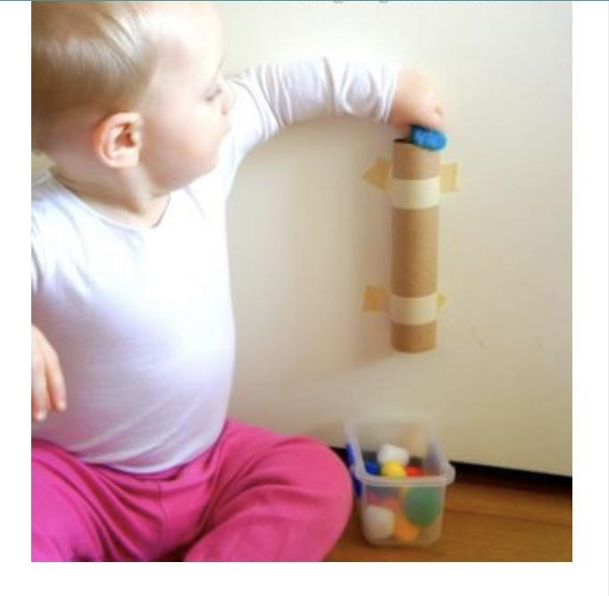
Supplies
- Paper towel roll
- Tape
- Pom poms
Directions- tape the paper towel roll to the wall and encourage your little to insert the pom-pom into the hole.

Magnetic letters on a cookie sheet.
6Months+ ( Fine Motor skills)
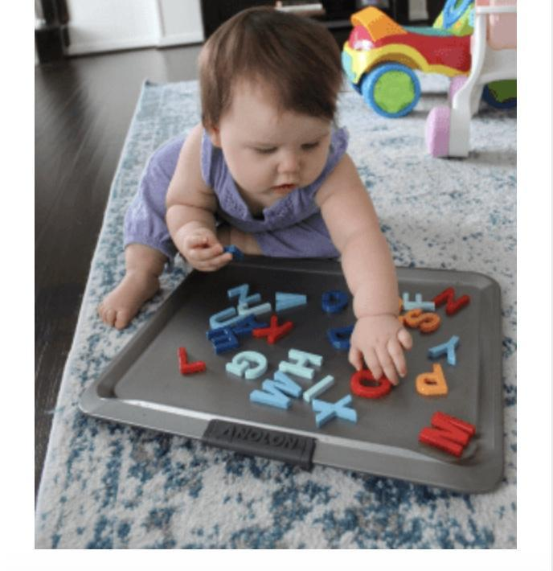
Materials
- Cookie sheet
- Magnetic letters
Directions- Place a few magnetic letters on a cookie sheet and encourage your child to take them off.

