Feet exploration
3-4 Months
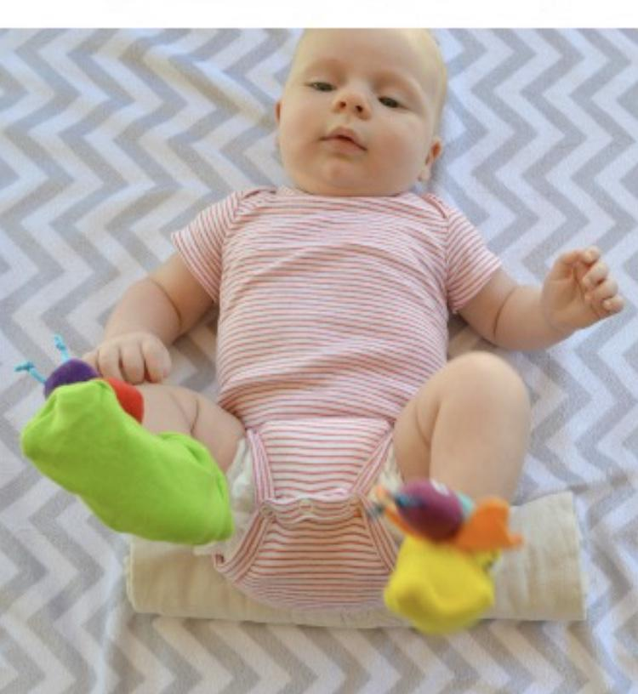
Put colorful socks or foot rattles on your child and place them on their back. After placing them on their back. Roll a towel or receiving blanket to lift the hips a bit. This will help your little one see his feet with colorful socks or foot rattles on them.

Squeak and hide
8-9 Months
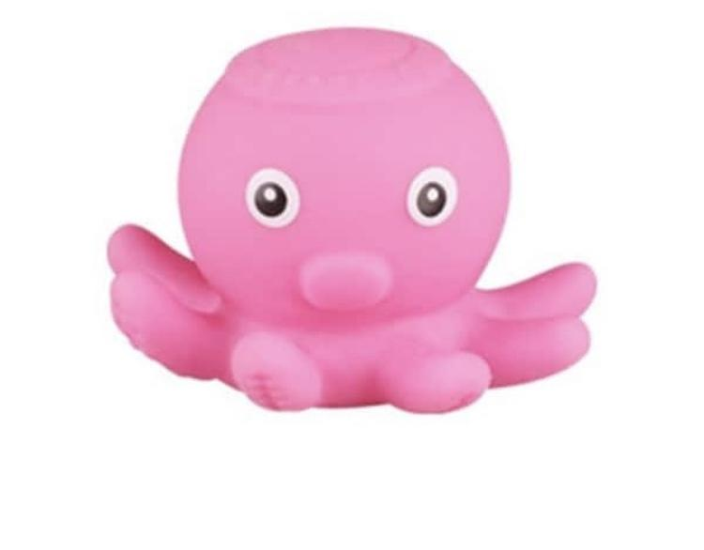
Take a squeaky toy and squeeze it so that it makes a squeaky sound. Hide it behind your back or under the blanket or behind the cushion let your baby try to look for it.

- This simple game is great for cognitive development in babies. It also helps in developing auditory skills and object prominences.

Fun with Bubbles
Blow bubbles with your little one. This will help gain hand- eye coordination

