March
2020
Subtitle
Unit 7 Water  During the month of March class 208 concentrated on learning all about Water. You may continue learning all about this unit at home with your child. Students will develop a clear understanding about  How water changes depending on how warm or cold it is.  Some things float in water and some sink.  Some things change when you put them in water. | 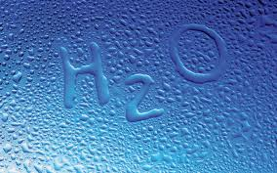

Where can we find water? Monday 23
Book Reading: Who sank the boat – Pamela Allan
https://www.youtube.com/watch?v=ZpFWuHSDFtQ
Parent & Child Activity:
At home invite your child to create a paper boat you may ask your child to draw themselves
In the boat. Together you can try floating the boat in a bin full of water or try this in the bathtub or sink while supervised.
Take this moment to ask your child
Do you think the boat will float?
Did you guess correct?
Why do you think
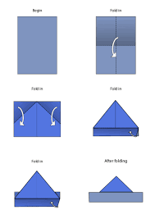

Tuesday 24
Book reading: Bean Floats a Boat – Ann Bevans & Mathew Gray
https://www.youtube.com/watch?v=lB9RGGI-aHE
Parent & Child Activity

Help your child find objects around the house in which they believe are capable of floating in water. Take turns with your child to experiment if the object you each selected will sink or float. Repeat these steps and tally up your scores.
Or you may gather up materials such as
A piece of paper
A pen
Sponge
Aluminum paper etc..

Be sure to ask your child questions such as
Is the object you selected able to go in water?
What do you think will happen next? Will it float ? Will it sink?
How does the object you selected feel?

Wednesday 25
Book reading: Hey Water – Antoinette Portis
https://www.youtube.com/watch?v=u7XN3k6kcEg
Parent & Child Activity:
Provide an assortment of containers and small pitchers of water or different size of cups and containers. Invite your child to pour the water into the containers. Engage in a discussion about the shape of water and how they might make water change its shape. Allow your child to self pour.
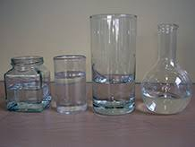

Thursday 26
Book Reading: Ice Boy – David Ezra
https://www.youtube.com/watch?v=6iW3x_1cxI0

Parent & Child Activity:

Ice-cubes meltdowns

Provide your child with ice cubes and warm water. Assist your child to pour warm water over ice cubs and together discuss the changes from solid to liquid. For more fun add small interesting objects such as pencil erasers, crumbled paper or cotton balls.
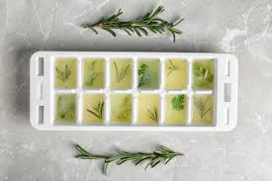

Friday 27
Book Reading :
Parent & Child Activity: Recycle water or juice bottles and create a sensory bottle with your child. Add water along with other small objects such as bobby pins, cotton balls etc for a more fun look!

. 