March 30 – April 3
2020
Unit Eight: Plants

During this month class 208 will be concentrated on learning all about plants. You may continue learning all about this unit at home with your child. Students will develop a clear understanding about  What are plants?  What are some different kinds of plants?  What do they need?  How are they important? | 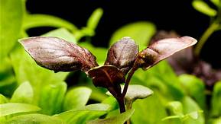

Monday 30
Book Reading: The Curious Garden by Peter Brown
YouTube: https://www.youtube.com/watch?v=6SHmN-wXykU
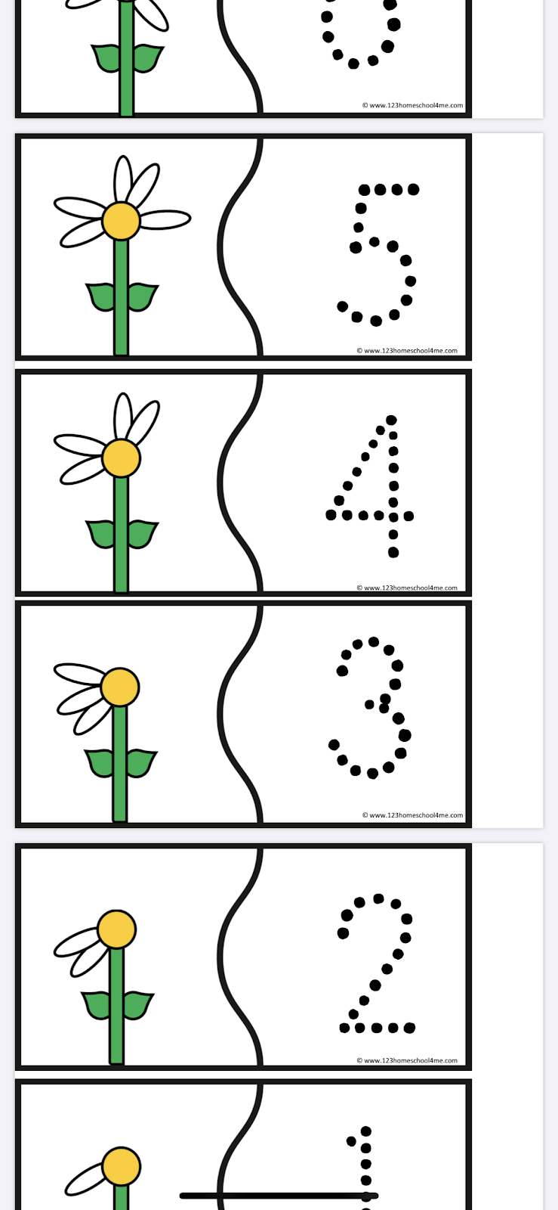
Parent & Child Activity: Flower Counting Puzzle ( 1-5 ONLY)

Print and cut out puzzle.
Together count the petals on each flower and find the matching number. Allow your child to trace the dotted numbers 1-5.

Note : If you do not have access to a printer, on a blank paper write the numbers 1-5 (dotted style.) Allow your child to count the petals and trace the matching number.

Tuesday 31
Book reading: And then its Spring by Julie Fogliano and Erin E. Stead
YouTube: https://www.youtube.com/watch?v=0l59Gbd3q90

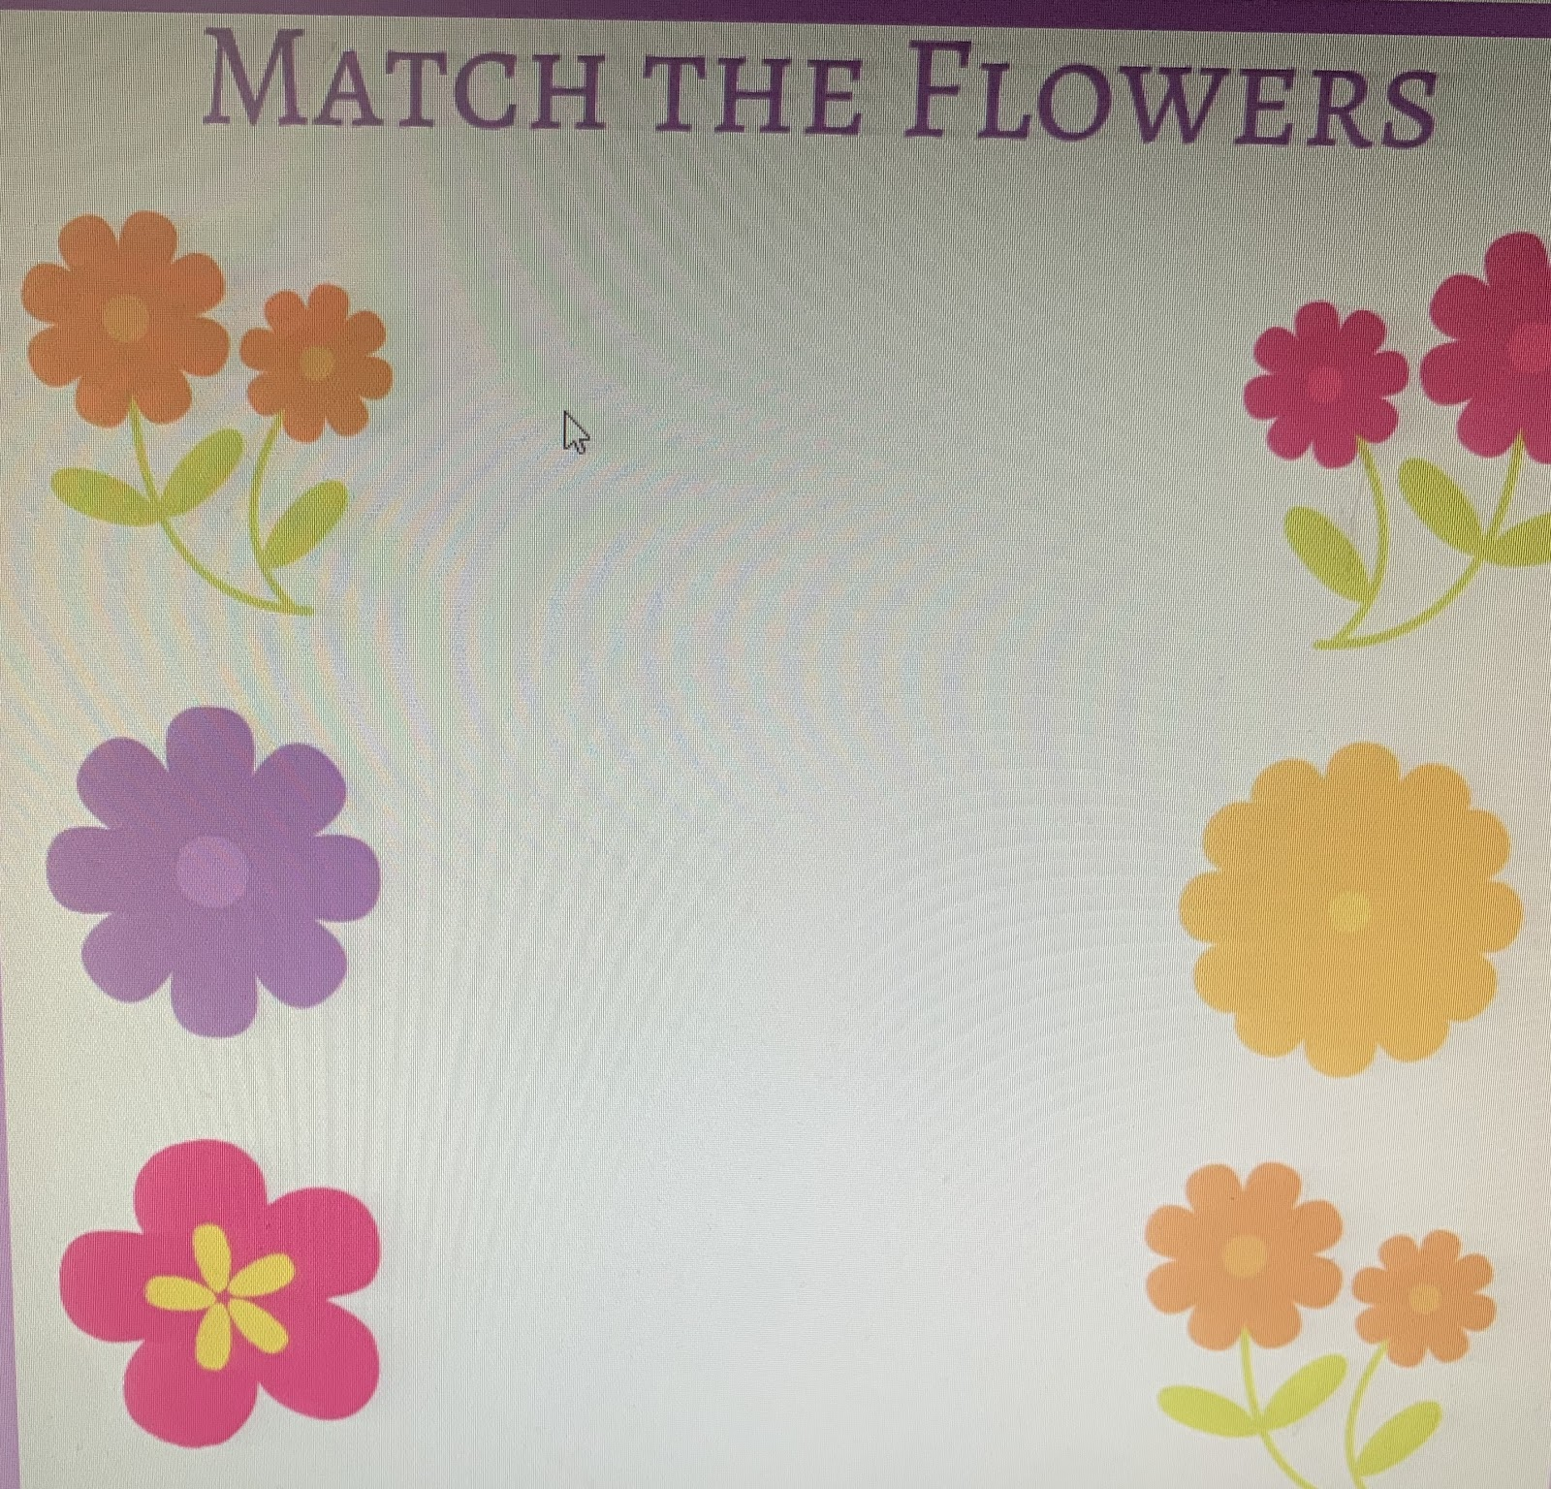
Parent & Child Activity: Matching Flowers Activity
Print out the matching flowers activity. Help the child match similar flowers by drawing a line across, Make sure to ask the child questions such as
What colors do you see?
Which flowers have the same shape?
Which two look alike?

Note : If you do not have access to a printer, you may have the child point to the pictures that are the same. You may count the petals together and talk about what makes each flower different.

Wednesday 1
Book reading: Up in the Garden and Down in the Dirt by Kate Messner
YouTube: https://www.youtube.com/watch?v=w5qhb1Jpow4
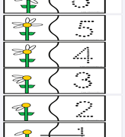

Parent & Child Activity: Flower Counting Puzzle ( 6-10 ONLY)
Print and cut out puzzle.
Help the child count the petals on each flower and find the matching number. Allow the child to trace dotted numbers 11-20

Note : If you do not have access to a printer, on a blank paper write the numbers 6-10 dotted style. Allow the child to count the petals and trace the matching number.

Thursday 2
Book Reading: If You Plant a Seed by Kadir Nelson
YouTube: https://www.youtube.com/watch?v=NNHjSV0nPrU
Parent & Child Activity: Flower Pattern Print out 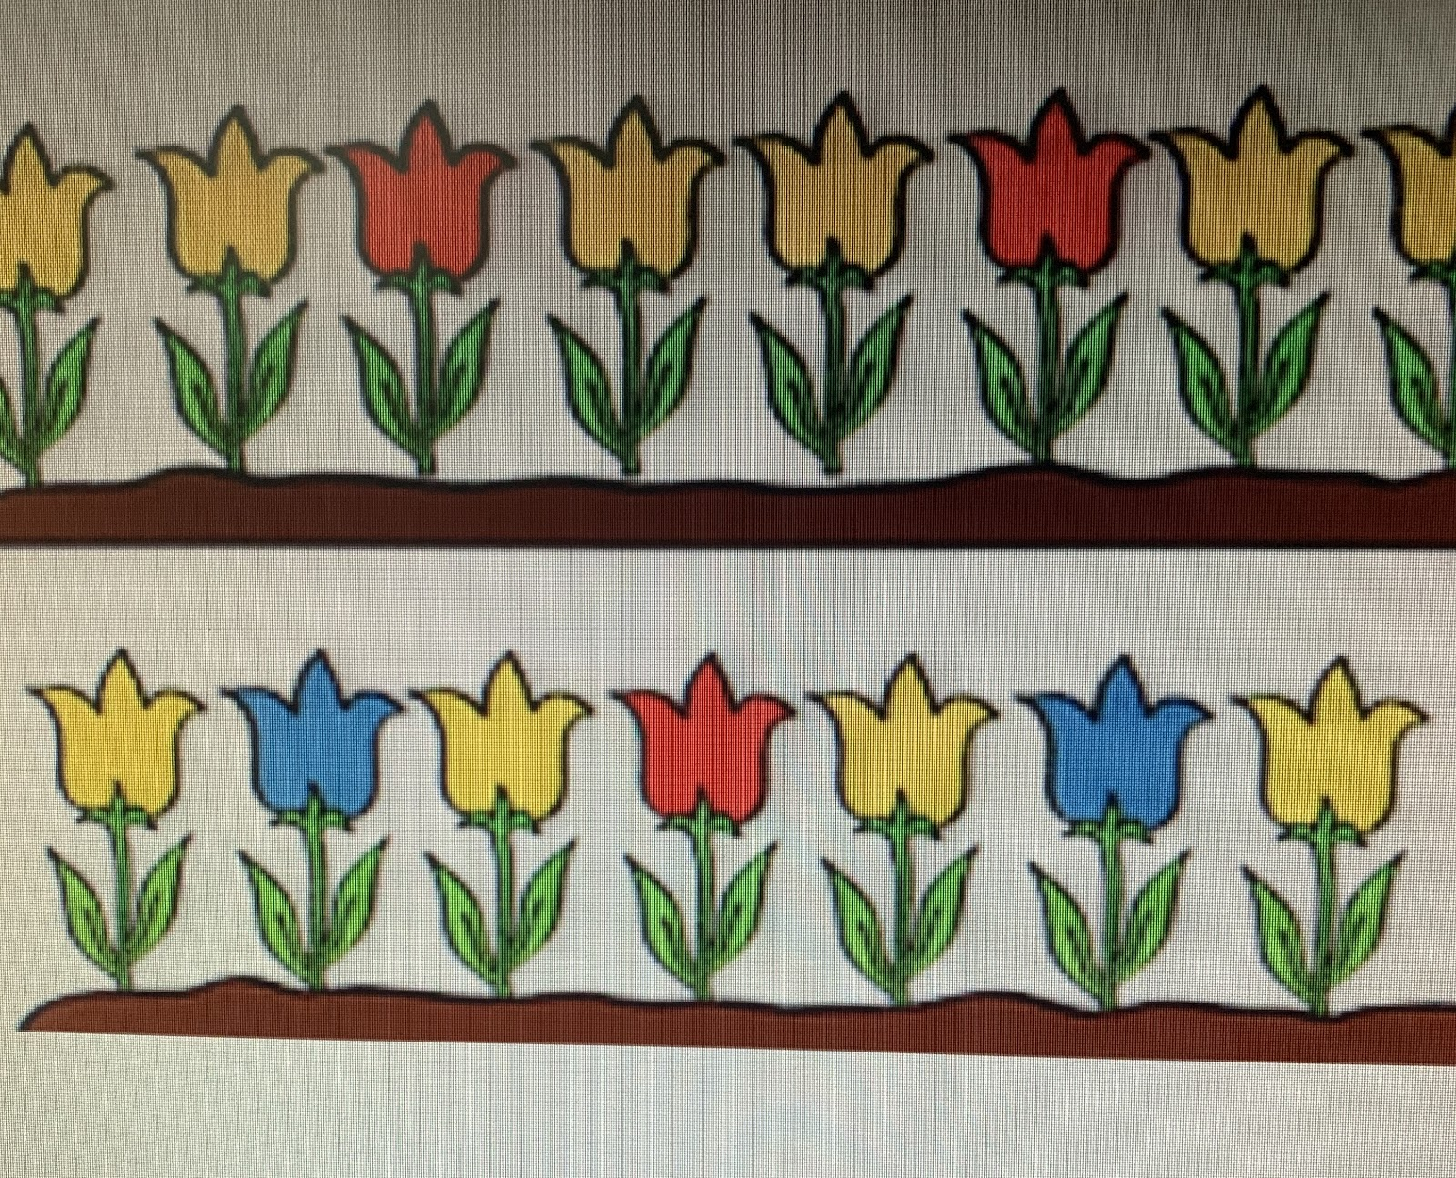
Have the child talk about the colors they see. Make sure to ask what color do you think comes next? Allow the child to color in the missing color.
Talk about patterns using words such as, first is… next is…

Note: If you do not have access to a printer, allow the child to point when viewing activity on the device being used. You may also gather small objects at home and create a pattern.

Friday 3
Book Reading : Plant Life Cycle (Email print-out)
Together read the booklet and talk about what is happening in each picture
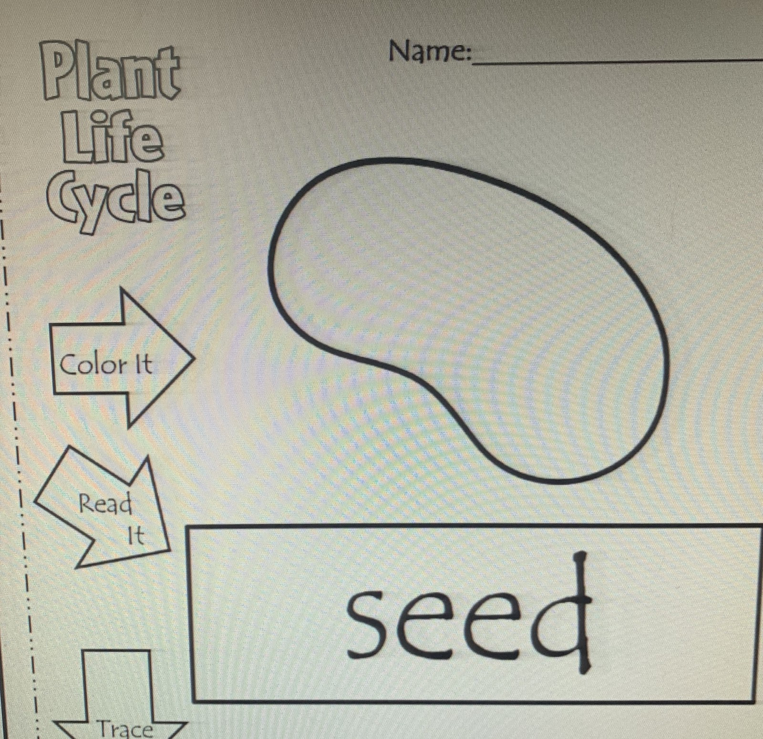
Parent & Child Activity: Plant Life Cycle
Print out Plant Life Cycle booklet. Have a conversation with the child about the life cycle of a plant, together put the Plant Life Cycle booklet in the following order
1.Seed
2. Rooting
3. Sprouting
4. Baby plant
5. Medium plant
6.Adult plant
Allow the child to color and trace words.

Note: If you do not have access to a printer, you may read the booklet together online discuss each cycle. Make sure to ask question such as
What do you think is happening to the seed?
What color do you see?
What do you think will happen next?

Provide the child with a blank paper and ask him/her to draw their own plant.

