Good morning students and parents of Class 213,

I hope that you and your families are all well! Attached are documents for you to utilize as we move towards a new remote learning model for all school days until April 20, 2020. Ms. Janae and Ms. Chrys will provide you with our current up to date unit of study lesson plan. We are currently learning about water and are in week 3(what does water do). This unit is interactive and a great deal of fun and can be incorporated throughout daily household activities. We've also provided various learning activities to keep our students busy while at home throughout the upcoming day. Stories that are incorporated in our lesson plans can still be read at home. DON'T PANIC! You do not have to purchase the book, you can simply go on YouTube and type in the book's title and Arthur and add read aloud and the story will appear. This is a great opportunity for parents to ask their child open ended questions to help your child work on their recall skills as well as work on introducing new vocabulary words.
Please feel free to reach out to us with any questions or concerns through email at
Ms. Janae: Janaeuribe@gmail.com
Ms. Chrys: Chryshulalezcano@gmail.com

We also ask parents to download to your child’s tablet or on your phone the app called Zoom. Ms. Chrys and I will conduct an online face to face check up on students in a group like setting on a Facetime call through the app. We are aiming to check in everyday at 11am and for other students whose family aren’t available at 11am we will check in at 2:30pm. If you are unable to download the app please let us know so we can work out other alternatives.

The Department of Early Childhood Education has created a Learn at Home activity packet with suggested activities and guidance for families and caregivers. Review the suggestions in this linked document for how your early childhood teachers can support remote learning for our youngest students while school buildings are closed. We will keep you updated if new or updated content is available throughout the coming weeks.

Parents:
All families can visit the nearest DOE District School to pick up grab-and-go breakfast starting at 7:30 AM and lunch starting at 11:30AM. Families can find the nearest District School by visiting https://www.nycenet.edu/schoolsearch or calling 311.

Thank you for your continued support to our youngest learners and their families.

Be well, Ms. Janae & Ms.Chrys

Unit Title: Water
Week: Three
Essential Question: What does water do?
Focus Question: What happens when we put things in water?

Monday March 23, 2020
*Parents please take pictures of your child's completed work/activity and email to: Janaeuribe@gmail.com or Chryshulalezcano@gmail.com

Vocabulary words of the day: sink, soak, sponge,float,

ebook/youtube story of the week: Float by Daniel Miyares
youtube link to story: https://www.youtube.com/watch?v=dC2i-I1leig

Level 1: Recall
Questions to ask once the story has ended: **Parents the story as no words have your child pay close attention to the pictures.
1. What did the boy make out of the newspaper?
2. What did the boy play with outside in the rain?
3. How did the boy’s boat get into the river?

Science Activity
Sink vs. Float Experiment: ask children what the words sink and float mean. Provide an assortment of objects that sink as well as some that float and invite children to place the objects in a tub of water and invite them to observe what happens. Before testing each object, children can predict and record whether they think each one will sink or float and then compare the results to their predictions.
PK.CKW.2 (Science): Tests predictions through exploration and experimentation.

Fine Motor/ Writing Activity: 4
Letter Ice: Supply ice cubes and let children use them to create letters. Provide pictures of letters for them to reference as they work. Talk about the sounds that the letters make.
Objectives/UPK Standards:PK.CLL.2: Demonstrate an emerging understanding of spoken words, syllables and sounds (phonemes).

Gross motor Activity:
Share a Puddle: Place a hula hoop on the floor or make a circle using shoes or various household items and ask your child to pretend it is a puddle. Play music and invite your child to walk around the puddle. When the music stops, have the children stop walking around the hula hoop puddle and jump into it
Objectives/UPK Standards: PK.PDH.2: Uses sensory information to plan and carry out movements.

Arts & Craft Activity:
Crayons and Watercolors: Invite your child to draw a picture with crayons. They may choose to draw an underwater or rainy day scene like from the story float. After their drawings are complete, provide watercolor paints and invite children to use large paint brushes and lightly paint over their crayon drawings. Discuss the changes to the picture and ask your child to add the watercolor paint. For parents who do not have watercolors or paint brushes at home it is ok you can have your child dip their pointer finger into a cup of water and outline their crayon drawings. Discuss with your child the types of texture they are feeling as well as what are they observing.
Objectives/UPK Standards: PK.CKW.6 (Science): Acquires knowledge about the physical properties of the world.
Math:
Catch a raindrop or a snowflakes: Invite your child to look out the window and observe the weather and discuss with your child where they think the rain/snow is coming from. After, have your child hold a piece of paper out of the window to catch a raindrop or a snowflakes. Once the paper is filled you and your child can count together and circle how many raindrops/snowflakes you collected together.
PK.CKW.1 (Science): Asks questions and makes predictions based on observations and manipulation of things and events in the environment.
PK.CKW.2 (Counting and Cardinality): Represent a number of objects with a written numeral 0 – 5 (with 0 representing a count of no objects).

Tuesday March 24, 2020
Vocabulary words of the day: temperature, umbrella, waterproof, drenched
Introduce the letter W
ebook/youtube story of the week: Float by Daniel Miyares
youtube link to story: https://www.youtube.com/watch?v=dC2i-I1leig

Questions to ask once the story has ended:
Level 2: Skill/Concept
- The boy put his boat in puddles outside. Where did the puddles come from?
- Why did the boy have to chase his boat?

Science Activity:
Have your child guess which object will sink and which will float. Tell your child that lighter objects are more likely to stay on the surface of the water and heavier objects are more likely to sink to the bottom of the tub. Drop a couple of objects into the water to show your child how you would like them to place the objects, avoiding splashing, and showing them what you are looking for to determine whether the object floats or sinks. Make a “float” and a “sink” pile and put your objects in their corresponding pile.
PK.CKW.2 (Science) Test predictions through exploration and experimentation.

Fine Motor/ Writing Activity:
When scissors are held correctly and when they fit a child's hand well, cutting activities will exercise the very same muscles which are needed to hold a pencil correctly, that is, between the thumb and index finger with the pencil resting on the middle finger. The correct scissor position is with the thumb and middle finger in the handles of the scissors, the index finger on the outside of the handle to stabilize, with fingers four and five curled into the palm.
**Parents practice cutting various things with your child. (examples listed below)
1. Cut up junk mail or magazine subscription cards.
2. Make fringe on the edge of a piece of construction paper.
3. Cut Play-Doh with scissors.
4. Cut straws or shredded paper.

Gross motor Activity:
Play ebook/youtube story: Listen to the Rain by Bill Martin
youtube link: https://www.youtube.com/watch?v=HXs1MP64Sv8
Water Dance: Play music that evokes thoughts of water such as Ravel’s “Jeux d’eau” or Handel’s “Water Music.” Invite your child to listen to the music and respond by dancing to show how the music makes them feel.
PK.CKW.7 (The Arts): Expresses what s/he knows, thinks, feels and believes through dance and creative movement.

Arts & Craft Activity:
Create a boat: Using various items at home such as sponges, egg cartons, juice boxes and more.
PK.CKW.1 (Science): Asks questions and makes predictions based on observations and manipulation of things and events in the environment.t
examples:
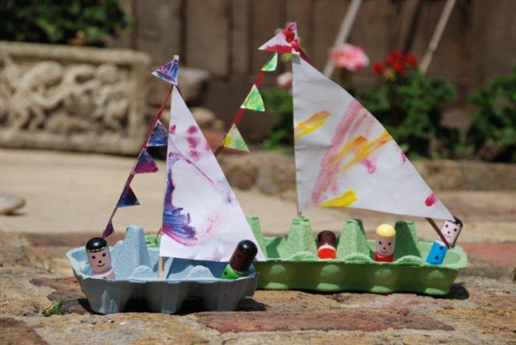

Math:
Introduce the letter “W” to your child practice writing it and working on the sound that the letter “W” makes. Conduct a magazine,newspaper, cereal box, or supermarket flyer. Have your child circle all the letters “W” that they find and then count. * Parents pay close attention to counting especially around the numbers 14, 15, 16.
PK.CKW.2 (Counting and Cardinality): Represent a number of objects with a written numeral 0 – 5 (with 0 representing a count of no objects).

Wednesday March 25, 2020
Vocabulary words of the day: absorb, boat, captain, dissolve,
Review letter W
ebook/youtube story of the week: Float by Daniel Miyares
youtube link to story: https://www.youtube.com/watch?v=dC2i-I1leig

Questions to ask once the story has ended:
Level 3: Strategic Thinking
1.How did the boy feel when his boat got wrecked in the river? How do you know?
2.How can you find out if something floats in water?
3.What are some things that float?

Science Activity:
Making predictions and sorting: Have your child test one object at a time, placing them into their own “float” and “sink” piles as their finish. As the child finishes, go around and check their piles for correctness. Ask your child to help clean up any spills that may have happened.
PK.CKW.2 (Science) Test predictions through exploration and experimentation.

Fine Motor/ Writing Activity:
Attach a large piece of drawing paper to the wall. Have your child use a large marker and try the following exercises to develop visual motor skills:
1.Make a letter, number, or letter part (stroke) model— one per sheet of paper. 2.Have the child trace over your line from left to right, or from top to bottom. 3.Have them trace over each figure at least 10 times.
Then have the child draw their figure next to your model several times.
Gross motor Activity:
Play ebook/youtube story: What Floats in a Moat by Lynne Berry
youtube link: https://www.youtube.com/watch?v=lltGaSroi6w
Melt: Invite children to consider what they would look like if they were melting and try to act this out. Play music and invite them to dance as though they were melting. Some children can be the audience while others dance. Invite children to alternate roles. PK.CKW.7 (The Arts): Expresses what he/she knows, thinks, feels and believes through dance and creative movement.

Arts & Craft Activity: Bubble Painting is a fun way to create art with your children! Easily craft your artwork into notecards, bookmarks, and more.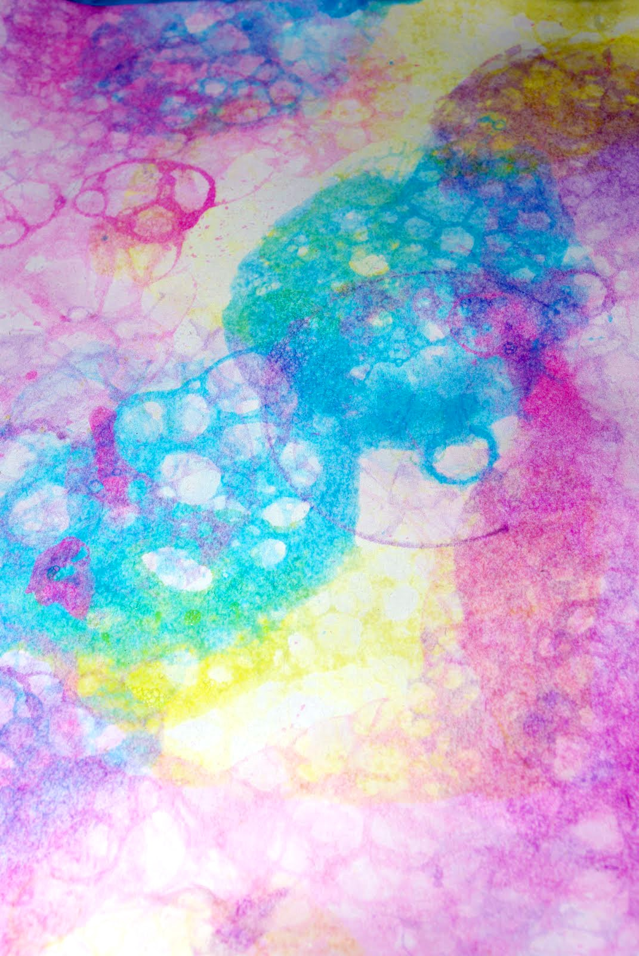

Math:
Scavenger hunt for the letter “W: *Parents write various letters on paper and tape all over a room in one specific room in the house. Have your child go on a scavenger hunt searching for all the letter “W” that they can find in the room. If your child picks up a wrong letter during the scavenger hunt it's okay! Inform your child what the letter is and continue the hunt.
PK.CKW.2 (Counting and Cardinality): Represent a number of objects with a written numeral 0 – 5 (with 0 representing a count of no objects).

Thursday March 26, 2020
Vocabulary words of the day: ferry, absorb,, island, repel
Review letter W
ebook/youtube story of the week: Float by Daniel Miyares
youtube link to story: https://www.youtube.com/watch?v=dC2i-I1leig

Questions to ask once the story has ended:
Level 4: Extended Thinking
1.Why do you think this book is called Float?
2.The boy’s boat floated in the puddles but when it went in the river it fell apart. Why?
3.Why do some things float and some things sink?

Science Activity:
Does it float or sink? Place the object into the corresponding labelled container that your child used yesterday to sort objects that sank and those that floated. Talk about why some objects sink and others don’t. Discuss the weight, size and material the object is made of and how this influences their floating ability. Talk about why there were bubbles when some objects sank.(* Parents Bottles tops are great for floating when turned over both ways. Can a bottle top hold a small stone and still float? )
PK.CKW.2 (Science) Test predictions through exploration and experimentation.

Fine Motor/ Writing Activity:
Attach a large piece of drawing paper to the wall. Have your child use a large marker and try the following exercises to develop visual motor skills:
1.Play “Connect the Dots.” Again make sure the child's strokes connect the dots from left to right, and from top to bottom
** You can have your child connect the dots to their first name. If your child already knows how to completely write their name without using dots or an outline begin working on their last name.

Gross motor Activity:
Play ebook/youtube story: Who Sank the Boat? by Pamela Allen
youtube link: https://www.youtube.com/watch?v=kZXzwXH32bU
Snowflakes: Invite your child to consider what their bodies would look like if they were falling snowflakes. Play music and invite them to dance like snowflakes.
PK.CKW.7 (The Arts): Expresses what he/she knows, thinks, feels and believes through dance and creative movement

Computer Technology:
Enter the question: Where Do We Find Water? into your search engine and join your child in observing the images that are displayed. Ask them which ones they have seen before and which ones they have never seen.
PK.CKW.5 (Technology): Uses the knowledge of technology to increase learning.

Math:
Review the letter “W”: W is for whale--- along with the sound of “w”.
Complete matching ocean animals shadow discuss what kind of body of water these sea creatures live in.
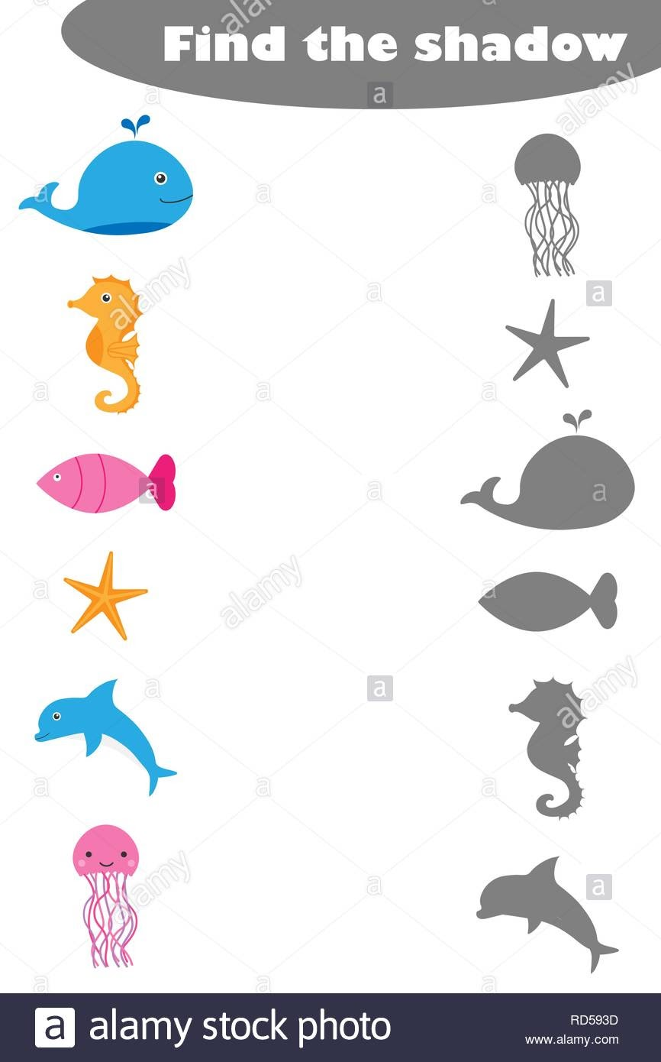
Friday March 27, 2020
Review all vocabulary words of the week: absorb, boat, captain, dissolve, diver, drenched, ferry, float, island, repel, sailor, saturate, sink, soak, sponge, swim, temperature, umbrella, waterproof
Review letter W
ebook/youtube story of the week: Float by Daniel Miyares
youtube link to story: https://www.youtube.com/watch?v=dC2i-I1leig

Have your child draw a picture of a toy at home they discovered floats in any body of water form such as an ocean, lake, pound, river etc.

Science Activity:
Bubbles: Make homemade bubbles with your child. Write out the recipe on chart paper for children to follow throughout the process. Before making the bubbles, invite children to try to blow bubbles with plain water and a bubble wand. As you make the bubbles, talk about what you are adding to the water. When the bubble mix is complete use it to blow bubbles outside.
Materials
- Large cup
- 1/2 cup dish soap
- 1 1/2 cups water
- 2 teaspoons sugar
- Bubble Wands

Instructions
- Get a large cup.
- Pour 1/2 cup of dish soap into the cup.
- Add 1 1/2 cups of water.
- Measure 2 teaspoons of sugar and add it to the water/soap mixture.
- Gently stir your mixture

PK.CKW.6 (Science): Acquires knowledge about the physical properties of the world.

Fine Motor/ Writing Activity:
The following activities involve the use of manipulatives to support young children's fine motor development, and will help to build the strength and dexterity necessary to hold a pencil appropriately.
1. Mold and roll Play-Doh® into balls—using the palms of the hands facing each other and with fingers curled slightly towards the palm.
2. Roll Play-Doh® into tiny balls (peas) using only the fingertips.

Gross motor Activity:
Play ebook/youtube story: Ask your child which story was their favorite this week and read/re-play the story for your child.
youtube link: stories from this week
1.Float by Daniel Miyares
youtube link to story: https://www.youtube.com/watch?v=dC2i-I1leig
2.Play ebook/youtube story: Listen to the Rain by Bill Martin
youtube link: https://www.youtube.com/watch?v=HXs1MP64Sv8

3. Play ebook/youtube story: What Floats in a Moat by Lynne Berry
youtube link: https://www.youtube.com/watch?v=lltGaSroi6w

4. Play ebook/youtube story: Who Sank the Boat? by Pamela Allen
youtube link: https://www.youtube.com/watch?v=kZXzwXH32bU

Water Xylophone: Create a water xylophone. Fill small glass jars with various amounts of water. Invite your child to gently tap the sides of the jar with a spoon and listen to the different tones produced.
PK.CKW.3 (The Arts): Expresses oneself by engaging in musical activities.

Computer Technology:
Islands: Search for images of aerial views of Manhattan, Long Island, Staten Island, Roosevelt Island and other local islands. Talk with your child about the relationship between water and islands as well as the islands in the New York City area.
PK.CKW.3 (Social Studies): Demonstrates knowledge of the relationship between people, places and regions.

Math:
When scissors are held correctly and when they fit a child's hand well, cutting activities will exercise the very same muscles which are needed to hold a pencil correctly, that is, between the thumb and index finger with the pencil resting on the middle finger. The correct scissor position is with the thumb and middle finger in the handles of the scissors, the index finger on the outside of the handle to stabilize, with fingers four and five curled into the palm.
After your child has cut the whale on the dotted lines have your child re-arrange the numbers 1-5. Guide them and prompt them to use the images of the whale to properly align the numbers 1-5.
