Hello Parents!

As a PreK teacher one thing I have observed in children—
Consistency is everything. Keeping up with your child’s school schedule at home will be challenging but here are some tips on how you can bring the classroom into your home!

Tip #1: Make a monthly calendar. Everyday your child engages in circle time in their class where the calendar is reviewed. This can be a fun craft between your little one and yourself. Making the calendar can be really inexpensive. Allow your child to pick the design of their own personal calendar. (Add stickers, use glitter, be creative) Dollar tree sells white poster boards which will work perfect for this project. Everyday review the days of the week, months of the year and to add some math count from the 1st until you land on what today is. Below is what the calendar in my personal classroom looks like:
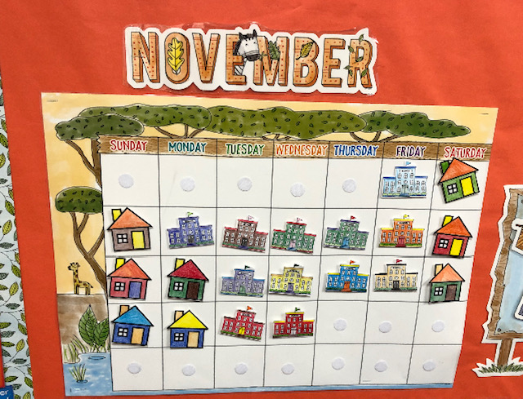
Tip #2: Create a weather wheel/ chart. You can make a weather wheel or chart by drawing a Sun, Clouds, Rain, Wind and even Snow because you just never know living in NYC. You can use this as a teaching moment with your little one. Ask them questions such as:
- If today was sunny what do you think the weather will be like tomorrow?
- It’s raining outside today. What kind of clothes do we wear when it’s raining?
Try your best to ask them, open-ended questions. Open ended questions are questions that begin with: Where, What, Why & How. These are questions they cannot answer with yes, no or maybe.

Tip #3: Talk about their feelings. Children enjoy school so much at this age, especially if they are the only child in the house. Try to touch base with them about their emotions and do different activities with them feel better. For example, encourage them to sing their favorite song, dance, jump rope, paint or draw.

If your child is in PreK in NYC and they follow the DOE curriculum they are currently learning about Water. If they are not learning about Water, I’m sure your little one will enjoy learning all about water. My goal is to help you all through this process that means even going through the next unit of study virtually until school resumes!
My teaching points for this unit are:
1. Where can we find water?
Text: Water Dance by Thomas Locker
2. What happens to water when it changes temperature?
Text: Rain! By Linda Ashman
- What happens when we put things in water? (sink/float)
Text: Float by Daniel Miyares
4. How does water help us?
Text: Water Can Be by Laura Purdie Salas
All books can be streamed on YouTube. Just type the name of the book and read aloud. Below are more books about water.
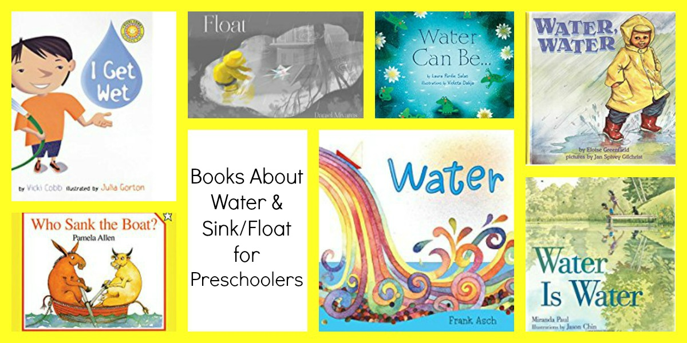

For this unit I found two episodes on the magic school bus that is on Netflix, (Season 1Episode 13) this episode talks about weather specifically thunder and water and (Season 2 Episode 5) this episode talks about the water cycle.

Below are some activities and experiments you can do with your child.

Arts & Crafts:
Markers and Water:
Invite children to use markers to create a picture. After they have finished with the markers, provide spray bottles of water and invite children to lightly spray their papers. After they have sprayed their papers, encourage them to watch and describe how the water has changed their work.
Paint on Ice:
Make large pieces of ice by freezing a shallow layer of water in a cookie sheet. Remove the ice from the container and invite children to paint on it with watercolors. Discuss what will happen when you put the water in the freezer and why the ice becomes water again after it is out of the freezer and the children begin to paint on it.
Letter Prints:
Create letter stamps using a sponge or similar material. Provide paint and invite children to create letter art. As the children work, talk with them about the sounds the letters make and how the sponge soaks up the paint.
Crayons and Watercolors:
Invite children to draw a picture with crayons. They may choose to draw an underwater or rainyday scene. After their drawings are complete, provide watercolor paints and invite children to use large paintbrushes and lightly paint over their crayon drawings. Discuss the changes to the picture as children add the watercolor paint.
Ice Cube Painting:
Make colored ice cubes out of water and food coloring. Insert a Popsicle stick into the water as it freezes to create a handle for children to hold while painting. Children can then use the colored ice paint. Before they begin painting, ask them to predict how the paints will work and what will happen as they use them.
Science & Discovery
Salt and Ice:
Supply salt and ice. Pour the salt onto the ice; observe and discuss what happens. Children could also use pipettes to squirt salt water onto the ice. Make connections to how and why workers add salt to streets in the city during the winter.
Water Cycle:
Draw the sun and clouds on the outside of a small sealable plastic bag. Fill 1/6 of the bag with water and seal. Hang in the window. Invite the children to predict what will happen. Let the bag hang for several days and observe. The water should evaporate into vapor then change back into a liquid as it cools, forming drops inside the bag.
Land or Water:
Provide an assortment of small animal and sea creature toys (e.g., dog, cow, fish, shark, etc.). Invite children to sort the toys into two categories: those that live in water and those that live on land. Use a blue piece of paper as a base for the water animals and green for land.
Bodies of Water:
Provide clay, playdough or other type of dough and invite children to make a landscape in a tray with the dough. When the landscape is complete, invite children to pour water over it, noting where water pools and creates bodies of water. Add small toy people, boats, etc., for children to use in their landscapes.
Bubbles:
Make bubbles with your child at home. Explore what happens to the water when the ingredients are added. Enjoy the bubbles outside!
Who lives in the ocean:
Talk about the different animals that live in the ocean.

